Ben-Gurion University of the Negev - Deep Learning Course
Assignment 3: Lyrics Generation using Recurrent Neural Networks
Chen Frydman 208009845 | Amit Ner-Gaon 211649801

1. Model Architecture
All three models share a two-layer LSTM backbone. Each input word is represented by its 300-dimensional Word2Vec embedding (pre-trained on Google News, weights frozen). The LSTM uses hidden_size=256, dropout=0.3, and a linear output layer mapping the final time-step hidden state to logits over the top-5,000-word vocabulary. Generation uses a sliding context window of lookback=7 words.
Vocabulary: the 5,000 most frequent tokens in the training corpus. Sequences containing OOV context words or unembeddable Word2Vec tokens were filtered out, yielding 57,047 training samples (477 songs) and 14,764 validation samples (119 songs) via a song-level 80/20 split to prevent data leakage.
Hardware used: GPU RTX 6000 via BGU’s cluster.
Model | MIDI Input | Parameters
Lyrics Only (Baseline) | None | 2,382,728
Melody Concat (Approach A) | Appended to every step | 2,387,848
Melody Hidden-Init (Approach B) | Projects to h₀ / c₀ | 2,388,872

2. Melody Integration Approaches
2.1 MIDI Data Analysis and Feature Extraction
We analysed the 619 successfully loaded MIDI files using Pretty_Midi. Figures B1–B7 (Appendix B) show distributions of note count, duration, instrument usage, note density, pitch, and tempo across the corpus. The dataset spans a wide tempo range (60–200 BPM), predominantly uses piano and synthesiser voices, and shows a bimodal pitch distribution centred around MIDI notes 55–75 (G3–D5).
Five scalar features are extracted per song: mean pitch, pitch standard deviation, mean note duration, mean note velocity, and total note count. These form a 5-dimensional vector that is z-score normalised using training-set statistics (μ=[58.97, 12.36, 0.52, 91.69, 3418], σ=[4.53, 2.70, 0.26, 16.59, 1857]). Songs with unreadable MIDI files are excluded from training.

2.2 Approach A - Melody Concat (MelodyConcatModel)
The normalised 5-D MIDI vector is concatenated with each word embedding, giving the LSTM a 305-dimensional input at every time step. The melody is therefore available at every autoregressive step, and the LSTM can modulate its hidden state at any position based on the melody signal. The architecture is otherwise identical to the baseline (input_size=305, hidden_size=256, num_layers=2, dropout=0.3).
2.3 Approach B - Melody Hidden-Init (MelodyHiddenInitModel)
A small projection layer maps the 5-D MIDI vector to the initial hidden state h₀ and cell state c₀ (shape: num_layers × batch × 256). The word-embedding input remains 300-D, identical to the baseline. The melody biases the entire generation trajectory through the initial hidden state without adding redundant step-by-step conditioning-a more compressed form of melody conditioning that encodes the melody as a latent style prior.
Approach A provides persistent, step-by-step melody access while approach B provides a single melody initialisation that the LSTM then freely evolves.
3. Training
All models: CrossEntropyLoss, Adam (lr=1×10⁻³), batch size 128, 15 epochs, gradient clipping (max-norm 5.0). Best checkpoint (lowest validation loss) was saved per model.
Training and validation losses are logged to TensorBoard - Figure A1 shows loss curves and Figure A2 shows perplexity curves for all three models.
Model | Best Val. Loss | Best Val. Perplexity | Best Epoch
Lyrics Only (Baseline) | 5.597 | 269.5 | ~5
Melody Concat (A) | 5.591 | 267.9 | ~5
Melody Hidden-Init (B) | 5.616 | 274.8 | ~4

All three models overfit after epoch ~5: training loss continues falling while validation loss rises (Figure A1, Figure A2). Melody Concat achieves marginally the best validation perplexity (267.9 vs. baseline 269.5), suggesting step-by-step melody conditioning provides a slight regularizing benefit. Melody Hidden-Init slightly exceeds the baseline (274.8), consistent with its more compressed melody representation being harder to exploit with a small corpus.
Figure A3 compares best validation metrics across all models.
4. Generated Lyrics - Seed Word and Melody Effects
For each of the five test songs, lyrics were generated with all three models and three seed words ("love", "night", "run") using proportional sampling - 45 outputs total, included in generated_lyrics.txt.

4.1 Effect of Seed Word
The seed fills the initial 7-word context window and strongly biases the first few tokens. "love" elicits romantic vocabulary early:
"cause i will try to you forget me baby / you believe me want me i have it's you"
(Bangles / Lyrics-Only / seed=love)
"night" draws temporal tokens, "run" elicits motion words. The seed effect decays within 5-8 steps as the hidden state is progressively overwritten by newly sampled words.
No model reliably preserves seed-word semantics throughout a full 80-word output.
4.2 Effect of Melody
Comparing baseline and melody-conditioned outputs for the same seed and test song shows consistent lexical differences: the melody models choose different words even with identical seeds. The effect is subtle at the surface level but confirmed quantitatively in Section 5.
5. Melody-Influence Probe
5.1 Design
For each test song (fixed seed word "love"), lyrics were generated under three MIDI conditions: (1) correct normalised MIDI;
(2) shuffled MIDI - same five values, dimensions randomly permuted;
(3) mismatched MIDI - features from a different test song. This was applied to both melody-conditioned models across all five test songs.
5.2 Metric: Jaccard Similarity
Output change is measured by Jaccard similarity of word sets: J(A,B) = |A∩B|/|A∪B|.
Lower J → melody changed the output more → melody is genuinely used. Jaccard is appropriate because we care about vocabulary change rather than word order, and it is bounded in [0,1], making results interpretable across songs.
5.3 Results and Discussion
Model | Condition | Mean Jaccard (↓ = more melody use)
Melody Concat (A) | Shuffled MIDI | 0.165
Melody Concat (A) | Mismatched MIDI | 0.160
Melody Hidden-Init (B) | Shuffled MIDI | 0.149
Melody Hidden-Init (B) | Mismatched MIDI | 0.138

Both models show Jaccard well below 0.5, confirming that MIDI conditioning genuinely alters the output - neither model ignores the melody (see Figure A4). Melody Hidden-Init (B) is consistently more sensitive: corrupting its melody produces a larger output change (mean 0.143) than for Melody Concat (A, mean 0.163). This aligns with the design: in Approach B the entire hidden-state trajectory is seeded by the MIDI vector, so a corrupted melody re-initialises generation from a different point. In Approach A the melody is one of 305 input dimensions and is partially averaged out by the dominant 300-D word-embedding signal at every step.
6. Decoding Strategy Comparison
Four strategies were compared on the first two test songs (Melody Concat, seed='love').
Figure A5 shows type-token ratio (TTR) and unique-word count.
Strategy | Avg. TTR | Avg. Unique Words | Coherence
Proportional | 0.781 | 62.5 | Low
Temperature (T=0.7) | 0.556 | 44.5 | High
Top-K (K=50) | 0.556 | 44.5 | Moderate
Nucleus (p=0.9) | 0.769 | 61.5 | Low–Moderate

6.1 Concrete Examples (Bangles - Eternal Flame, seed='love')
Temperature (T=0.7) - most coherent; controlled repetition mirrors real lyric structure:
"i don't know i love you and i wish / you if i know i love i have i / know i love you baby i don't think tonight"
Proportional - high diversity, low coherence:
"your mind can't love it within in fresh is / a the night who you will see a sign / how another can't sleep nowhere no past time uptown"
Top-K (K=50) - moderate diversity, more grammatical:
"my girl were here just and i have the / sign you are a your face there's not gonna / can't see you got the love cause she really"
Nucleus (p=0.9) - diverse, similar fragmentation to proportional:
"that my beat the words wanna is yours feeling / for fun down in a hard what's a aw / will be inside me we'll mean to that that"
6.2 Preferred Strategy
We recommend temperature-scaled sampling (T=0.7). Lower temperature concentrates probability on high-likelihood tokens, producing more grammatical sequences. The resulting repetition (TTR=0.556) mirrors real lyric structure - choruses repeat in genuine songs. Proportional and nucleus sampling achieve higher diversity but generate random-seeming word streams. Top-K is a viable alternative but its hard vocabulary truncation can cause abrupt shifts.

7. Failure Modes
7.1 Degenerate Repetition Loop
"your head splendid intergalactic another dimension intergalactic intergalactic intergalactic intergalactic intergalactic beastie up intergalactic planetary walla tickin"
(Blink-182 / Melody Hidden-Init / seed='run')
'intergalactic' appears eight consecutive times. Once a rare word is sampled, it dominates the 7-word context window, making it the maximum-likelihood next token at every step - a self-reinforcing loop. Cause: no repetition penalty is applied. Adding n-gram blocking or a frequency penalty during decoding would suppress this.
7.2 Loss of Grammatical Coherence
"i know what you was it's if we don't say now you was this days i don't apple knew cool with a lookin jesus you can find it crawled to you there think you're afraid unnecessary"
(Bangles / Lyrics-Only / seed='love')
Tokens 'apple', 'jesus', and 'unnecessary' appear with no syntactic connection to neighbouring words. Cause: the LSTM learns pairwise co-occurrence statistics across 600 diverse songs but a lookback of 7 words is too short to enforce long-range syntactic constraints.
7.3 Cross-Song Vocabulary Contamination
"alright unnecessary nation brother jolly so about out home ... the funk words brother could a black but the funk tangled christmas these nation dreaming"
(Blink-182 / Melody Hidden-Init / seed='night')
'funk' appears three times and 'brother/brothers' three times - vocabulary from funk/hip-hop bleeding into a punk-pop song. This is because the shared vocabulary across all 600 training songs means genre-specific tokens co-occur with high-frequency tokens. Once such a token is sampled it pulls in further genre-incongruent vocabulary. Per-genre conditioning or a style embedding could mitigate this.

Appendix A - Training and Evaluation Figures
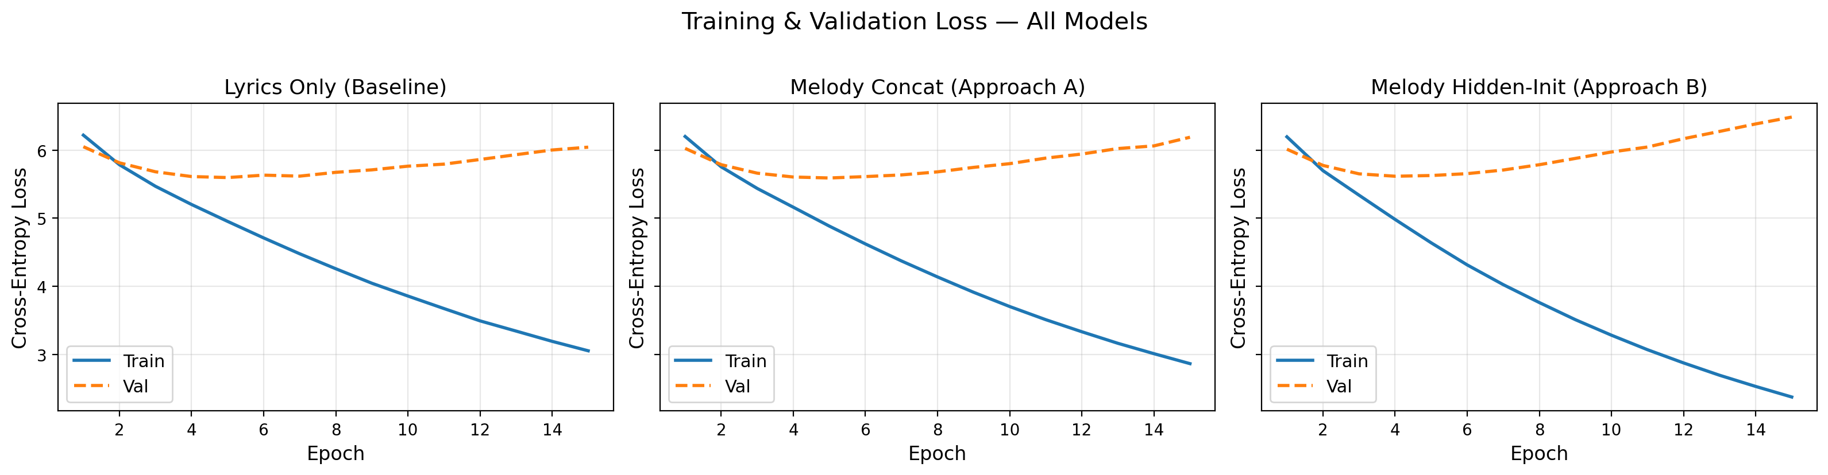
Figure A1: Training and validation cross-entropy loss for all three models (15 epochs).
All models overfit after epoch ~5; Melody Concat achieves the lowest validation loss.
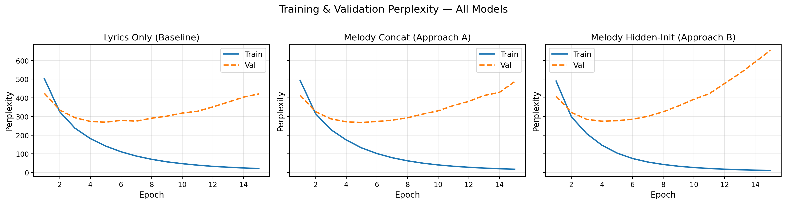
Figure A2: Training and validation perplexity (exp of cross-entropy) for all models.
Training perplexity falls steeply while validation perplexity rises after epoch 5.
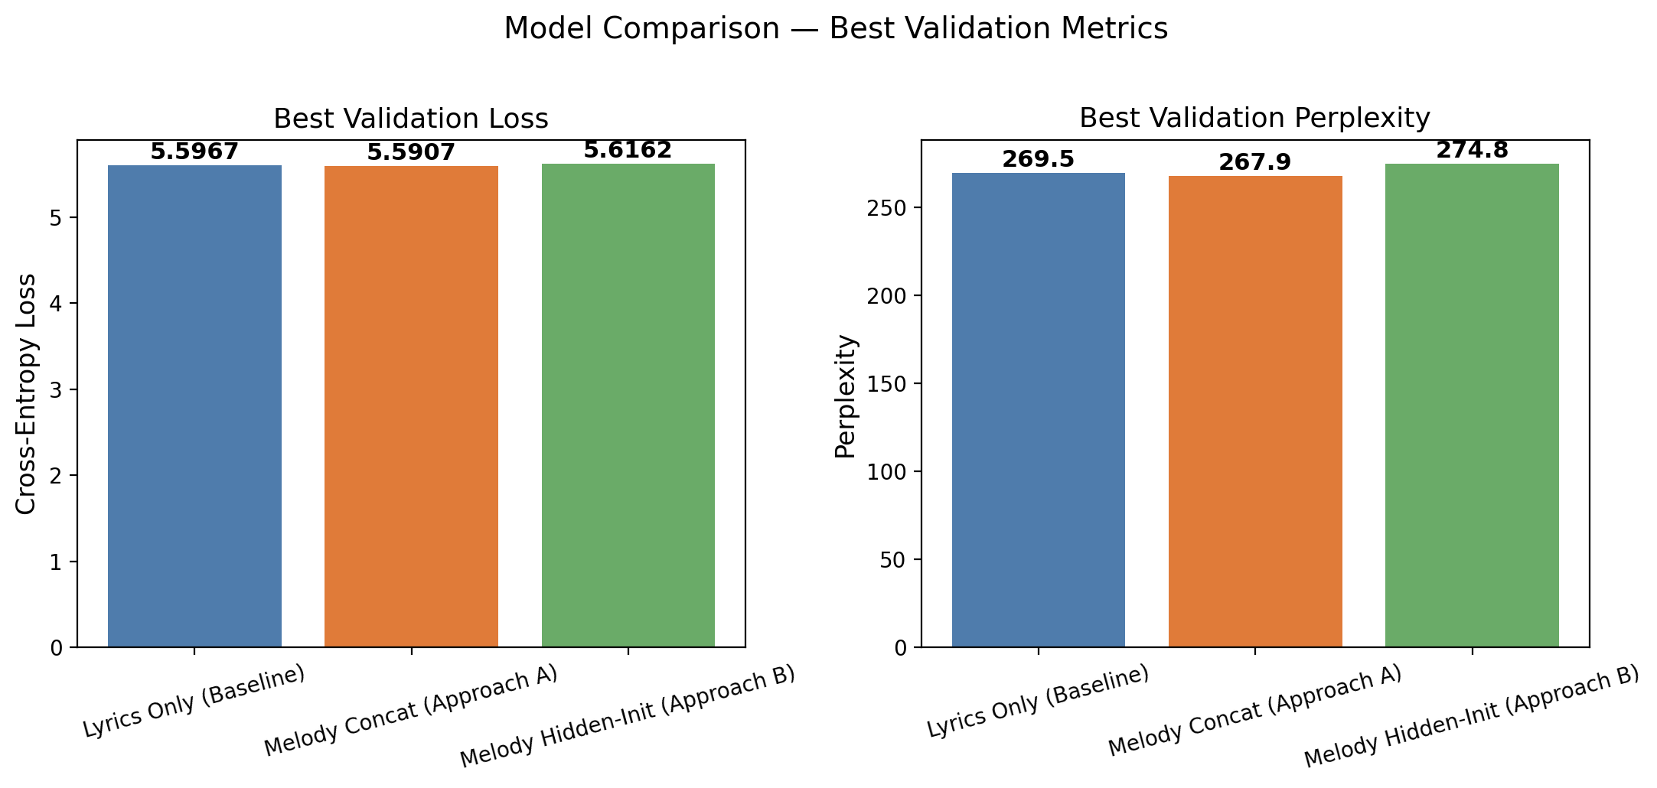
Figure A3: Best validation loss and perplexity per model.
Melody Concat achieves the lowest perplexity (267.9);
Melody Hidden-Init slightly exceeds the baseline.
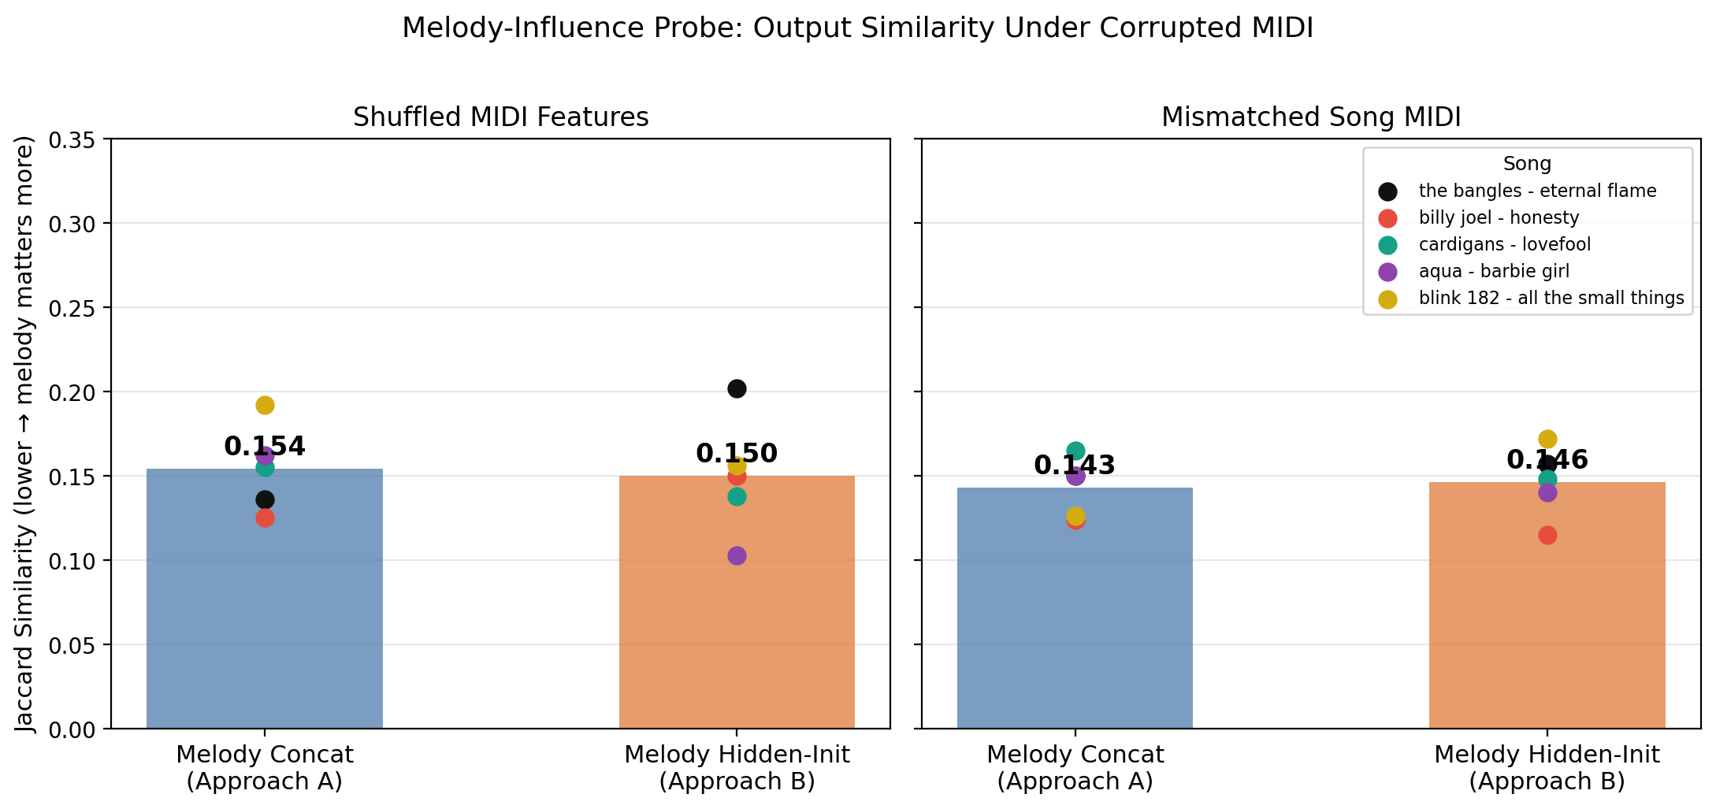
Figure A4: Melody-influence probe.
Bars = mean Jaccard similarity vs. correct-MIDI output across 5 test songs;
dots = individual songs. Lower = melody corruption changes output more.
Melody Hidden-Init (B) is more sensitive to MIDI corruption than Melody Concat (A).
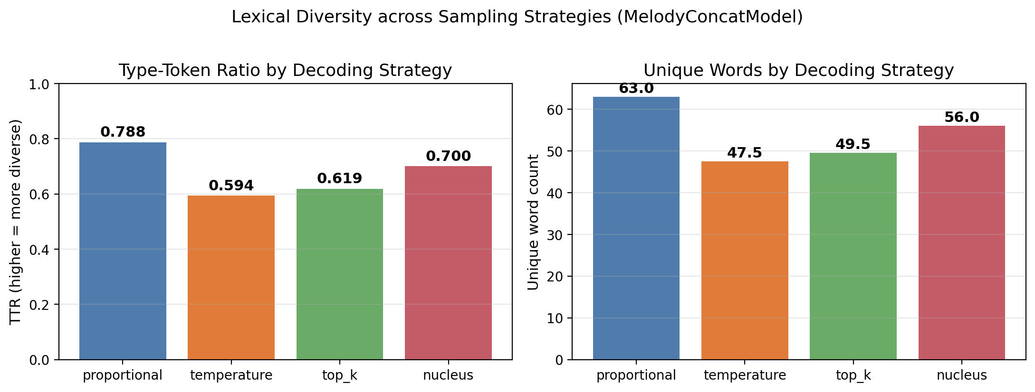
Figure A5: Lexical diversity per decoding strategy (MelodyConcatModel, 2 test songs).
Temperature and Top-K trade diversity for coherence; Proportional and Nucleus are more diverse.

Appendix B - MIDI Data Analysis Figures
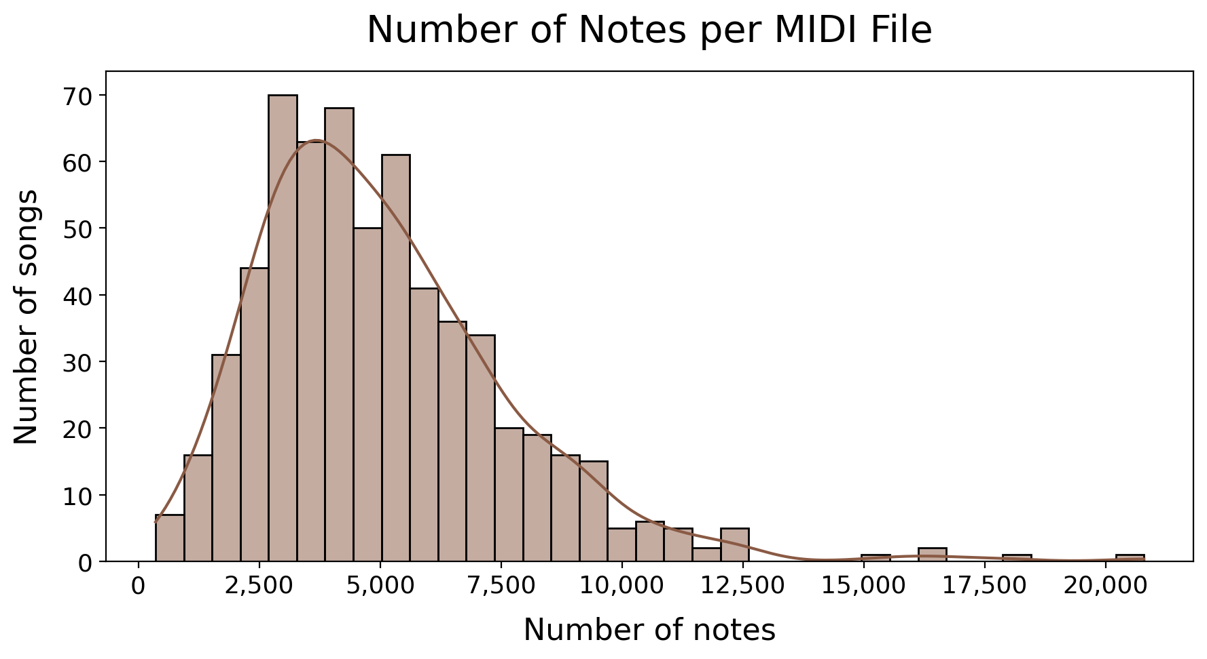
Figure B1: Distribution of note count per MIDI file across the training corpus.
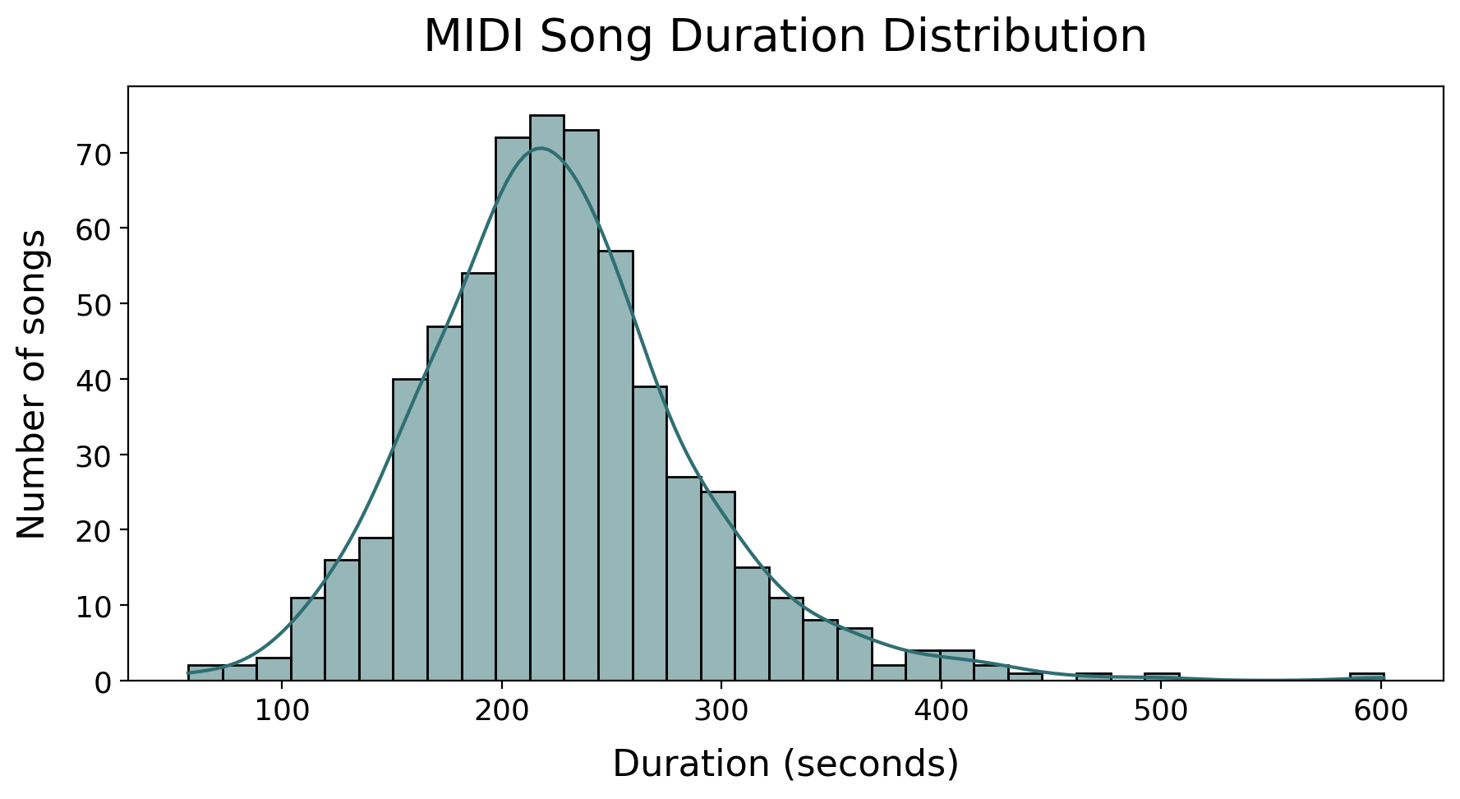
Figure B2: Distribution of MIDI file duration (seconds).
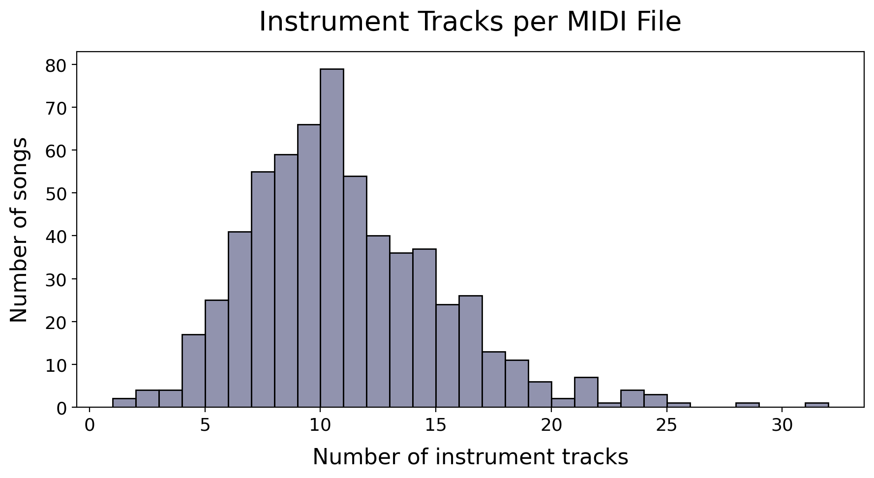
Figure B3: Distribution of instrument (track) count per MIDI file.
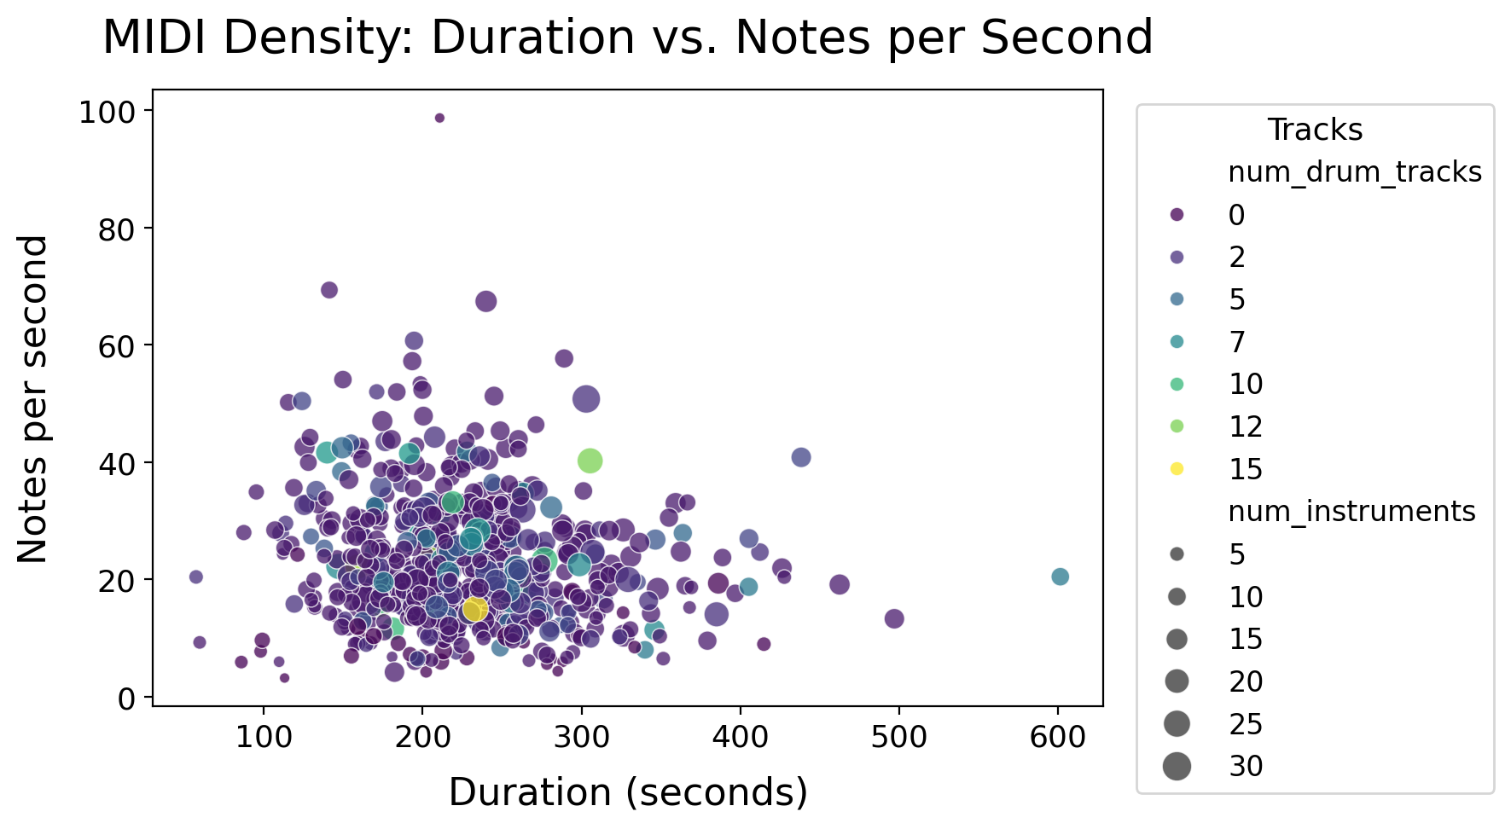
Figure B4: Note density (notes/second) vs. file duration scatter plot.
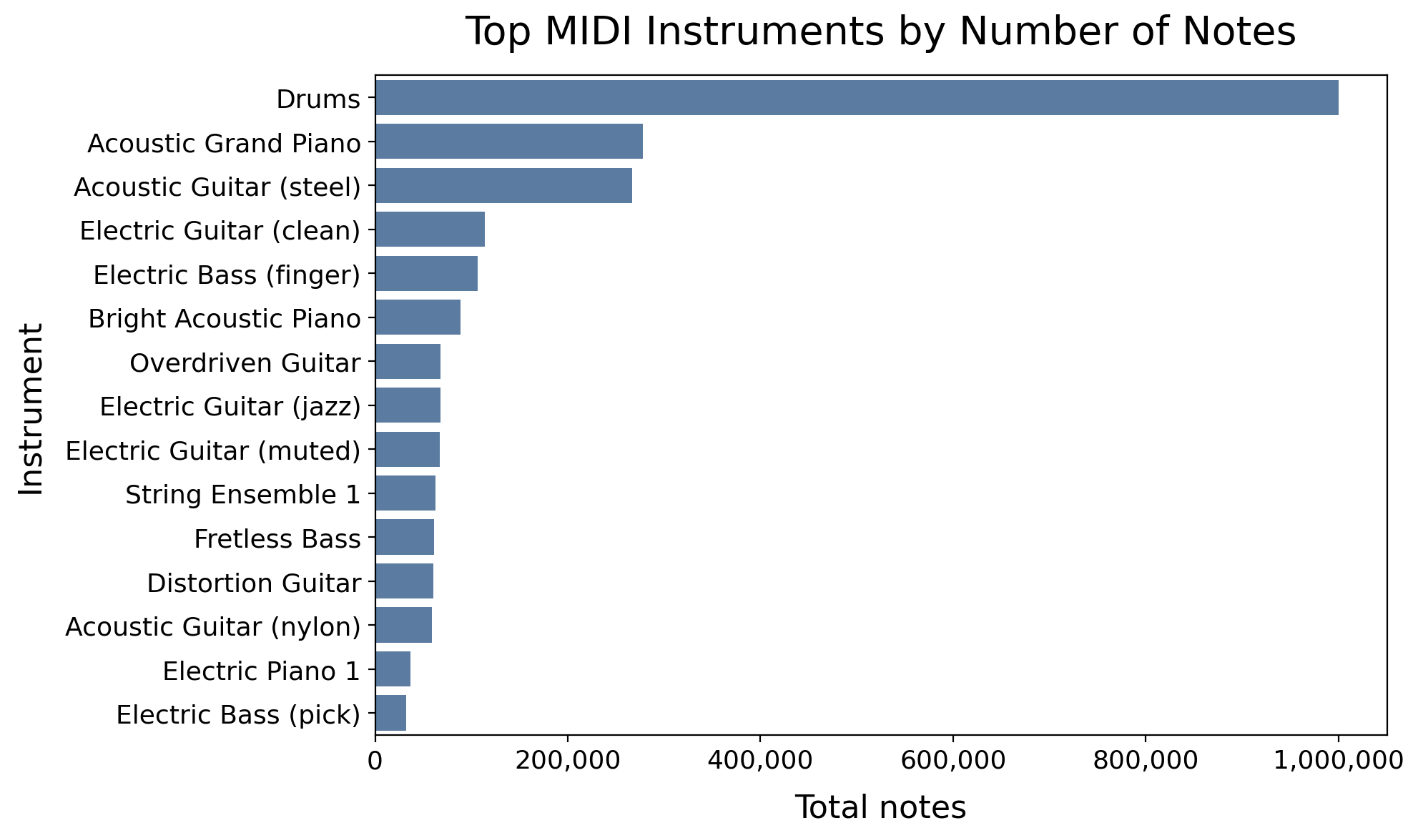
Figure B5: Most frequently used MIDI instruments (program numbers) across the corpus.
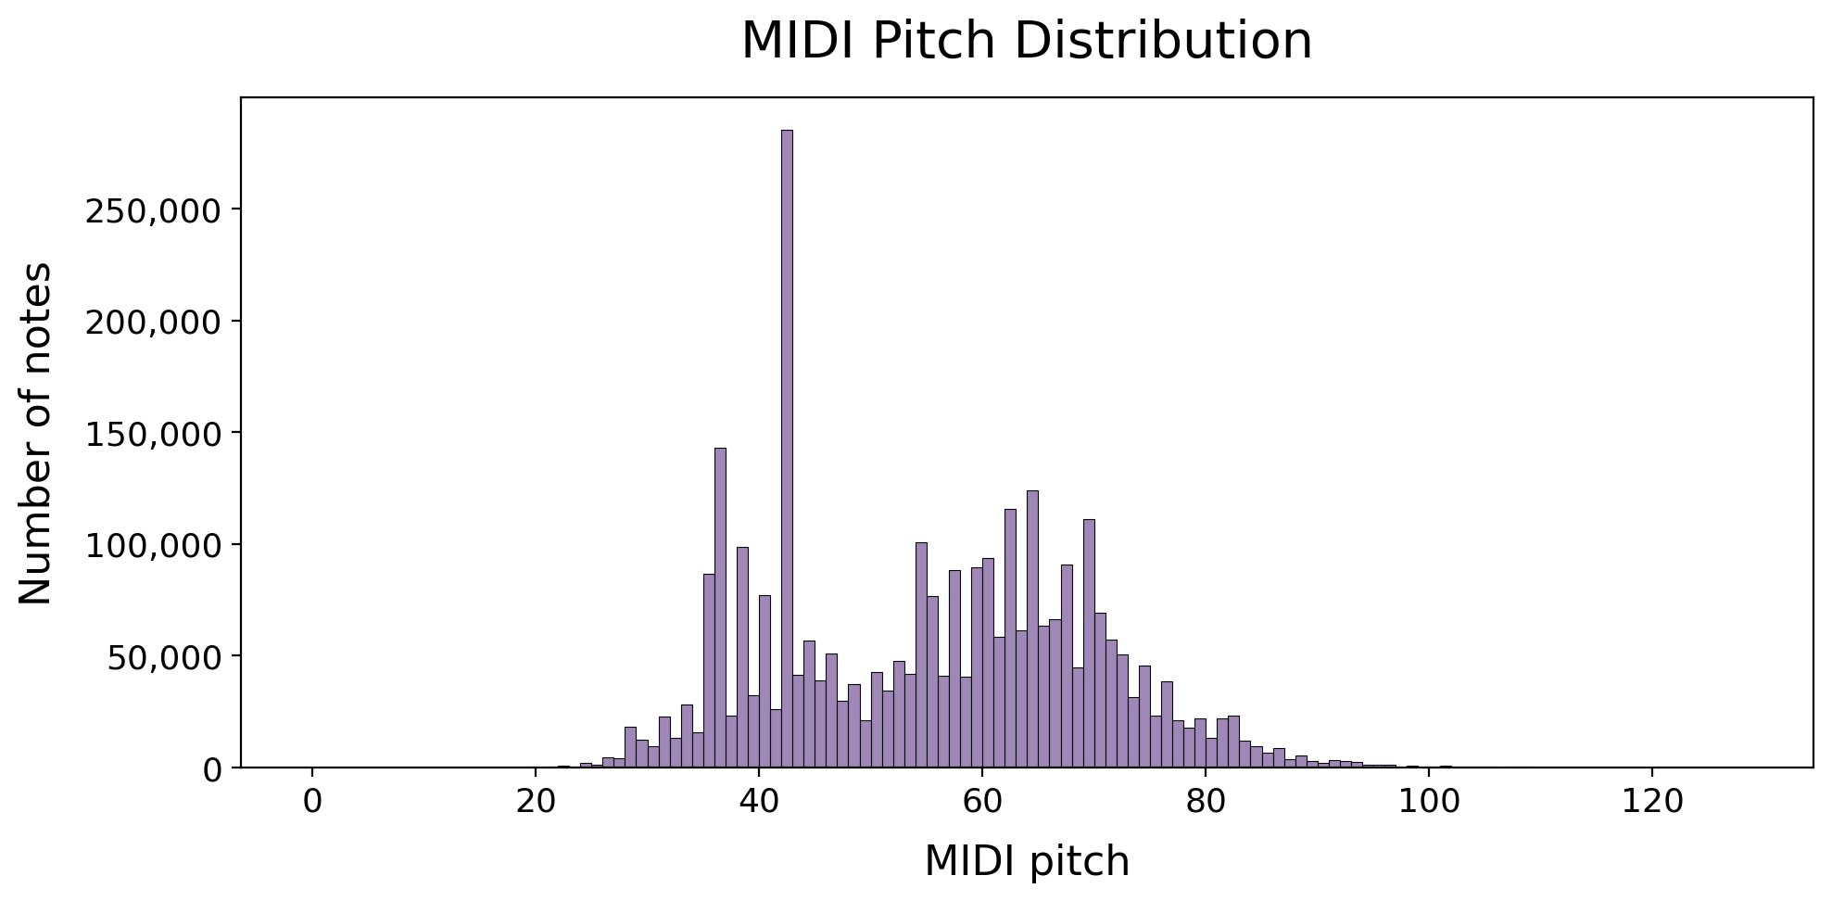
Figure B6: Distribution of mean pitch (MIDI note number) per file. Bimodal distribution centred around G3–D5 (MIDI 55–75).
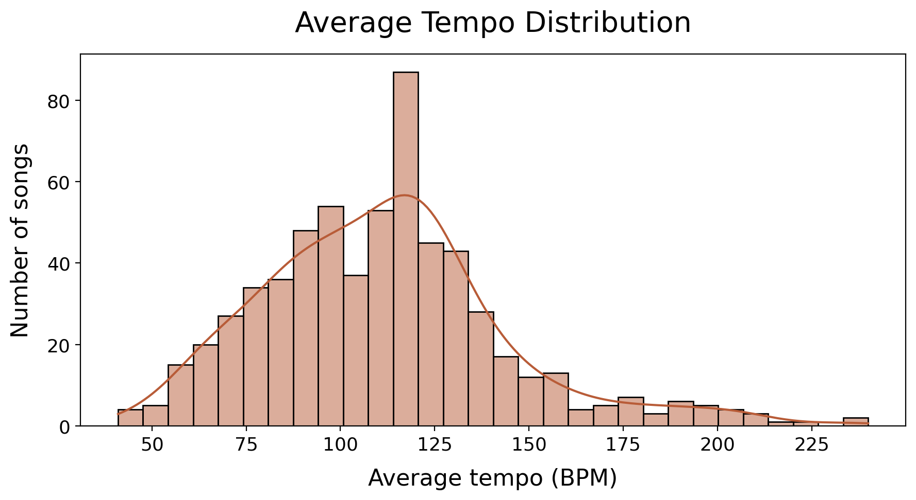
Figure B7: Distribution of tempo (BPM) across MIDI files.

