**Forter Docker Questions**



Dockerfile is a text file containing instructions for building a Docker image.  
Each line specifies an action for Docker to perform, Instructions are executed sequentially, creating a layered image.

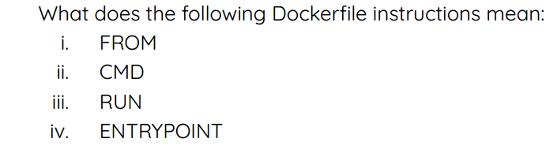 **i. FROM:**

Specifies the base image to use.  
Provides the starting point for your container's environment.  
Common base images include Ubuntu, Python, etc.

**ii. CMD:**

Defines the command to execute when the container starts. Can be overridden with docker run arguments.

**iii. RUN:**

Executes a command within the container's filesystem. Often used to install dependencies, copy files, etc.

**iv. ENTRYPOINT:**

Similar to CMD, but provides more flexibility, Can take arguments passed to docker run.



**b. Docker Image:**

Docker Image is a read-only template that encapsulates an application's environment. Built from a Dockerfile and used to create Docker containers.  
Can be shared and reused across multiple environments.



**c. Docker Container:**

A running instance of a Docker image. Provides isolation and portability for applications. Shares the underlying host's operating system kernel.