**Research on College Students' Satisfaction with**

**Information Literacy Education**

**4. Results**

**Research question 1: College students' information literacy level.**

*Figure 1: Cross graph of information literacy level and education stage of college students*

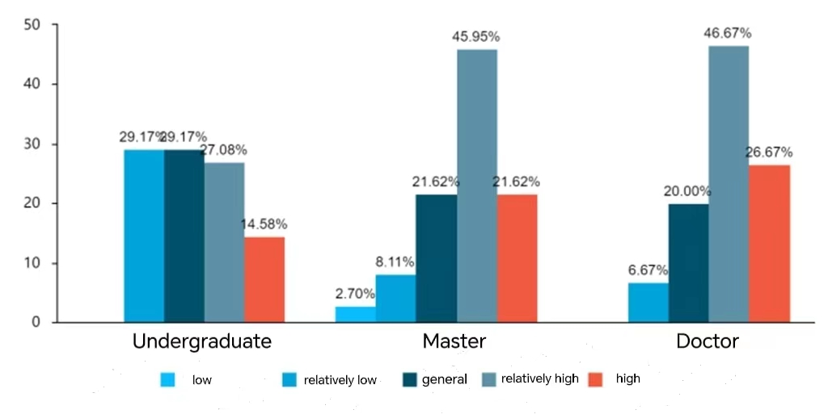

As shown in the figure 1, the doctorial students with high information literacy account for the largest proportion (26.67%), and the proportion of undergraduates is the least (14.58%). And the percentage of undergraduates with low information literacy is the highest at 29.17 percent. The result reveals that doctoral students have the highest level of information literacy, and undergraduates have the lowest level of information literacy. In view of the above, the promotion of education has a positive effect on the level of information literacy. Therefore, when conducting information literacy education, the library have the responsibility to take into account the important influencing factor of education level.

**Research question 2: College students' approval degree of information literacy education.**

*Figure 2: Do you think library information literacy education is instructive?*

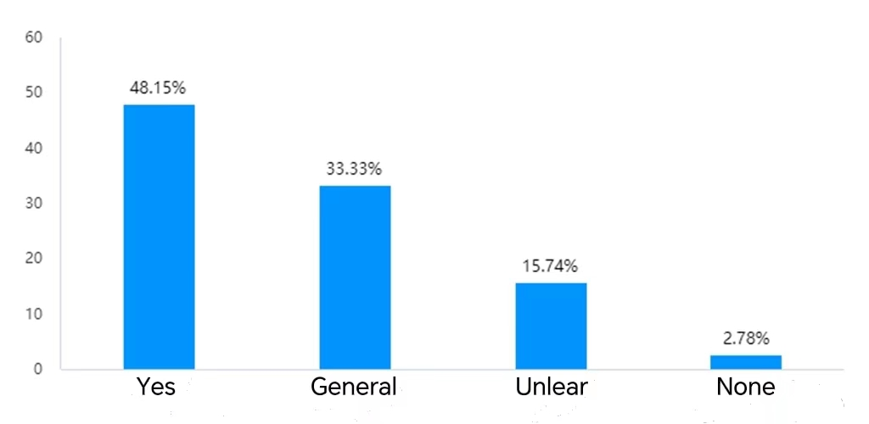

*Figure 3: In what ways do you find information literacy education at your college or university to be most helpful or valuable?*

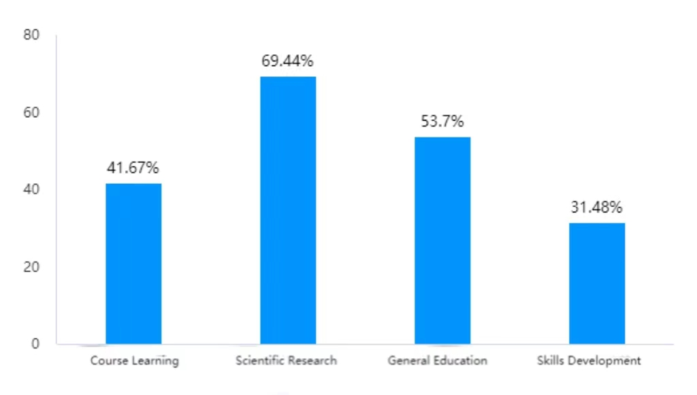

52(48.15%) respondents stated that library information literacy education is instructive (Figure 2), particularly in scientific research (Figure 3). What’s more, 34(31.48%) respondents think information literacy education at their skills development is helpful or valuable. Compared to the other two aspects (General Education and Course Learning), the proportion of respondents who believe that skill improvement is beneficial is the least likely, which shows that this is the weak point of information literacy education. In summary, it has been observed that the current information literacy education in libraries has little positive impact on the improvement of skills. Thus, the library should focus on this in the future. In addition, college **s**tudents have certain recognition and expectation for library information literacy education. These are the directions of the information literacy education of libraries in the future.

**Research question 3: College students' satisfaction with information literacy education.**

*Figure 4: Radar graph of college students' satisfaction*

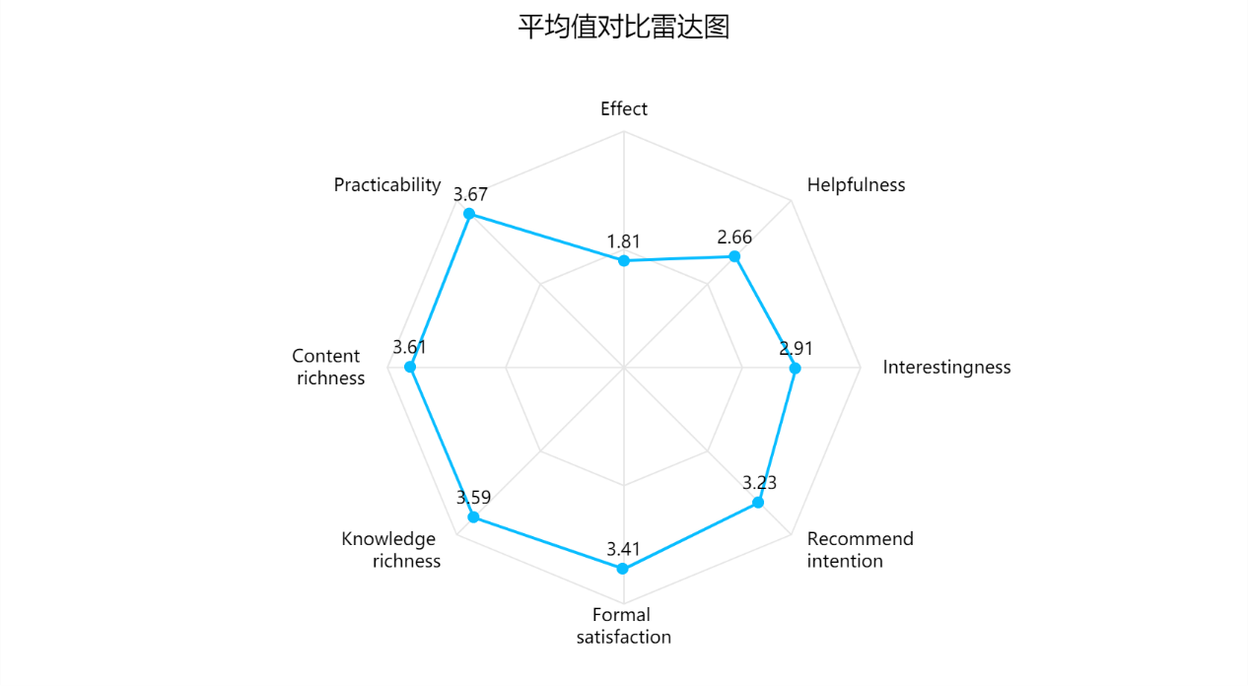

This section uses a five-point Likert scale to get information from the respondents. The result presented in figure 4 showed that college students are more satisfied with the content and form of library information literacy education, but less satisfied with its effect. Practicality(‾x=3.67) was ranked highest by the mean score among all satisfaction indicators and was followed by content richness(‾x=3.61) and knowledge richness(‾x=3.59). Effect (‾x=1.81) was the least item indicated by the respondents. Besides, helpfulness(‾x=3.61) and interestingness(‾x=3.61) were also below the median. Thus, although the library has carried out abundant information literacy education, it has not achieved good results and is of little help to students. In addition, the interest of library information literacy education needs to be improved. This is just what the paper focuses on and hopes to solve.

**Research question 4: Student's suggestions for information literacy education**

*Figure 5: Student's suggestions for information literacy education*

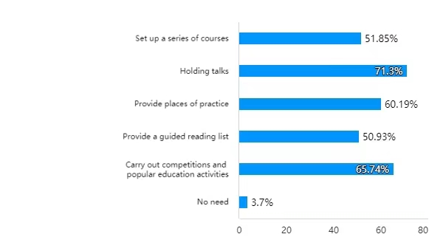

When asked about the suggestions for information literacy education that only 4(3.7%) respondents think information literacy education is not needed, and the others gave suggestions from different angles. Among these, holding talks and competitions and other popular education activities are more desired. This implies students' demand for information literacy education, which provides perspectives for library information literacy education. In making subsequent recommendations, this paper will also focus on the results of the respondents' surveys.

**5. Discussion**

**Research question 1: College students' information literacy level.**

The first research question investigated the relationship between students' grade levels and students' level of information literacy. The survey found that the level of information literacy is directly proportional to the grade level of students, which is consistent with the findings of Kong & Gong (2015). This could be attributed to the positive correlation between students' grade level and the depth and breadth of their exposure to information literacy education. Senior students receive richer information literacy education, possess stronger self-directed learning abilities, and have more extensive practical experience in information retrieval and related areas, which cause a higher level of information literacy. Based on this positive correlation, college libraries should provide targeted and focused information literacy education for students of different academic years.

**Research question 2：College students’ approval degree of information literacy education.**

The second research question addressed the level of acceptance of information literacy education among students at Southeast University, investigating the students’ opinions on whether library information literacy education is instructive. The survey results revealed that among the student groups who endorse the instructive value of information literacy education, those with the highest level of need in scientific research are the most prevalent. As Yuan and Liu (2015) noted, undergraduate and graduate students have the greatest need for completing research projects and writing academic papers in information literacy education. Therefore, the information literacy curriculum in university libraries should emphasize the development of students' scientific research skills, meeting their needs by providing relevant literature search tutorials and teaching research tools.

**Research question 3: College students' satisfaction with information literacy education.**

The third research question focused on investigating students' satisfaction with information literacy education, quantified through multidimensional indicators. Statistically significant results revealed that students perceived the usefulness of information literacy education to be low. As Min (2019) stated, whether students can access information that is useful to them is an important factor affecting their satisfaction with information literacy education courses. The surveyed students' low evaluation of the usefulness of information literacy education in this research is the main reason for their low satisfaction. Additionally, this study found that students generally perceive the level of interest in information literacy education to be relatively low, which also had a negative impact on their satisfaction. However, previous research and library staff have not paid attention to students' evaluation of the interestingness of information literacy education. Therefore, university libraries should focus on enhancing the usefulness and interest of information literacy education. Specifically, the library should conduct surveys to understand students' practical needs for course content, enrich the teaching format of the course, and enhance the interestingness of information literacy education. These measures will be more conducive to students' learning of relevant knowledge.

**Research question 4: Students' suggestions for information literacy education.**

The fourth research question investigated the specific suggestions from students regarding information literacy education. This study summarized various suggestions submitted by students to gain a more intuitive understanding of the direction for improving information literacy education in the library. In this study, students showed a preference for lecture and practice-based teaching. Lectures allow students to learn knowledge systematically within a certain period of time, which is conducive to improving their attention and increasing their learning efficiency. Practice-based teaching can provide students with detailed operational demonstrations, which are more vivid and flexible than mere lectures, and are easier for students to understand and remember. Therefore, in the future, the library can focus on these two types of teaching methods when conducting information literacy education to attract students' interest and meet students' needs.