107-1 VLSI Testing

Programming Assignment #1

電子所碩一 R07943107 徐晨皓

1. **Please fill in the following table in your report.**

|  |  |  |  |  |  |  |
| --- | --- | --- | --- | --- | --- | --- |
| circuit number | number of test vector | number of gates | number of total faults | number of detected faults | number of undetected faults | fault coverage |
| C499 | 66 | 554 | 2390 | 2263 | 127 | 94.69% |
| C1355 | 63 | 554 | 2726 | 1702 | 1024 | 62.44% |
| C6288 | 42 | 4800 | 17376 | 17109 | 267 | 98.46% |
| C7552 | 289 | 5679 | 19456 | 19144 | 312 | 98.40% |

1. **Please print out the critical parts of your code and explain it.**
2. *sim.cpp*

In this part, we perform the fault-free simulation, which is claimed to be event-driven. However, from the code and the hints from TAs, this function is not exactly event-driven since all input gates are assumed to have the value change (marked as *CHANGED*) when the primary inputs are assigned by new test vectors.

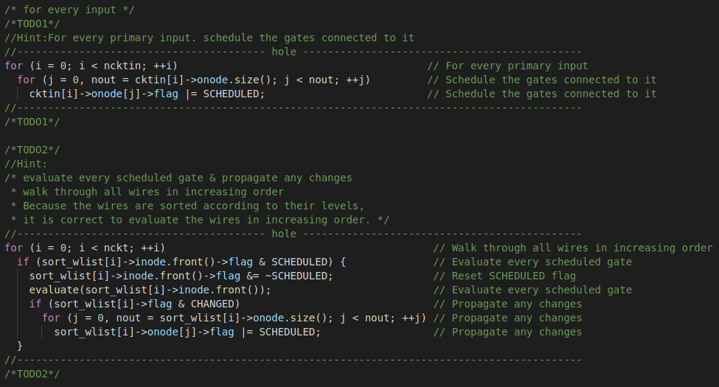

1. *fault_sim.cpp*
2. Fault injection

In this part, the faults are injected into faulty wires by change the value of the wires. If the fault type is stuck-at-0, the value the faulty wire will be changed into 0; otherwise, if the fault type is stuck-at-1, the value of the faulty wire will be converted into 1.

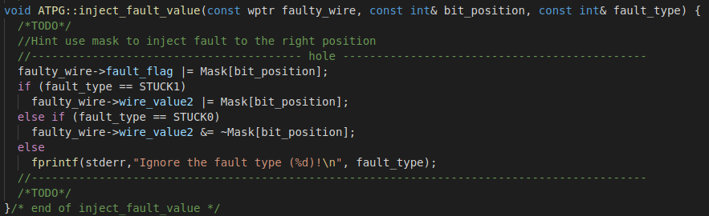

1. Fault detection

In this part, if we detect that the faulty value of an output wire is different from its fault-free value, then we mark the fault as detected and drop it out from the fault list.

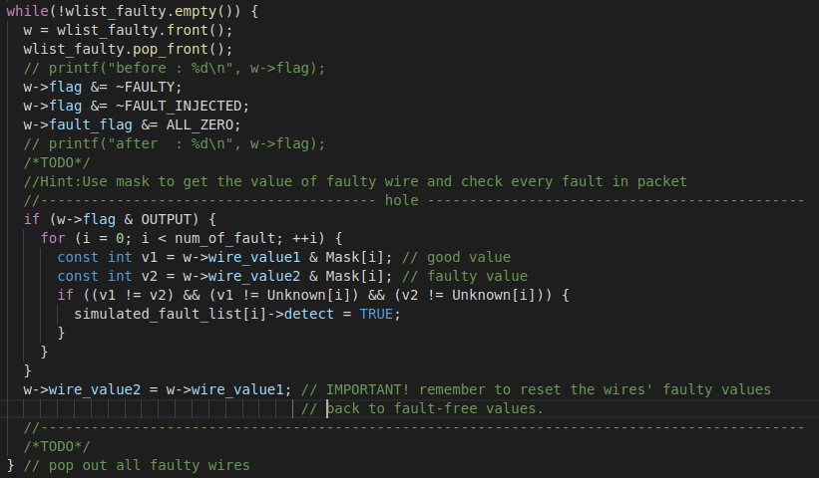

1. **(10% bonus) In our parallel fault simulation algorithm, faults will be dropped once they have been detected. Now, we would like to support *N*-detect in our fault simulation, and that mean every fault should be detected *N* times before dropping. You should support the command below,**

$$./atpg -fsim <pattern file> –ndet <N> <circuit file>$$

***N* is a number from 1 to 8. For example,**

$$./atpg -fsim ../sample_circuits/c17.input –ndet 3 ../sample_circuits/c17.ckt$$

**When you print *vector[i] detects m faults* on the screen. Please make sure that these $m$ faults have been detected for *N* times.**

I have completed the N-detect in fault simulation. The table below shows the experimental results of the fault coverage by applying N-detect fault simulation on c7552.ckt. We can see that the fault coverage decreases as N increases.

|  |  |
| --- | --- |
| **N** | **Fault coverage (%)** |
| 1 | 98.40 |
| 2 | 94.50 |
| 3 | 91.90 |
| 4 | 90.27 |
| 5 | 88.28 |
| 6 | 86.71 |
| 7 | 84.88 |
| 8 | 83.21 |