一、命令

1. 显示单个相关的类：/d1 reportSingleClassLayoutmyclass
2. 显示所有类/d1 reportAllClassLayout
3. 结果

派生类中重写了，虚表里面就有自己的函数

class myclass

{

public:

virtual void fun()

{

std::cout << "myclass::fun\n";

}

virtual void get()

{

}

int aaaaaa;

};

class myclass11: public myclass

{

public:

virtual void fun()

{

std::cout << "myclass::fun\n";

}

};

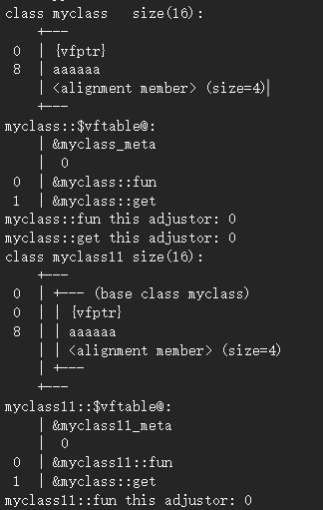

class myclass12 : public myclass

{

public:

virtual void fun()

{

std::cout << "myclass::fun\n";

}

virtual void fun11()

{

std::cout << "myclass::fun\n";

}

char m_ch;

};

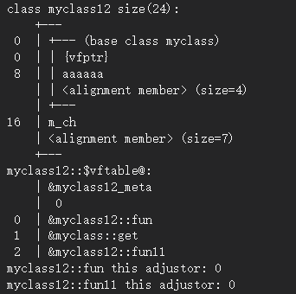

class myclass1

{

public:

virtual void add()

{

std::cout << "myclass1::add\n";

}

virtual void send()

{

std::cout << "myclass1::send\n";

}

int m_myval;

};

class myclass22 : public myclass, public myclass1

{

public:

char m_chval;

};

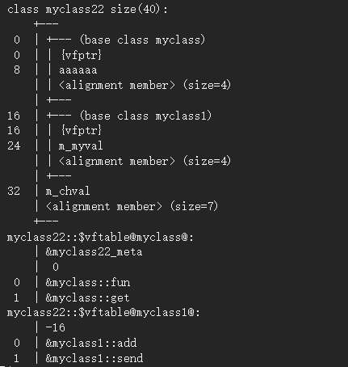

class myclass22 : public myclass, public myclass1

{

public:

virtual void SetAgent()

{

std::cout << "myclass22::SetAgent\n";

}

char m_chval;

};

