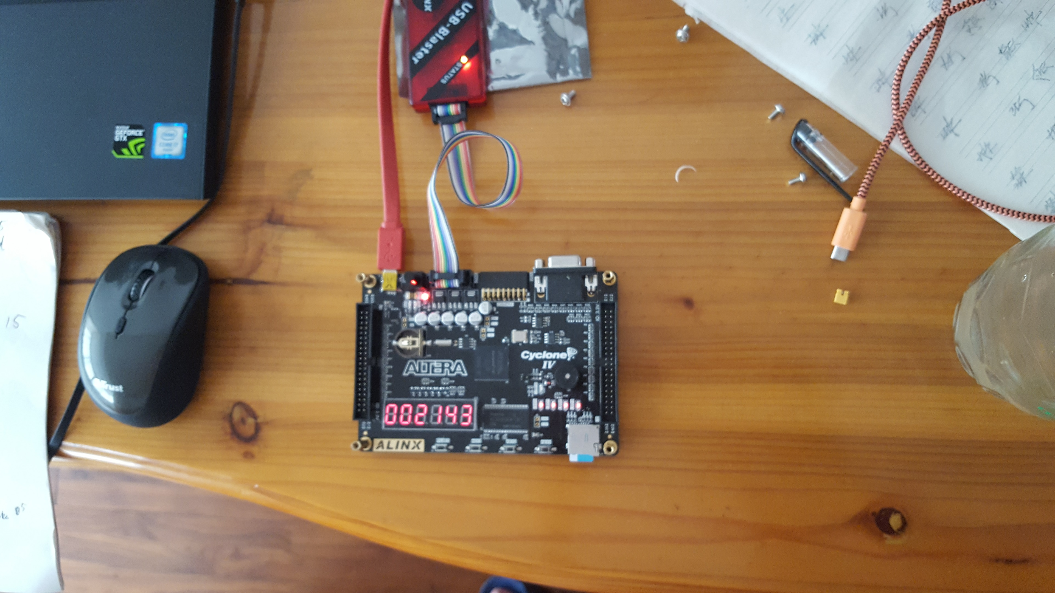

Second

Hour

Minute

Website to buy the development board:

https://world.taobao.com/item/520820269574.htm?fromSite=main&spm=a230r.1.14.55.ebb2eb25uCkE9&ns=1&abbucket=20#detail