Related work
In recent years, generative AI application become ubiquitous. The capability of the machine learning model also benefits from the trend with resources and researcher filling in the field. Deepfake issue, therefore, rise to the surface with crimes of serious damage. The detection of fake image and video challenged by better performance stable diffusion and Midjourney. The accessibility of these image generation tools also exacerbates the situation. While it is inevitable that the technology will keep progressing, many researchers are working hard to cope with the security issue at the same time.
Deep-learning-based detection model is one of the more successful method to capture the sophistication of the advance generative models. We classify the classic deepfake detection model by the following structures:
- CNN-based model: ResNet as a deep convolutional neural network achieved high performance in many image classification tasks include deepfake detection [ He et al., Agarwal et al.]. Using customized dataset generated by ProGAN to train the ResNet50 model , Wang et al. found that most of the CNN-generated images share some common systematic flaws that can be detected. EfficientNet is another CNN-based model that performs well in image classification. Tan and Le achieved 0.9974 AUC-ROC score with it in the DeepFake Detection Challenge (DFDC).
- Transformer model: Vision Transformer (ViT) is one of the most popular image transformer models. By taking advantage on the CNN-based model’s success, researchers start to take the combination of transformer and CNN-based model. Coccomini et al. use the EfficientNetB7 with ViT to achieve an AUC of 0.951 and an F1 score of 88.0%, very close to the state-of-the-art result on the DFDC. Heo et al. argue that CNN-based model has a problem considering local and global features, they combine vector-conctenated CNN features with ViT and resulting with outperforms the SOTA model by 0.006 AUC and 0.013 f1 score on the DFDC test dataset.
- Diffusion model: The success of diffusion models in image generation raised the concerns of the deepfake issues. Many of the previous deepfake detectors are struggling with image generated by diffusion models. The diffusion reconstruction error (DIRE) proposed by Wang et al. focusing on detecting such images. They found that diffusion generated image can be reconstructed by a diffusion model while real image cannot.

However, with the boosting development of image generation model, the generalizable detector still remains a challenging topic. In this study, we take the dataset generated by latest diffusion model, and try to analyze through the character of different detector model to achieve a better generalizability.
- He K, Zhang X, Ren S et al (2016) Deep residual learning for image recognition. In: Proceedings of the IEEE conference on computer vision and pattern recognition. pp 770–778
- Agarwal S, Farid H, Fried O et al (2020) Detecting deep-fake videos from phoneme-viseme mismatches. In: Proceedings of the IEEE/CVF conference on computer vision and pattern recognition workshops. pp 660–661
- Wang, S. Y., Wang, O., Zhang, R., Owens, A., & Efros, A. A. (2020). CNN-generated images are surprisingly easy to spot... for now. In Proceedings of the IEEE/CVF conference on computer vision and pattern recognition (pp. 8695-8704).
- Tan, M., & Le, Q. (2019, May). Efficientnet: Rethinking model scaling for convolutional neural networks. In International conference on machine learning (pp. 6105-6114). PMLR.
- Coccomini, D. A., Messina, N., Gennaro, C., & Falchi, F. (2022, May). Combining efficientnet and vision transformers for video deepfake detection. In International conference on image analysis and processing (pp. 219-229). Cham: Springer International Publishing.
- Heo, Y. J., Yeo, W. H., & Kim, B. G. (2023). Deepfake detection algorithm based on improved vision transformer. Applied Intelligence, 53(7), 7512-7527.
- Wang, Z., Bao, J., Zhou, W., Wang, W., Hu, H., Chen, H., & Li, H. (2023). Dire for diffusion-generated image detection. In Proceedings of the IEEE/CVF International Conference on Computer Vision (pp. 22445-22455).
ResNet
As we know, ResNet is one of the classic CNN model structures for graph data tasks. The efficiency of the parameter usage allows us to quickly get a taste of the dataset. To understand the features and characteristics about the dataset, we finetune three ResNet model: ResNet50, ResNet101, ResNet152, and evaluate those models with noisy inputs.
The most challenging part for finetuning ResNet models is the overfitting problem. Learning rate is the key parameters. When learning rate larger than 0.0001, training process shows overfitting and the fluctuation of the validation loss. When the learning rate is less than 0.0001, the model seems fall into a local minimum with higher loss. As the results, we use 0.0001.
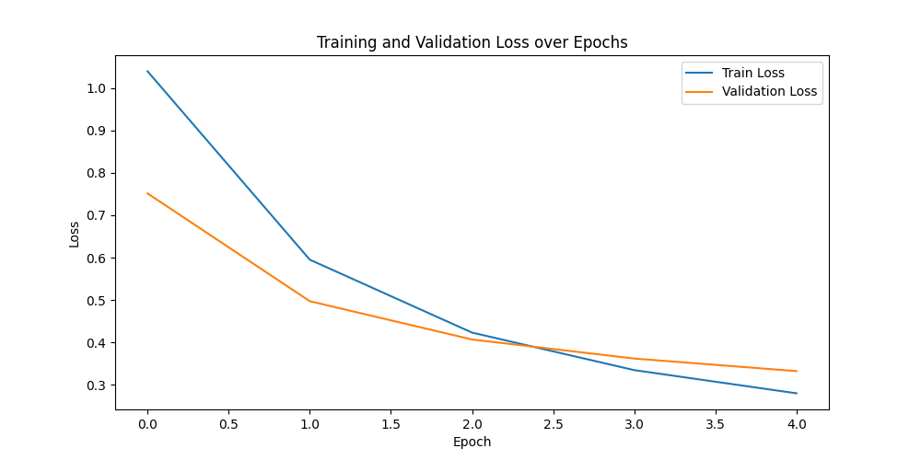
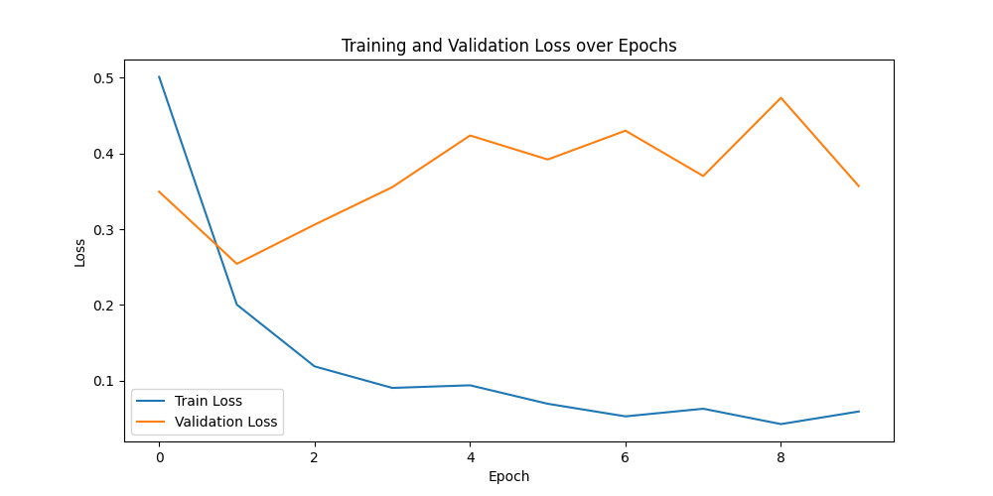
[Table 1] shows the overall results of each model, to compare with the original baseline in the study of the dataset [deepfake face], we classify the image with 3 different generators. The results show that images generated by Stable Diffusion v1.5 achieved the highest accuracy. These images appear more realistic than those from the other two generators, on the other hands, it seems easier for model to classify it. The overall accuracy reaches 90%.
Model evaluation
In the real-world cases, image could be noisy. For instance, applying filter on photo, or compressing photo to lower pixel and smaller size when sending through social media. Having the tolerance on noise is also important for deepfake detection to handle the false positive rate. To test the robustness of models, we applied various perturbations—saturation, contrast, Gaussian blur, and pixelization [Figure 1]. Contrast and pixelization had the greatest impact, suggesting these features are key for classification [Table 2]. Since some input images were already saturated, saturation had less effect on performance.
In the study about the vulnerability of deepfake detectors [paper link], we know that adversarial can bypass the detectors by denoising the fake image with diffusion model. As an inspiration, we also used a diffusion model to reconstruct all input images, and the accuracy as expected, drop dramatically [Figure 2]. Despite the shorter diffusion time steps, the result could suggests that these models may be learning the characteristics of each generator rather than the “fake” pattern as how human identify the fake image.
The generalization of the model is also another issue of deepfake detectors. Previous study shows that CNN-based deepfake detection model usually suffers from overfitting and generalization [paper link]. We test the model with the DiffusionDB-Face dataset and the results shows in [Table 3].

ResNet
- adversarial_training.py: fine-tune ResNet model with perturbated image
- denoise_diffusion_model.py: using diffusion model to add noise to DFF dataset
- eval_DFDB.py: evaluate model with DFDB dataset.
- eval_ResNet_noise.py: evaluate mode with noisy image generated by denoise_diffusion_model.py
- load_data.py: load DFF dataset
- perturbation.py: evaluate model with perturbate data
- ResNet_2class.py: fine tune ResNet model for two class (fake, real)
- ResNet_4class.py: fine-tune ResNet model for four class (wiki, insights, text2img, inpainting)

