Lost Station Restart the Hatch

A Single Room VR Repair Prototype
Wang Haobin  Department of Artificial Intelligence  Dong-A University  chenmenglr@gmail.com | Bora Youn  Course Instructor  Dong-A University  boracles@snu.ac.kr
Corresponding author: Bora Youn (boracles@snu.ac.kr).

Abstract
Lost Station Restart the Hatch is a short VR repair game for one player. The player moves to a workbench, grabs an energy core, releases it into a matching socket, watches the hatch open, and reaches the exit. The Unity prototype combines controller interaction, visible mission states, spatial sound, and an English Mission Console. On 21 October 2026, the student completed a recorded playthrough using a physical Quest 2 and controllers through USB Link to Windows Unity. The 54-second continuous excerpt shows Help, Reset, movement, core handling, insertion, door opening, and completion. The Quest APK is built at version 0.4.0, but standalone installation and headset Camera recording remain planned. A peer usability study is also planned.

Keywords
Virtual reality; controller interaction; spatial audio; usability; repair task

Introduction

Project Goal
The project targets new VR users practicing a short, goal-directed interaction. A power failure gives the player a clear reason to move, manipulate an object, and check feedback. The single-room scope makes the complete task practical for a brief course demonstration. Unlike an isolated grab exercise, the prototype connects manipulation to visible progress and an exit condition.

Player Task
The player walks or teleports to the repair pad and holds Grip to pick up the cyan energy core. Releasing it near the amber coupler restores power and opens the twin hatch. Crossing the doorway to the EXIT marker completes the mission. Help and Reset remain available when the player needs guidance or a fresh attempt.

Prototype Design

Environment and Interaction
Contrasting colors distinguish the repair pad, core, socket, hatch, and exit. The physical core must be grabbed and released near the socket; proximity alone cannot solve the task. A metal core cartridge now fits a matching three-clamp coupler. A 2.65-second sequence secures the core, retracts the locks, slides the twin hatch panels apart, and turns the passage lights green.
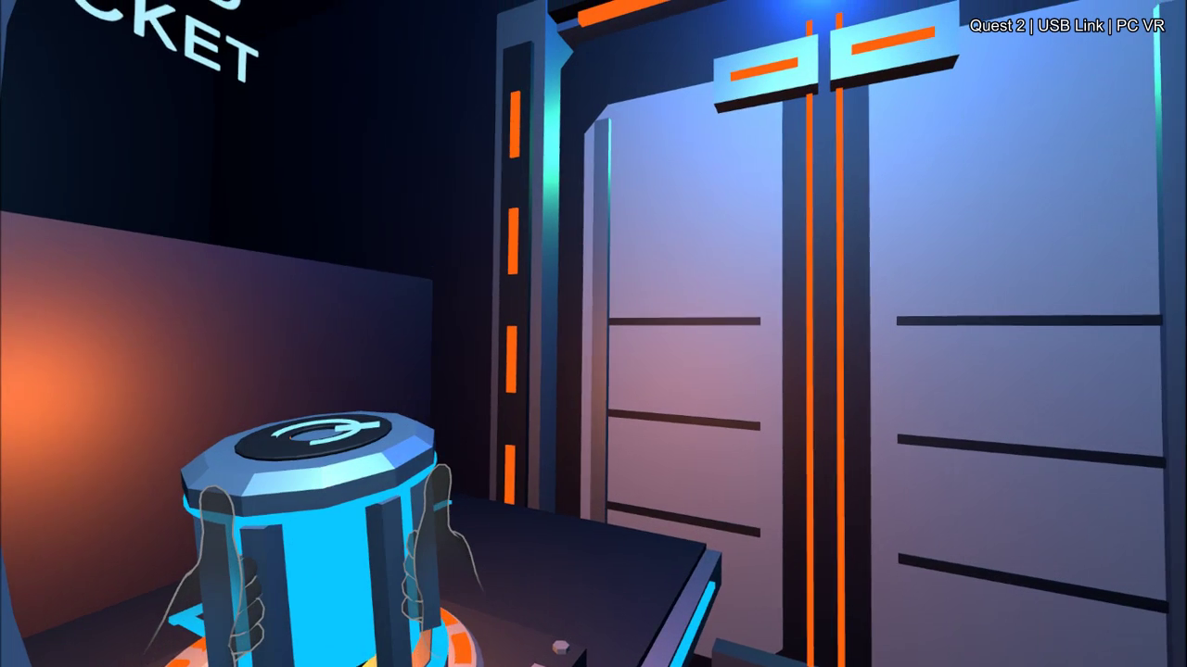
Figure 1. Core at the coupler during recorded Quest 2 USB Link play, 21 October 2026. Windows Unity PC VR; not standalone APK footage.

Status and Audio Feedback
The status panel and indicator lights change with the mission state. Spatial audio supplies ambience and cues for grabbing, releasing, power, door movement, and completion. The student confirmed hearing game sound and the PC VR video retains that audio. Perceived vibration, spatial localization quality, and listening comfort still need structured checks.

Interface and Input
The left stick controls walking and strafing. The right stick provides 30-degree snap turns; pushing forward aims teleportation and releasing confirms it. Grip holds the core, while Trigger selects interface buttons. The left Menu button toggles instructions; B closes the menu. RESET MISSION on the panel or console restarts the task; desktop R remains available. The recorded PC VR run demonstrates Help and Reset use, but does not verify every control gesture.

Implementation

System Components
Unity 6000.3.24f1 and Meta XR Interaction SDK 205 provide the rig, teleportation, grabbing, and ray interface. Mission logic tracks grab history, release into the coupler, door state, and exit entry. The English scene builds as an ARM64 APK, version 0.4.0 (code 3). The group repository [1] contains the project; the newer local build must be uploaded before its download link represents this version.

Current Validation Evidence
The earlier simulator completed the task and sound-event sequence. The hardware update passed 15 scripted Play checks; the controls update passed 28 scene/input checks and six simulator Play checks. These are software checks. The 21 October recording adds actual Quest 2 controller play through USB Link: reset, Help, movement, grab and reposition, insertion, power feedback, the split-door animation, and exit completion. The continuous 54-second excerpt has no internal cuts or speed changes; game audio is raised by 4 dB. It demonstrates PC VR operation, not native APK execution or peer usability.
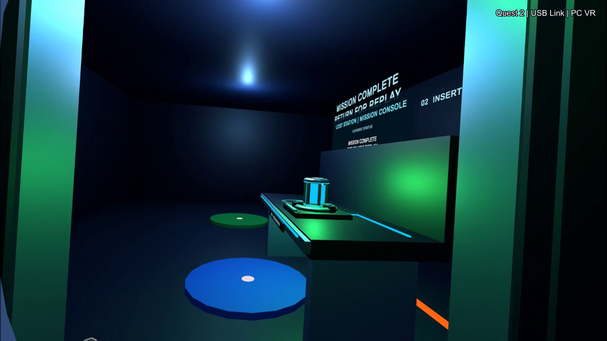
Figure 2. Mission completion after crossing the hatch, from the same continuous PC VR recording.

Evaluation

Planned Standalone Quest Test
Planned: install the exact version 0.4.0 APK on Quest and repeat the full task. Check readability, walking, teleportation, grip, Help, Reset, sound, vibration, and comfort. Record the successful run inside the headset with Camera and game audio, then save it as Wang_VR_Week07_Demo.mp4. This required native recording remains outstanding.

Planned First Use Study
Planned: invite one classmate to play for about ten minutes with only the starting instructions. Record hesitation, requests for help, task completion, and recovery from mistakes. Fix the most consequential issue and ask the same person to repeat the task. No peer observations or retest results are available yet.

Discussion and Conclusion

Limitations
A single student playthrough cannot establish usability for new players. USB Link runs the game on the PC and does not measure standalone Quest performance. The video does not establish vibration perception, precise turning accuracy, or sustained comfort. The one-room setting also limits conclusions about larger navigation tasks.

Next Steps
Wang Haobin is responsible for the project, presentation, and remaining validation. Next steps are native APK installation and recording, the peer test and retest, and revisions based on midterm feedback. The current PC VR video will support the presentation with its platform clearly labeled. A mission-state diagram and peer observation summary are planned for the next paper revision.

References
- Wang Haobin. Lost Station Restart the Hatch course group repository. https://github.com/ChenMengLR/VR_Group_Project_2026_2 (accessed 22 October 2026). Local evidence: Quest_PCLink_Demo_20261021.json and Wang_VR_Week07_PCLink_Demo.mp4, recorded 21 October 2026.

