Lost Station
Bounded Low Gravity and Staged Repair Interactions in VR
Wang Haobin  Department of Artificial Intelligence  Dong-A University  chenmenglr@gmail.com | Bora Youn  Dong-A University  Course Instructor  boracles@snu.ac.kr
Corresponding author: Bora Youn (boracles@snu.ac.kr).

Abstract
Lost Station is a single-player virtual reality repair experience that connects a space-station setting with controllable floating and a staged restoration task. Players retrieve an energy core that can drift after release, restore cabin power, pull a virtual lever, and leave through an animated hatch. The Unity prototype combines a bounded low-gravity boost, explicit braking, controller-based movement, teleportation, and power-dependent object interaction. Its current implementation passed 37 interaction checks, 24 mission regression checks, and 30 route and collision checks in software validation. An informal developer trial on Quest 2 through PC Link was reported without discomfort; it was not a participant study. A standalone Quest package has been built and inspected, while native-device performance and first-use evaluation remain future work. The contribution is an implemented interaction design that makes movement, manipulation, and environmental feedback part of a compact, recoverable repair sequence.
Keywords
virtual reality; low-gravity locomotion; object manipulation; repair interaction; environmental feedback

Introduction

Problem and design goal
A space-station repair scenario creates a design opportunity to connect the way a player moves with the objects and events that advance a mission. In Lost Station, a failed power system initially leaves the cabin dim and the exit sealed. Progress requires retrieving a reserve core, restoring power, and deliberately releasing the hatch. The design question is how to combine a recognizable floating interaction with a short task whose dependencies remain understandable and whose errors can be recovered from.
The prototype explores bounded low gravity rather than unrestricted six-degree-of-freedom flight. It retains a floor, gravity, collision, and an upright view while permitting a small vertical boost and airborne steering. This scope keeps the repair objects close to the player and makes an explicit brake meaningful. The intended experience is agency over movement and repair; any improvement in immersion or comfort requires evaluation.

Target users and use context
The intended users are adult visitors and students trying a short, single-player VR demonstration with tracked controllers. A participant follows English instructions, explores a compact route, manipulates a core, and opens the exit. Prior VR experience is not assumed. Help, reset, teleportation, and snap turning remain available alongside continuous movement. The prototype is an entertainment and interaction-design demonstration; it is not an astronaut-training simulator.

Related work and differentiation
VR locomotion includes continuous controller-based movement and discontinuous teleportation, with hybrid designs combining techniques [1]. Comparative research has examined locomotion through usability, game experience, and interviews [2]. These perspectives motivate evaluating task control separately from the subjective impression of floating.
Mission: ISS already offers zero-gravity navigation, capsule docking, and spacewalk activities [3]. Lost Station focuses on a smaller fictional repair sequence: bounded movement supports core retrieval, a visible power transition enables a lever, and the lever initiates evacuation. This combination defines the project scope without claiming that floating in VR is new. Meta's comfort guidance recommends options such as teleportation and snap turning and cautions against sudden acceleration and unnatural camera motion [4]; it informs the availability of alternative controls, not a claim of demonstrated comfort.
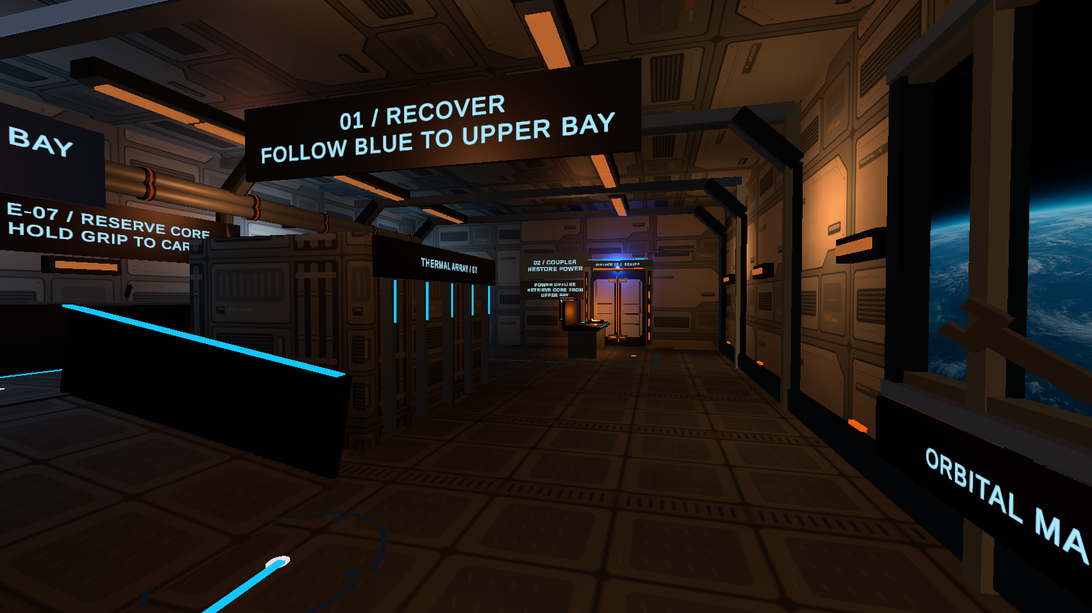
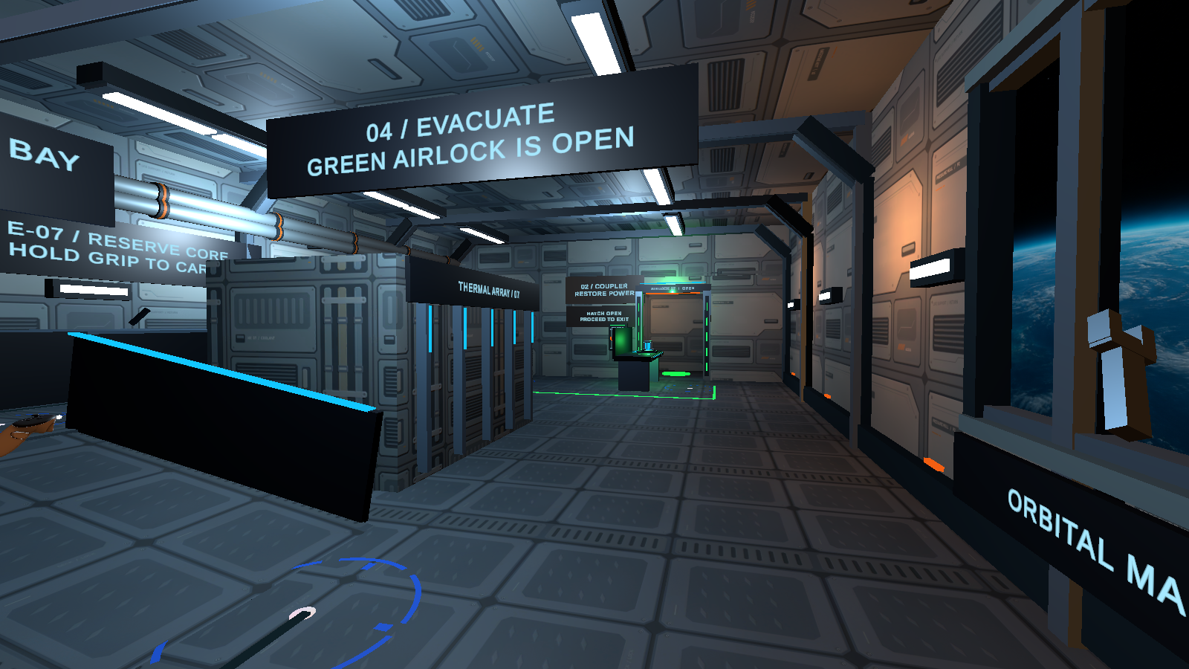
Figure 1. Emergency state (top) and completed power and hatch sequence (bottom). Actual Unity Play captures with Meta XR Simulator, from the same viewpoint.

System

Design requirements
Four requirements guide the implementation. Movement must be interruptible through braking, teleportation, menu access, and reset. A released core must remain recoverable through bounded drift and repeated grabbing. Mission progress must expose its dependencies through text, light, sound, and mechanical state. Finally, reset must restore the entire task, including a held lever or a hatch that is already moving. These requirements are reflected in the control architecture and state sequence in Figure 3.

Interaction flow
At the entrance, blue route cues lead around a reactor obstruction and up a shallow ramp to a supply bay raised by 0.6 m. The player holds Grip to carry the reserve core, returns toward the coupler, and releases the core into its matching socket. Docking starts a 2.4 s restoration sequence across the dock, main passage, and upper bay. The hatch remains closed while these circuits recover.
Once power is ready, a status label directs the player to the lever beside the hatch. Holding its grip and pulling downward beyond the activation angle starts the twin-door animation. A partial pull springs back on release. The route changes to its evacuation state after the door opens, and entering the exit completes the mission. Help provides control instructions, while reset restores the mission to its initial state.

Architecture
The project uses Unity 6000.3.24f1, Meta XR SDK 205.0.0, and Universal Render Pipeline 17.3.0. The existing tracked rig, collision capsule, locomotor, and grab components provide the interaction foundation. SpaceStationControls routes controller input to StationLowGravity; StationFloatingBody manages the core after release. SpaceStationMission coordinates docking, power readiness, hatch opening, exit detection, and reset. StationCabinPower drives the lighting transition, while StationAirlockLever constrains the handle to one axis and requests opening only when its power and grab conditions are satisfied. SpaceStationRoute updates guidance as mission state changes.

Low gravity and recoverable manipulation
A new press of the right-controller A button initiates one boost while grounded. The configured gravity factor is 0.10, with a target maximum lift of 0.20 m and movement speed of 0.9 m/s. The left stick steers during flight. Holding the left-controller X button cancels planar drift and applies a controlled descent. Holding A does not repeat the boost. Menu opening, input-focus loss, teleportation, and reset cancel active motion; the camera has no added roll or artificial head bob.
The core initially rests on its support. After a grab and release, it floats slowly and can be grabbed again. A soft tether begins returning it toward its release anchor beyond 0.28 m, and drift speed is limited to 0.28 m/s. This is a recoverability aid, not a hard positional boundary or orbital simulation. Docking and reset stop floating. Small floating props reinforce the setting without adding another required task.

Power feedback and manual hatch release
The lever shown in Figure 2 rotates through a 0–65 degree range and activates at 55 degrees while held. It is locked before power restoration and returns when released before activation. The mission accepts one valid opening request and supports reset during the animation. Thus, inserting the core changes what the player can do next, while a separate physical action controls the final opening.
Amber emergency lighting gives way to restored cabin illumination. English status text, route indicators, and spatial audio communicate the repair sequence alongside the changing lights; Figure 1 shows the cabin before repair and after the hatch has opened. These cues are intended to connect object manipulation to environmental change. Their readability, salience, and accessibility across users have not yet been measured.
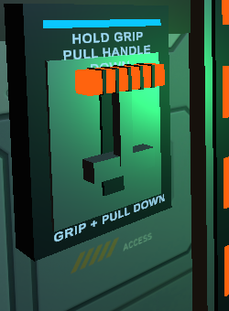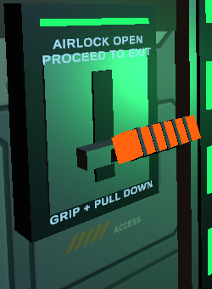
Figure 2. Lever ready for a pull (top) and latched after opening (bottom). Detail crops from actual Unity Play captures with Meta XR Simulator and scripted input.

Evaluation

Method
Functional validation combined Unity Play checks with Meta XR Simulator and deterministic Editor checks of the saved recovery-route scene. In Play mode, scripted production-control inputs and synthetic grab events exercised actual physics and mission coroutines. Editor checks examined slopes, collision boundaries, and teleport destinations. These checks assess implementation behavior and are distinct from participant observations.
The developer also reported trying the updated prototype on a Quest 2 connected to the PC through Link or Air Link and experiencing no dizziness or other discomfort. This was an informal self-trial, reported on 11 November 2026. No standardized symptom score, session duration, or independent observation is available for this account. It is not treated as a usability experiment or proof of standalone APK execution.

Findings and verification scope
All 37 new-interaction checks passed. A scripted boost reached a peak lift of 0.1896 m, and planar velocity was zero at the brake checkpoint. Checks also confirmed repeated core grabbing, termination of floating after docking, locking before power restoration, return after partial lever release, and reset while holding the lever or opening the hatch. The 24 mission-regression checks and 30 route/collision checks passed as well. These totals count assertions within developer test runs and do not represent participant data.
The version 0.6.0 ARM64 Quest APK passed signature, archive-integrity, scene, and component inspection. A ten-second automated Unity capture illustrates lever-triggered opening. Neither package inspection nor simulator capture establishes native Quest frame timing or physical-controller usability. The developer's report of no discomfort is limited to that individual's informal PC VR experience; it cannot establish comfort for first-time users.

Planned first use evaluation
A formative study is planned with an adult classmate who has not used the scene. In an approximately ten-minute session, the participant will attempt the repair using only the starting instructions. Observations will record hesitation, requests for help, unsuccessful grabs, braking use, understanding of the power-to-lever dependency, and task completion. Brief questions will ask whether floating was noticeable, stopping felt controllable, and any discomfort occurred. The main observed issue will be revised and the same participant invited to repeat the task. No participant results are currently available. A later comparison with ordinary locomotion would be needed to investigate the contribution of the low-gravity option.

Conclusion

Contribution and expected value
Lost Station implements a compact repair experience in which bounded movement, a recoverable floating object, staged power feedback, and a manual lever share one mission sequence. The prototype demonstrates how a space theme can shape both movement and object dependencies. Its expected value is an understandable, hands-on encounter with linked VR interactions; improved presence, learnability, or comfort remains a hypothesis for future evaluation.

Exhibition method and responsibilities
The planned exhibit uses one Quest headset, two controllers, a marked clear play area, and a mirrored display so observers can follow progress. A facilitator introduces the controls, offers teleportation, and allows the participant to pause or stop. The short demonstration covers the initial power failure, a controlled boost, core retrieval and insertion, the lighting transition, lever operation, and exit. PC VR is the initial rehearsal configuration; the standalone build still requires on-device installation and checking before an untethered demonstration. Wang Haobin is responsible for the prototype, documentation, demonstration, and remaining tests, with course supervision from Bora Youn.

Limitations and next steps
The movement is deliberately constrained and does not reproduce physical weightlessness or free flight. Current functional evidence comes from scripted checks, and the headset account comes from the developer. Native Quest performance, first-use behavior, reach accessibility, and sustained comfort remain unmeasured. Next work will prioritize standalone-device verification, the planned peer session, and adjustments to boost strength, braking, instructions, and lever reach based on observed difficulties.
References
- Boletsis, C. and Chasanidou, D. A Typology of Virtual Reality Locomotion Techniques. Multimodal Technologies and Interaction, 6(9), 72. 2022. https://doi.org/10.3390/mti6090072
- Boletsis, C. and Cedergren, J. E. VR Locomotion in the New Era of Virtual Reality: An Empirical Comparison of Prevalent Techniques. Advances in Human-Computer Interaction, 2019, Article 7420781. 2019. https://doi.org/10.1155/2019/7420781
- Magnopus. Mission: ISS: Immersive VR Experience. https://www.magnopus.com/projects/mission-iss. Accessed 11 November 2026.
- Meta. Comfort. Meta Horizon OS Developers. https://developers.meta.com/vr/design/comfort/. Accessed 11 November 2026.

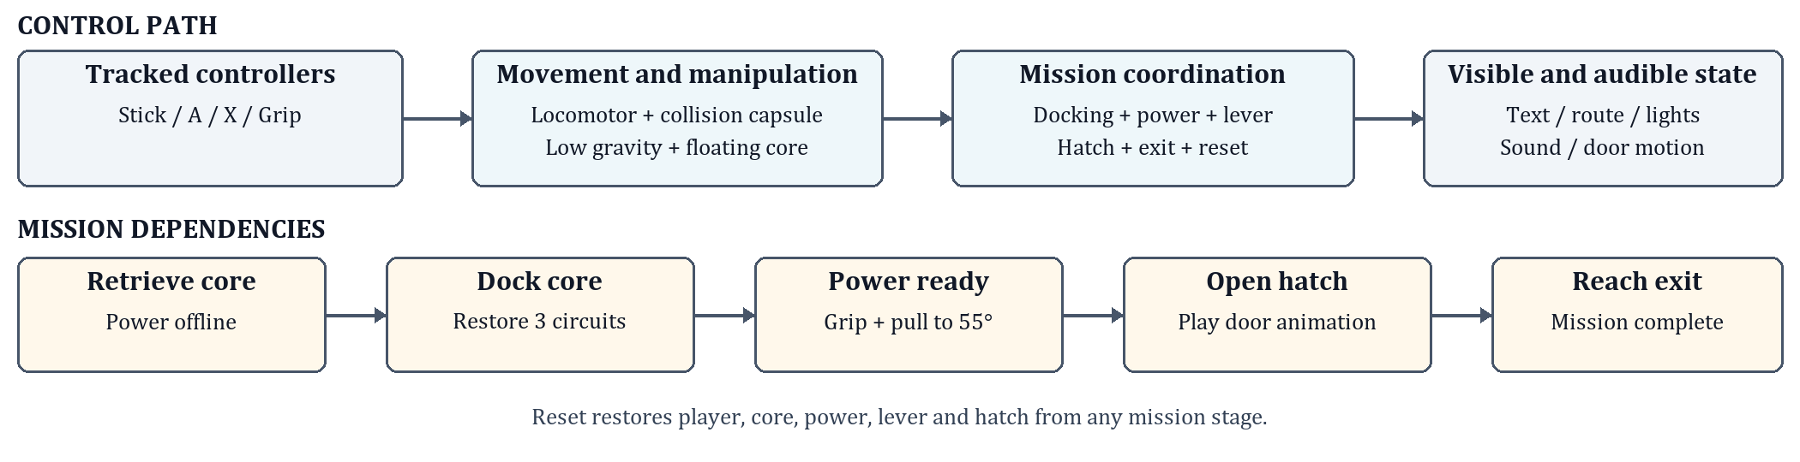
Figure 3. Implemented control architecture and mission dependencies. Power restoration enables the lever; a valid pull starts hatch opening. Reset restores the whole sequence.

