CSC148 - SUMMER 2017(Instructor: Sadia)

Chen Sun

Abstract data types and data structures for implementing them.

Linked data structures.

Encapsulation and information-hiding.

Object-oriented programming.

Specifications. Analyzing the efficiency of programs.

Recursion.

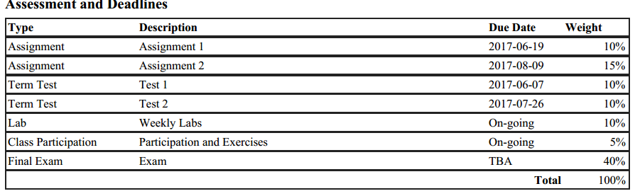

----------------------------

Lab – pair programming 1% each

Week 1

Everything in Python is an Object – like list, string and dictionary

Object have attributes and methods

Define a new Class

Noun as attribute, verb as methods

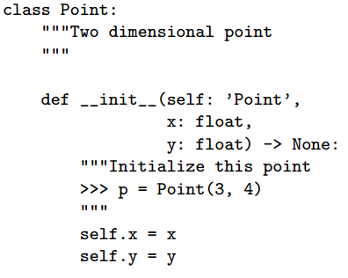

Object Oriented Analysis

* Find Object : Nouns
* Object Behavior : Methods
* Object States : instance variables
* Determine Object Interactions

Inheritance

* Copying-and-pasting from the old class, and then making a few changes, is a bad idea
* Inheritance allows a new class to specialize an existing class by specifying only what is different between them
* Inheritance models ‘is-a’ relationships : cat is an animal – animal is a superclass, cat is a subclass

To inherit from another class, add the superclass name in parentheses class InvisibleShip(Ship):

If the method exists in InvisibleShip, it is called, otherwise the one in ship is called

Magic methods for python classes:

* Comparing two instances of a class using >,<,==
  + Only if we have define __lt__, __gt__,__le__,__eq__...
  + To see if p1 less than p2, p1.__lt__(p2)
  + Similarly for __add__ and __mult__