**About TEST CODE:**

1. Comment out line 20 of the main function, as shown in the figure below



1. Remove the double slash from lines 14,15,16,21,42,45,47 of the main function,, as shown in the figure below

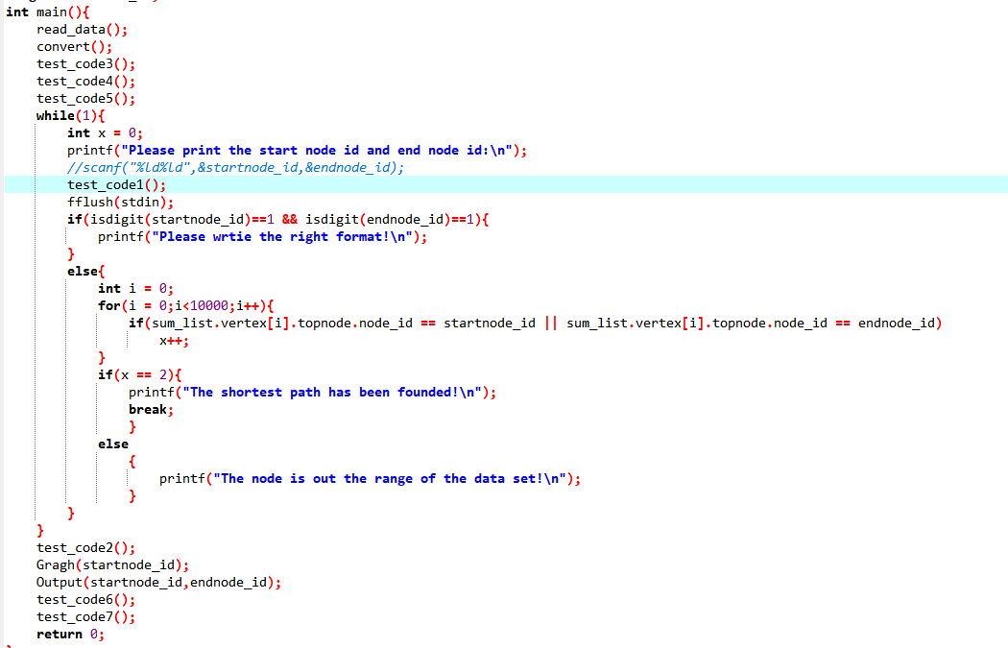

**About how to run the programme:**

Enter the id of the starting id and the ending id.

If the id is out the range of the data set, error message would be printed.

**About Gnuplot:**

The code for data visualization using Gnuplot is as follows：

plot "F:\all.txt" using 1:2 with linespoints linecolor 3 linewidth 1 pointtype 16 pointsize 0.9,"F:\short.txt" using 1:2 with linespoints linecolor 7 linewidth 1 pointtype 16 pointsize 0.9

**Explanation:**

1.The "F:\all.txt" is the absolute path to the file that stores all the point information.

2.The "F:\short.txt" is the absolute path of a file that stores information about the shortest path between two points.

If you would to visualize the data, copy the second line of code to GNUPLOT's command line.