1st Batch

Task 1A (about 10min)

Set 2 velocity to separate horizontal and vertical directions. Then right and up + the velocity, left and down – the velocity. *~~Time.deltaTime for each line otherwise I’m committing a crime~~

Task 1B (about 50mins)

Set velocity to a float, so in if(GetKeyThing) could keep simple

Velpcity * vector3.some direction

Problem is when press arrow button again, velocity keep what it got before and growing from that.

Add this



Fix some of the problem. But the movement is not smooth when change direction. Cause every time when I release some key the velocity set back to 0, even I set to bigger number.

work a little, but still not smooth move

Other try like set 4 vector3 represent vector3.some direction * time deltatim, then if release key set that vector 3 to zero. But not work.

Then finally, normalize the direction then do other thing.

But player will keep moving when release the key. I run out of time to do more changes.

2nd batch

Task 1C (20 mins)

Oh, it’s next task work.

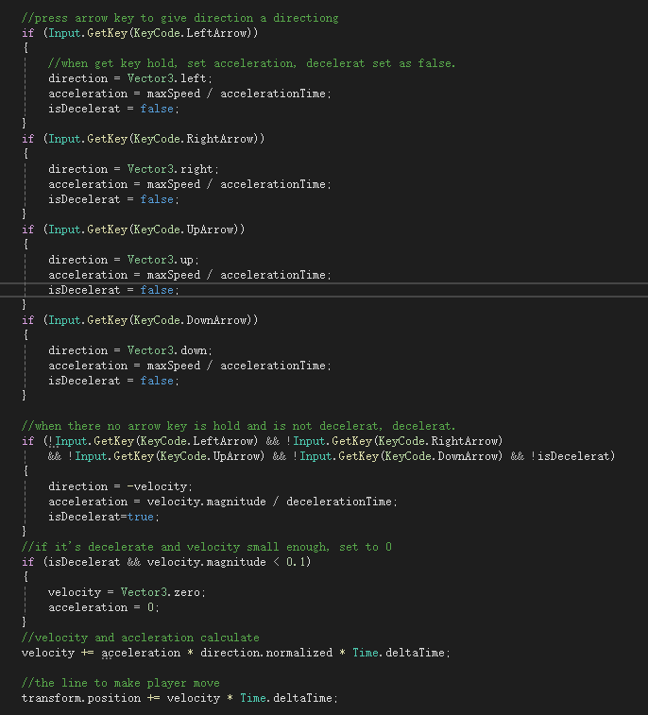

Also when release the key the player will keep move in a tiny amount of speed. To avoid that, set to 0

Set a boolean to check if player is decelerating. if only check if the key up the movement will be really weird.

Task 2A

Plan:

The enemy chasing the player in a **constant speed**. Once reach a certain distance, enemy will stop closing and keep that distance away from the player.

Task 2B (20 mins)

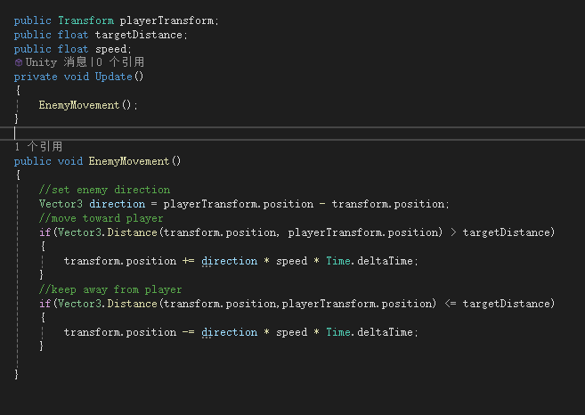

Since wrong measuring the time using, also fix the player movement that didn’t remain the max speed

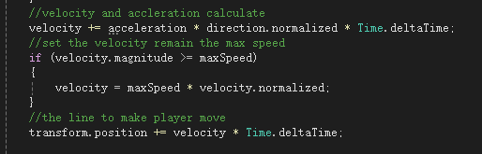

At first I put it after

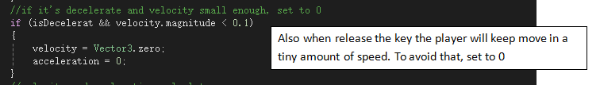

and player will keep move even release the key. So after calculate velocity, then set the max speed.

Orders are matter.

Task 3:(20mins)

Seem should work but no.

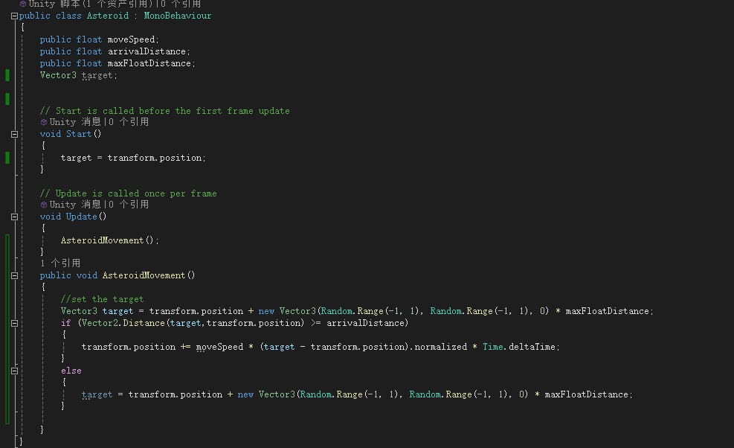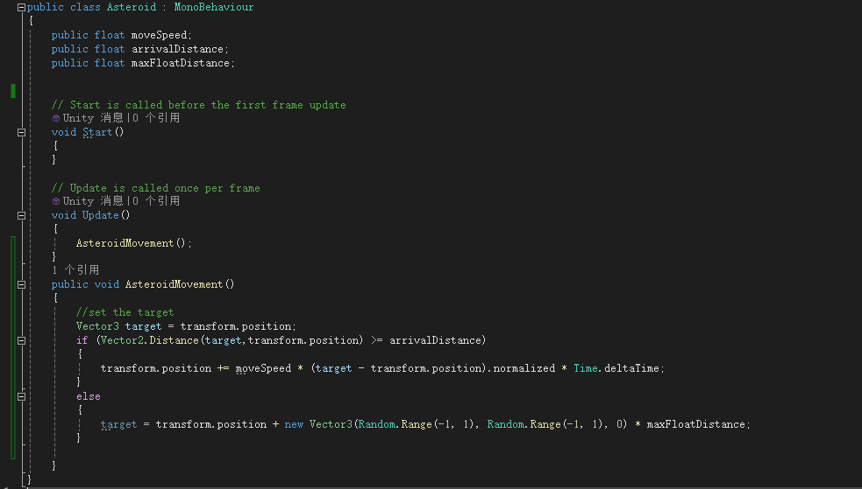

Each update call the method it will reset target as transform.

Every time call the method it will set a new target. So each frame will move to a new direction. Hard to observe the change

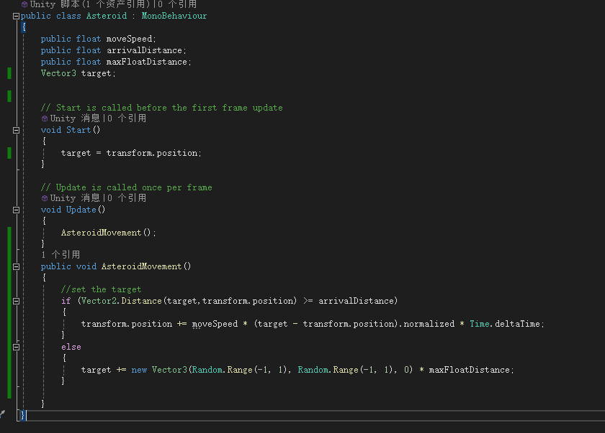

Now it worked.

Task4(30 mins)

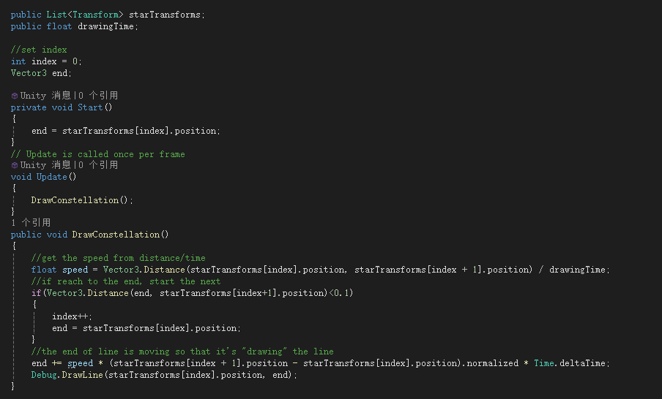

Then I got this



The list only contains 11 transform. ++ will make over the size.

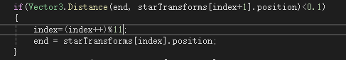

It keeps drawing the first line.

(it’s a gif)

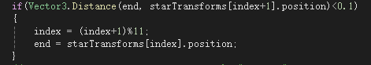

Works but still over size.

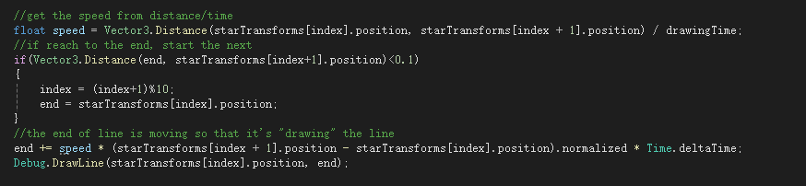

I have index + 1 so size -1