Intelligent Systems - Fall 2016

2nd Lab Session's Report

By Student A and Student B

Part 1: Design a neural network
Describe how you have computed the network architecture and weights.
You should describe the network according to the following format:

Input layer: 2 units, x1 x2
First hidden layer: 2 neurons
Neuron1: w11 = 1/128, w21=1/70, b=1
Neuron2: W12 = 1,w22=0,b=0
Output layer: 3 neurons
Neuron1: w11=-1,w21=0,b=-0.5
Neuron2:w12=1,w22=-1,b=0.5
Neuron3:w12=1,w23=1,b=1.5

Structure of the Neural Network:

Of course, it is your task to define the number of layers, the number of neurons per layer, and the exact values for the weights.

Part 2: Implementation of the MLP simulator
Provide source code and explanations (comments) for both the feedforward() and backpropagation() procedure.
The feedforward function.
//Computes the output of the MLP for a particular input pattern (pat)
void feedforward(int pat)
{

//copy pattern into input layer
for(int i=0; i < layers[0].size; i++) {
if(i==0) layers[0].o[i] = 1.0; //bias neuron
else layers[0].o[i] = pattern[pat][i-1]/128.0; //input normalisation required (between 0 and 1)
}

// propagate the data through layers
for(int i=1; i<nb_layers; i++) {

//at each layer deal with the bias neuron (unit 0)
int k;
if(i!=outputlayer()) {
k=1;
layers[i].o[0]=1.0; //bias neuron
}
else k=0; // except the output layer since it doesn't have one!

for(; k<layers[i].size; k++) {
//
// BEGIN IMPLEMENTATION
//
// compute the activation of neuron k in layer i (weighted sum)
//initialize the value of activation
layers[i].u[k] = 0;
//compute activation
for(int j=0; j<layers[i-1].size;j++)
{
layers[i].u[k]+=layers[i].w[j][k]*layers[i-1].o[j];
}

// then compute the output of neuron k in layer i (using the activation function transfer_f())
layers[i].o[k]=transfer_f(layers[i].u[k]);
// that's it for the feedforward procedure
// END IMPLEMENTATION
}
}
}

The backpropagation function.
//Implementation of the BackPropagation Algorithm
// compute and performs the weigth'change according to the current input
// pattern pat
//
void backpropagation(int pat)
{
//compute the error and dE_du at the output layer (outputlayer())
for(int i=0; i < layers[outputlayer()].size; i++) {
//
// BEGIN IMPLEMENTATION
//
int rms_error;
// compute the difference between the network ouput and the desired output (pattern[pat][])
// compute the local contribution to the RMS error (rms_error+=square of the difference computed above)
rms_error = layers[outputlayer()].o[i]-pattern[pat][i+2];
// compute the partial derivative of the error with respect to the activation at the output layer (layers[outputlayer()].dE_du[]) using the derivative of the activation function (deriv_transfer_f(layers[].u[]))
layers[outputlayer()].dE_du[i]=2*rms_error*deriv_transfer_f(transfer_f(layers[outputlayer()].u[i]));

// END IMPLEMENTATION
}

//compute the deltas for the remaining layers if any!
for(int i=nb_layers-2; i>0; i--) {
for(int j=0; j<layers[i].size; j++) {
//
// BEGIN IMPLEMENTATION
//
// compute the weighted sum of delta j in hidden layer i
int delta_w=0;
for(int k=0; k<layers[i-1].size; k++)
{
delta_w += layers[i+1].dE_du[k]*layers[i+1].w[j][k];
}

// compute the partial derivative of the error with respect to the activation at the current layer (layers[i].dE_du[j]) using the derivative of the activation function (deriv_transfer_f(layers[].u[]))
layers[i].dE_du[j]=delta_w*deriv_transfer_f(transfer_f(layers[i].u[j]));
// END IMPLEMENTATION

}
}

//compute weight change and update accordingly for all layers
for(int i=1; i <nb_layers ; i++) {
for(int j=0; j<layers[i-1].size; j++) {

int k;
if(i!=outputlayer()) k=1; //outputlayer doesn't have a bias neuron but the others do
else k=0;

for(; k<layers[i].size; k++) {
//
// BEGIN IMPLEMENTATION
// update the weight jk in layer i using the learning rate (learning_rate) and the previously computed layer[].dE_du[] and output layer[].o[]
layers[i].w[j][k]-=learning_rate*layers[i].dE_du[k]*layers[i].o[j];
// END IMPLEMENTATION

}
}
}
}

Part 3: Training and Recall experiments
Detail and comment all the experiments achieved:
- Network training
Programs running at the training mode, MAXCYCLE = 100, RMS_ERROR_THRESHOLD = 0.01, which means the training will end at the 100th CYCLE or when rms_error less than or equal to 0.01.
After 100 times’ training, we got the result as follows:
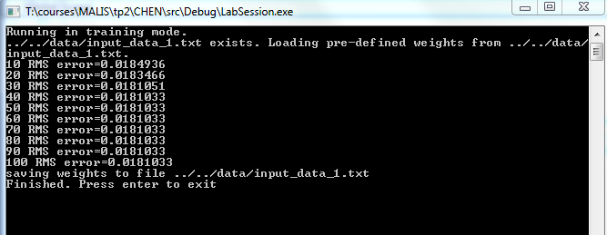

- Recall performance (on the training set set30.x1x2rgb and on the recall set set120.x1x2rgb
Using recall model and set120.x1x2rgb, the result is shown as follows(part of them):
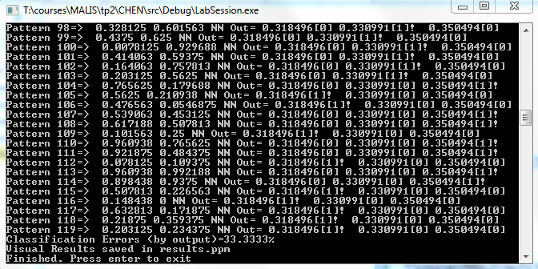
And the result of classification is shown as follows:

- The effect of the learning rate, the number of training cycles and the RMS error stopping criterion. Here you could include a graph showing the RMS error as a function of the number of training cycles for different learning rate values.
  - Change the learning rate
learning rate | number of training cycles | RMS error stopping criterion | RMS error
0.5 | 100 | 0.01 | 0.0181033
0.8 | 100 | 0.01 | 0.179776
1 | 100 | 0.01 | 1.179024
1.2 | 100 | 0.01 | 0.178388
2 | 100 | 0.01 | 0.178338
  - Change the number of training cycles
learning rate | number of training cycles | RMS error stopping criterion | RMS error
0.5 | 100 | 0.01 | 0.0181033
0.5 | 50 | 0.01 | 0.0192801
0.5 | 100 | 0.01 | 0.0192748
0.5 | 500 | 0.01 | 0.0191805
0.5 | 1000 | 0.01 | 0.0188239
  - Change the RMS error stopping criterion

learning rate | number of training cycles | RMS error stopping criterion | RMS error
0.5 | 1000 | 0.001 | 0.0191805
0.5 | 1000 | 0.01 | 0.0191033
0.5 | 1000 | 0.05 | 0.0190801
0.5 | 1000 | 0.1 | 0.0190748

