Test Report

# Positive Test Cases

## Update price

1. Run the program



1. Pass below prices to as stdin

2017-11-01T09:42:23+00:00 KRAKEN BTC USD 1000.0 0.0009

2017-11-02T09:47:23+00:00 COINBASE BTC USD 1004.0 0.00089

2017-11-01T09:42:23+00:00 GDAX BTC USD 1010.0 0.00088

2017-11-01T09:42:23+00:00 KRAKEN ETH USD 500.0 0.0019

2017-11-01T09:42:23+00:00 COINBASE ETH USD 501.0 0.0018

1. The prices will be saved to a text file and a rate graph will be generated and log

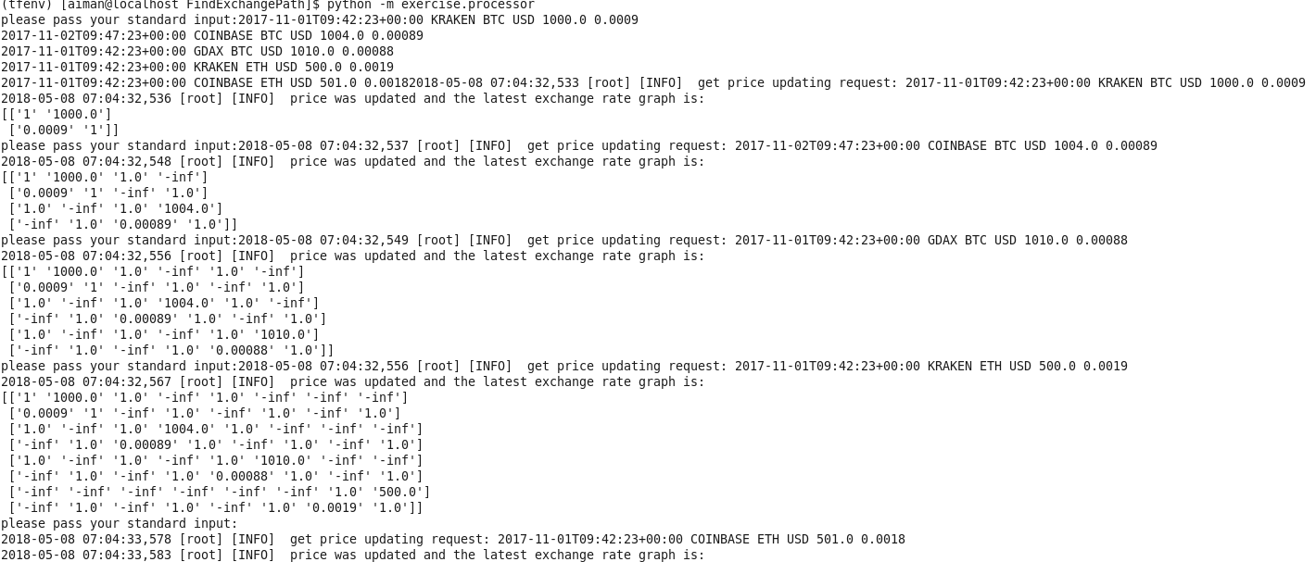

1. Pass one exchange rate whose timestamp is older, the price will not be changed.

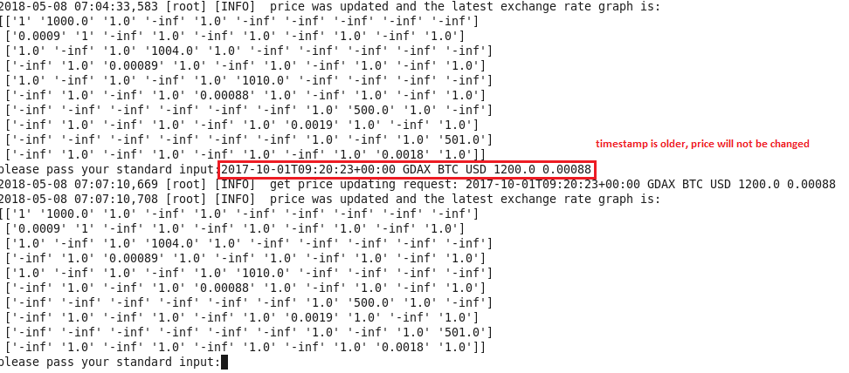

## Request exchange rate

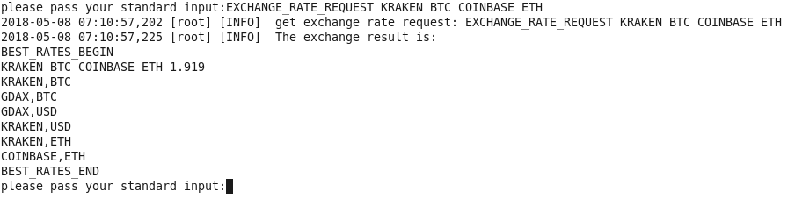

## Exit program

Exit by entering “exit”



## Logging

Logs are outputted to standard output and saved to file as well. It is easy to track.

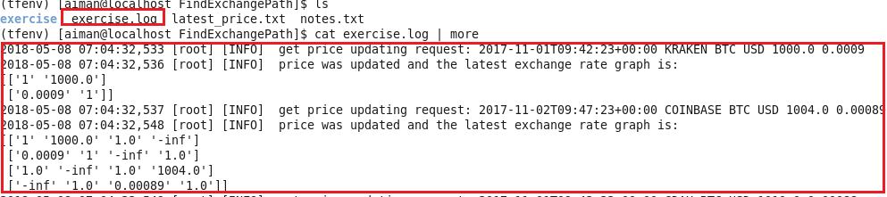

# Negative Test Cases

## Update price – Invalid timestamp format

Program will detect and log



## Update price – invalid overall format

Program will detect and log



## Exchange rate request – No price information

Exchange rate request but there is no any price info. Program will detect and log.



## Exchange rate request – invalid source or destination exchange/currency

Program will detect and log



## Exchange rate request – request format is invalid

Program will detect and log



## Unreasonable price

The following price in COINBASE in unreasonable as people can exchange BTC and USD between KRAKEN and COINBASE continuously to earn money. It will lead to continuous loop if we want to find path from “KRAKEN BTC” to “GDAX USD”. The program will detect and log.

2017-11-01T09:42:23+00:00 KRAKEN BTC USD 1000.0 0.0009

2017-11-02T09:47:23+00:00 COINBASE BTC USD 2000.0 0.0005

2017-11-01T09:42:23+00:00 GDAX BTC USD 1001.0 0.0009

