Network Information Security
Laboratory Report
Work 1
Secure REST API Development with CI/CD and Real CVE Vulnerability Analysis
Variant: CVE-2019-11043
Name: Chen Yiming
HDU ID: 23320218
Date: October 20, 2026

Abstract
This report presents Work 1 of the Network Security laboratory: a secure Flask REST API with protections against SQL injection, XSS and broken authentication (JWT + bcrypt), a GitHub Actions pipeline running Bandit (SAST) and pip-audit (SCA) on every push and pull request, and a complete vulnerability research cycle on CVE-2019-11043 — unauthenticated remote code execution in PHP-FPM behind nginx, caused by unchecked pointer arithmetic on an empty PATH_INFO value.
The vulnerability was reproduced in a Vulhub container, its root cause (a heap buffer overflow reached through an empty PATH_INFO value and abused to inject PHP_VALUE settings) was analysed, the environment was fixed by upgrading php-fpm to 7.2.24 with the nginx configuration deliberately preserved, and the fix was verified by attack replay and regression testing.
Keywords: REST API security; SQL injection; XSS; JWT; bcrypt; CI/CD; SAST; SCA; CVE-2019-11043; PHP-FPM; nginx; remote code execution

1. Purpose
The purpose of this work is to gain practical experience across the full security lifecycle of a small web service: designing and implementing a REST API with baseline protections against the OWASP Top 10, integrating static and dependency security scanning into a CI/CD pipeline, and then reproducing, analysing and remediating a real-world vulnerability (CVE) in a controlled Docker environment.
The assignment covers protection against SQL injection (SQLi), cross-site scripting (XSS) and broken authentication; automated SAST/SCA scanning with GitHub Actions; and a complete vulnerability research cycle — reproduce, find the root cause, fix, and verify the fix with regression testing.

2. Project Overview
Public repository: https://github.com/ChenYiming-aaa/network-security-work1
Last successful pipeline run: https://github.com/ChenYiming-aaa/network-security-work1/actions/runs/39550217994
Tech stack: Python 3.12 / Flask 3, SQLite, PyJWT (HS256), bcrypt, markupsafe; GitHub Actions for CI; Docker + Vulhub for the CVE part. The repository has two parts: the secure API and its CI pipeline (root) and the CVE-2019-11043 reproduction and fix (cve-2019-11043/).

3. Secure REST API Implementation

3.1 Endpoints
The API implements the two required methods plus one self-designed endpoint:
Method | Path | Auth | Description
POST | /api/users | — | User registration (self-designed endpoint). Password hashed with bcrypt before storage.
POST | /auth/login | — | Credential verification; issues a JWT on success.
GET | /api/data | JWT required | Returns the posts list (protected endpoint).

Example calls:
$ curl -X POST http://127.0.0.1:5000/api/users -H "Content-Type: application/json" -d '{"username":"alice","password":"Str0ngPass!","display_name":"Alice"}'
$ curl -X POST http://127.0.0.1:5000/auth/login -H "Content-Type: application/json" -d '{"username":"alice","password":"Str0ngPass!"}' — returns the JWT
$ curl http://127.0.0.1:5000/api/data -H "Authorization: Bearer <JWT>" — returns the data
Without a valid token /api/data answers 401 (a forged or tampered token likewise); ten test cases covering all branches are archived in evidence_api_verification.log in the repository.

3.2 Protection against SQL injection
Every SQL statement uses SQLite parameterized queries (? placeholders); user input is bound as a parameter by the database driver and is never concatenated into the query string. The login endpoint looks the user up with SELECT id, username, password_hash FROM users WHERE username = ?.
The classic payload ' OR 1=1-- sent as the username is therefore treated as a literal (nonexistent) username, and the attack fails with 401 invalid credentials — verification log item [6].

3.3 Protection against XSS
All user-controlled fields returned in API responses (display_name and the post fields) are passed through markupsafe.escape() before serialization. A registered display_name of <script>alert(1)</script> is returned as &lt;script&gt;alert(1)&lt;/script&gt; — log item [9].
Because this is a pure JSON API, the Content-Type: application/json header plus frontend escaping would already prevent browser-side XSS; the server-side escaping is applied as deliberate defence in depth.

3.4 Protection against broken authentication
On successful login the server issues a JWT signed with HS256 and a 30-minute expiry. A decorator (require_jwt) protects the /api/data endpoint: it parses the Authorization: Bearer header, verifies the signature and the exp claim, and pins the accepted algorithm to an explicit whitelist (algorithms=["HS256"]), which blocks algorithm-confusion attacks such as alg: none.
Passwords are hashed with bcrypt — built-in random salt and an adaptive cost factor — and are never stored or logged in plaintext; the registration response returns only the hash prefix ($2b$12$…) as proof. As an additional hardening measure, a login attempt for a nonexistent user still performs one bcrypt comparison against a dummy hash, so that "unknown user" and "wrong password" responses are indistinguishable by timing.
JWT_SECRET is read from the environment with no default value: if it is missing, the application raises RuntimeError at startup instead of silently using a well-known development secret (demonstrated in the appendix of the verification log).

3.5 API verification
The API was tested with curl; evidence_api_verification.log in the repository records 10 cases, each with the executed command, the full response headers (curl -i) and a timestamp: missing token → 401, forged token → 401, registration → 201 with bcrypt hash prefix, duplicate registration → 409, wrong password → 401, SQL injection payload → 401, successful login → 200 with JWT, valid token → 200 with data, XSS payload → escaped output, tampered signature → 401.

4. CI/CD Pipeline with Security Scanners
The pipeline is defined in .github/workflows/ci.yml and runs on every push and every pull request:
1. SAST — Bandit scans the whole tree and prints its verdict to the job log (Figure 2), produces an HTML report uploaded as the bandit-report artifact, and fails the build on medium-or-higher findings.
2. SCA — pip-audit audits the pinned requirements.txt against the PyPA vulnerability database; any known advisory fails the build (--strict).
3. Smoke test boots the API and asserts that GET /api/data without a token answers 401 — the service is up and the JWT auth boundary is active.
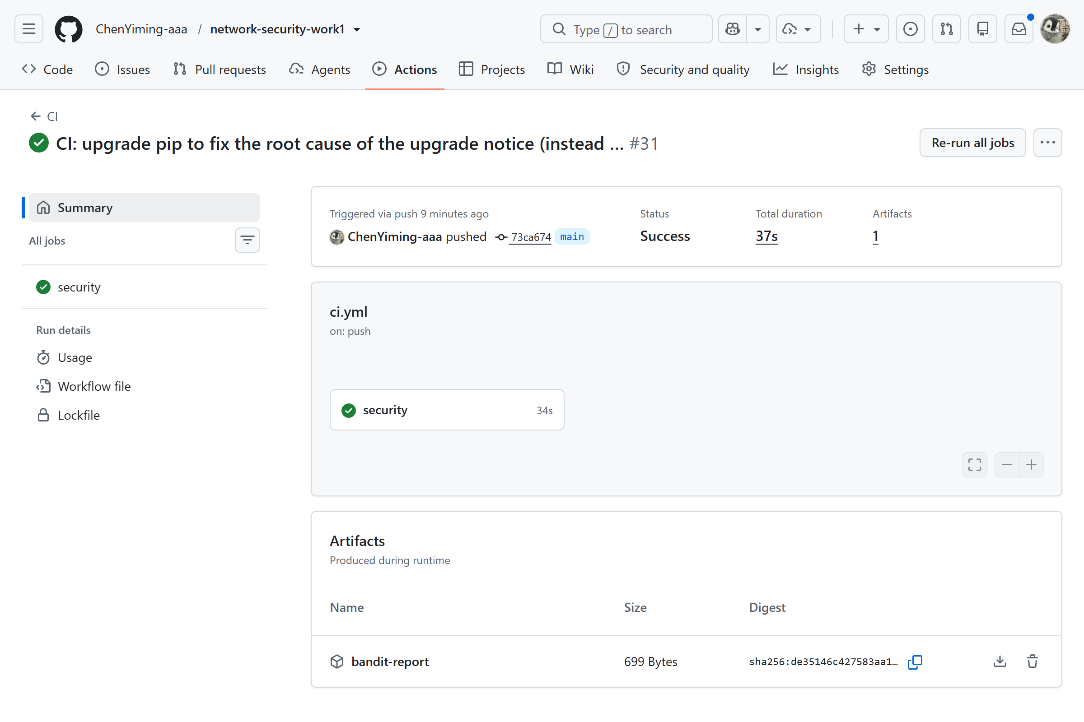
Figure 1 — GitHub Actions, run #31: the workflow succeeds — Bandit SAST, pip-audit SCA and the smoke test all pass, one artifact produced.
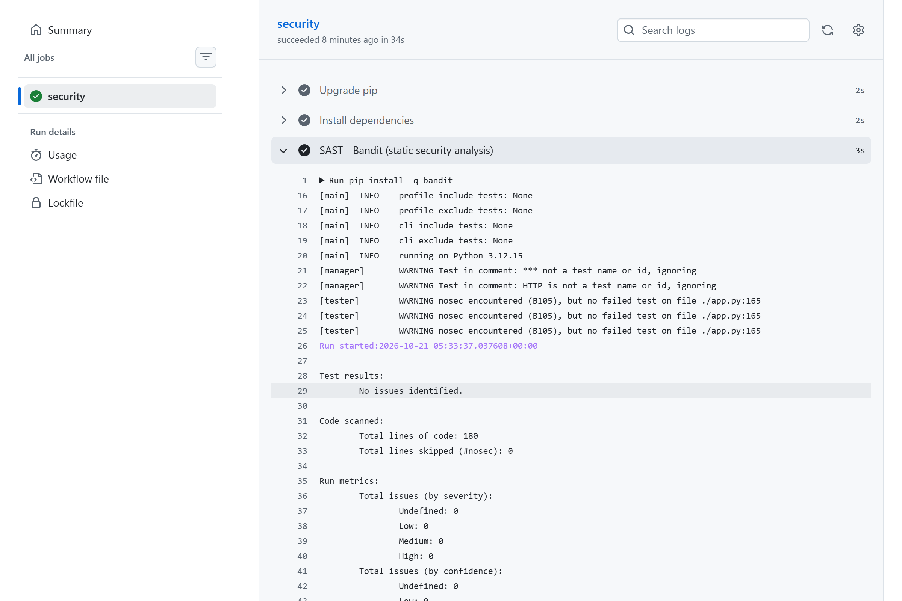
Figure 2 — GitHub Actions, run #31, security job, SAST step log: Bandit reports "No issues identified", 180 lines of code scanned and every severity counter at zero, then writes bandit-report.html for the artifact.
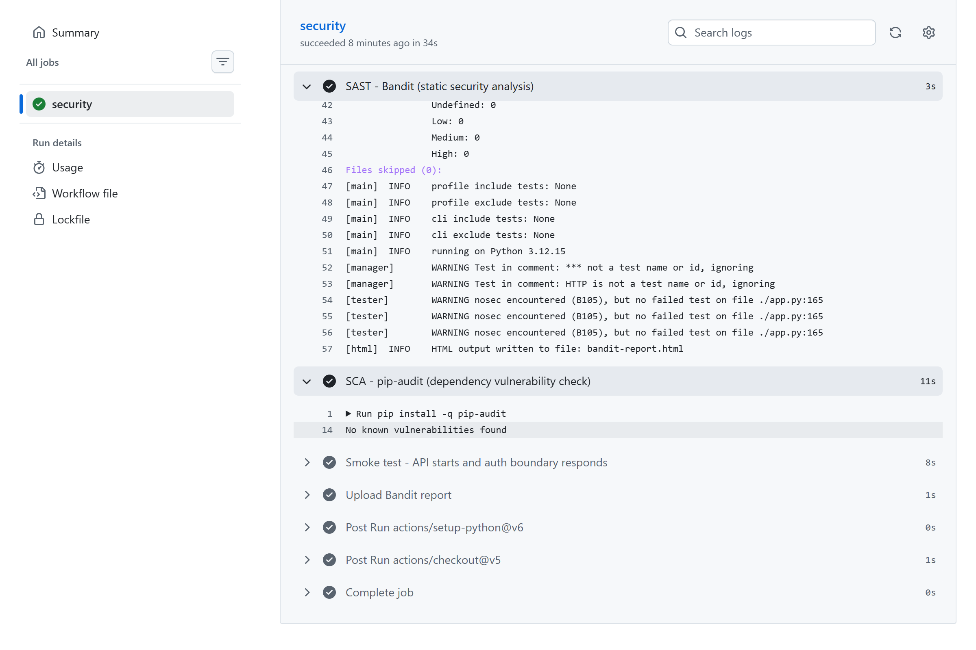
Figure 3 — GitHub Actions, run #31, SCA step log: pip-audit reports "No known vulnerabilities found" for the pinned dependencies.

5. CVE Analysis: CVE-2019-11043

5.1 Vulnerability overview
CVE-2019-11043 is an unauthenticated remote code execution vulnerability in PHP-FPM, the FastCGI Process Manager of PHP (sapi/fpm/fpm_main.c), exploitable when PHP-FPM runs behind nginx with a common fastcgi_split_path_info configuration that passes an empty PATH_INFO parameter. NVD rates it CVSS 3.1 9.8 (Critical) (AV:N/AC:L/PR:N/UI:N/S:U/C:H/I:H/A:H) and classifies it as CWE-120, a classic buffer overflow: a buffer copy/write without checking size bounds.
The affected versions are PHP 7.1.x below 7.1.33, 7.2.x below 7.2.24 and 7.3.x below 7.3.11 in certain FPM + nginx configurations; the fixed releases 7.1.33 / 7.2.24 / 7.3.11 were published on 24 October 2019.
The issue was reported by Emil Lerner (PHP bug #78599), and the reference exploit is neex/phuip-fpizdam, which is used in this work. The lab manual's originally suggested environment (vulhub/flask/CVE-2018-1000656) no longer exists in the official Vulhub repository — the flask/ directory now contains only the unnumbered ssti demo — so this equivalent web-stack component environment was selected instead; it keeps a real CVE ID and a simple, curl-based reproduction.

5.2 Environment
Vulhub php/CVE-2019-11043: an nginx front container (nginx:1) proxying FastCGI to a php-fpm container built on vulhub/php:7.2.10-fpm, published on port 8080 and serving a minimal index.php that prints "hello world". The nginx configuration matches PHP requests with location ~ [^/]\.php(/|$), splits the URL with fastcgi_split_path_info ^(.+?\.php)(/.*)$ and passes fastcgi_param PATH_INFO $fastcgi_path_info — exactly the configuration pattern the vulnerability requires. The environment was started with docker compose up -d; docker ps confirmed both containers were running and responses carried the X-Powered-By: PHP/7.2.10 header.
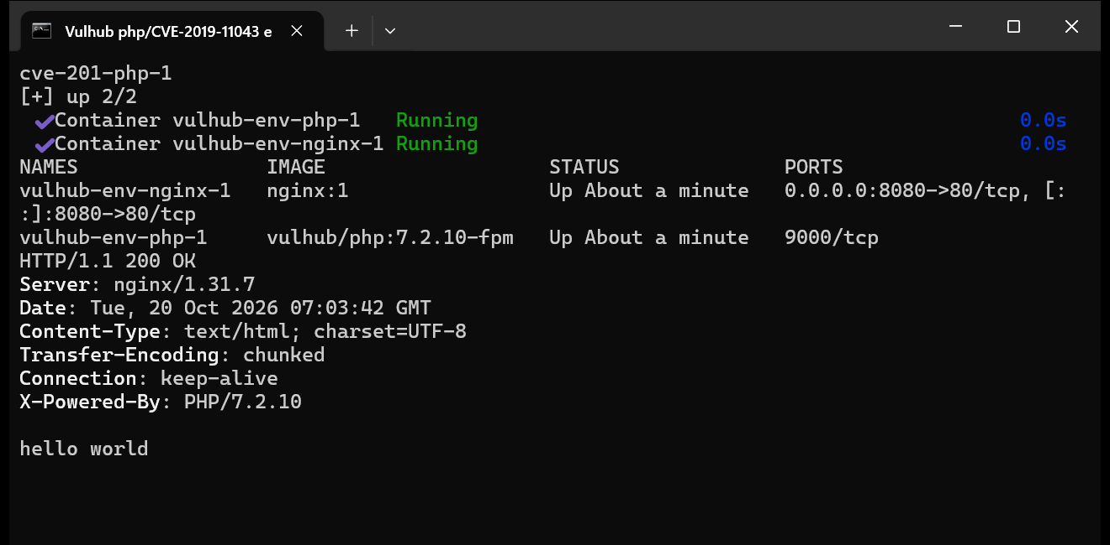
Figure 4 — The vulnerable target running: docker compose up -d and docker ps output, the service answers with X-Powered-By: PHP/7.2.10.

5.3 Reproduction (before fix)
A0 (sanity): curl -i http://localhost:8080/index.php → HTTP 200, X-Powered-By: PHP/7.2.10, body "hello world" — normal behaviour, as expected.
Step 1 — QSL detection and the write. The exploit probes the server with requests of varying query-string length (QSL) to find the lengths at which the out-of-bounds write kills a php-fpm worker (HTTP 502); those lengths are the candidate heap alignments. It then performs the attack with the detected parameters:
./phuip-fpizdam http://localhost:8080/index.php
The tool reported "Status code 502 for qsl=1800, adding as a candidate", "The target is probably vulnerable. Possible QSLs: [1790 1795 1800]" and "Attack params found: --qsl 1795 --pisos 248 --skip-detect", then performed the attack and confirmed: "Success! Was able to execute a command by appending ?a=/bin/sh+-c+'which+which'& to URLs". The write realigned the FastCGI parameter block so that a later request's PHP_VALUE is attacker-controlled (allow_url_include=On, auto_prepend_file=php://input) — exactly the RCE primitive this CVE describes.
curl "http://localhost:8080/index.php?a=/bin/sh+-c+'id'&"
Step 2 — command execution. php-fpm runs several worker processes and only a poisoned one executes the injected code, so the same URL is retried until it hits the poisoned worker: it returned uid=33(www-data) gid=33(www-data) groups=33(www-data), and further probes showed whoami → www-data and arbitrary file read (head -n1 /etc/os-release → PRETTY_NAME="Debian GNU/Linux 9 (stretch)"). All commands and raw outputs are archived in cve-2019-11043/evidence/reproduce_before_fix.log.
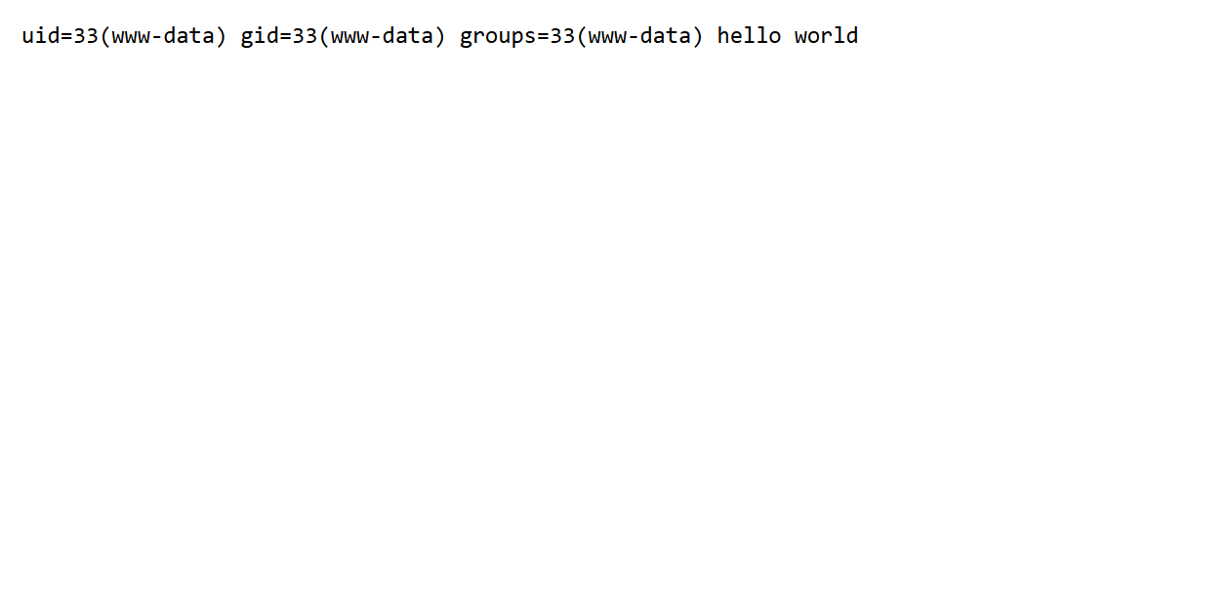
Figure 5 — The attack URL in the browser: the poisoned php-fpm worker executes id (uid=33(www-data)) on PHP 7.2.10.
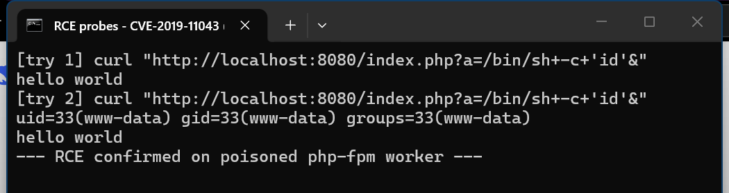
Figure 6 — Terminal: repeated RCE probes until the poisoned worker answers (www-data, uid=33, Debian GNU/Linux 9).

5.4 Root cause analysis
In my own words: the vulnerability is unchecked pointer arithmetic on an empty PATH_INFO value — a "path info buffer underflow". php-fpm's init_request_info() assumed that if the PATH_INFO parameter is present, the request really is script.php/path-info, and that the path-info pointer sits after the script name inside the received script filename.
In the vulnerable configuration, for a crafted URL the fastcgi_split_path_info regex fails to capture a path-info part, so $fastcgi_path_info is empty — but the fastcgi_param PATH_INFO directive still passes the parameter with an empty value. php-fpm performs the adjustment anyway: the presence of the parameter is taken as proof of the layout, the pointer arithmetic subtracts the script path length from a pointer into the FastCGI params buffer, and the resulting path_info pointer lands before the start of the buffer.
The underflow becomes an out-of-bounds write: php-fpm writes a zero byte through the wild pointer, and the attacker controls how far off the write lands by tuning the query-string length — which is exactly what the QSL probing in the reproduction does. With the heap realigned, a subsequent request's FastCGI parameters are reinterpreted as PHP_VALUE ini settings, injecting allow_url_include=On and auto_prepend_file=php://input; the raw request body is then executed as PHP code by the worker (user www-data) — unauthenticated RCE.
The fix in PHP 7.1.33 / 7.2.24 / 7.3.11 adds the missing validation to init_request_info(): before the pointer arithmetic, the code verifies that the PATH_INFO value is consistent with the script filename — i.e. that the path-info part really points inside the received script path — and bails out of the path-info branch otherwise. With the check in place, an empty PATH_INFO no longer produces an out-of-bounds pointer, the write primitive disappears and the whole PHP_VALUE injection chain cannot start.
Two configuration choices determine the blast radius: nginx passes PATH_INFO even when it is empty (the pattern the bug requires), and the php-fpm worker runs as www-data — so a single poisoned worker is enough for command execution, while the multi-worker pool makes the attack probabilistic rather than immediate. The code defect provides the write primitive; the deployment configuration decides whether it is reachable and what it can do.
The full analysis, including the NVD description and references, is in cve-2019-11043/root-cause-analysis.md.

5.5 Fix
The primary fix is to update the software to the version where the vulnerability is fixed: the docker-compose.yml image changes from vulhub/php:7.2.10-fpm to php:7.2.24-fpm. The nginx configuration is deliberately kept identical to the vulnerable environment (same default.conf, fastcgi_split_path_info and empty-PATH_INFO behaviour included), so that the verification proves the attack fails because of the version fix itself rather than because the environment was hardened.
The fix was applied with the standard cycle — docker compose down, edit docker-compose.yml, docker compose up -d — and the changed files (cve-2019-11043/fix/docker-compose.yml, with the vulnerable originals archived under fix/original/) are committed to the repository as required.

5.6 Verification after fix
The exact same attack was replayed against the rebuilt php 7.2.24 container:
Replayed attack | Before fix (php 7.2.10-fpm) | After fix (php 7.2.24-fpm)
PoC QSL detection | Possible QSLs: [1790 1795 1800] | no qsl candidates found — invulnerable
PoC full attack | attack params found (--qsl 1795 --pisos 248), RCE confirmed | no worker poisoned, no attack params found
RCE probe ?a=/bin/sh+-c+'id'& (retried) | uid=33(www-data)… executed | no command output — only hello world (8/8)

Regression testing confirmed that normal functionality is preserved: GET /index.php still returns HTTP 200 with hello world and the X-Powered-By: PHP/7.2.24 header, and the PoC's detection phase against the fixed server reports "no qsl candidates found, invulnerable or something wrong". Raw outputs are in cve-2019-11043/evidence/verify_after_fix.log.
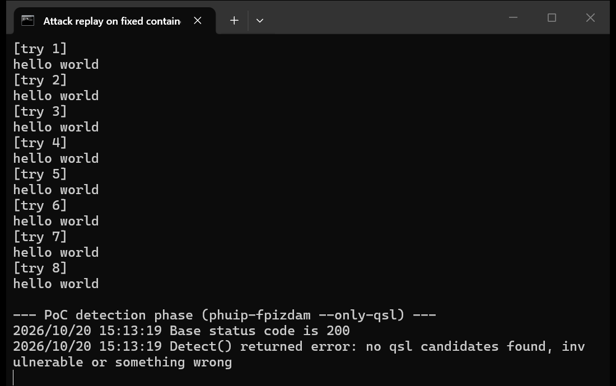
Figure 7 — Attack replay on the fixed container: 8/8 replays of the exact pre-fix payload produce no command output (only the normal hello world), and the PoC detection reports the server invulnerable.

Figure 8 — Regression: the normal page still works after the fix.

6. Conclusion
This work covered the full security lifecycle of a small web service. The API implements the three required endpoints with parameterized SQL, output escaping, and JWT + bcrypt authentication, all verified with curl evidence. The CI pipeline runs Bandit (SAST) and pip-audit (SCA) on every push and pull request.
The CVE part reproduced CVE-2019-11043 (unauthenticated PHP-FPM RCE behind nginx), identified its root cause — unchecked pointer arithmetic on an empty PATH_INFO value, turning into a heap overflow and PHP_VALUE injection — remediated it by upgrading to the fixed php:7.2.24-fpm while deliberately keeping the nginx configuration, and verified both the rejection of the original attacks and the preservation of normal functionality.
The main lessons were that a parameter's mere presence is not proof of the layout it is assumed to have — implied invariants must be validated at the trust boundary — that dependency scanning earns its place in CI, and that fix verification needs both attack replay and regression testing.

References
1. NVD — CVE-2019-11043 detail: https://nvd.nist.gov/vuln/detail/CVE-2019-11043
2. PHP bug #78599 — heap buffer overflow in fpm_main.c (CVE-2019-11043): https://bugs.php.net/bug.php?id=78599
3. Vulhub repository (php/CVE-2019-11043): https://github.com/vulhub/vulhub
4. OWASP Top 10 (2021): https://owasp.org/www-project-top-ten/
5. OWASP Cheat Sheet Series: https://cheatsheetseries.owasp.org/
6. JWT introduction: https://jwt.io/introduction
7. GitHub Actions documentation: https://docs.github.com/en/actions
8. Docker documentation: https://docs.docker.com/

Appendix — Submission Checklist
Item | Location
Public git repository | https://github.com/ChenYiming-aaa/network-security-work1
README.md (API, security measures, CVE, reproduction, analysis, fix, proofs) | repository root
Last successful pipeline run | https://github.com/ChenYiming-aaa/network-security-work1/actions/runs/39550217994
Folder with fixes | cve-2019-11043/fix/ (docker-compose.yml; originals in fix/original/)
Evidence (logs and screenshots) | cve-2019-11043/evidence/, screenshots/

