**How to use the template project**

1. Check out the template project from git here: [git@10.61.213.103:~/repo/hr_genie/msa-project-template.git](mailto:git@10.61.213.103:~/repo/hr_genie/msa-project-template.git)
2. Run command and go to the folder of your project, run : mvn clean install

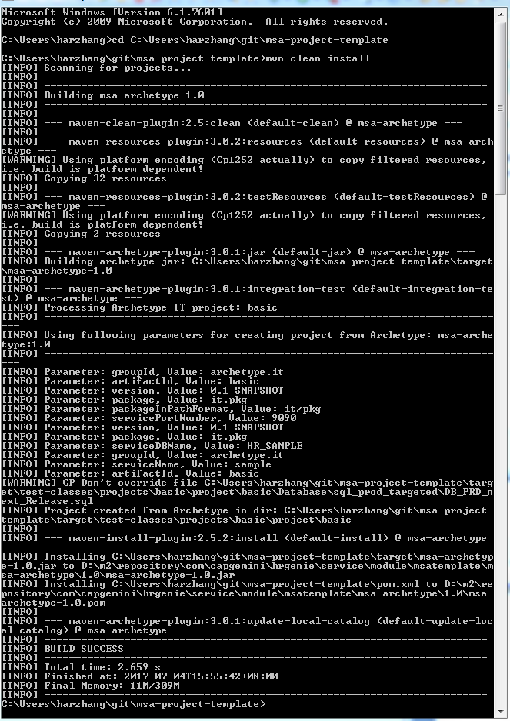

1. Open Eclipse , Click File->New->Maven Project

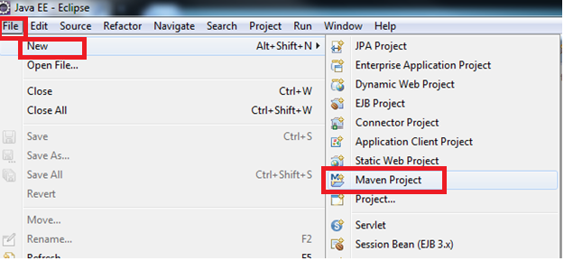

1. The new maven project opened, Click “Next” button

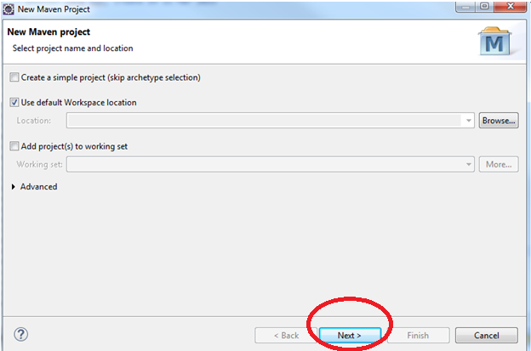

1. Archetype windows open, Click “Add Archetype” button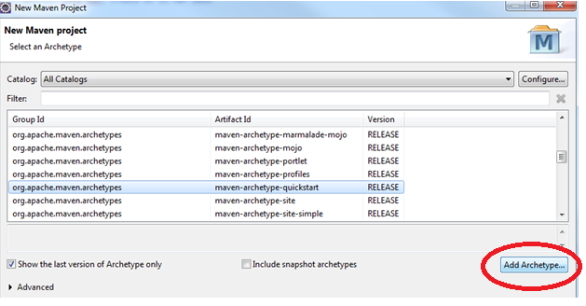
2. Fill the following value, Click “OK”.

Group Id: com.capgemini.hrgenie.service.module.msatemplate

Artifact Id: msa-archetype

Version: 1.0

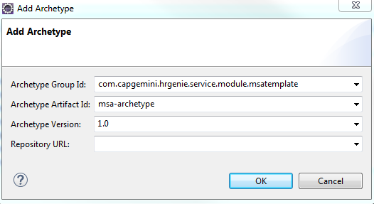

1. Filter by “hr”, you can see the one you just add, select it ,click “Next”.

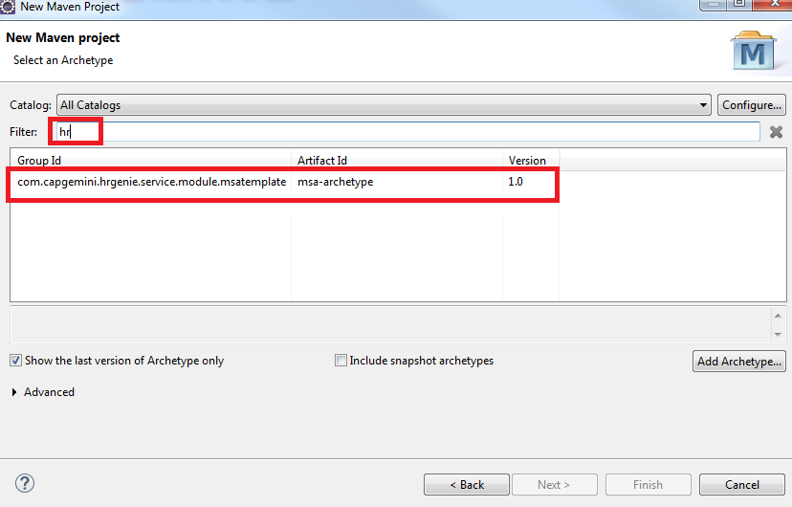

1. Fill the value

Group Id: com.capgemini.hrgenie.service.module

Artifact Id: test

Version:0.0.1-SNAPSHOT

Package: com.capgemini.hrgenie.service.module.test

ServiceName:Test

serviceDBName:HR_TEST

servicePortNumber:9999

Here are the format need follow:

Note: Artifact Id is the project name, format: lower case

Package: com.capgemini.hrgenie.service.module. +Artifact Id

ServiceName format, UpperCamelCase

serviceDBName, this is the dbname will be used for this MSA project

servicePortNumber, this is the port number for the MSA

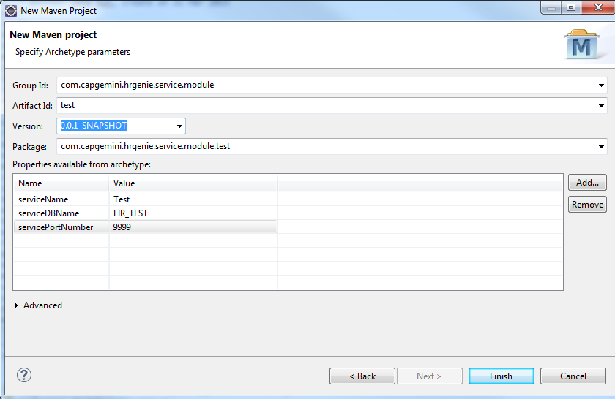

1. Click “Finish”, you can see the project generated:

