**Through starting from a case study：Github**

GitHub is a web-based platform that provides hosting for software development projects utilizing the Git version control system. It offers a range of features designed to facilitate collaboration among developers, project management, and code hosting. Here are some key aspects of GitHub:

**Version Control:** GitHub allows developers to host their Git repositories, enabling version control for their projects. This allows multiple developers to collaborate on a project simultaneously, tracking changes, and managing different versions of the codebase.

**Collaboration Tools:** GitHub provides features like pull requests, issues, and code reviews to facilitate collaboration among developers. Pull requests allow contributors to propose changes, while issues can be used to track bugs, feature requests, and other tasks. Code reviews enable developers to provide feedback on proposed changes before they are merged into the main codebase.

**Project Management:** GitHub includes project management tools such as project boards, milestones, and labels to help organize and track progress on tasks. Project boards can be used to visualize the status of tasks and issues, while milestones and labels can help categorize and prioritize work.

**Community and Social Features:** GitHub fosters a strong developer community through features like profiles, activity feeds, and social interactions such as starring repositories and following other users. This helps developers discover interesting projects, contribute to open-source initiatives, and connect with like-minded individuals.

**Documentation and Wikis:** GitHub allows developers to create and maintain documentation for their projects using Markdown syntax. Additionally, repositories can include wikis for collaboratively documenting project-related information, such as installation instructions, usage guides, and best practices.

**Integration with Third-Party Tools:** GitHub integrates with a wide range of third-party tools and services, including continuous integration (CI) platforms, code analysis tools, project management software, and communication tools. This allows developers to streamline their development workflow and incorporate additional functionality into their projects.

**To master the open source platform: GitHub**

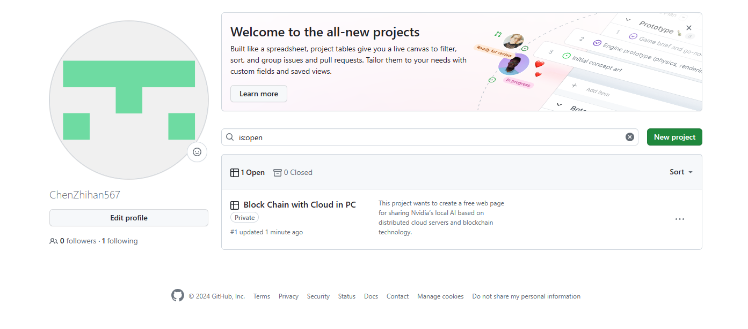

**How to initiate and manage an open source project, what are the differences between open source projects and corporate projects in development?**

**Initiating an Open Source Project:**

* **Identify Purpose and Goals:** Define the purpose of the project and its goals clearly. What problem does it solve? What benefits does it provide? Determine the scope of the project. What features will be included? What are the project's limitations?
* **Choose a License:** Select an open-source license that aligns with your project's goals and the level of freedom you want to offer to contributors. Common licenses include MIT, Apache, GNU GPL, etc. Each has its own terms and conditions.
* **Set Up Repository and Version Control:** Choose a platform like GitHub, GitLab, or Bitbucket to host your project. Initialize a version control system like Git to track changes and manage contributions.
* **Create Documentation:** Develop comprehensive documentation, including installation instructions, usage guides, and contribution guidelines. Documentation is crucial for users and contributors to understand and engage with your project effectively.
* **Establish Community Guidelines:** Create a code of conduct to foster a welcoming and inclusive community. Define contribution guidelines, including how to report issues, submit feature requests, and propose changes.
* **Start Building:** Begin developing the project according to the defined goals. Encourage contributions from the community by maintaining an open and transparent development process.

**Managing an Open Source Project:**

* **Engage with Contributors:** Encourage collaboration and communication among contributors. Review and merge pull requests in a timely manner. Provide constructive feedback to contributors.
* **Maintain Quality:** Ensure code quality by conducting code reviews and implementing automated testing. Regularly update documentation to reflect changes and improvements.
* **Handle Issues and Bugs:** Monitor issue trackers and respond promptly to bug reports and feature requests. Prioritize tasks and allocate resources effectively to address issues.
* **Foster Community Growth:** Organize events like hackathons, meetups, or conferences to bring together contributors and users. Recognize and appreciate contributions from community members.

**Differences Between Open Source and Corporate Projects:**

* **Development Model:** 
  + Open source projects typically follow a decentralized development model, where contributions can come from individuals or organizations outside the core development team.
  + Corporate projects often have a more centralized development model, where development is driven primarily by employees of the organization.
* **Ownership and Governance:**
  + In open source projects, ownership is distributed among contributors, and project governance is often collaborative and community-driven.
  + Corporate projects are usually owned and governed by the organization funding or leading the development, with decisions made internally by company stakeholders.
* **Motivation and Incentives:**
  + Contributors to open source projects are often motivated by personal interest, a desire to solve a problem, or a belief in the project's mission.
  + In corporate projects, developers may be motivated by financial incentives, career advancement, or meeting business objectives set by the company.
* **Release Cycle and Roadmap:**
  + Open source projects may have more flexible release cycles and roadmaps, driven by community feedback and contributions.
  + Corporate projects often adhere to strict release schedules and roadmaps determined by business needs and priorities.
* **Licensing and Intellectual Property:**
  + Open source projects typically use open-source licenses, allowing for free use, modification, and distribution of the codebase.
  + Corporate projects may use proprietary licenses to protect intellectual property and restrict usage and distribution rights.