**BIG DATA V.S. PRIVACY: Is our individual privacy in risk?**

According to the ethics and ethics related to statistics and experiments, our privacy should be protected and not allowed to be invaded at will. However, the reality is that with the advancement of technology, our privacy rights are becoming in danger:

**Online Data Collection:** Companies and organizations routinely collect data on individuals' online activities, including their browsing history, search queries, and social media interactions. This data can be used for targeted advertising, behavior analysis, and other purposes, often without individuals' explicit consent.

**Surveillance:** Governments and corporations engage in various forms of surveillance, including mass surveillance programs, CCTV cameras, facial recognition technology, and monitoring of communications. These practices raise concerns about civil liberties, freedom of speech, and the right to privacy

**Data Breaches:** Data breaches and leaks are increasingly common, exposing individuals' personal and sensitive information to hackers and cybercriminals. This can lead to identity theft, financial fraud, and other forms of harm.

**Smart Devices:** Internet-connected devices, such as smartphones, smart TVs, and smart home devices, can collect and transmit data about individuals' activities and behaviors. While these devices offer convenience and functionality, they also raise privacy concerns, particularly regarding data security and unauthorized access.

**Biometric Data:** The use of biometric data, such as fingerprints, facial recognition, and DNA, raises unique privacy concerns due to the inherently personal and immutable nature of these identifiers. Biometric data can be used for authentication, surveillance, and tracking purposes, raising concerns about consent and control over one's own information.

**Algorithmic Decision-Making:** Algorithms are increasingly used to make decisions that impact individuals' lives, including in areas such as lending, hiring, and law enforcement. However, these algorithms can perpetuate biases and discrimination, leading to unfair outcomes and infringing on individuals' rights to privacy and equal treatment.

**BIG DATA V.S. PRIVACY: Could we design some resolution or mechanism to reach a best trade off?**

**Legislation and Regulation:** Governments can enact comprehensive privacy laws and regulations that establish clear guidelines for the collection, use, and protection of personal data. These laws should include provisions for informed consent, data minimization, transparency, and accountability. Additionally, regulatory agencies can enforce these laws through audits, fines, and other measures to ensure compliance.

**Privacy by Design:** Companies and developers can adopt a "privacy by design" approach when designing products and services, integrating privacy protections into the development process from the outset. This includes implementing privacy-enhancing technologies, such as encryption and anonymization, and conducting privacy impact assessments to identify and mitigate risks to individuals' privacy.

**Data Governance and Ethics:** Organizations can establish robust data governance frameworks and ethical guidelines to govern the collection, use, and sharing of personal data. This includes establishing policies for data access and sharing, data retention and deletion, and data security measures. Ethical considerations should also be incorporated into decision-making processes involving the use of personal data.

**User Empowerment:** Empowering individuals with greater control over their personal data can help mitigate privacy risks. This includes providing individuals with clear information about how their data is being collected and used, as well as giving them options to opt-out or limit the sharing of their data. User-friendly privacy tools, such as privacy-enhancing browser extensions and mobile apps, can also help individuals exercise greater control over their online privacy.

**Encrypted docking algorithm for personal information:** By implementing an encrypted docking algorithm for personal information, individuals can retain control over their data while still allowing for its use in beneficial ways. This approach aims to strike a balance between privacy and utility, ensuring that personal information is protected while still enabling valuable applications such as research, personalized services, and targeted adv.

**B – Money: Study Wei Dai’s proposal of B-Money, work out its protocols and pseudocodes**

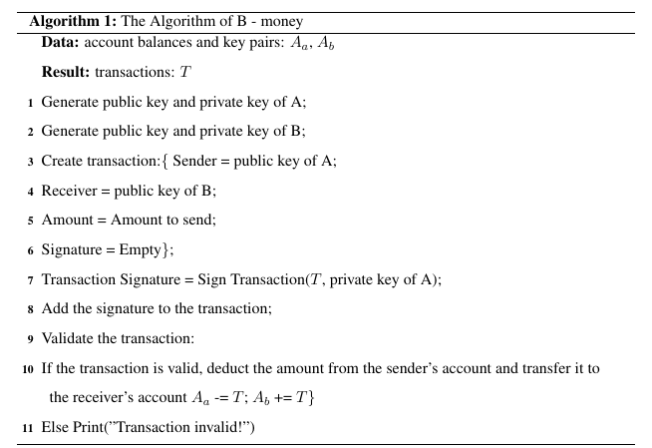In his proposal, Dai outlined a system where transactions would be verified by a network of computers through cryptographic methods. The idea was to create a decentralized form of money that would enable secure and private transactions without the need for a central authority, such as a bank.

**B – Money: Discuss the differences between Bitcoin and B-money**

**Design Philosophy:** B-money aimed to create a decentralized electronic cash system with a focus on anonymity and privacy. Bitcoin, on the other hand, was designed to be a decentralized digital currency with a transparent and publicly verifiable transaction ledger.

**Consensus Mechanism**: B-money did not specify a consensus mechanism for validating transactions, whereas Bitcoin uses a proof-of-work consensus mechanism, where miners compete to solve cryptographic puzzles to add blocks of transactions to the blockchain.

**Blockchain Structure**: Bitcoin utilizes a blockchain structure to record all transactions in a sequential and immutable manner. B-money did not specify the use of a blockchain, although it laid the conceptual groundwork for similar distributed ledger technologies.

**Token Issuance**: In B-money, there was no mechanism for issuing new tokens, while Bitcoin has a predetermined issuance schedule where new bitcoins are created as rewards for miners who successfully validate blocks.

Overall, while B-money laid the conceptual groundwork for decentralized digital currencies, Bitcoin emerged as the first practical implementation of such a system and has since become the dominant cryptocurrency in terms of market capitalization, adoption, and development.