9-4对坐标的曲面积分

1. http://edu-image.nosdn.127.net/D62BA37FDFBCA4629E33561D8B1DC63B.png?imageView&thumbnail=520x520&quality=100

由题，AB直线的参数方程为x=1+t，y=1+2t，z=1+3t；对应的t取值区间为t从0至1。则原式变为==13。

2. http://edu-image.nosdn.127.net/4F772775DE8ED14FBCBBDEAA478A6361.png?imageView&thumbnail=520x520&quality=100

由题，原式=+=+=+ ===

3. http://edu-image.nosdn.127.net/490789DB080137E46DF27D142A3BDD63.png?imageView&thumbnail=520x520&quality=100

原式==== = = ===

4. 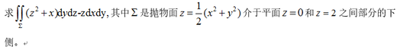

原式========= ==