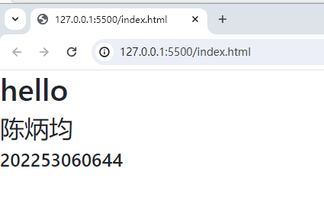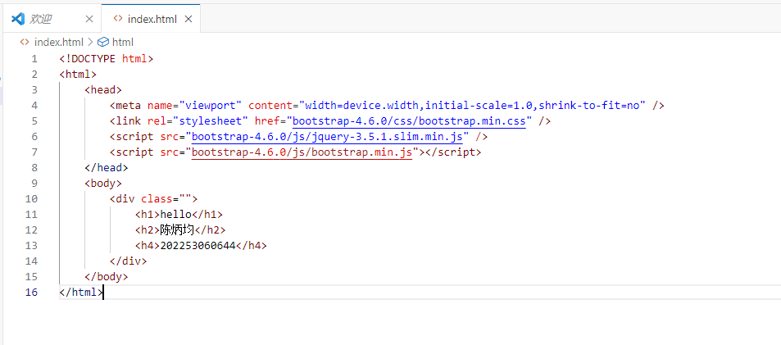

<!DOCTYPE html>

<html>

    <head>

        <meta name="viewport" content="width=device.width,initial-scale=1.0,shrink-to-fit=no" />

        <link rel="stylesheet" href="bootstrap-4.6.0/css/bootstrap.min.css" />

        <script src="bootstrap-4.6.0/js/jquery-3.5.1.slim.min.js" />

        <script src="bootstrap-4.6.0/js/bootstrap.min.js"></script>

    </head>

    <body>

        <div class="">

            <h1>hello</h1>

            <h2>陈炳均</h2>

            <h4>202253060644</h4>

        </div>

    </body>

</html>

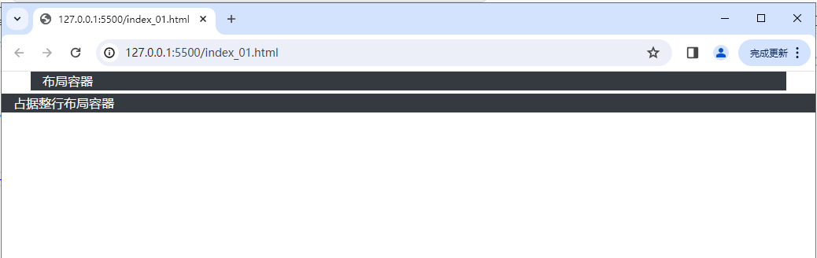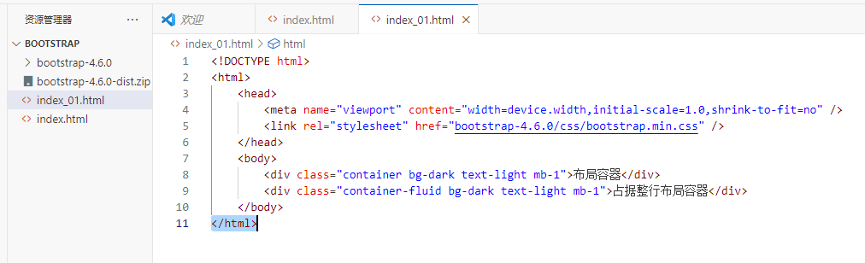

<!DOCTYPE html>

<html>

    <head>

        <meta name="viewport" content="width=device.width,initial-scale=1.0,shrink-to-fit=no" />

        <link rel="stylesheet" href="bootstrap-4.6.0/css/bootstrap.min.css" />

    </head>

    <body>

        <div class="container bg-dark text-light mb-1">布局容器</div>

        <div class="container-fluid bg-dark text-light mb-1">占据整行布局容器</div>

    </body>

</html>