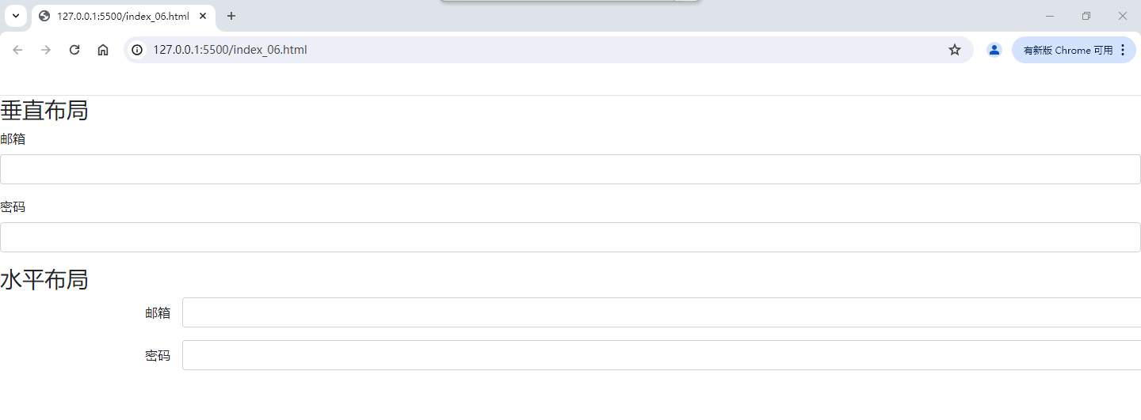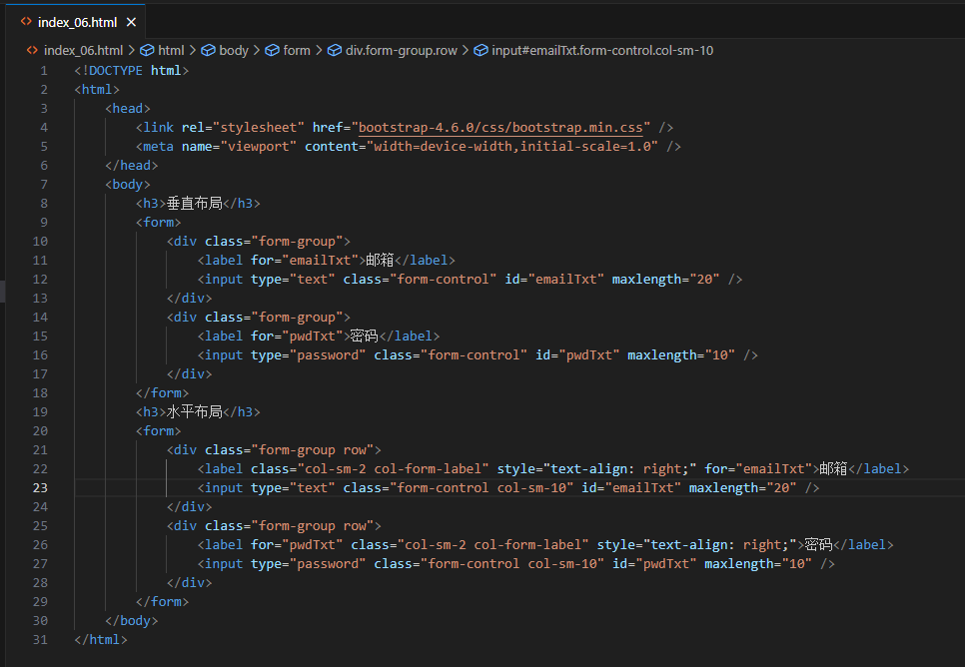

<!DOCTYPE html>

<html>

<head>

<link rel="stylesheet" href="bootstrap-4.6.0/css/bootstrap.min.css" />

<meta name="viewport" content="width=device-width,initial-scale=1.0" />

</head>

<body>

<h3>垂直布局</h3>

<form>

<div class="form-group">

<label for="emailTxt">邮箱</label>

<input type="text" class="form-control" id="emailTxt" maxlength="20" />

</div>

<div class="form-group">

<label for="pwdTxt">密码</label>

<input type="password" class="form-control" id="pwdTxt" maxlength="10" />

</div>

</form>

<h3>水平布局</h3>

<form>

<div class="form-group row">

<label class="col-sm-2 col-form-label" style="text-align: right;" for="emailTxt">邮箱</label>

<input type="text" class="form-control col-sm-10" id="emailTxt" maxlength="20" />

</div>

<div class="form-group row">

<label for="pwdTxt" class="col-sm-2 col-form-label" style="text-align: right;">密码</label>

<input type="password" class="form-control col-sm-10" id="pwdTxt" maxlength="10" />

</div>

</form>

</body>

</html>

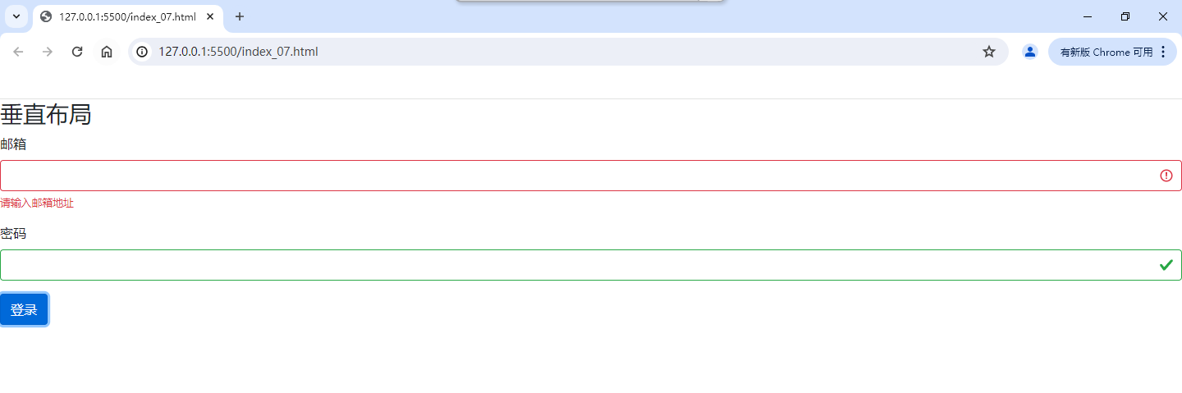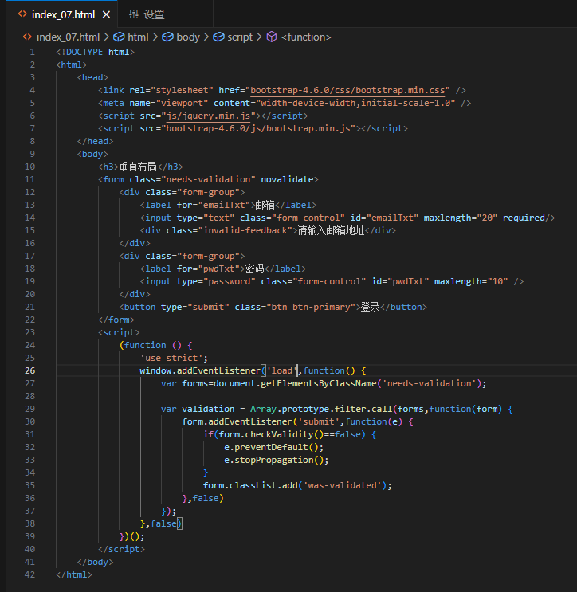

<!DOCTYPE html>

<html>

<head>

<link rel="stylesheet" href="bootstrap-4.6.0/css/bootstrap.min.css" />

<meta name="viewport" content="width=device-width,initial-scale=1.0" />

<script src="js/jquery.min.js"></script>

<script src="bootstrap-4.6.0/js/bootstrap.min.js"></script>

</head>

<body>

<h3>垂直布局</h3>

<form class="needs-validation" novalidate>

<div class="form-group">

<label for="emailTxt">邮箱</label>

<input type="text" class="form-control" id="emailTxt" maxlength="20" required/>

<div class="invalid-feedback">请输入邮箱地址</div>

</div>

<div class="form-group">

<label for="pwdTxt">密码</label>

<input type="password" class="form-control" id="pwdTxt" maxlength="10" />

</div>

<button type="submit" class="btn btn-primary">登录</button>

</form>

<script>

(function () {

'use strict';

window.addEventListener('load',function() {

var forms=document.getElementsByClassName('needs-validation');

var validation = Array.prototype.filter.call(forms,function(form) {

form.addEventListener('submit',function(e) {

if(form.checkValidity()==false) {

e.preventDefault();

e.stopPropagation();

}

form.classList.add('was-validated');

},false)

});

},false)

})();

</script>

</body>

</html>

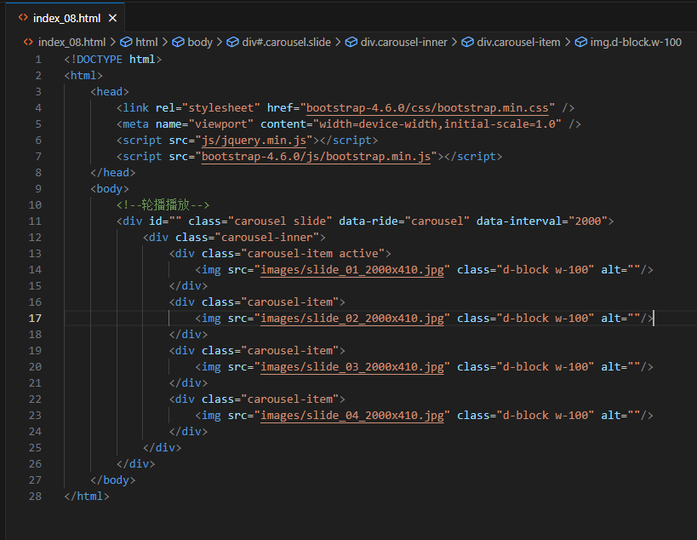

<!DOCTYPE html>

<html>

<head>

<link rel="stylesheet" href="bootstrap-4.6.0/css/bootstrap.min.css" />

<meta name="viewport" content="width=device-width,initial-scale=1.0" />

<script src="js/jquery.min.js"></script>

<script src="bootstrap-4.6.0/js/bootstrap.min.js"></script>

</head>

<body>

<!--轮播播放-->

<div id="" class="carousel slide" data-ride="carousel" data-interval="2000">

<div class="carousel-inner">

<div class="carousel-item active">

<img src="images/slide_01_2000x410.jpg" class="d-block w-100" alt=""/>

</div>

<div class="carousel-item">

<img src="images/slide_02_2000x410.jpg" class="d-block w-100" alt=""/>

</div>

<div class="carousel-item">

<img src="images/slide_03_2000x410.jpg" class="d-block w-100" alt=""/>

</div>

<div class="carousel-item">

<img src="images/slide_04_2000x410.jpg" class="d-block w-100" alt=""/>

</div>

</div>

</div>

</body>

</html>

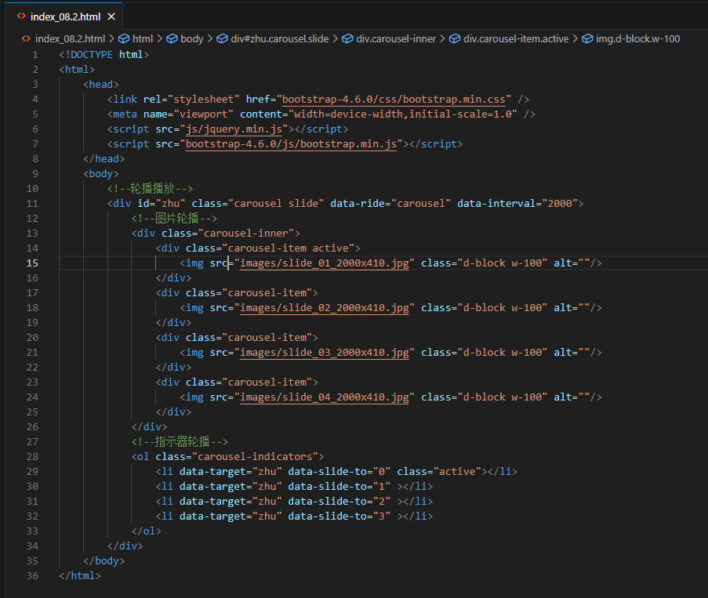

<!DOCTYPE html>

<html>

<head>

<link rel="stylesheet" href="bootstrap-4.6.0/css/bootstrap.min.css" />

<meta name="viewport" content="width=device-width,initial-scale=1.0" />

<script src="js/jquery.min.js"></script>

<script src="bootstrap-4.6.0/js/bootstrap.min.js"></script>

</head>

<body>

<!--轮播播放-->

<div id="zhu" class="carousel slide" data-ride="carousel" data-interval="2000">

<!--图片轮播-->

<div class="carousel-inner">

<div class="carousel-item active">

<img src="images/slide_01_2000x410.jpg" class="d-block w-100" alt=""/>

</div>

<div class="carousel-item">

<img src="images/slide_02_2000x410.jpg" class="d-block w-100" alt=""/>

</div>

<div class="carousel-item">

<img src="images/slide_03_2000x410.jpg" class="d-block w-100" alt=""/>

</div>

<div class="carousel-item">

<img src="images/slide_04_2000x410.jpg" class="d-block w-100" alt=""/>

</div>

</div>

<!--指示器轮播-->

<ol class="carousel-indicators">

<li data-target="zhu" data-slide-to="0" class="active"></li>

<li data-target="zhu" data-slide-to="1" ></li>

<li data-target="zhu" data-slide-to="2" ></li>

<li data-target="zhu" data-slide-to="3" ></li>

</ol>

</div>

</body>

</html>

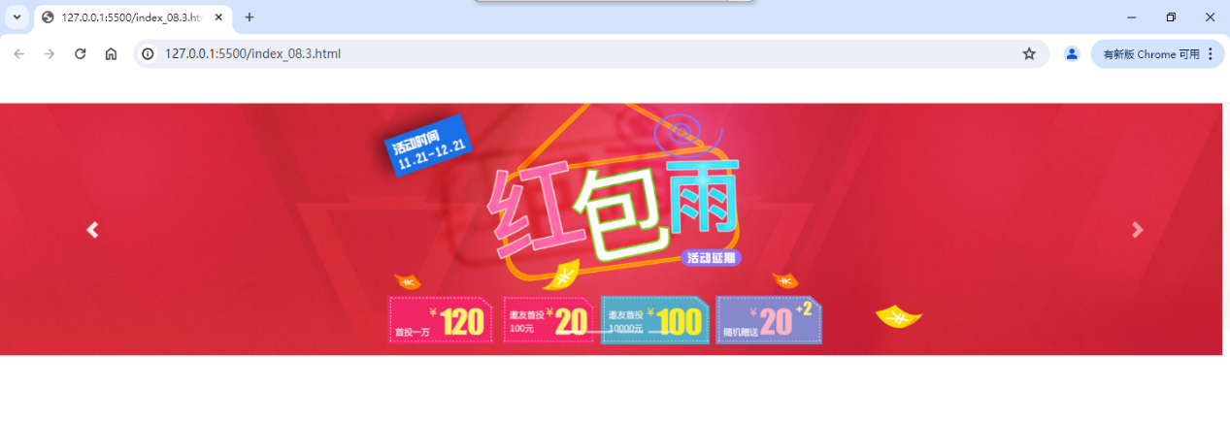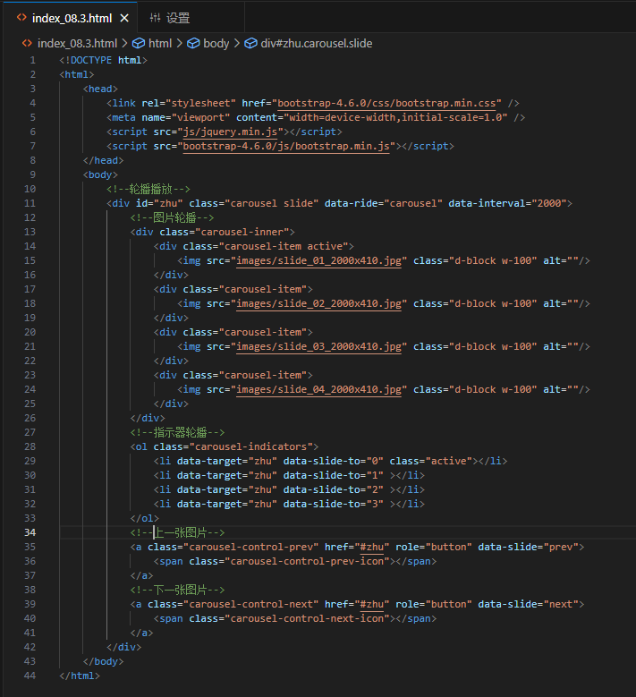

<!DOCTYPE html>

<html>

<head>

<link rel="stylesheet" href="bootstrap-4.6.0/css/bootstrap.min.css" />

<meta name="viewport" content="width=device-width,initial-scale=1.0" />

<script src="js/jquery.min.js"></script>

<script src="bootstrap-4.6.0/js/bootstrap.min.js"></script>

</head>

<body>

<!--轮播播放-->

<div id="zhu" class="carousel slide" data-ride="carousel" data-interval="2000">

<!--图片轮播-->

<div class="carousel-inner">

<div class="carousel-item active">

<img src="images/slide_01_2000x410.jpg" class="d-block w-100" alt=""/>

</div>

<div class="carousel-item">

<img src="images/slide_02_2000x410.jpg" class="d-block w-100" alt=""/>

</div>

<div class="carousel-item">

<img src="images/slide_03_2000x410.jpg" class="d-block w-100" alt=""/>

</div>

<div class="carousel-item">

<img src="images/slide_04_2000x410.jpg" class="d-block w-100" alt=""/>

</div>

</div>

<!--指示器轮播-->

<ol class="carousel-indicators">

<li data-target="zhu" data-slide-to="0" class="active"></li>

<li data-target="zhu" data-slide-to="1" ></li>

<li data-target="zhu" data-slide-to="2" ></li>

<li data-target="zhu" data-slide-to="3" ></li>

</ol>

<!--上一张图片-->

<a class="carousel-control-prev" href="#zhu" role="button" data-slide="prev">

<span class="carousel-control-prev-icon"></span>

</a>

<!--下一张图片-->

<a class="carousel-control-next" href="#zhu" role="button" data-slide="next">

<span class="carousel-control-next-icon"></span>

</a>

</div>

</body>

</html>