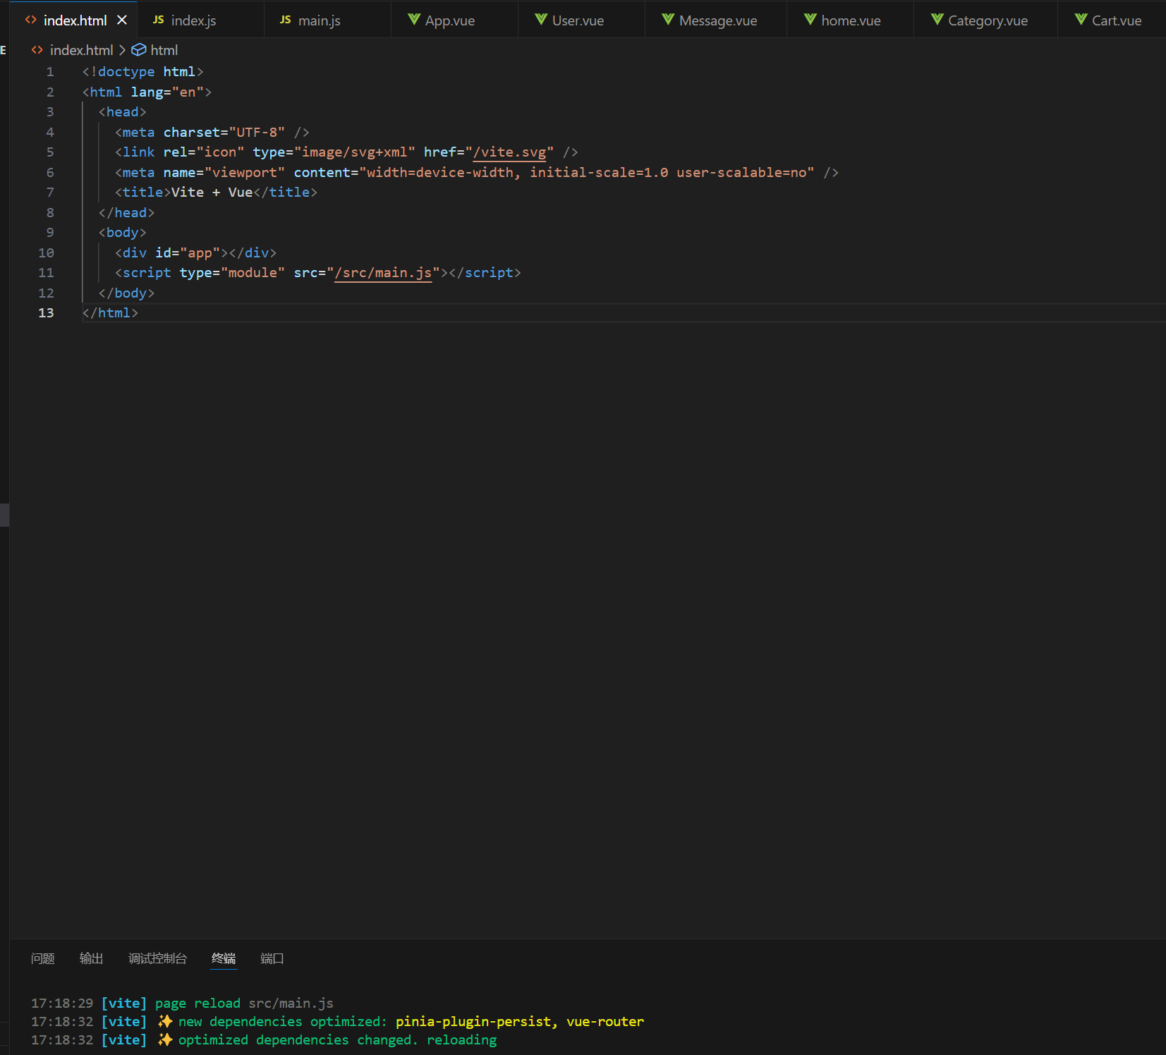

Index.html

<!doctype html>

<html lang="en">

  <head>

    <meta charset="UTF-8" />

    <link rel="icon" type="image/svg+xml" href="/vite.svg" />

    <meta name="viewport" content="width=device-width, initial-scale=1.0 user-scalable=no" />

    <title>Vite + Vue</title>

  </head>

  <body>

    <div id="app"></div>

    <script type="module" src="/src/main.js"></script>

  </body>

</html>

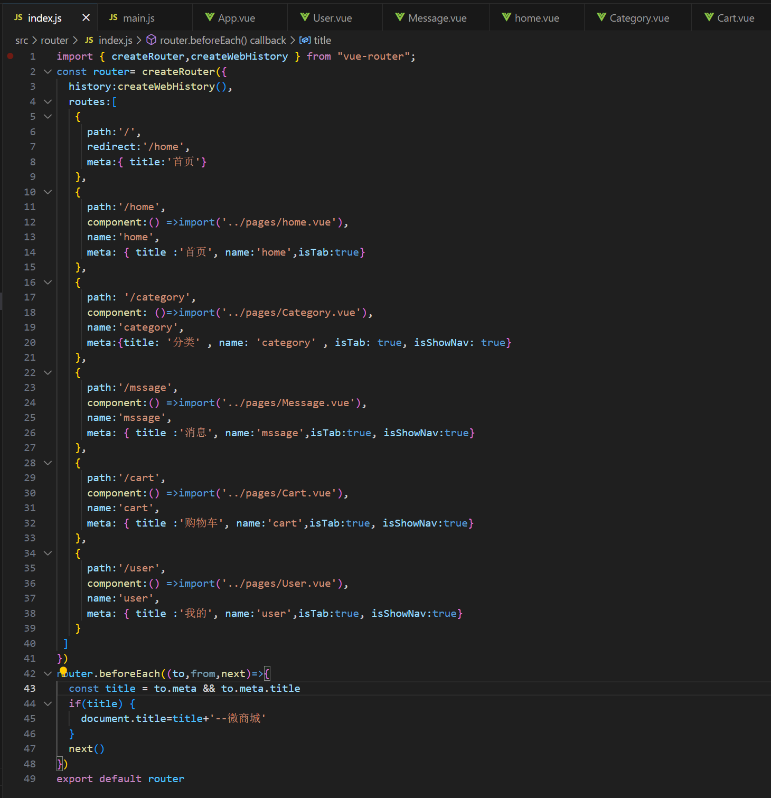

Index.js

import { createRouter,createWebHistory } from "vue-router";

const router= createRouter({

history:createWebHistory(),

routes:[

{

path:'/',

redirect:'/home',

meta:{ title:'首页'}

},

{

path:'/home',

component:() =>import('../pages/home.vue'),

name:'home',

meta: { title :'首页', name:'home',isTab:true}

},

{

path: '/category',

component: ()=>import('../pages/Category.vue'),

name:'category',

meta:{title: '分类' , name: 'category' , isTab: true, isShowNav: true}

},

{

path:'/mssage',

component:() =>import('../pages/Message.vue'),

name:'mssage',

meta: { title :'消息', name:'mssage',isTab:true, isShowNav:true}

},

{

path:'/cart',

component:() =>import('../pages/Cart.vue'),

name:'cart',

meta: { title :'购物车', name:'cart',isTab:true, isShowNav:true}

},

{

path:'/user',

component:() =>import('../pages/User.vue'),

name:'user',

meta: { title :'我的', name:'user',isTab:true, isShowNav:true}

}

]

})

router.beforeEach((to,from,next)=>{

const title = to.meta && to.meta.title

if(title) {

document.title=title+'--微商城'

}

next()

})

export default router

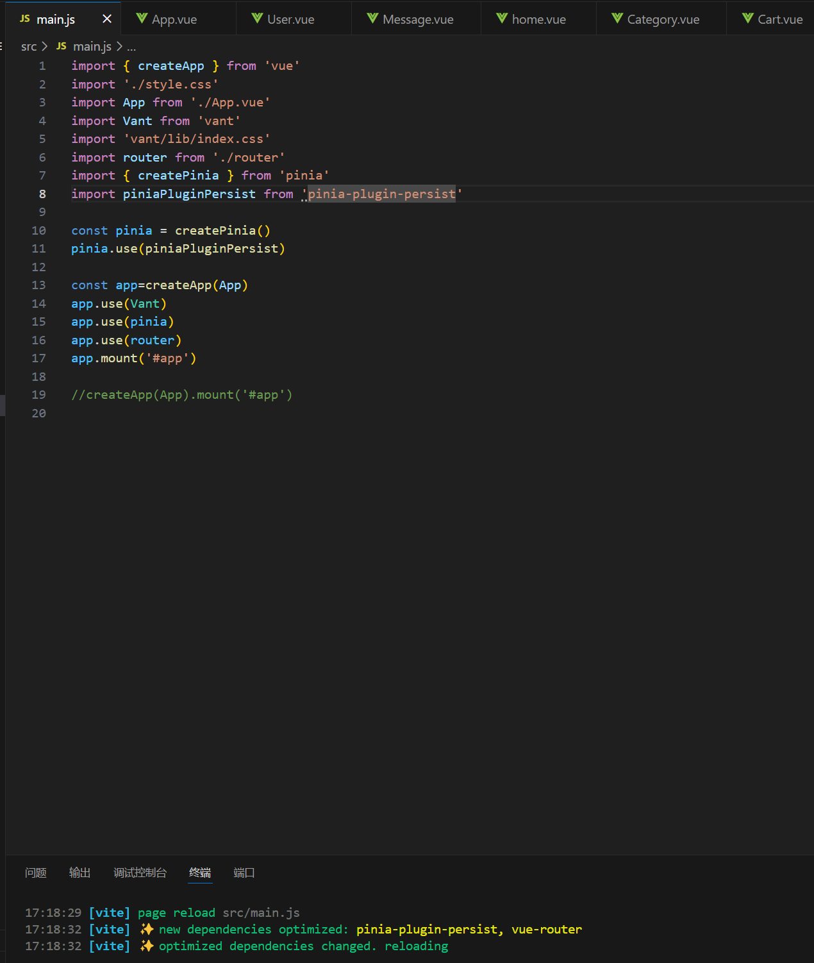

Main.js

import { createApp } from 'vue'

import './style.css'

import App from './App.vue'

import Vant from 'vant'

import 'vant/lib/index.css'

import router from './router'

import { createPinia } from 'pinia'

import piniaPluginPersist from 'pinia-plugin-persist'

const pinia = createPinia()

pinia.use(piniaPluginPersist)

const app=createApp(App)

app.use(Vant)

app.use(pinia)

app.use(router)

app.mount('#app')

//createApp(App).mount('#app')

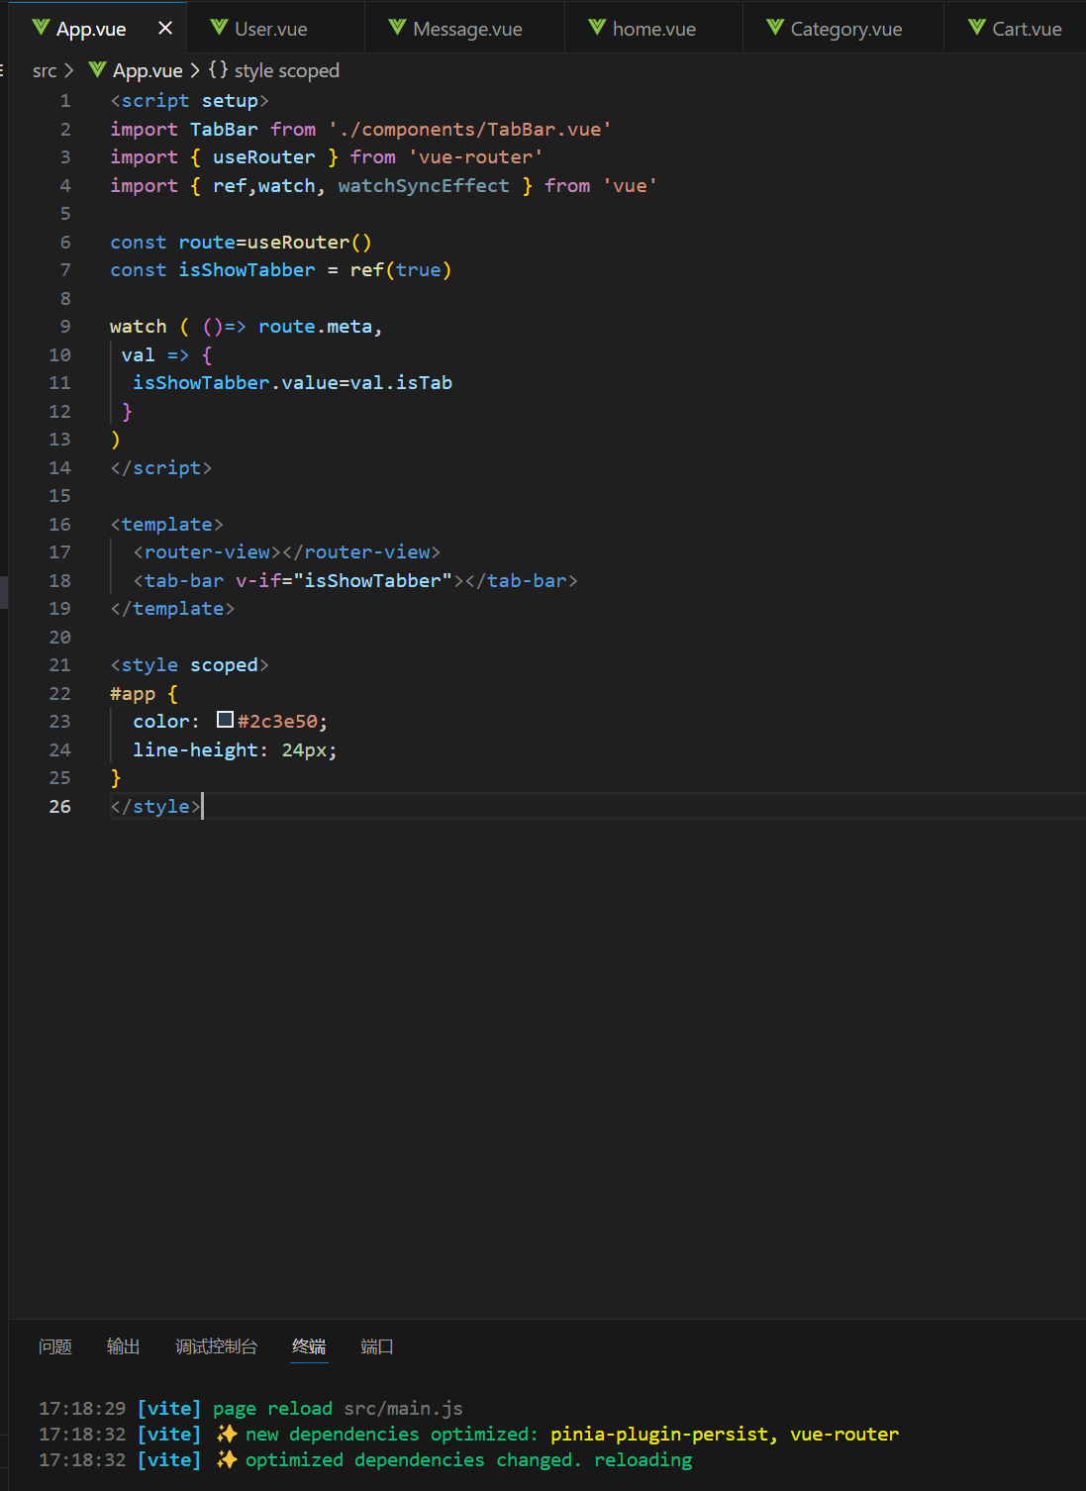

App.vue

<script setup>

import TabBar from './components/TabBar.vue'

import { useRouter } from 'vue-router'

import { ref,watch, watchSyncEffect } from 'vue'

const route=useRouter()

const isShowTabber = ref(true)

watch ( ()=> route.meta,

 val => {

  isShowTabber.value=val.isTab

 }

)

</script>

<template>

  <router-view></router-view>

  <tab-bar v-if="isShowTabber"></tab-bar>

</template>

<style scoped>

#app {

  color: #2c3e50;

  line-height: 24px;

}

</style>

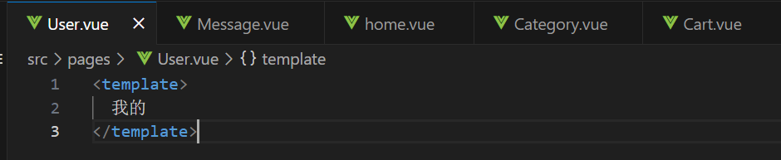

User.vue

<template>

  我的

</template>

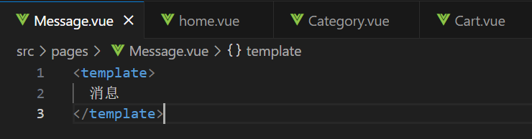

Message.vue

<template>

  消息

</template>

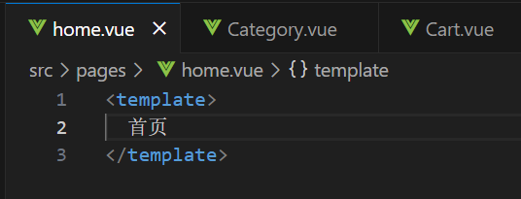

Home.vue

<template>

首页

</template>

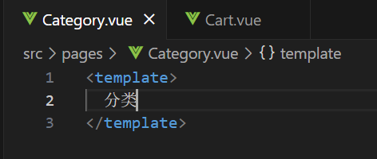

Category.vue

<template>

分类

</template>

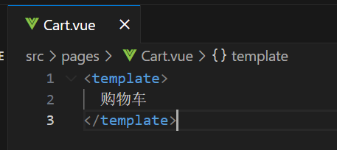

Cart.vue

<template>

  购物车

</template>

