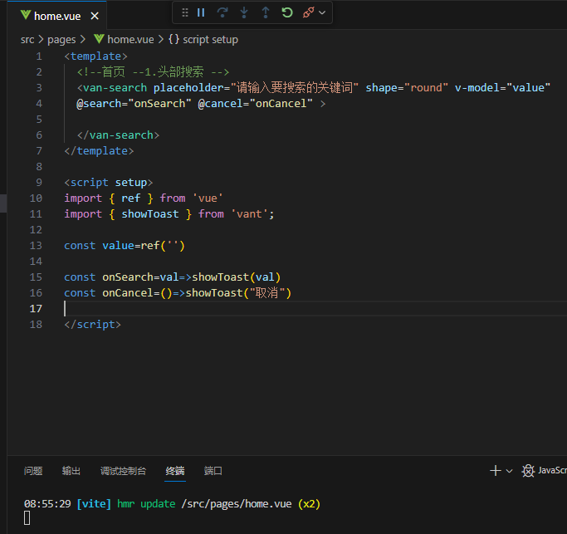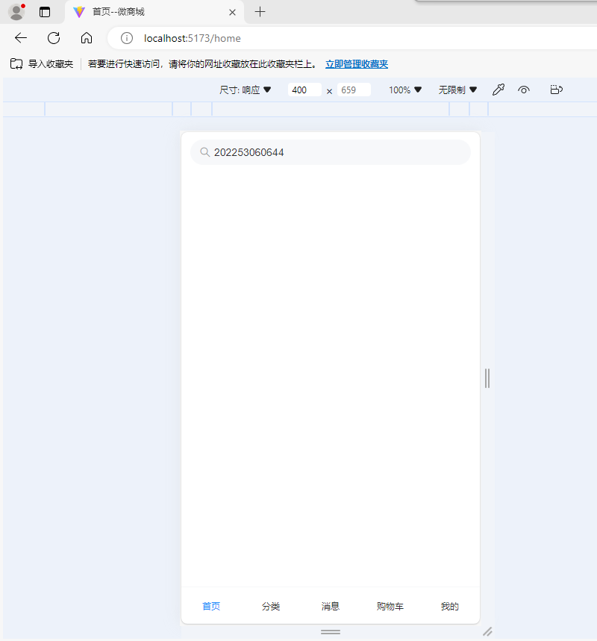

Home.vue

<template>

  <!--首页 --1.头部搜索 -->

  <van-search placeholder="请输入要搜索的关键词" shape="round" v-model="value"

  @search="onSearch" @cancel="onCancel" >

  </van-search>

</template>

<script setup>

import { ref } from 'vue'

import { showToast } from 'vant';

const value=ref('')

const onSearch=val=>showToast(val)

const onCancel=()=>showToast("取消")

</script>

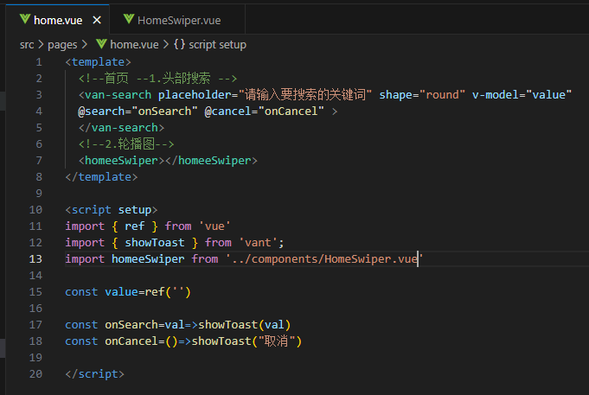

Home.vue

<template>

  <!--首页 --1.头部搜索 -->

  <van-search placeholder="请输入要搜索的关键词" shape="round" v-model="value"

  @search="onSearch" @cancel="onCancel" >

  </van-search>

  <!--2.轮播图-->

  <homeeSwiper></homeeSwiper>

</template>

<script setup>

import { ref } from 'vue'

import { showToast } from 'vant';

import homeeSwiper from '../components/HomeSwiper.vue'

const value=ref('')

const onSearch=val=>showToast(val)

const onCancel=()=>showToast("取消")

</script>

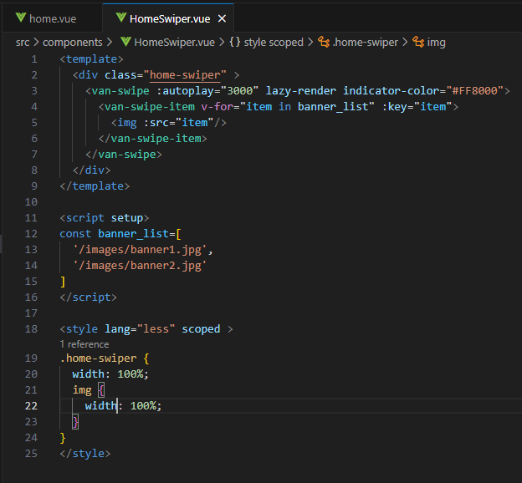

HomeSwiper.vue

<template>

  <div class="home-swiper" >

    <van-swipe :autoplay="3000" lazy-render indicator-color="#FF8000">

      <van-swipe-item v-for="item in banner_list" :key="item">

        <img :src="item"/>

      </van-swipe-item>

    </van-swipe>

  </div>

</template>

<script setup>

const banner_list=[

  '/images/banner1.jpg',

  '/images/banner2.jpg'

]

</script>

<style lang="less" scoped >

.home-swiper {

  width: 100%;

  img {

    width: 100%;

  }

}

</style>

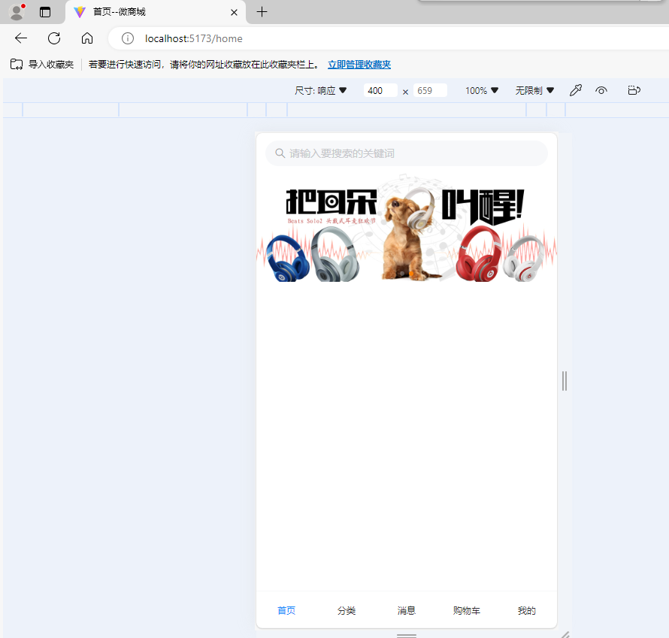

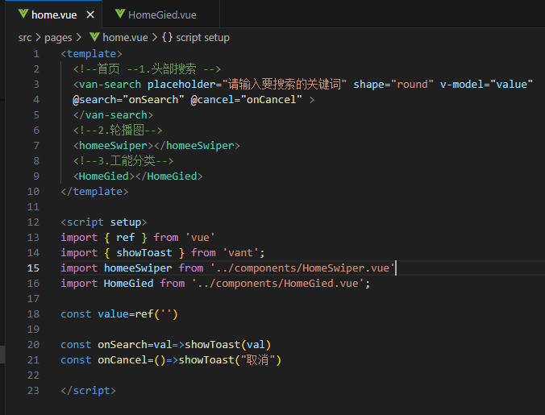

Home.vue

<template>

  <!--首页 --1.头部搜索 -->

  <van-search placeholder="请输入要搜索的关键词" shape="round" v-model="value"

  @search="onSearch" @cancel="onCancel" >

  </van-search>

  <!--2.轮播图-->

  <homeeSwiper></homeeSwiper>

  <!--3.工能分类-->

  <HomeGied></HomeGied>

</template>

<script setup>

import { ref } from 'vue'

import { showToast } from 'vant';

import homeeSwiper from '../components/HomeSwiper.vue'

import HomeGied from '../components/HomeGied.vue';

const value=ref('')

const onSearch=val=>showToast(val)

const onCancel=()=>showToast("取消")

</script>

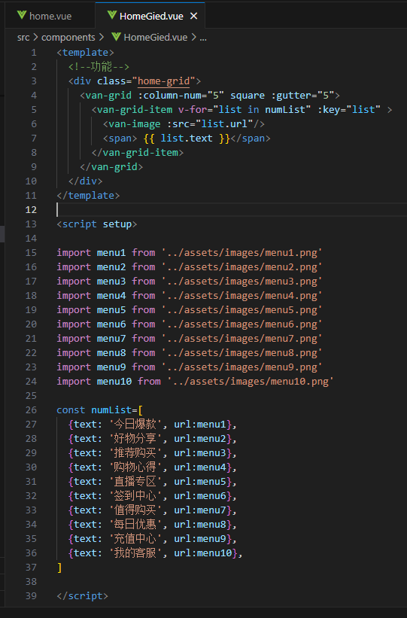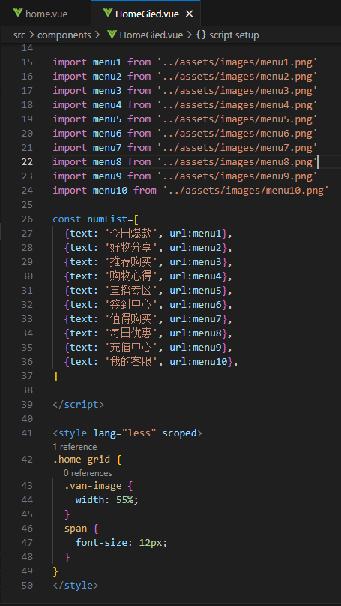

HomeGied.vue

<template>

  <!--功能-->

  <div class="home-grid">

    <van-grid :column-num="5" square :gutter="5">

      <van-grid-item v-for="list in numList" :key="list" >

        <van-image :src="list.url"/>

        <span> {{ list.text }}</span>

      </van-grid-item>

    </van-grid>

  </div>

</template>

<script setup>

import menu1 from '../assets/images/menu1.png'

import menu2 from '../assets/images/menu2.png'

import menu3 from '../assets/images/menu3.png'

import menu4 from '../assets/images/menu4.png'

import menu5 from '../assets/images/menu5.png'

import menu6 from '../assets/images/menu6.png'

import menu7 from '../assets/images/menu7.png'

import menu8 from '../assets/images/menu8.png'

import menu9 from '../assets/images/menu9.png'

import menu10 from '../assets/images/menu10.png'

const numList=[

  {text: '今日爆款', url:menu1},

  {text: '好物分享', url:menu2},

  {text: '推荐购买', url:menu3},

  {text: '购物心得', url:menu4},

  {text: '直播专区', url:menu5},

  {text: '签到中心', url:menu6},

  {text: '值得购买', url:menu7},

  {text: '每日优惠', url:menu8},

  {text: '充值中心', url:menu9},

  {text: '我的客服', url:menu10},

]

</script>

<style lang="less" scoped>

.home-grid {

  .van-image {

    width: 55%;

  }

  span {

    font-size: 12px;

  }

}

</style>

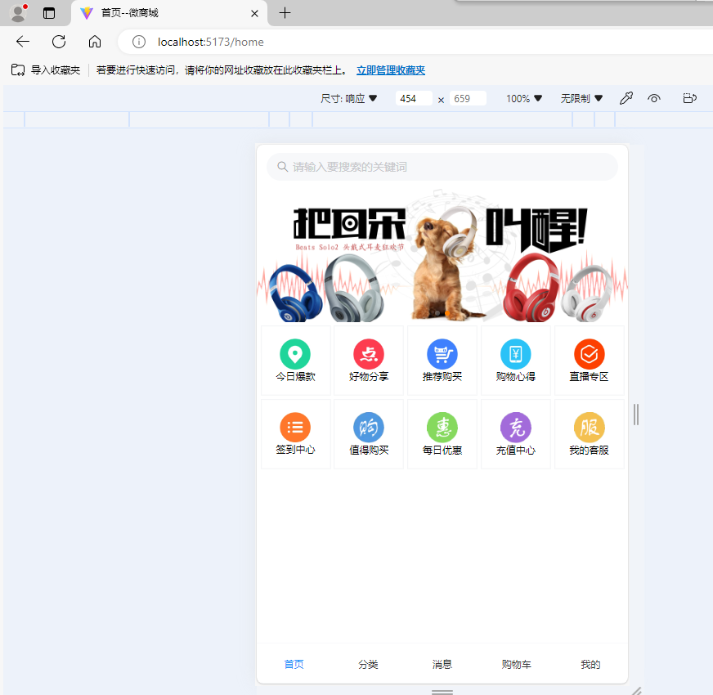

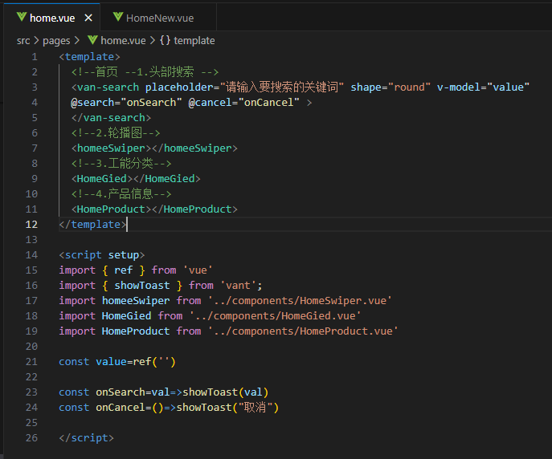

Home.vue

<template>

  <!--首页 --1.头部搜索 -->

  <van-search placeholder="请输入要搜索的关键词" shape="round" v-model="value"

  @search="onSearch" @cancel="onCancel" >

  </van-search>

  <!--2.轮播图-->

  <homeeSwiper></homeeSwiper>

  <!--3.工能分类-->

  <HomeGied></HomeGied>

  <!--4.产品信息-->

  <HomeProduct></HomeProduct>

</template>

<script setup>

import { ref } from 'vue'

import { showToast } from 'vant';

import homeeSwiper from '../components/HomeSwiper.vue'

import HomeGied from '../components/HomeGied.vue'

import HomeProduct from '../components/HomeProduct.vue'

const value=ref('')

const onSearch=val=>showToast(val)

const onCancel=()=>showToast("取消")

</script>

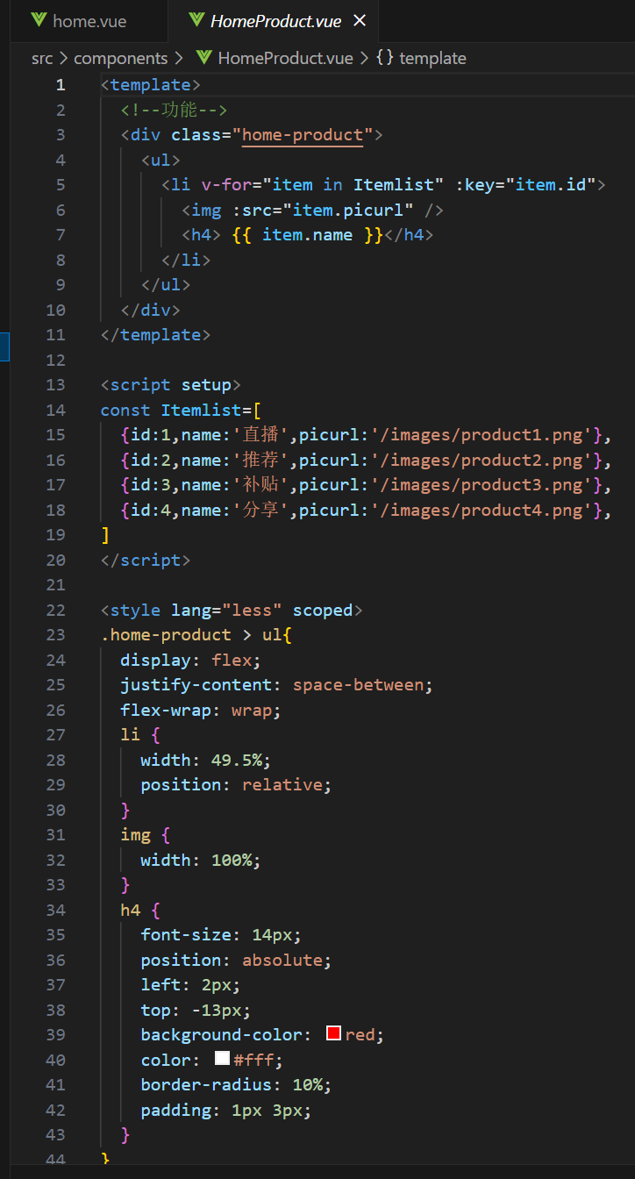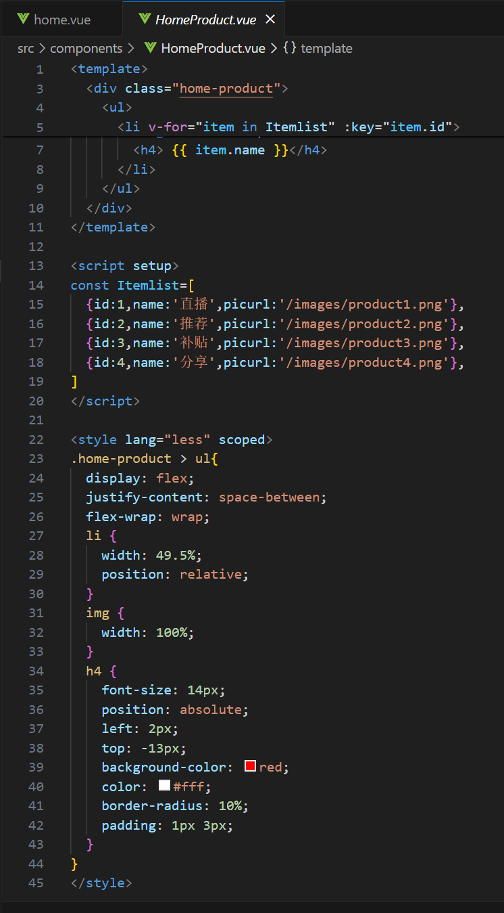

HomeProduct.vue

<template>

  <!--功能-->

  <div class="home-product">

    <ul>

      <li v-for="item in Itemlist" :key="item.id">

        <img :src="item.picurl" />

        <h4> {{ item.name }}</h4>

      </li>

    </ul>

  </div>

</template>

<script setup>

const Itemlist=[

  {id:1,name:'直播',picurl:'/images/product1.png'},

  {id:2,name:'推荐',picurl:'/images/product2.png'},

  {id:3,name:'补贴',picurl:'/images/product3.png'},

  {id:4,name:'分享',picurl:'/images/product4.png'},

]

</script>

<style lang="less" scoped>

.home-product > ul{

  display: flex;

  justify-content: space-between;

  flex-wrap: wrap;

  li {

    width: 49.5%;

    position: relative;

  }

  img {

    width: 100%;

  }

  h4 {

    font-size: 14px;

    position: absolute;

    left: 2px;

    top: -13px;

    background-color: red;

    color: #fff;

    border-radius: 10%;

    padding: 1px 3px;

  }

}

</style>

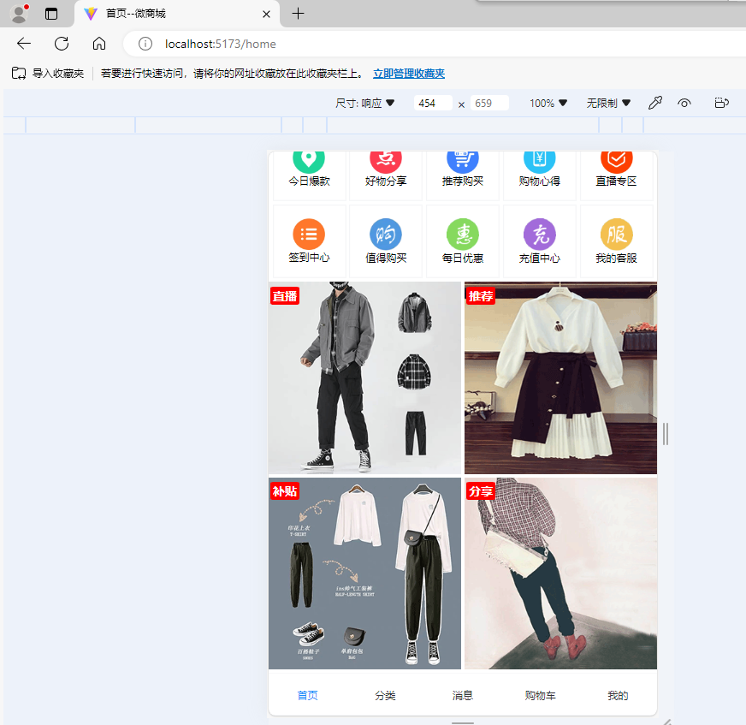

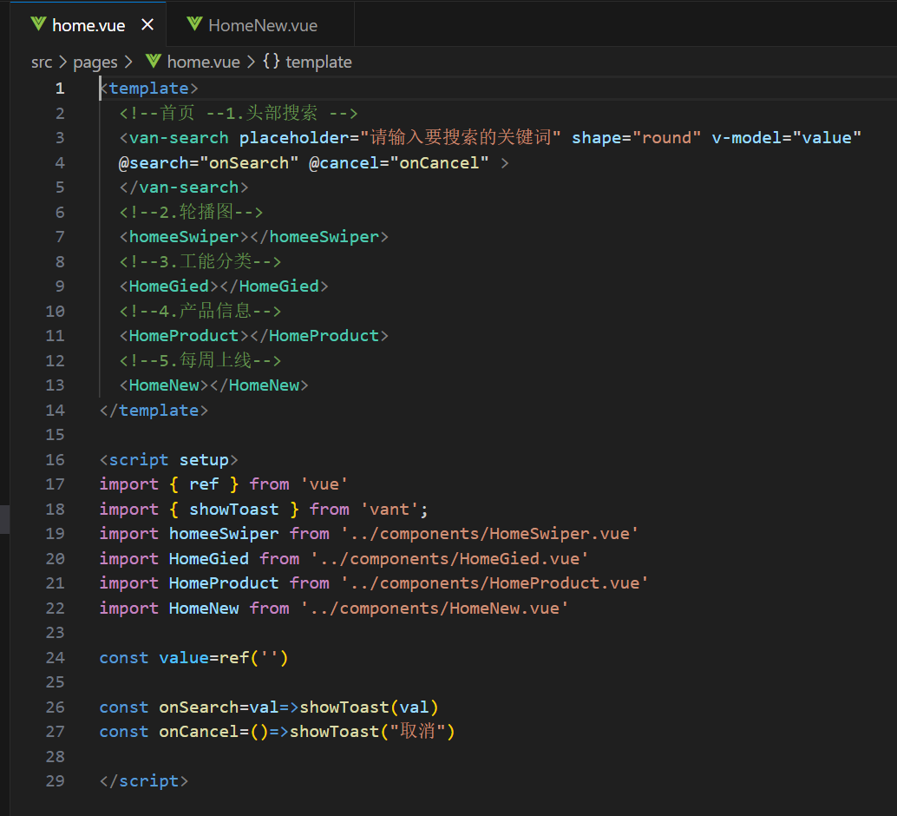

Home.vue

<template>

  <!--首页 --1.头部搜索 -->

  <van-search placeholder="请输入要搜索的关键词" shape="round" v-model="value"

  @search="onSearch" @cancel="onCancel" >

  </van-search>

  <!--2.轮播图-->

  <homeeSwiper></homeeSwiper>

  <!--3.工能分类-->

  <HomeGied></HomeGied>

  <!--4.产品信息-->

  <HomeProduct></HomeProduct>

  <!--5.每周上线-->

  <HomeNew></HomeNew>

</template>

<script setup>

import { ref } from 'vue'

import { showToast } from 'vant';

import homeeSwiper from '../components/HomeSwiper.vue'

import HomeGied from '../components/HomeGied.vue'

import HomeProduct from '../components/HomeProduct.vue'

import HomeNew from '../components/HomeNew.vue'

const value=ref('')

const onSearch=val=>showToast(val)

const onCancel=()=>showToast("取消")

</script>

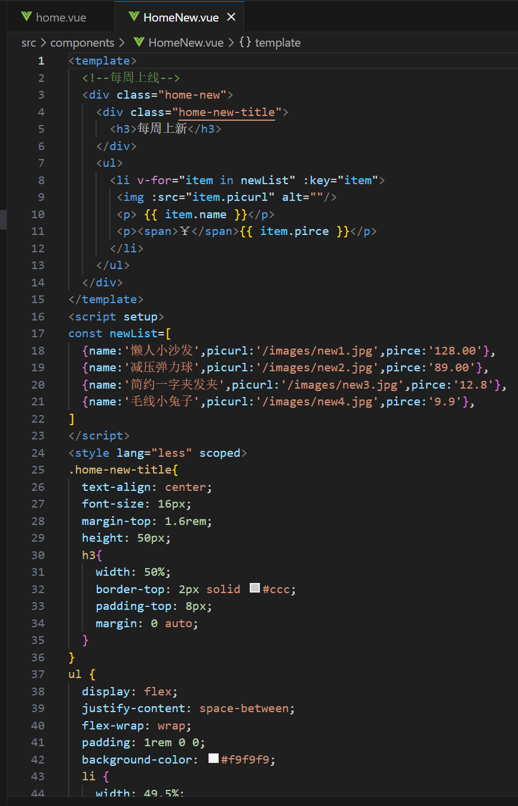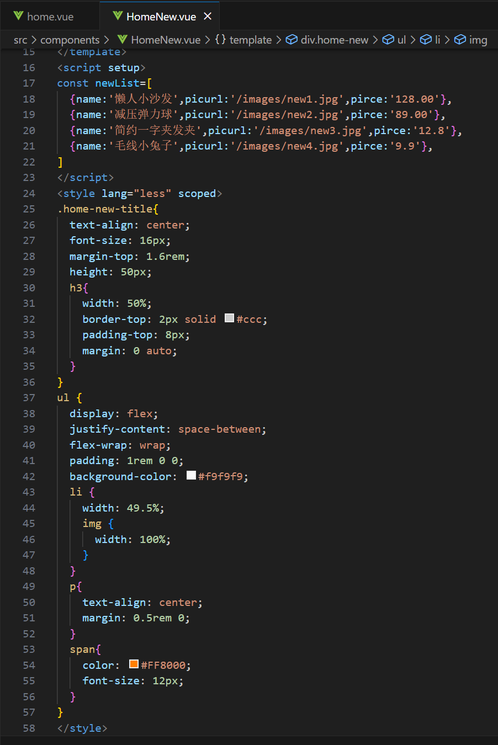

HomeNew.vue

<template>

  <!--每周上线-->

  <div class="home-new">

    <div class="home-new-title">

      <h3>每周上新</h3>

    </div>

    <ul>

      <li v-for="item in newList" :key="item">

       <img :src="item.picurl" alt=""/>

       <p> {{ item.name }}</p>

       <p><span>￥</span>{{ item.pirce }}</p>

      </li>

    </ul>

  </div>

</template>

<script setup>

const newList=[

  {name:'懒人小沙发',picurl:'/images/new1.jpg',pirce:'128.00'},

  {name:'减压弹力球',picurl:'/images/new2.jpg',pirce:'89.00'},

  {name:'简约一字夹发夹',picurl:'/images/new3.jpg',pirce:'12.8'},

  {name:'毛线小兔子',picurl:'/images/new4.jpg',pirce:'9.9'},

]

</script>

<style lang="less" scoped>

.home-new-title{

  text-align: center;

  font-size: 16px;

  margin-top: 1.6rem;

  height: 50px;

  h3{

    width: 50%;

    border-top: 2px solid #ccc;

    padding-top: 8px;

    margin: 0 auto;

  }

}

ul {

  display: flex;

  justify-content: space-between;

  flex-wrap: wrap;

  padding: 1rem 0 0;

  background-color: #f9f9f9;

  li {

    width: 49.5%;

    img {

      width: 100%;

    }

  }

  p{

    text-align: center;

    margin: 0.5rem 0;

  }

  span{

    color: #FF8000;

    font-size: 12px;

  }

}

</style>

