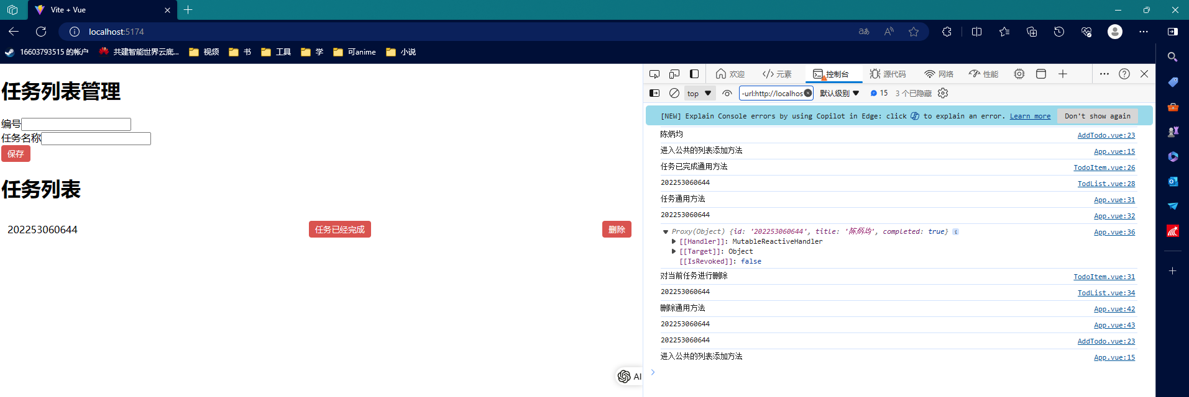

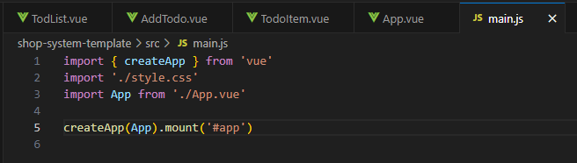

Mian.js

import { createApp } from 'vue'

import './style.css'

import App from './App.vue'

createApp(App).mount('#app')

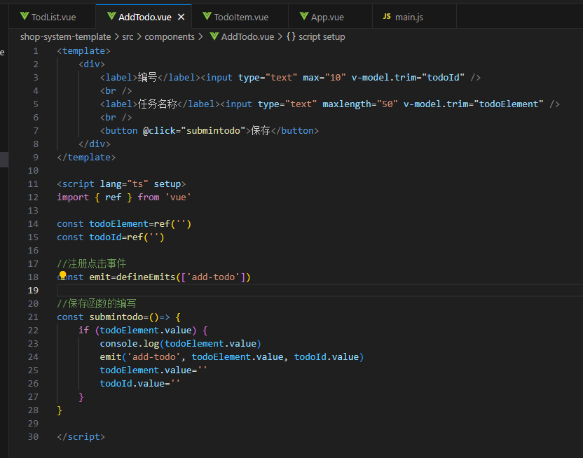

AddTodo.vue

<template>

    <div>

        <label>编号</label><input type="text" max="10" v-model.trim="todoId" />

        <br />

        <label>任务名称</label><input type="text" maxlength="50" v-model.trim="todoElement" />

        <br />

        <button @click="submintodo">保存</button>

    </div>

</template>

<script lang="ts" setup>

import { ref } from 'vue'

const todoElement=ref('')

const todoId=ref('')

//注册点击事件

const emit=defineEmits(['add-todo'])

//保存函数的编写

const submintodo=()=> {

    if (todoElement.value) {

        console.log(todoElement.value)

        emit('add-todo', todoElement.value, todoId.value)

        todoElement.value=''

        todoId.value=''

    }

}

</script>

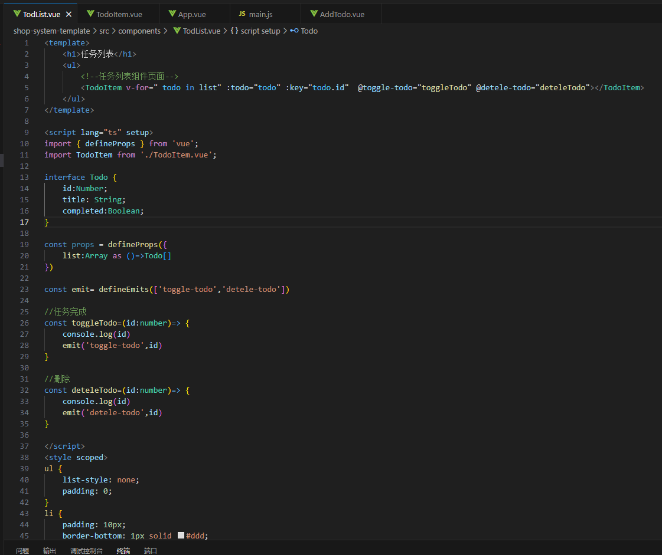

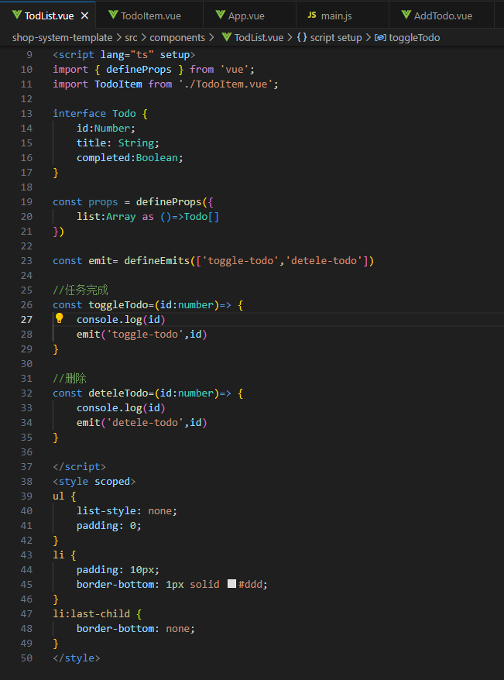

TodList.vue

<template>

    <h1>任务列表</h1>

    <ul>

        <!--任务列表组件页面-->

        <TodoItem v-for=" todo in list" :todo="todo" :key="todo.id"  @toggle-todo="toggleTodo" @detele-todo="deteleTodo"></TodoItem>

    </ul>

</template>

<script lang="ts" setup>

import { defineProps } from 'vue';

import TodoItem from './TodoItem.vue';

interface Todo {

    id:Number;

    title: String;

    completed:Boolean;

}

const props = defineProps({

    list:Array as ()=>Todo[]

})

const emit= defineEmits(['toggle-todo','detele-todo'])

//任务完成

const toggleTodo=(id:number)=> {

    console.log(id)

    emit('toggle-todo',id)

}

//删除

const deteleTodo=(id:number)=> {

    console.log(id)

    emit('detele-todo',id)

}

</script>

<style scoped>

ul {

    list-style: none;

    padding: 0;

}

li {

    padding: 10px;

    border-bottom: 1px solid #ddd;

}

li:last-child {

    border-bottom: none;

}

</style>

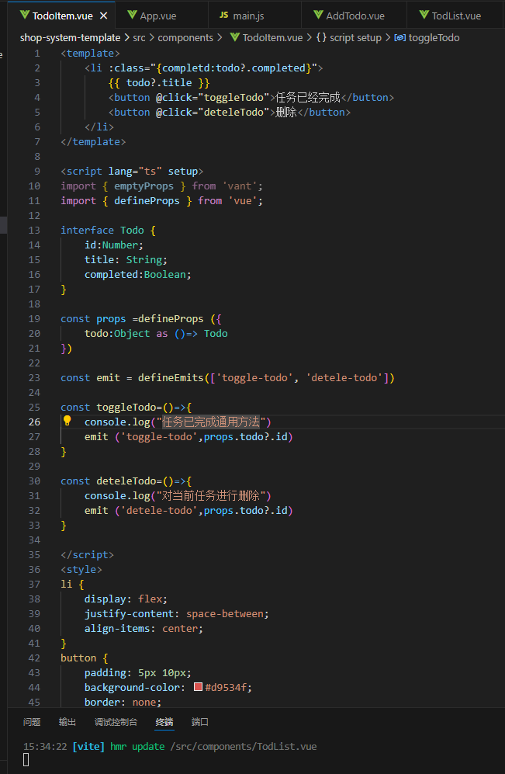

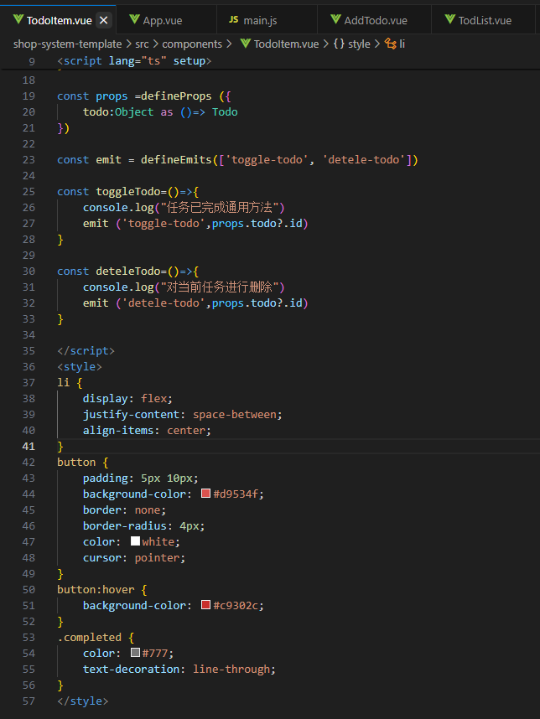

TodoItem.vue

<template>

    <li :class="{completd:todo?.completed}">

        {{ todo?.title }}

        <button @click="toggleTodo">任务已经完成</button>

        <button @click="deteleTodo">删除</button>

    </li>

</template>

<script lang="ts" setup>

import { emptyProps } from 'vant';

import { defineProps } from 'vue';

interface Todo {

    id:Number;

    title: String;

    completed:Boolean;

}

const props =defineProps ({

    todo:Object as ()=> Todo

})

const emit = defineEmits(['toggle-todo', 'detele-todo'])

const toggleTodo=()=>{

    console.log("任务已完成通用方法")

    emit ('toggle-todo',props.todo?.id)

}

const deteleTodo=()=>{

    console.log("对当前任务进行删除")

    emit ('detele-todo',props.todo?.id)

}

</script>

<style>

li {

    display: flex;

    justify-content: space-between;

    align-items: center;

}

button {

    padding: 5px 10px;

    background-color: #d9534f;

    border: none;

    border-radius: 4px;

    color: white;

    cursor: pointer;

}

button:hover {

    background-color: #c9302c;

}

.completed {

    color: #777;

    text-decoration: line-through;

}

</style>

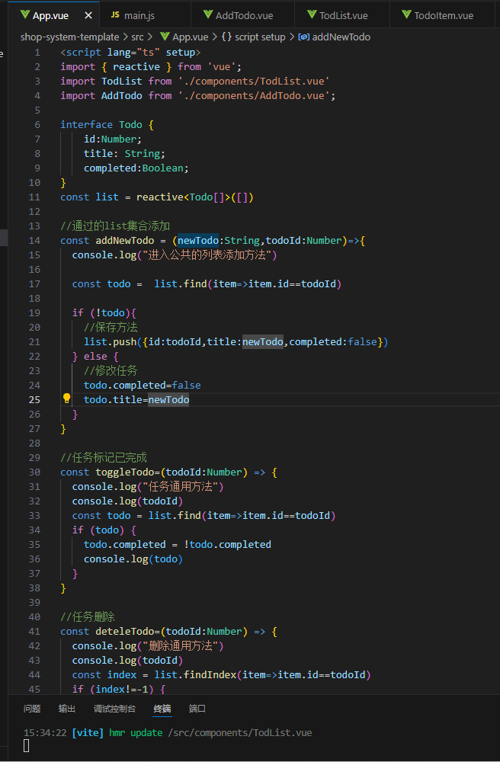

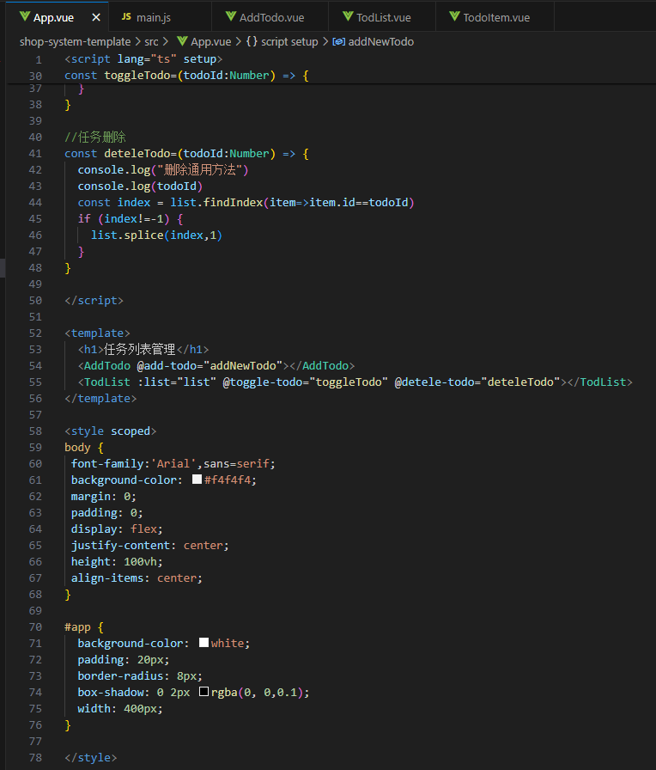

App.vue

<script lang="ts" setup>

import { reactive } from 'vue';

import TodList from './components/TodList.vue'

import AddTodo from './components/AddTodo.vue';

interface Todo {

    id:Number;

    title: String;

    completed:Boolean;

}

const list = reactive<Todo[]>([])

//通过的list集合添加

const addNewTodo = (newTodo:String,todoId:Number)=>{

  console.log("进入公共的列表添加方法")

  const todo =  list.find(item=>item.id==todoId)

  if (!todo){

    //保存方法

    list.push({id:todoId,title:newTodo,completed:false})

  } else {

    //修改任务

    todo.completed=false

    todo.title=newTodo

  }

}

//任务标记已完成

const toggleTodo=(todoId:Number) => {

  console.log("任务通用方法")

  console.log(todoId)

  const todo = list.find(item=>item.id==todoId)

  if (todo) {

    todo.completed = !todo.completed

    console.log(todo)

  }

}

//任务删除

const deteleTodo=(todoId:Number) => {

  console.log("删除通用方法")

  console.log(todoId)

  const index = list.findIndex(item=>item.id==todoId)

  if (index!=-1) {

    list.splice(index,1)

  }

}

</script>

<template>

  <h1>任务列表管理</h1>

  <AddTodo @add-todo="addNewTodo"></AddTodo>

  <TodList :list="list" @toggle-todo="toggleTodo" @detele-todo="deteleTodo"></TodList>

</template>

<style scoped>

body {

 font-family:'Arial',sans=serif;

 background-color: #f4f4f4;

 margin: 0;

 padding: 0;

 display: flex;

 justify-content: center;

 height: 100vh;

 align-items: center;

}

#app {

  background-color: white;

  padding: 20px;

  border-radius: 8px;

  box-shadow: 0 2px rgba(0, 0,0.1);

  width: 400px;

}

</style>