苏宁云商股份有限公司

中间件研发中心

调用链

API接口文档

苏宁易购 版权所有

www.suning.com

文档版本信息

|  |  |  |  |  |  |  |
| --- | --- | --- | --- | --- | --- | --- |
| **版本** | **时间** | **状态** | **简要描述** | **部门** | **更改人** | **批准人** |
| V1.0 | 2017/8/9 | N | 新建接口说明文档 |  | 王乐 |  |

注：状态可以为N-新建、A-增加、U-更新、D-删除

目录

**1.** **权限角色:** 3

**2.** **协议返回值约定：** 3

**3.** **一些常用字段说明：** 3

**4.** **关于接口前域名** 3

**一、** **接口列表：** 4

**1.** **A01实时统计图1：** 4

**a)** **接口说明:** 4

**b)** **参数说明:** 4

**c)** **使用说明:** 4

**d)** **返回结果:** 4

**e)** **字段说明:** 9

**2.** **A01A03实时统计图2:** 9

**a)** **接口说明:** 10

**b)** **参数说明:** 10

**c)** **使用说明:** 10

**d)** **返回结果:** 10

**e)** }**字段说明:** 11

**3.** **A03实时统计分析单个应用图3:** 11

**a)** **接口说明:** 11

**b)** **参数说明:** 11

**c)** **使用说明:** 11

**d)** **返回结果:** 11

**e)** **字段说明:** 13

**4.** **A03实时统计分析单个应用图4:** 13

**a)** **接口说明:** 14

**b)** **参数说明:** 14

**c)** **使用说明:** 14

**d)** **返回结果:** 14

**e)** **字段说明:** 18

**文档说明：**

1. **权限角色:**

用户(user)：已登录的用户；

管理员等权限设定由云迹提供；

1. **协议返回值约定：**

该协议返回格式统一为JSON，调用方法为HTTP的GET或POST，返回数据的JSON模板及注释如下：

{

"result": {},//结果集

"errorMessage": "",//错误信息

"success": 1 //是否成功标识

}

1. **一些常用字段说明：**

系统即应用；

时间无特殊说明单位均为ms；

接口中未说明的字段均为无用字段（复用接口），有问题请联系讨论。

服务类型有ESB，RSF，HTTP（包括HTTP，HTTPCLIENT，TRACE），REDIS，DAL五种。

Date类型请传标准格林威治时间，例：2017-06-16T09:18:15.000Z

licenseId:应用Id，应用唯一标识（hiro）；

appId:应用Id，应用唯一标识（spm）；

agentId:agent节点标识（spm）；

traceId：链路Id，链路唯一标识；

错误数（errorCount）：服务出错数；

访问量（visitCount）：应用访问量；

调用量（invokeCount）：服务调用量；

1. **关于接口前域名**

Hiro相关的接口生产域名为<http://tracer.cloudytrace.com>

Spm相关的接口生产域名为<http://spm.cloudytrace.com>

sit,pre,环境分别为tracersit，tracertest等，类推。

1. **接口列表：**
2. **A01实时统计图1：**

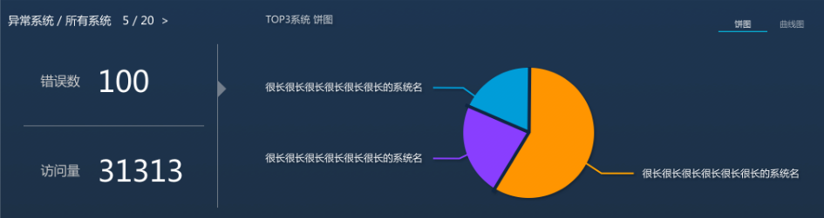

1. **接口说明:**

|  |  |
| --- | --- |
| **接口属性** | **属性值** |
| url | /overview/app/getAll.htm |
| 格式 | json |
| 请求方式 | post |
| 是否需要登录 | true |

1. **参数说明:**

|  |  |  |  |
| --- | --- | --- | --- |
| **参数名** | **必选** | **类型及范围** | **说明** |
| startTime | true | Date | 开始时间 |
| endTime | true | Date | 结束时间 |

1. **使用说明:**

该接口实现上图数据的查询：包含所有应用的访问量所有应用的错误数以及对应的top3的应用的折线图以及饼图。

1. **返回结果:**

{

"success": 1,

"errorMessage": "",

"result": {

"overViewAnalysisModel": {

"app": {

"errorCount": 9,

"totalCount": 284

},

"visit": {

"errorCount": 14,

"totalCount": 8829

},

"visitErrorChart": {

"kChart": {

"name": "lineChart",

"description": "lineChart",

"lines": [

{

"name": "苏宁风险检测平台系统2_MINOS2_PRE_jboss_10.27.232.151_MINOS2_PRE_Apache_10.27.232.151",

"type": "苏宁风险检测平台系统2_MINOS2_PRE_jboss_10.27.232.151_MINOS2_PRE_Apache_10.27.232.151",

"period": 0,

"points": [

{

"dtX": 1501812840000,

"valY": 1,

"fromDt": "08-04 10:14",

"toDt": "08-04 10:16",

"minimum": 1,

"maximum": 1,

"sum": 1

} ,

{

"dtX": 1501816080000,

"valY": 0,

"fromDt": "08-04 11:08",

"toDt": "08-04 11:10",

"minimum": 0,

"maximum": 0,

"sum": 0

}

]

},

{

"name": "平台商品中心服务系统_PCSS_PRE_jboss_10.27.211.24",

"type": "平台商品中心服务系统_PCSS_PRE_jboss_10.27.211.24",

"period": 0,

"points": [

{

"dtX": 1501812960000,

"valY": 0,

"fromDt": "08-04 10:16",

"toDt": "08-04 10:18",

"minimum": 0,

"maximum": 0,

"sum": 0

},

{

"dtX": 1501813200000,

"valY": 0,

"fromDt": "08-04 10:20",

"toDt": "08-04 10:22",

"minimum": 0,

"maximum": 0,

"sum": 0

}

]

},

{

"name": "体育会员中心系统_SACS_PRE_中台",

"type": "体育会员中心系统_SACS_PRE_中台",

"period": 0,

"points": [

{

"dtX": 1501814520000,

"valY": 1,

"fromDt": "08-04 10:42",

"toDt": "08-04 10:44",

"minimum": 1,

"maximum": 1,

"sum": 1

},

{

"dtX": 1501815120000,

"valY": 3,

"fromDt": "08-04 10:52",

"toDt": "08-04 10:54",

"minimum": 3,

"maximum": 3,

"sum": 3

}

]

}

]

},

"pieChart": {

"pie": [

{

"name": "苏宁风险检测平台系统2_MINOS2_PRE_jboss_10.27.232.151_MINOS2_PRE_Apache_10.27.232.151",

"proportion": 5

},

{

"name": "平台商品中心服务系统_PCSS_PRE_jboss_10.27.211.24",

"proportion": 2

},

{

"name": "体育会员中心系统_SACS_PRE_中台",

"proportion": 4

}

],

"total": 11

}

},

"visitChart": {

"kChart": {

"name": "lineChart",

"description": "lineChart",

"lines": [

{

"name": "综合商品价格信息服务_ICPS_PRE_was_10.27.162.215",

"type": "综合商品价格信息服务_ICPS_PRE_was_10.27.162.215",

"period": 0,

"points": [

{

"dtX": 1501812840000,

"valY": 107,

"fromDt": "08-04 10:14",

"toDt": "08-04 10:16",

"minimum": 107,

"maximum": 107,

"sum": 107

},

{

"dtX": 1501812960000,

"valY": 127,

"fromDt": "08-04 10:16",

"toDt": "08-04 10:18",

"minimum": 127,

"maximum": 127,

"sum": 127

}

]

},

{

"name": "苏宁易购单点登录B2CSSOJ_SSOApache_PRE_Apache_10.27.109.231_SSOJBOSS_PRE_jboss_10.27.109.231",

"type": "苏宁易购单点登录B2CSSOJ_SSOApache_PRE_Apache_10.27.109.231_SSOJBOSS_PRE_jboss_10.27.109.231",

"period": 0,

"points": [

{

"dtX": 1501812840000,

"valY": 12,

"fromDt": "08-04 10:14",

"toDt": "08-04 10:16",

"minimum": 12,

"maximum": 12,

"sum": 12

},

{

"dtX": 1501812960000,

"valY": 6,

"fromDt": "08-04 10:16",

"toDt": "08-04 10:18",

"minimum": 6,

"maximum": 6,

"sum": 6

}

]

},

{

"name": "会员中心系统_CMF_PRE_was_10.19.95.58",

"type": "会员中心系统_CMF_PRE_was_10.19.95.58",

"period": 0,

"points": [

{

"dtX": 1501812840000,

"valY": 110,

"fromDt": "08-04 10:14",

"toDt": "08-04 10:16",

"minimum": 110,

"maximum": 110,

"sum": 110

},

{

"dtX": 1501812960000,

"valY": 122,

"fromDt": "08-04 10:16",

"toDt": "08-04 10:18",

"minimum": 122,

"maximum": 122,

"sum": 122

}

]

}

]

},

"pieChart": {

"pie": [

{

"name": "综合商品价格信息服务_ICPS_PRE_was_10.27.162.215",

"proportion": 2399

},

{

"name": "苏宁易购单点登录B2CSSOJ_SSOApache_PRE_Apache_10.27.109.231_SSOJBOSS_PRE_jboss_10.27.109.231",

"proportion": 545

},

{

"name": "会员中心系统_CMF_PRE_was_10.19.95.58",

"proportion": 3801

}

],

"total": 6745

}

}

}

}

}

1. **字段说明:**

|  |  |  |
| --- | --- | --- |
| **字段名** | **类型** | **说明** |
| result.overViewAnalysisModel |  | 结果集 |
| result.*.app |  | 应用数和错误应用数 |
| result.*.visit |  | 应用访问量和错误访问量 |
| result.*.errorCount |  | 错误数 |
| result.*.totalCount |  | 总数 |
| result.*.visitErrorChart |  | 错误访问量top3应用图表 |
| result.visitChart |  | 访问量top3应用图表 |
| result.*.visitErrorChart.kChart |  | 折线图 |
| result.*.visitErrorChart.pieChart |  | 饼图 |
| errorMessgae | String | 错误信息 |
| success | Int | 成功标识，1成功，0失败 |

1. **A01A03实时统计图2:**

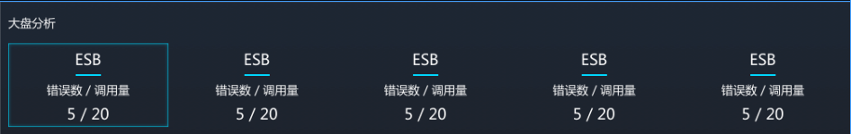

1. **接口说明:**

|  |  |
| --- | --- |
| **接口属性** | **属性值** |
| url | /overview/dashboard.htm |
| 格式 | json |
| 请求方式 | post |
| 是否需要登录 | true |

1. **参数说明:**

|  |  |  |  |
| --- | --- | --- | --- |
| **参数名** | **必选** | **类型及范围** | **说明** |
| startTime | true | Date | 开始时间 |
| endTime | true | Date | 结束时间 |
| licenseId | false | String | 应用编码（单个应用时存在，所有应用不需要传此字段） |

1. **使用说明:**

查询单个应用或所有应用的大盘分析数据

1. **返回结果:**

{

"success": 1,

"errorMessage": "",

"result": {

"dashboard": {

"redis": {

"errorCount": 1244,

"totalCount": 302140

},

"dal": {

"errorCount": 0,

"totalCount": 17372

},

"http": {

"errorCount": 0,

"totalCount": 2

},

"esb": {

"errorCount": 0,

"totalCount": 562

},

"rsf": {

"errorCount": 9,

"totalCount": 5423

}

}

}

1. }**字段说明:**

|  |  |  |
| --- | --- | --- |
| **字段名** | **类型** | **说明** |
| errorMessgae | String | 错误信息 |
| success | int | 成功标识，1成功，0失败 |
| result. dashboard |  | 结果集 |
| result.*.redis |  | Redis类型的相关数据 |
| result.*.dal |  | Dal类型的相关数据 |
| result.*.http |  | Http类型的相关数据 |
| result.*.esb |  | ESB类型的相关数据 |
| result.*.rsf |  | RSF类型的相关数据 |

1. **A03实时统计分析单个应用图3:**

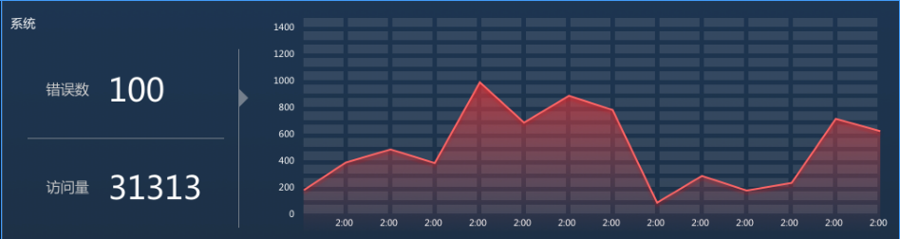

1. **接口说明:**

|  |  |
| --- | --- |
| **接口属性** | **属性值** |
| url | /overview/service/singleAppInfo.htm |
| 格式 | json |
| 请求方式 | post |
| 是否需要登录 | true |

1. **参数说明:**

|  |  |  |  |
| --- | --- | --- | --- |
| **参数名** | **必选** | **类型及范围** | **说明** |
| startTime | true | Date | 开始时间 |
| endTime | true | Date | 结束时间 |
| licenseId | true | String | 应用编码 |

1. **使用说明:**

用于查询单个应用的访问量访问错误数以及各时段对应的折线图

1. **返回结果:**

{

"success": 1,

"errorMessage": "",

"result": {

"overViewServiceAnalysisModel": {

"visitCount": {

"errorCount": 0,

"totalCount": 545

},

"visitErrorCountChart": {

"chart": {

"name": null,

"description": null,

"lines": [

{

"name": null,

"type": "苏宁易购单点登录B2CSSOJ_SSOApache_PRE_Apache_10.27.109.231_SSOJBOSS_PRE_jboss_10.27.109.231",

"period": 0,

"points": [

{

"dtX": 1501812840000,

"valY": 0,

"fromDt": "08-04 10:14",

"toDt": "08-04 10:16",

"minimum": 0,

"maximum": 0,

"sum": 0

},

{

"dtX": 1501812960000,

"valY": 0,

"fromDt": "08-04 10:16",

"toDt": "08-04 10:18",

"minimum": 0,

"maximum": 0,

"sum": 0

}

]

}

]

}

},

"visitCountChart": {

"chart": {

"name": null,

"description": null,

"lines": [

{

"name": null,

"type": "苏宁易购单点登录B2CSSOJ_SSOApache_PRE_Apache_10.27.109.231_SSOJBOSS_PRE_jboss_10.27.109.231",

"period": 0,

"points": [

{

"dtX": 1501812840000,

"valY": 12,

"fromDt": "08-04 10:14",

"toDt": "08-04 10:16",

"minimum": 0,

"maximum": 0,

"sum": 12

},

{

"dtX": 1501812960000,

"valY": 6,

"fromDt": "08-04 10:16",

"toDt": "08-04 10:18",

"minimum": 0,

"maximum": 0,

"sum": 6

}

]

}

]

}

}

}

}

}

1. **字段说明:**

|  |  |  |
| --- | --- | --- |
| **字段名** | **类型** | **说明** |
| result.overViewServiceAnalysisModel |  | 结果集 |
| result.*.visitCount |  | 应用访问量访问错误数数据 |
| result.*.visitErrorCountChart |  | 访问错误数各时段的折线图 |
| result.*.visitCountChart |  | 访问量各时段的折线图 |
| errorMessgae | String | 错误信息 |
| success | Int | 成功标识，1成功，0失败 |

1. **A03实时统计分析单个应用图4:**

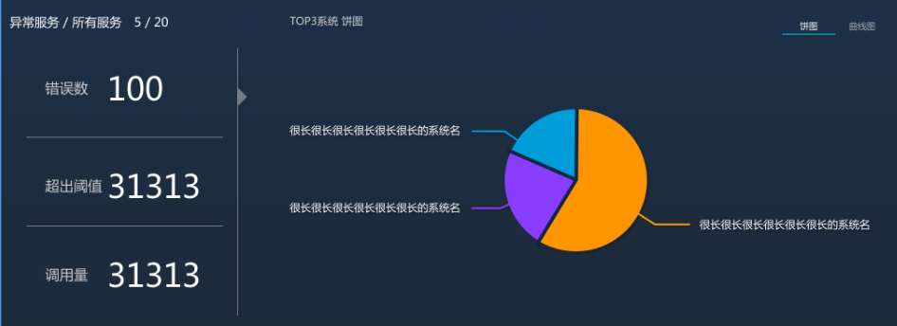

1. **接口说明:**

|  |  |
| --- | --- |
| **接口属性** | **属性值** |
| url | /overview/service/getAll.htm |
| 格式 | json |
| 请求方式 | post |
| 是否需要登录 | true |

1. **参数说明:**

|  |  |  |  |
| --- | --- | --- | --- |
| **参数名** | **必选** | **类型及范围** | **说明** |
| startTime | true | Date | 开始时间 |
| endTime | true | Date | 结束时间 |
| licenseId | true | String | 应用编码 |

1. **使用说明:**

接口用于查询单个应用下服务纬度的统计信息以及各时段的折线图和饼图top3

1. **返回结果:**

{

"success": 1,

"errorMessage": "",

"result": {

"overViewServiceAnalysisChartModel": {

"serviceInvokeCount": 16494,

"serviceErrorCount": 0,

"serviceSlowCount": 17,

"serviceCountAndErrorCount": {

"errorCount": 0,

"totalCount": 10

},

"serviceInvokeChart": {

"kChart": {

"name": "lineChart",

"description": "lineChart",

"lines": [

{

"name": "Jedis@get",

"type": "Jedis@get",

"period": 0,

"points": [

{

"dtX": 1501812840000,

"valY": 494,

"fromDt": "08-04 10:14",

"toDt": "08-04 10:16",

"minimum": 243,

"maximum": 251,

"sum": 494

}

]

},

{

"name": "MinosRSFServiceImpl@isExisRisk",

"type": "MinosRSFServiceImpl@isExisRisk",

"period": 0,

"points": [

{

"dtX": 1501812840000,

"valY": 8,

"fromDt": "08-04 10:14",

"toDt": "08-04 10:16",

"minimum": 2,

"maximum": 6,

"sum": 8

}

]

},

{

"name": "https://passportpre.cnsuning.com/ids/login",

"type": "https://passportpre.cnsuning.com/ids/login",

"period": 0,

"points": [

{

"dtX": 1501812840000,

"valY": 8,

"fromDt": "08-04 10:14",

"toDt": "08-04 10:16",

"minimum": 3,

"maximum": 5,

"sum": 8

}

]

}

]

},

"pieChart": {

"pie": [

{

"name": "Jedis@get",

"proportion": 14909

},

{

"name": "MinosRSFServiceImpl@isExisRisk",

"proportion": 245

},

{

"name": "https://passportpre.cnsuning.com/ids/login",

"proportion": 240

}

],

"total": 15394

}

},

"serviceErrorChart": {

"kChart": {

"name": "lineChart",

"description": "lineChart",

"lines": [

{

"name": "https://passportpre.cnsuning.com/ids/needVerifyCode",

"type": "https://passportpre.cnsuning.com/ids/needVerifyCode",

"period": 0,

"points": [

{

"dtX": 1501812840000,

"valY": 0,

"fromDt": "08-04 10:14",

"toDt": "08-04 10:16",

"minimum": 0,

"maximum": 0,

"sum": 0

}

]

},

{

"name": "DetectServiceImpl@validate",

"type": "DetectServiceImpl@validate",

"period": 0,

"points": [

{

"dtX": 1501814760000,

"valY": 0,

"fromDt": "08-04 10:46",

"toDt": "08-04 10:48",

"minimum": 0,

"maximum": 0,

"sum": 0

},

{

"dtX": 1501815240000,

"valY": 0,

"fromDt": "08-04 10:54",

"toDt": "08-04 10:56",

"minimum": 0,

"maximum": 0,

"sum": 0

}

]

}

]

},

"pieChart": {

"pie": [

{

"name": "https://passportpre.cnsuning.com/ids/needVerifyCode",

"proportion": 0

},

{

"name": "http://quanpre.cnsuning.com/getPromFourPageNew__APP_.do",

"proportion": 0

},

{

"name": "DetectServiceImpl@validate",

"proportion": 0

}

],

"total": 0

}

},

"serviceSlowChart": {

"kChart": {

"name": "lineChart",

"description": "lineChart",

"lines": [

{

"name": "Jedis@get",

"type": "Jedis@get",

"period": 0,

"points": [

{

"dtX": 1501812840000,

"valY": 425,

"fromDt": "08-04 10:14",

"toDt": "08-04 10:16",

"minimum": 115,

"maximum": 310,

"sum": 425

}

]

}

]

},

"pieChart": {

"pie": [

{

"name": "Jedis@get",

"proportion": 10381

}

],

"total": 10381

}

}

}

}

}

1. **字段说明:**

|  |  |  |
| --- | --- | --- |
| **字段名** | **类型** | **说明** |
| result.overViewServiceAnalysisChartModel |  | 结果集 |
| result.*.serviceInvokeCount |  | 单个应用的服务调用量 |
| result.*.serviceErrorCount |  | 单个应用的服务错误总数 |
| result.*.serviceSlowCount |  | 单个应用超过响应阀值的次数 |
| result.*. serviceCountAndErrorCount |  | 应用下服务数和错误服务数 |
| result.*. serviceInvokeChart |  | 应用下top3服务调用量图表 |
| result. *. serviceSlowChart |  | 应用下top3超出阀值次数图表 |
| result.*. serviceErrorChart |  | 应用下top3服务错误数图表 |
| result.*.*.kChart |  | 服务折线图 |
| result.*.*.pieChart |  | 服务饼图 |