
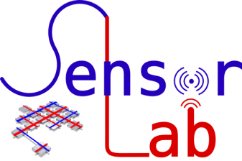

Georg-August-Universität Göttingen
Faculty of Mathematics and Computer Science
Institute of Computer Science
Telematics Group
Sensorlab

A Car-to-X Communication Framework for autonomous cars with Wi-Fi Car Tracing and Traffic Light Control Optimizing
Winter 2016/2017

Chencheng Liang – University of Goettingen – 11603960
chencheng.liang@stud.uni-goettingen.de
Ishwarya Chandrasekaran – University of Hannover … – 123456789
Your email

Abstract
You use red color to write, I will use green color to write.
Plz don't change my sentence without any comment and color.

We build a car-to-x communication framework, in which we implement car Wi-Fi localization, the infrastructure control, and communication between car and infrastructure. The Wi-Fi localization is a process that collects some useful information, such as IP address, Wi-Fi access point, then call Google API to process that information to return the longitude and latitude. The infrastructure control is an interface, which can receive the instruction come from a server or other sources, then execute the instruction in the corresponding physical infrastructure. The communication between car and infrastructure is implemented by two different ways. The first way is through the server, which is responsible for receive the location information, processing location information, generating instructions, and sending instructions to the infrastructure. The second way is to communicate between the car and the infrastructure directly.
We implement a simple car-to-traffic light communication in the video demo, in which car Wi-Fi localization remains the same, the infrastructure control is to control the traffic light. The communication between car and infrastructure has two channels, one is server based communication, one is direct communication..

- Introduction
Motivation.
Why informing the traffic light status to the driver in advance is important.

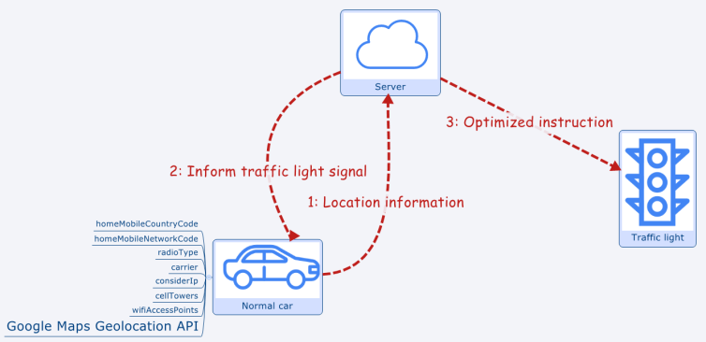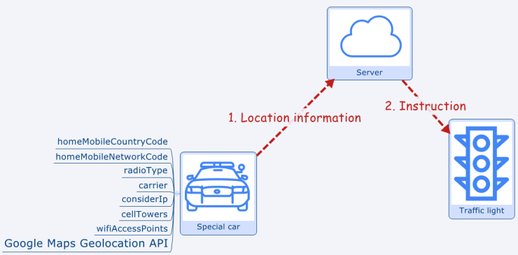
Figure 1. Normal cars communication diagram Figure 2. Special cars communication diagram
Wi-Fi localization process: we collect home Mobile Country Code (MCC), home Mobile Network Code (MNC), radio type, carrier, IP address, cell towers information, Wi-Fi access points, then send a request with that information to Google Maps Geolocation API , then the Google API will reply us the longitude, latitude, and the accuracy. The detail of this process will been explain in implementation section.
Server based communication for normal car is shown in Figure 1. Normal a car run the Wi-Fi location process, then send the location information to the server. The server will generate a new instruction according to the newest location information, then send the instruction (such as turn x axis light to green) to the nearest traffic light, and send the nearest traffic light signal back to the normal car.
Server based communication for special car is shown in Figure 2. The special car, such as police car or ambulance will send its location information to server, then the server will generate a green light signal instruction, then send this to the nearest traffic light. So every traffic light nearby the special car will turn green light for it.
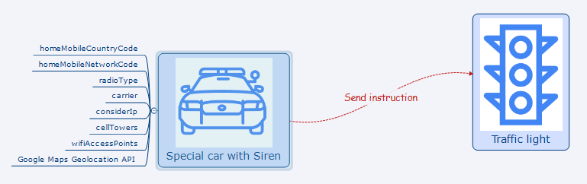
Figure 3. Traffic light direct control by special car diagram
Describe Figure 3

- Methodology and Design
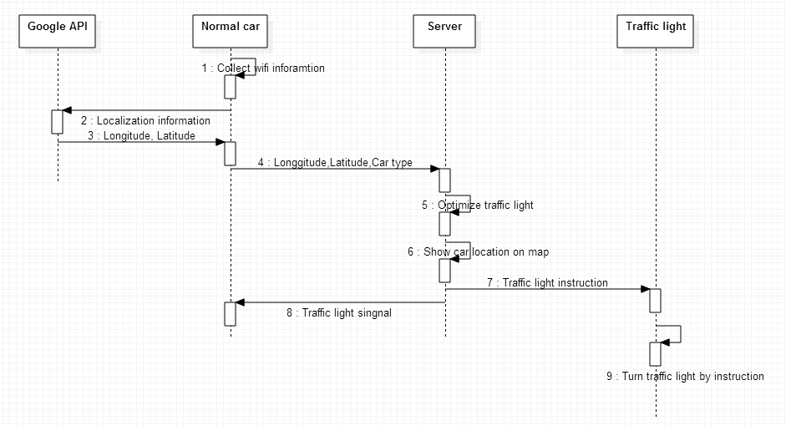
Figure 4. Normal cars sequential diagram
Figure 4 shows how to achieve the interaction between normal car and traffic light:
1: The normal car carry a Raspberry Pi, The Raspberry Pi will collect the information for localization, these information as we mentioned before including home mobile country code, home mobile network code, radio type, carrier, cell towers, IP address, and Wi-Fi access points. We collect as much as possible of that information.
2: We call Google Geolocation API to process that information ().
3: The Google Geolocation API will return a location which consists of longitude and latitude.
4: The Raspberry Pi on the car will send the longitude and latitude to the server which has a fixed IP address.
5: After receiving the longitude and latitude of the car, we have a algorithm to decide where is the nearest traffic light for the car, then we have a simple algorithm to get an optimized traffic light instruction and send it to traffic light. The traffic light information is also sent to the car (x axis green light turn on or y axis red light turn on, etc.). The two algorithms will be explained in implementation section 3.3.1 Server based communication demo.
6: This is optional, especially for test, in server, when we receive location information from the car (with Raspberry Pi), we can show it with the traffic light on Google Map. This need a chromdiver and chrome browser. A simple result got by the demo (explained in implement section) is shown in Figure 5, in which we can see that the traffic light (green point) is in our sensor lab, one raspberry pi is in sensor lab whch behaves as traffic light. The red point is the position of the car, which also is a raspberry pi placed in another location.
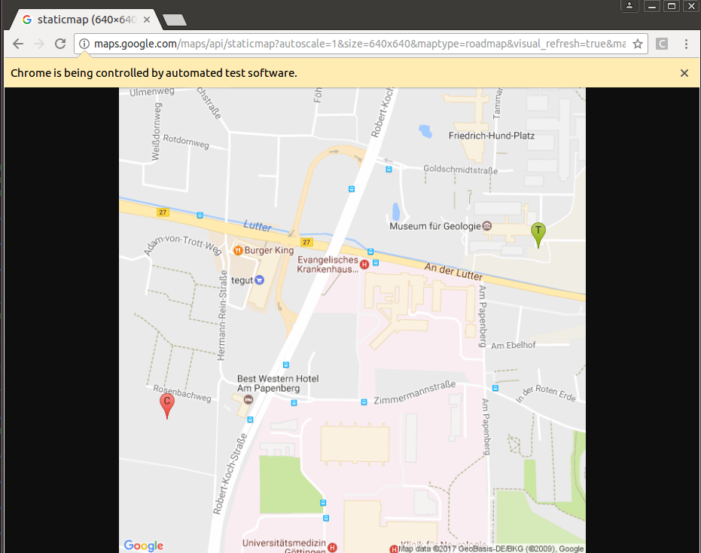
Figure 5. Position of the car and the traffic light in demo
7: After we get instruction from the step 5, we can send this instruction (this will be newest traffic light status) to the traffic light.
8: The server will send the newest traffic light status to the car (with Raspberry Pi), then the autonomous car will know the traffic light status. Why informing the traffic light status to the car in advance is important, we have discussed that in introduction part.
9: The traffic light will receive the instructions from server, if the instruction is the same with current light status, such as the x axis’s green light is on, the traffic light will not change its status. If the received instruction is different from current status, the traffic light will change its light status according to the instruction.

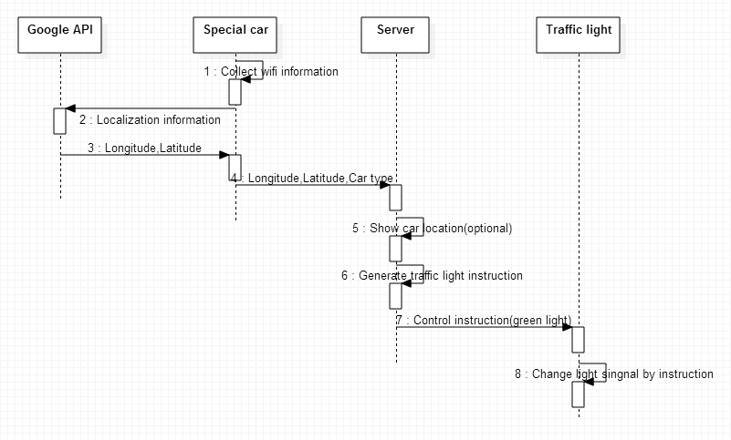
Figure 6. Special cars sequential diagram
Figure 6 shows how to achieve the interaction between special car and traffic light:
1: The special cars, such as police car, ambulance, carry a Raspberry Pi, The Raspberry Pi will collect the information for localization, this step is the same with the first step in Figure 4.
2, 3, 4: It is the same in Figure 4.
5: It is the same the step 6 in Figure 4.
6: If the car type is the special car, then the server will directly generate an instruction which turn on the green light on the axis where the special car is.
7: The server will send this instruction to the traffic light.
8: After receive the instruction, the traffic light will change the light signal to green for the special car.

Add your sequential diagram and explain.

3. Implementation
In this section, we will explain how we implement our design, and describe our demo and discuss our results. Our project is designed for multiple cars and multiple traffic lights, but in this report, we only explain the simple demo shown in the video, which consists with only 3 hardware, because we only have 3 hardware. By running this demo in field, we can prove that our project is actually working in reality rather than only on local virtual machines and node simulators.
3.1 Hardware preparation and deployment
According to the design, we need two Raspberry Pis basic sets (In this project, I have one Raspberry Pi provided by Sensor lab, and another Raspberry Pi own by my project partner) and a server.
The Raspberry Pi set includes one Raspberry Pi 3, one SD card, one HDMI cable, one power supply, one USB dongle, and one screen.
One Raspberry Pi 3 is deployed on a car, another is a emulator of traffic light, which can be deployed at the road or test at home.
The SD card is used to be the storage hardware of Raspberry Pi 3, it contain operating system and can store the file we generated or downloaded.
The power supply can be a power bank or an electricity slot to provide power for the Raspberry Pi 3.
The USB dongle is used to get Wi-Fi for Raspberry Pi 3.
The screen and HDMI are for programming and testing the demo program, in the real scene, screen and HDMI cable are not necessary.
The server we can use a virtual machine or real machine with Ubuntu operating system run on it.
3.2 Software preparation and deployment
Download Raspbian operating system (download link: https://www.raspberrypi.org/downloads/raspbian/) on SD card, and install the operating system in Raspberry Pis.
We build a linux server using Ubuntu operating system, which can be on a virtual machine. The server’s IP should be fixed. But in our demo, we don’t have fix IP, so we input our server IP every time.
In Raspbian and the linux server use command (sudo apt-get install python3-pip) to install pip, then use commands (sudo pip install selenium and sudo pip install uuid) to install selenium and uuid. All environment installing scripts are in install.sh. By executing this bash, all the environmental will be installed.
To get access of Google Geolocation API, we need to apply a key (key acquiring link: https://developers.google.com/maps/documentation/geolocation/intro).
For showing the location in Google map, we need to download chromedriver (download link: https://sites.google.com/a/chromium.org/chromedriver/). This file is not large, so we included it in our code file. And we need a Google browser.
In server based communication, the normal_car.py, special_car.py, and TrafficLight.py should be run on the Raspbian. The server.py should be run on our linux server.

3.3 Demo explaining and results
The results of server based communication demo has been shown in our first demo video, and 3.3.1 is for explaining of our first demo, so we will not provide any screen shoot from the first demo in 3.3.1 anymore.
3.3.1 Server based communication demo
The normal car scenario
1. Run TrafficLight.py on a Raspberry pi. In TrafficLight.py we use socket to receive a UDP packet with 8080 port. The packet contain the instruction to control the traffic light.
2. Run server.py on our Linux system. In server, we use socket to receive UDP packet from port 2333. In this scenario we suppose the car type is normal car. Then the server will call a algorithm to decide the nearest traffic light for the car.
The algorithm is rather simple, it use the receive longitude and latitude to subtract every longitude and latitude of traffic lights, then the traffic light with the smallest absolute value is the nearest traffic light for that normal car. For example, there are two traffic light with their location information: traffic light 1 (55,56), traffic light 2 (31,45). The receive car location is (50,50), then the result of subtraction for two traffic light are (5,6) and (-19,-5), then add them together and get the absolute value, the final values for traffic lights 1 and 2 are 11 and 24. So we know the nearest traffic light is traffic light 1.
Then we run an algorithm to generating an optimized traffic light signal. In this algorithm, we consider the number of cars on the x axis and y axis. For example, if the x axis has more cars than y axis, then we have an instruction that turn on the green light on x axis, and vice versa.
After the newest instruction is generated, server will send a UDP packet containing traffic light instruction to traffic light by socket with port 8080, and send a UDP packet containing the current traffic light status the normal car by socket with port 9090
3. Run normal_car.py on a Raspberry pi. In normal_car.py, we collect location information, then use socket to send a UDP packet (longitude, latitude, car type, and car IP address) to server with port 2333. And normal car will receive UDP packet from server with port 9090, the content is current traffic light signal status.
In normal_car.py, we have Wi-Fi localization process, which relies on
Google Maps Geolocation API. First we collect location information and put them into a JSON format:
{
"homeMobileCountryCode": 310,
"homeMobileNetworkCode": 410,
"radioType": "gsm",
"carrier": "Vodafone",
"considerIp": "true",
"cellTowers": [
"cellId": 42,
"locationAreaCode": 415,
"mobileCountryCode": 310,
"mobileNetworkCode": 410,
"age": 0,
"signalStrength": -60,
"timingAdvance": 15
],
"wifiAccessPoints": [
"macAddress": "00:25:9c:cf:1c:ac",
"signalStrength": -43,
"age": 0,
"channel": 11,
"signalToNoiseRatio": 0
]
}
Not every information of this JSON is necessary, we just collect as much information as we can. Some information collection methods are finished such as get macAddress, signalStrength, and signalToNoiseRatio. Some methods we tried but remain unfinished, such as cellTowers. Then we send this to https://www.googleapis.com/geolocation/v1/geolocate?key= API_KEY by urllib2.Request. The urllib2.Request will return a URL, then we get a response by using urllib2.urlopen to open the returned URL from urllib2.Reques, the urllib2.urlopen will return a JSON format:
{
"location": {
"lat": 51.0,
"lng": -0.1
},
"accuracy": 1200.4
}
in which, lat is latitude, lng is longitude, accuracy is the location radius, which means the real location will been in a circle with the central coordination (51,-0.1) and radius 1200.4 meters.
More detail about how to use Google Maps Geolocation API for localization can be found here (https://developers.google.com/maps/documentation/geolocation/intro#cell_tower_object).
The special car scenario.
1. Run TrafficLight.py on a Raspberry pi, this is the same as normal car scenario.
2. Run server.py on Linux server. After server receive the packets from the special car (UDP packet, port 2333), the server will decide the nearest traffic light for the car, this is the same with normal car scenario. Then the server will check the car type, since this car is a special car, instead of executing the algorithm to get optimized traffic light signal instruction, the server will directly send a green light signal to the nearest traffic light (UDP packet, port 8080). And will not send back current traffic light signal to the special car, because all traffic lights nearby the special car will turn the traffic light with the same axis of special car to green.
3. Run special_car.py on a Raspberry pi, This is almost the same with the normal car scenario, the only difference is the car type parameter is 'special'

3.3.2 Describe Your demo

3.4 The problems we encountered in practice
One problem is the permission of the server. We tried to use the computer in sensor lab to be our server, but we do not have permission to install some necessary software, which means we cannot use any sudo command. Therefore, we use our own virtual machine as the server, in which we have full permission. This is fit to the real scenario, if we have a server, we have all permission to configure our server.
Another problem is the network problem. Since we are using campus network, we do not have a fixed IP address, our devices are always in a subnet. For convenience and the demo, we take the IP address as a input parameter. For example we will run server with this command: python special.py 10.10.13.157. But if we have the fixed IP address for the server, we do not need to input IP address anymore, we just run our code. All things will work automatically.
The three devices in our demo are connected in one subnet, which is provided by campus, called GeoMobile/GuestoOnCampus. With the same student account to login, the devices will be connected under one subnet, so they can communicate to each other.

4. Evaluation
One strength of our project is that we achieved indoor localization, which overcomes the drawback of GPS localization mechanism which need in an open space and sometime even need a good weather.
Another essential thing we did is that we not just build a Wi-Fi localization and traffic light control application, we build a localization-based node control framework. Because we build programming interfaces on the server and the traffic light.
In the server when we receive location information, we can run different algorithm to get various instructions. And in the traffic light, we can replace traffic light to other hardware which can execute the instructions to achieve other requirements. For the car, actually the raspberry can be install on other mobile object and trace the location information and send to the server.
For example with our framework, we can also achieve this scenario: put the raspberry pi in the traffic light to your garage, then when your car comes to your garage, the server will recognize that then send instruction to the raspberry pi in your garage, then it will open the garage door for you.
And our code is written in Python, so any other hardware which is compatible with Python will perfectly can perfectly run our code. Therefore, we are not bind with raspberry pi, this project can be used in other hardware.
One design drawback for the server based communication framework is that we use Raspberry Pi in the car to get access to Google API and get the longitude and latitude (step 2 and 3 in Figure1 and Figure3), then send to the server. But it is better to do these steps on server, so the tracing device on the car could be more energy-efficient.

5. Conclusion and future works
We build a car-to-x communication framework, and we implement it with a car-to-traffic light application. In the video demo, we show that our application is working which also proves that our framework is working.
We already put our code in Github (https://github.com/lcckkkhaha/A-Car-to-X-Communication-Framework-for-autonomous-cars-with-Wi-Fi-Car-Tracing-and-Traffic-Light-Cont).
For the future work, now we built a client-server system with UDP communication, but it has a lot of problems with network caused by NAT, firewall, etc. So we plan to build a browser-server(B/S) system. So the car only needs to post their information to the web server, and fetch the information from the server.
With this B/S structure, the tracing device in the car can be any device which provides tracing function, these devices only need to put their location information to the web server. And for any infrastructure which receive the instruction, it only need to have access to the web server, then they can get the instructions, and user managing become visible to users. Every user can have an account to control and get information from their devices or the infrastructures.

