STAGE – 1
1.) Install prerequisites such as gcc, make, readline, flex/lex, bison/yacc
sudo apt-get install libreadline-dev flex bison make gcc wget curl
curl -sSf https://raw.githubusercontent.com/eXpOSNitc/expos-bootstrap/main/download.sh | sh
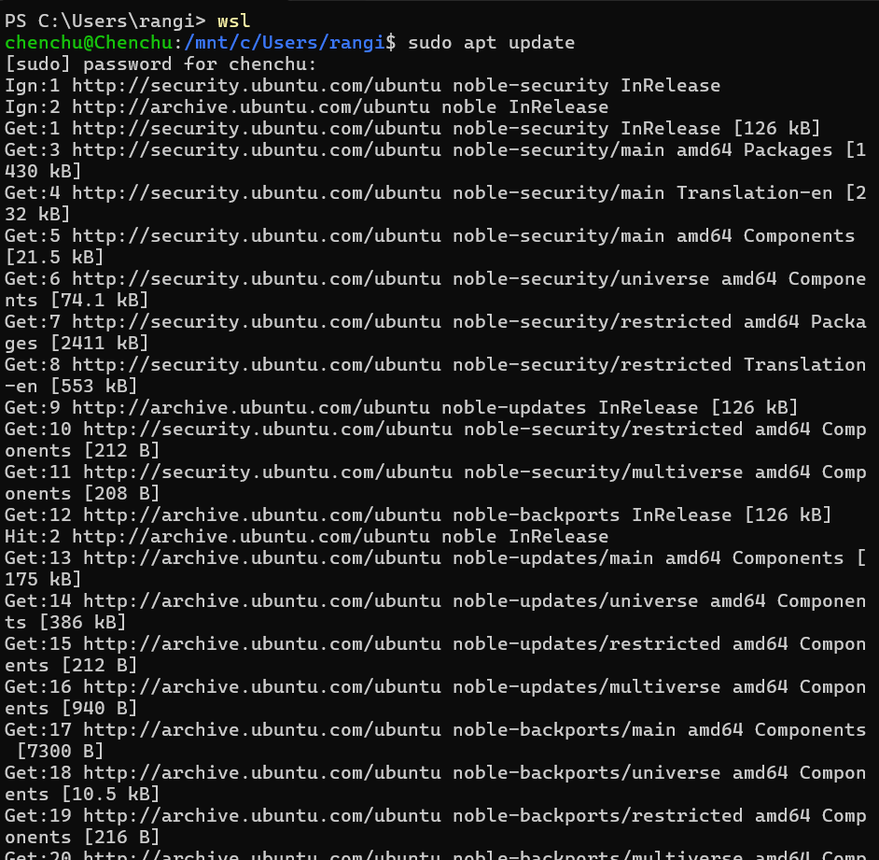
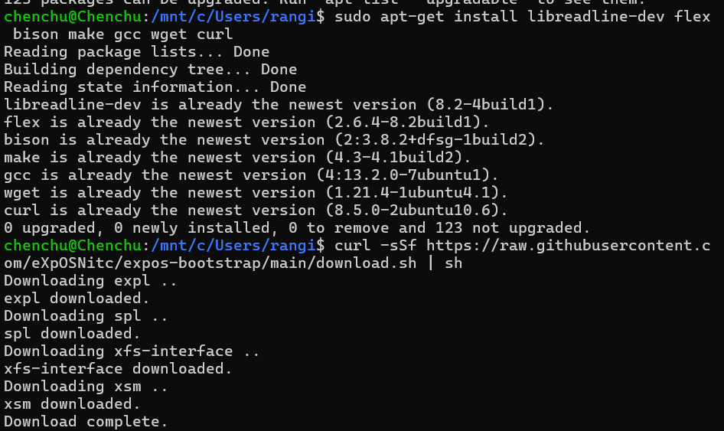
Creating myexpos directory
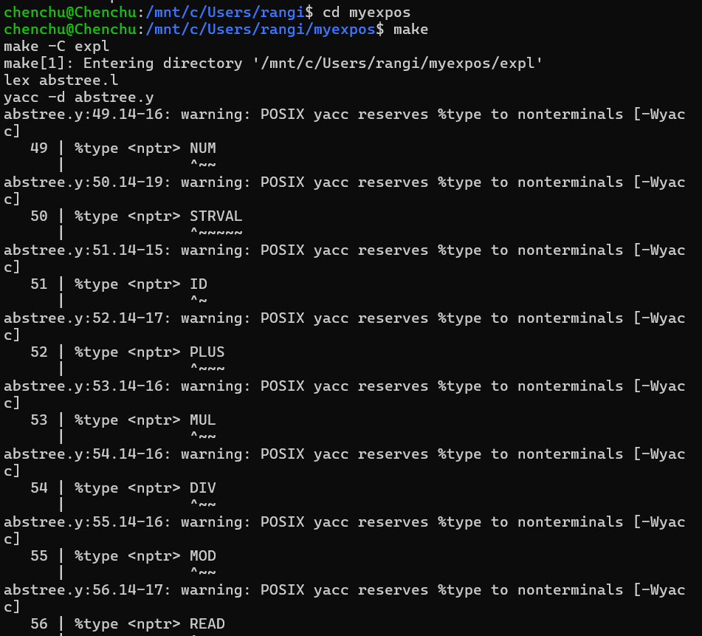
expl – converts your program into machine code
spl – converts OS code into machine code
xfs-interface – to manage file and disk
xsm – runs the compiled machine code
tes t – Check if things work

STAGE-2
Run the XFS Interface
1.)fdisk - prepares (formats) the virtual disk so eXpOS can use it
2.) df - shows how much disk space is used and free

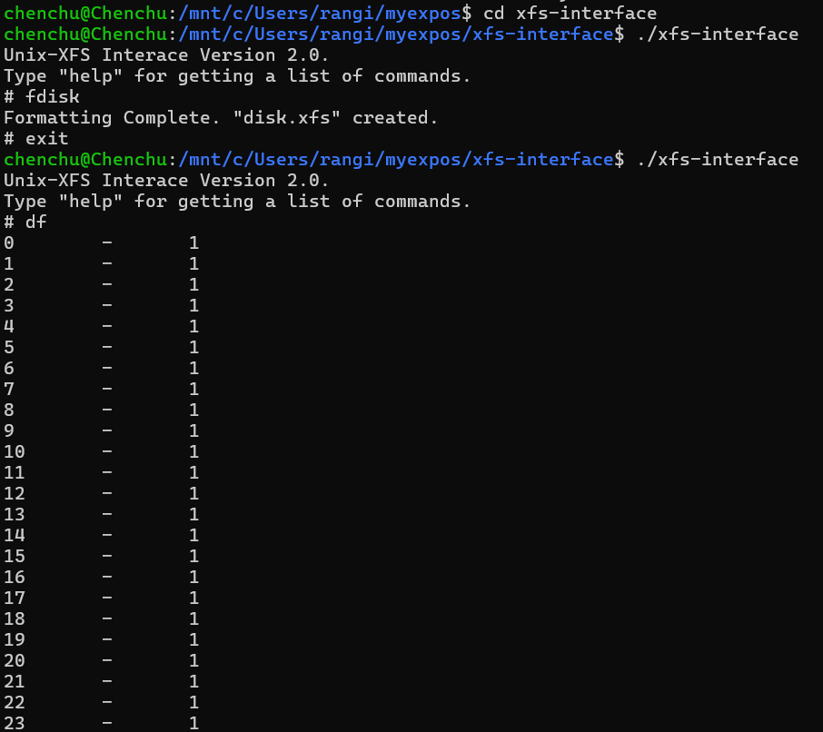

- Creating a file with sample data and save the file as $HOME/myexpos/sample.dat
- Load this data file $HOME/myexpos/sample.dat to the XFS disk
- One free disk block is allocated
- New inode entry is created to sotore file name, size, user id and data block
- An entry for this file will be made in the Root File also

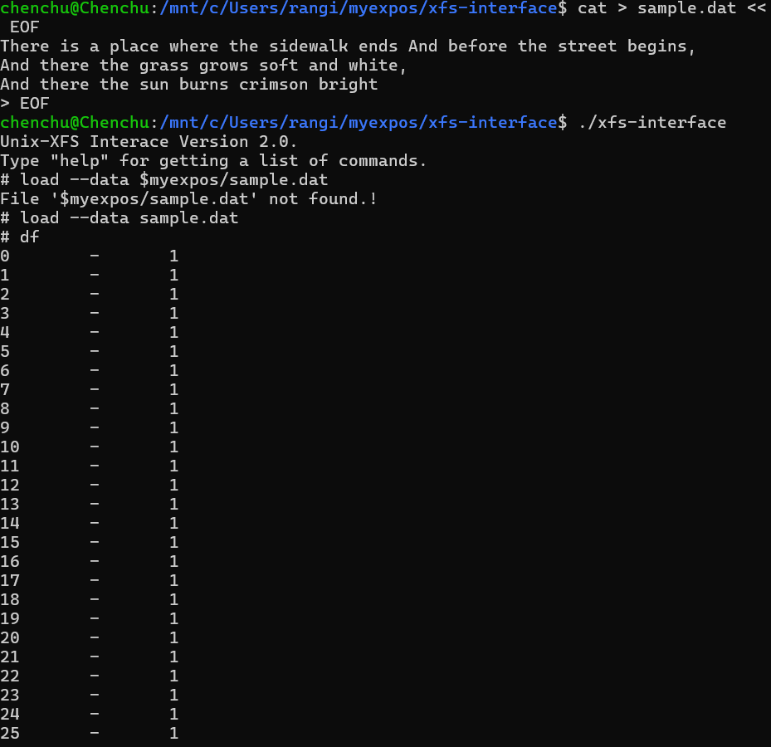

1.)Inode table is stored in disk blocks 3 and 4
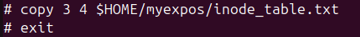

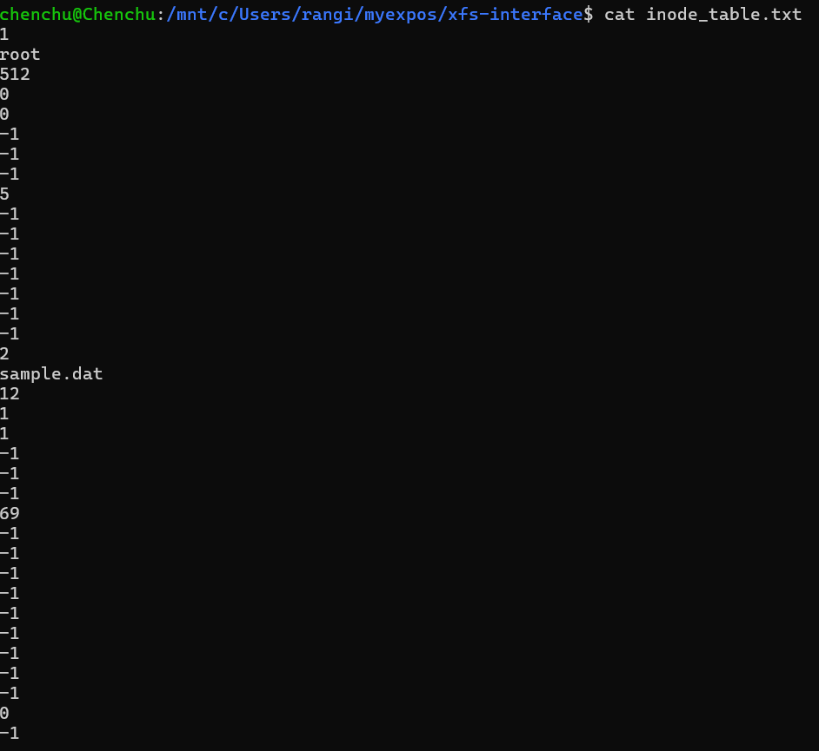
2.)Copy the data blocks from the XFS disk and display it as a UNIX file
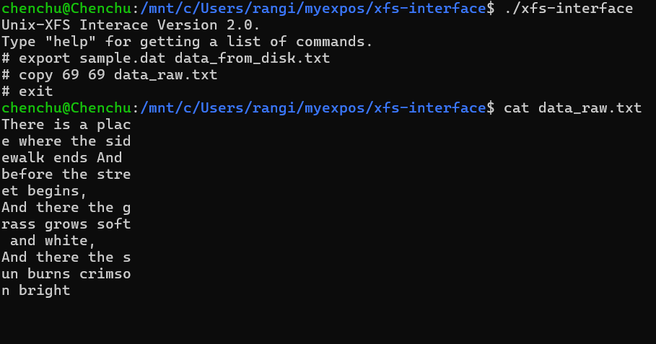

ASSIGNMENT – 1
1.)Copy the contents of Root File (from Block 5 of XFS disk) to a UNIX file $HOME/myexpos/root_file.txt and verify that an entry for sample.dat is made in it also.

2.)Delete the sample.dat from the XSM machine using xfs-interface and note the changes for the entries for this file in inode table, root file and disk free list.

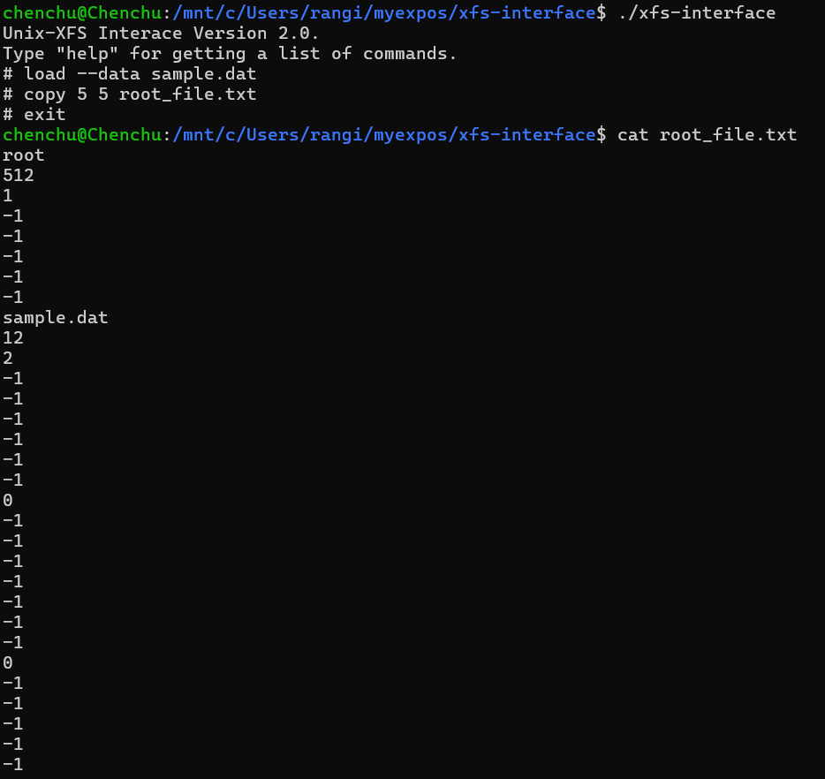
ASSIGNMENT-2
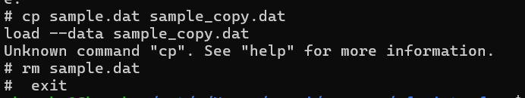

STAGE – 3
1.)
Create the assembly program to print "HELLO_WORLD". The assembly code to print "HELLO_WORLD" :

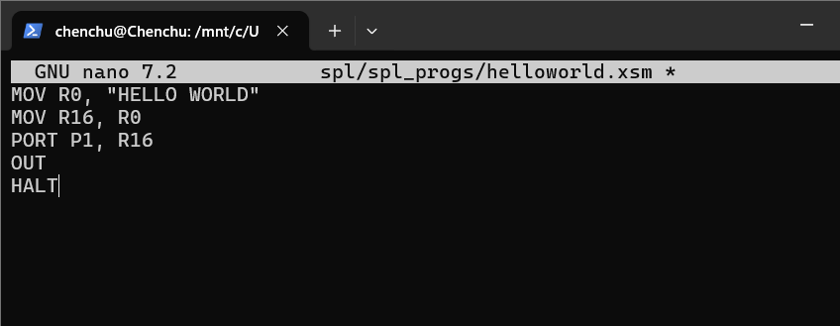
- Load the file as OS Startup code to disk.xfs using XFS-Interface.

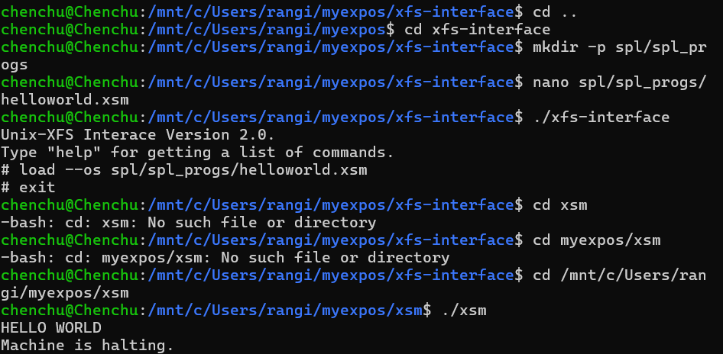

ASSIGNMENT-1
Write an assembly program to print numbers from 1 to 20 and run it as the OS Startup code.
- Create the assembly program to print 1 to 20 "print_numbers". The assembly code to print :

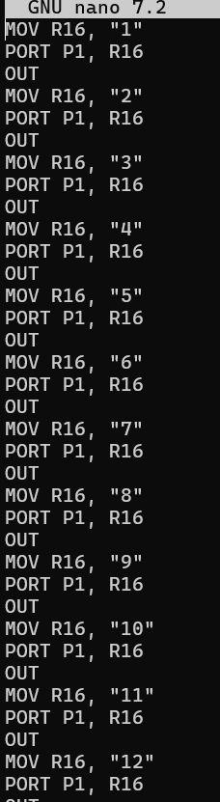
2.)Load the file as OS Startup code to disk.xfs using XFS-Interface
3.)Run the machine

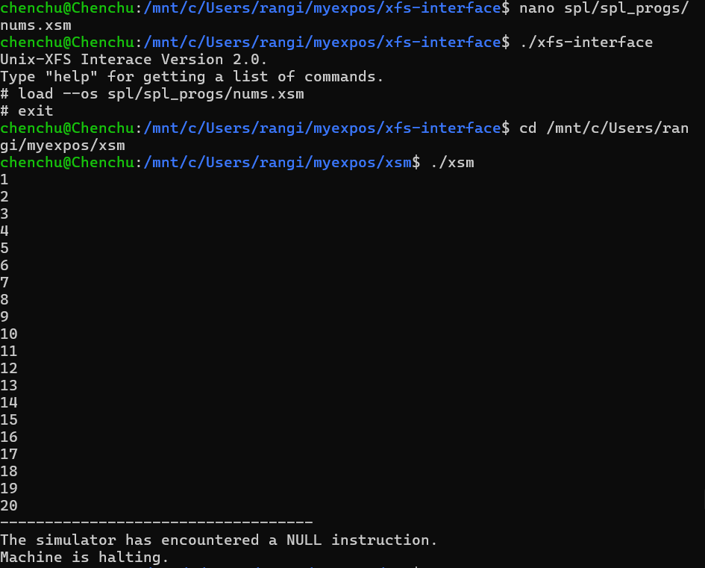

STAGE-4
- Create the program to print odd numbers form 1 to 20 using SPL

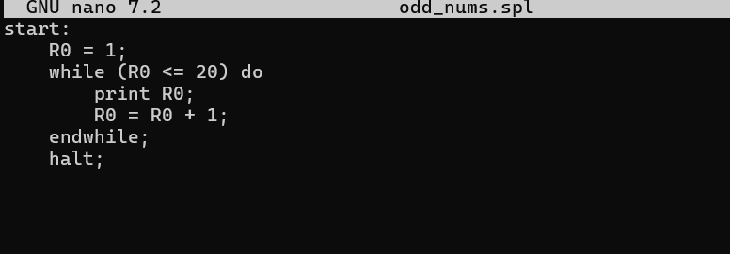
1.)Save the file and compile this SPL program using the commands and load the file generated by the SPL compiler

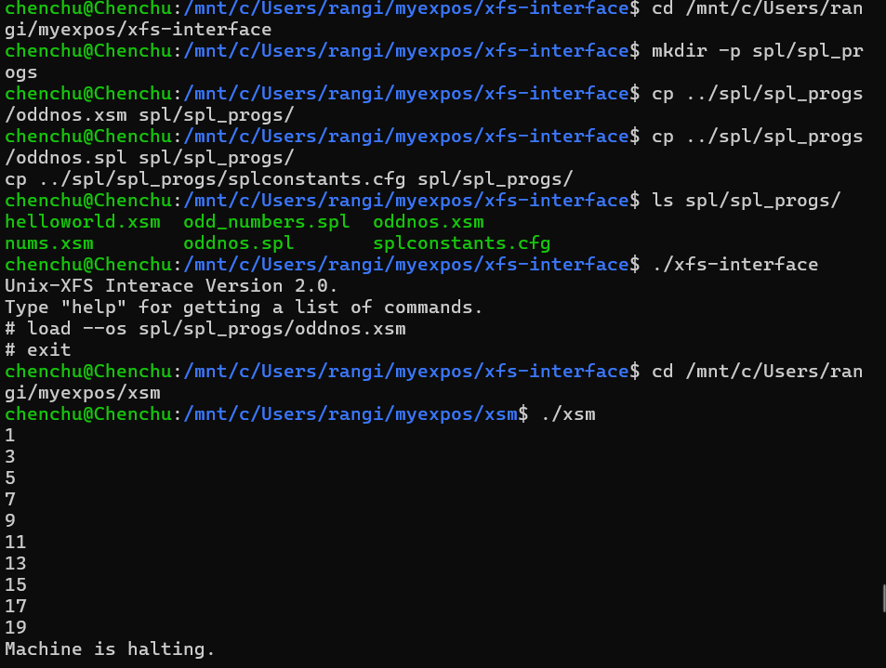

ASSIGNMENT-1
write the spl program to print sum of squares of the first 20 natural numbers. load it using xfs interface and run the in the machine.
- Create the program to print the sum of squares of the first 20 natural numbers

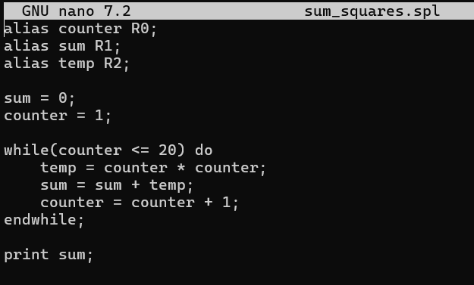
2.)save the file and compile this spl program using commands
3.)Load the file generated by the spl compiler
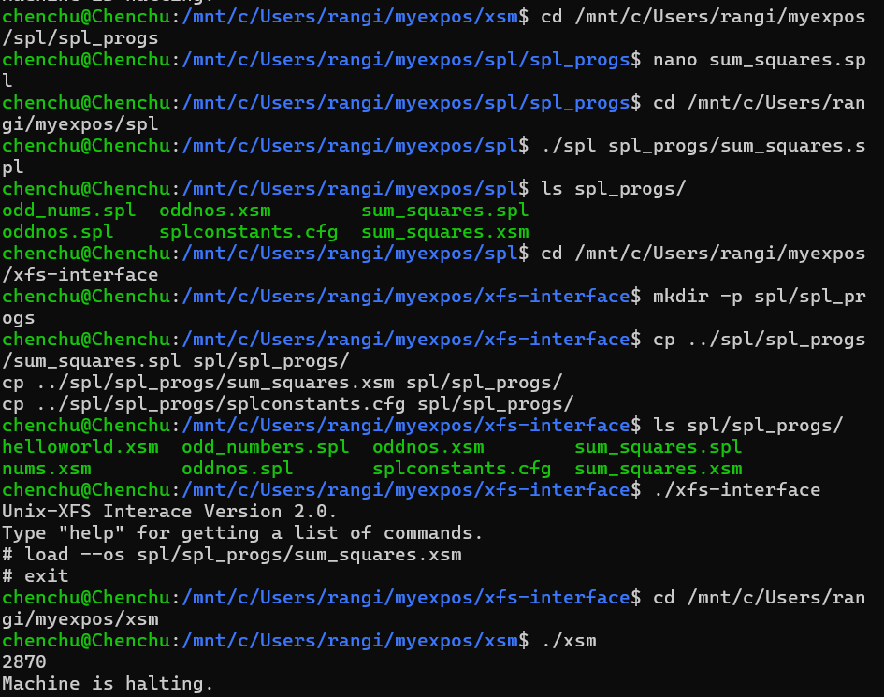

STAGE-5
- Write an SPL code to generate odd numbers from 1 to 10

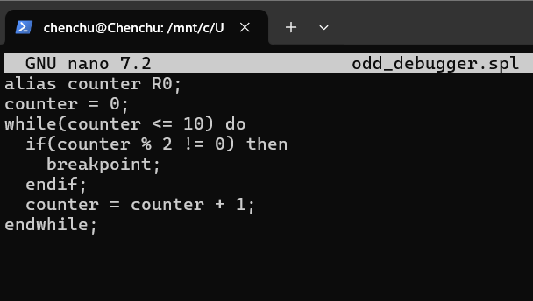

- Compile the program using the spl compiler
- Load the compiled xsm code
- Run the machine in debug mode

