My e-commerce platform

**Layered architecture**

Prons: loose coupling (maintenance, re-use, extensible)

e.g. MVC, MVVM

**Modularity**

Pons: decoupling, parallel development

e.g. AMD (RequireJS), CMD (CJS), **CommonJS**, ES6

Logic Layer: main module – submodule 1, submodule 2, …

Data Layer: Service <-> Server

Instrumentation Layer: Instructions

**Criteria**

Stability, Extensibility, Speed, Efficiency, Compatibility, …

According to:

Software Process, (Front and End)Segregation Mode, Webpack Selection, Framework Selection, Version Control, Publish Mode

Better use **Agile Development**

**Framework**

jQuery, Angular, Avalon, Vue, React

CSS, Less, Sass

Client Side: Stability, SEO (**jQuery, CSS**)

Management: Effiency, don’t have to care about SEO (**React, Sass**) **JUST TRY SOMETHING NEW!**

**Webpack**

Grunt, Gulp, Webpack

Grunt: too complicated…

Gulp: ↓

**Webpack**: support CommonJS!

**Version Control**

SVN, git

**Git**: just git it

**Publish**

Use Git

**Back-end**

**Implement interfaces**

**Front-end**

**Call interfaces**

**Interface file**

Name, address, request and response

Request:

0 - success

1 – fail (with error message)

10 – not logged in

Environment Set Up

jQuery (no need to install)

webpack (**Nodejs**)

git (**git**)

sublime (already installed)

chrome (installed)

Fiddler (installed)

Node.js & npm:

Single thread, Asynchronous programming

V4.4.7 64bits

Git:

More later

gitbash

Git

git configure

git add

git commit –am ‘comment’

git push

git checkout –b branchname

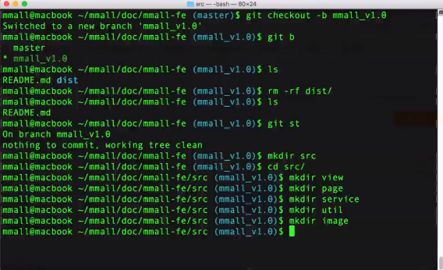

Webpack

<http://webpack.github.io/docs/>

npm install webpack –g //install global first

npm install webpack@version# --save-dev

**webpack.config.js**

entry: entry of js

externals

output: target file

resolve: alias

module: files, loaders

plugins:

**webpack loaders**

html: html-webpack-plugin / html-loader

js: babel-loader + bable-present-es2015

css: style-loader + css-loader

image + font: url-loader

**commend**

webpack

webpack –p

webpack –watch

webpack –config webpack.config.js

webpack-dev-server