Healthcare Data Analysis
End-to-End Data Analytics Project - Insights Report
STAGE 1

1. Business Understanding

Project Goal
To analyse health care data, identify disease trends, evaluate treatment outcomes, optimize hospital operations, and provide actionable insights that improve patient care, reduce costs, and support effective health care decision-making.

Business Problem
A health care organization wants to analyse patient records, treatment outcomes, hospital performance, and health care costs to improve patient care and operational efficiency. The organization needs to identify disease trends, high-risk patient groups, treatment effectiveness, and resource utilization to support data-driven health care decisions.

Objectives
- Analyze patient demographics and health conditions.
- Identify common diseases and high-risk patient groups.
- Evaluate treatment effectiveness and recovery outcomes.
- Analyze health care costs and resource utilization.
- Understand factors affecting patient admissions and hospital stays.
- Build an interactive dashboard for health care performance monitoring.

Expected Insights
- Most common diseases and medical conditions.
- High-risk patient groups based on age, gender, or health factors.
- Treatment success and recovery rates.
- Departments with the highest patient admissions.
- Health care cost distribution and resource utilization.
- Patient length-of-stay and hospital performance trends.

Business Decisions
- Improve patient care strategies and treatment plans.
- Optimize hospital resource allocation and staffing.
- Reduce health care costs while maintaining quality of care.
- Focus preventive care programs on high-risk patient groups.
- Enhance disease management and monitoring processes.
- Improve overall hospital efficiency and patient satisfaction.
STAGE 2 · CHENDAN

2. Data Cleaning
- Loaded the health care dataset into Python using Pandas.
- Examined dataset structure, rows, columns, and data types.
- Identified numerical and categorical features for cleaning.

2.1 Handling Missing Values
- Checked missing values using isnull().sum().
- Filled null values in numerical columns (age, treatment_cost, insurance_coverage, doctor_rating, etc.) using the column mean.
- Filled null values in categorical columns (gender, disease, hospital, city, state, etc.) using the mode (most frequent value).

2.2 Duplicate Record Removal
- Identified duplicate records using duplicated().
- Removed duplicate rows using drop_duplicates().
- Verified that all duplicate records were successfully removed.

2.3 Data Type Validation
- Checked column data types using dtypes.
- Converted date columns (admission_date, discharge_date) into proper datetime format.
- Converted numeric columns to appropriate integer or float data types where necessary.

2.4 String and Text Cleaning
- Removed unwanted special characters such as @, #, $, %, &, !, ?, and *.
- Applied string cleaning using regular expressions.
- Trimmed extra spaces using str.strip().

2.5 Standardization of Categorical Values
- Standardized inconsistent values in:
  - Gender (Male@, Male? → Male)
  - Disease (Heeart Disease, Heart Diseasee → Heart Disease)
  - Bed Type (Prrivate, Privatee → Private)
  - Test Results (Normall, Normaal → Normal)
  - Severity Level (Highh, Mediumm → High, Medium)
- Ensured consistent categories across the dataset.

2.6 Date Cleaning
- Removed special characters from date columns.
- Standardized mixed date formats into a consistent format (YYYY-MM-DD).
- Validated date conversions and handled invalid date entries.
- Changed the insurance_coverage values from 1 and 0 to Covered and Uncovered

2.7 Data Quality Validation
- Verified that no missing values remained.
- Confirmed duplicate records were removed.
- Checked unique values in categorical columns after cleaning.
- Validated numerical columns for appropriate ranges and formats.

2.8 Final Dataset Readiness
- Produced a clean and structured healthcare dataset.
- Ensured data consistency, accuracy, and reliability.
- Prepared the dataset for Exploratory Data Analysis (EDA), visualization, MySQL analysis, and dashboard development.

Outcome
The healthcare dataset was successfully cleaned by handling missing values, removing duplicates, correcting data types, standardizing categorical values, cleaning text fields, and validating data quality. The final dataset was ready for analysis, visualization, and business intelligence reporting.
STAGE 3 · ANOOKYA

3. Exploratory Data Analysis (EDA)
The following findings are calculated from the supplied cleaned dataset. The findings come from the healthcare notebook, using the cleaned dataset of 20,171 patient records. They describe patterns in this dataset and should be treated as descriptive results, not proof of cause and effect.

3.1 Patient Age Distribution
EDA question: What does the age distribution of the patient records look like?
Main points
- The average and median ages are both about 44 years.
- Recorded ages range from 0 to 89 years, and the middle half range from 23 to 65 years.
Insight: The records include patients across a broad age range. The zero-age records should be checked to confirm they represent valid infant records rather than missing or miscoded ages.
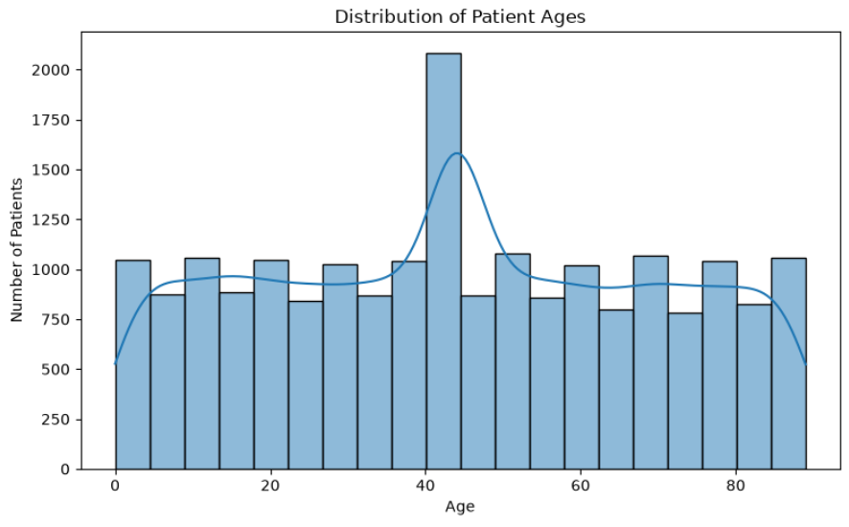

3.2 Number of Patients by Disease
EDA question: Which diseases appear most often in the patient records?
Main points
- Cancer is the most frequent category, with 6,008 records (29.8%).
- Heart disease, diabetes, and flu each account for about 23% of records.
Insight: Cancer is the largest disease group in this dataset, but the four disease categories are relatively close in size. The organization can use these counts to guide further review of service demand.
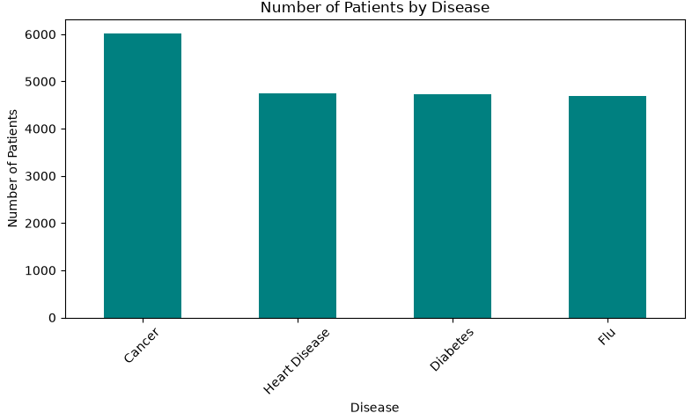

3.3 Average Treatment Cost by Disease
EDA question: How does average treatment cost vary across the recorded diseases?
Main points
- Cancer has the highest average treatment cost at about 256,587 data set units.
- Diabetes has the lowest average at about 250,317 units; the difference is about 6,270 units.
Insight: Average costs are similar across the four diseases in this data set. Disease category alone does not show a large difference in average treatment cost; patient-level factors and treatment details would be needed for a fuller cost analysis.
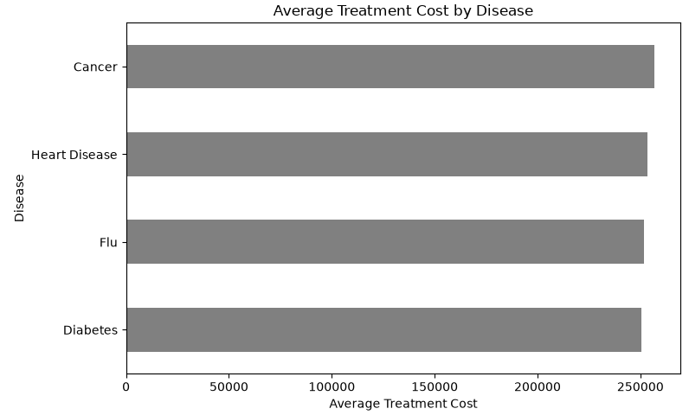

3.4 Re-admissions by Severity Level
EDA question: Does the readmission percentage differ across severity levels?
Main points
- Readmission rates are about 46.7% for High, 47.0% for Medium, and 47.5% for Low severity.
- The rates differ by less than one percentage point across the three groups.
Insight: The chart shows very similar readmission rates across severity groups. Severity level by itself does not separate readmission patterns clearly in these records, so other patient and care factors may need review.
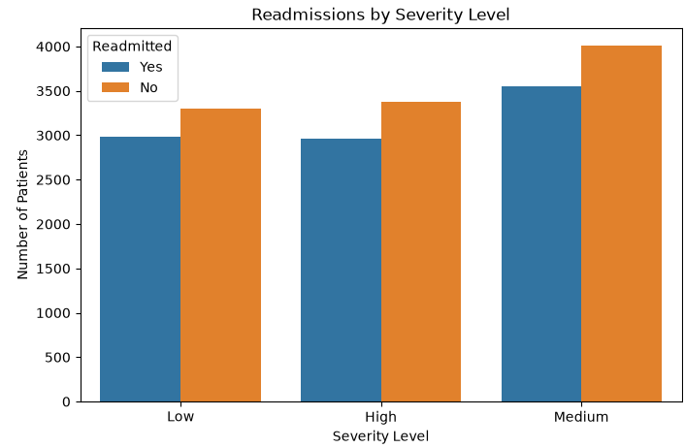

3.5 Monthly Patient Admissions
EDA question: How do admission counts change from month to month?
Main points
- The data includes admission dates from January 2024 through December 2026.
- November 2025 has 2,016 records, a sharp peak compared with most other months.
Insight: The November 2025 peak may represent a real increase or a date/data-entry issue. Validate that month before using the trend for staffing or resource planning. The data set also includes dates after October 1, 2026, which should be checked if future-dated records are not expected.
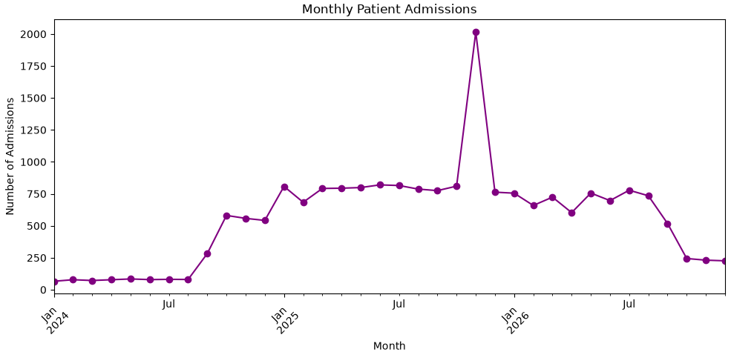

3.6 Patients by Insurance Coverage
EDA question: How many patient records are marked as covered versus not covered?
Main points
- 10,541 records (52.3%) are marked Not Covered.
- 9,630 records (47.7%) are marked Covered.
Insight: The two groups are fairly close in size, with slightly more records marked Not Covered. This split can help frame follow-up analysis of costs or access, but it does not explain why coverage differs.
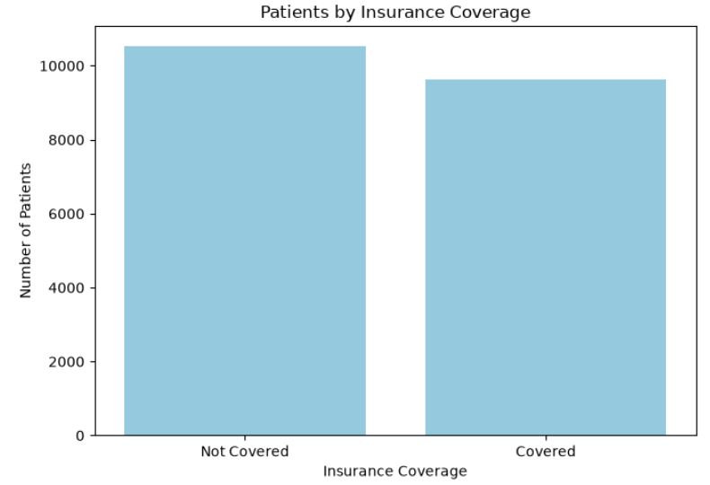

3.7 Number of Patients by Gender
EDA question: How are patient records distributed across the gender categories?
Main points
- Male accounts for 7,678 records (38.1%).
- Other accounts for 6,268 (31.1%) and Female for 6,225 (30.9%).
Insight: The data set has a larger Male category, while Other and Female have similar counts. These are record counts and should not be interpreted as population-level gender rates.
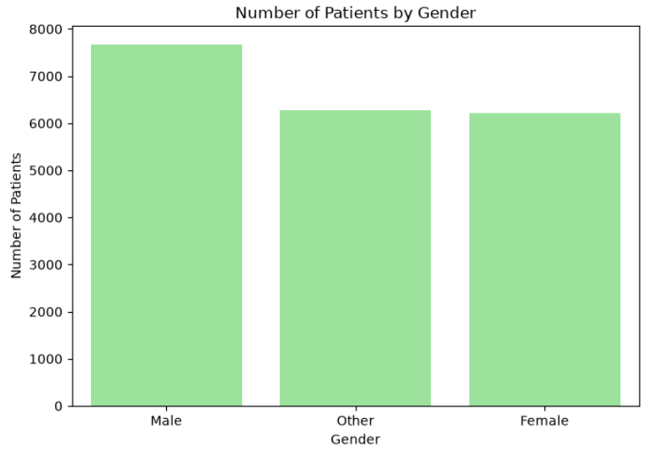

3.8 Distribution of Hospital Ratings
EDA question: Which hospital rating is recorded most often?
Main points
- Fair is the most frequent rating, with 6,017 records (29.8%).
- Excellent is least frequent, with 239 records (1.2%).
Insight: Fair is the most commonly recorded rating, while Excellent is uncommon. Because this chart counts rating entries rather than summarizing ratings by hospital, it does not by itself establish which hospitals perform best.
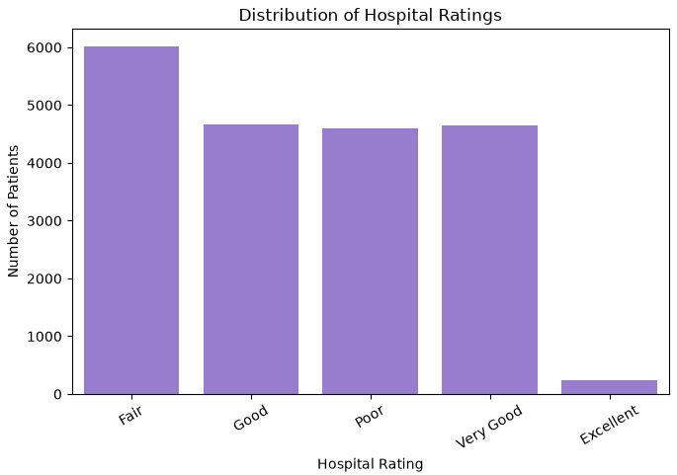
STAGE 4 · CHENDAN

4. MySQL Analysis
The following questions apply the supplied MySQL queries to the cleaned data set. Output values below are calculated from the supplied cleaned file and rounded for readability. The results summarize additional analyses run on the health care data set using MySQL.

4.1 What is the average length of stay for each disease?
Disease | Average stay (days)
Cancer | 14.93
Diabetes | 14.82
Flu | 14.82
Heart Disease | 14.95

Insight
- Average stays are very similar across the four diseases, ranging from 14.82 to 14.95 days.
- Heart disease has the longest average stay (14.95 days), only about 0.13 days above diabetes and flu.

4.2 How many re-admissions are recorded for each disease?
Disease | Readmissions
Cancer | 2812
Diabetes | 2296
Flu | 2179
Heart Disease | 2202

Insight
- Cancer has the most re-admissions (2,812), while flu has the fewest (2,179).
- These are counts, not readmission rates; differences may also reflect how many records each disease has.

4.3 What is the average medication cost for each disease?
Disease | Average medication cost
Cancer | 25,403.66
Diabetes | 25,114.84
Flu | 25,499.77
Heart Disease | 25,255.25

Insight
- Average medication costs are close across diseases, from 25,114.84 to 25,499.77.
- Flu has the highest average and diabetes the lowest, a difference of about 384.93 cost units.

4.4 Which 10 hospitals treated the most patients?
Hospital | Patient count
Smith PLC | 1246
Smith Inc | 32
Smith Group | 30
Johnson LLC | 26
Johnson Ltd | 26
Smith and Sons | 26
Johnson Group | 25
Jones and Sons | 20
Williams Inc | 20
Johnson PLC | 18

Insight
- Smith PLC has the most patient records (1,246), far more than the second-ranked hospital, Smith Inc (32).
- The large gap may reflect an especially high patient volume or hospital-name grouping differences, so it is useful to validate the records.

4.5 Which 5 states have the highest total treatment costs?
State | Total treatment cost
Colorado | 411,871,106.00
Montana | 107,064,572.00
New Mexico | 105,505,084.00
Rhode Island | 104,693,798.00
Arkansas | 104,177,405.00

Insight
- Colorado has the highest total treatment cost at 411,871,106, well above the next state, Montana (107,064,572).
- The top five states contribute substantial totals; Colorado’s total is about 3.85 times Montana’s.

4.6 How are patient records distributed across bed types?
Bed type | Patient records
ICU | 7570
Private | 6361
General | 6240

Insight
- ICU has the most patient records (7,570), followed by Private (6,361) and General (6,240).
- The three bed types have relatively similar counts, although ICU is the largest group.

4.7 Which 10 doctors handled the most patients?
Doctor ID | Patient count
298 | 1256
169 | 70
149 | 68
139 | 66
303 | 66
108 | 65
487 | 64
453 | 63
116 | 62
241 | 62

Insight
- Doctor 298 has the most patient records (1,256), while the next doctor has 70.
- This is a large difference in assigned record counts and may warrant checking workload distribution or doctor-ID data.

4.8 What is the average treatment cost for each bed type?
Bed type | Average treatment cost
General | 255,546.29
Private | 252,337.76
ICU | 252,128.96

Insight
- Average treatment costs are highest for General beds (255,546.29).
- General is about 3,208.53 higher than Private and 3,417.33 higher than ICU on average.
STAGE 5 · ANOOKYA

5. Power BI Dashboard
The Power BI dashboard provides an interactive summary of 20,171 health care records. It presents patient demographics, disease frequency, treatment and medication costs, re-admissions, monthly admissions, insurance coverage, hospital ratings, and resource use by bed type, hospital, doctor, and state. Admission dates range from January 2024 to December 2026. The source data does not identify a currency, so costs are shown in data set units.
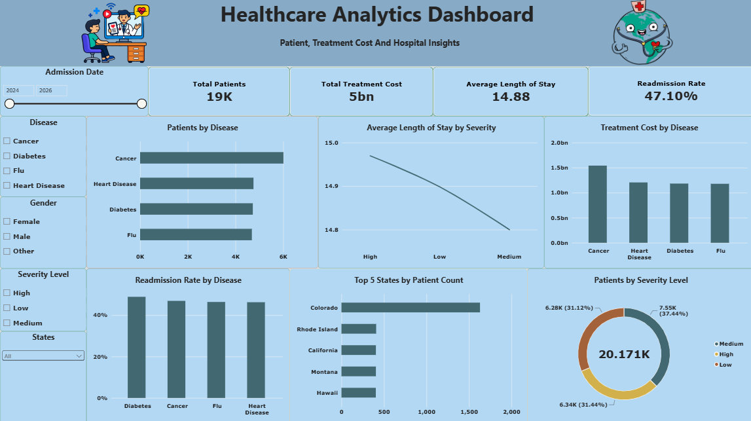

Dashboard KPIs
KPI | Value | Description
Total Patients | 19K | Number of patients
Total Treatment Cost | 5bn | Sum of treatment cost
Average Length of Stay | 14.88 days | Mean days per admission
Readmission Rate | 47.10% | Share of readmitted patients

Dashboard Slicers
The slicers on the left of the dashboard filter every KPI card and chart at the same time, so any combination of disease, gender, severity, state and admission period can be reviewed.
Slicer | Options | Use
Admission Date | 2024 to 2026 | Filters all visuals based on the selected year range
Disease | Cancer, Diabetes, Flu, Heart Disease | Compares a single disease or a group of diseases
Gender | Female, Male, Other | Splits results by patient gender
Severity Level | High, Low, Medium | Focuses on one severity group
States | All States | Provides a dropdown selection to filter the dashboard by any state

Dashboard Charts
The dashboard has six charts. Values below are read from the dashboard screenshot and are approximate where the chart shows no data label.
Chart | Type | What it shows
Patients by Disease | Bar | Cancer is highest at about 6K; the other three diseases are each about 4.7K
Average Length of Stay by Severity | Line | About 14.97 days for High, falling to about 14.80 for Medium, so the range is under 0.2 days
Treatment Cost by Disease | Column | Cancer is highest at about 1.5bn; the other three are each about 1.2bn
Readmission Rate by Disease | Column | About 47% for every disease, with Diabetes slightly highest
Top 5 States by Patient Count | Bar | Colorado leads at about 1,600 patients; the other four states are each about 400
Patients by Severity Level | Donut | Medium 7.55K (37.44%), High 6.34K (31.44%), Low 6.28K (31.12%); 20.171K in total

6. Dashboard Insights and Follow-Up
The dashboard combines patient, admission, cost, and hospital measures in one view.

Patient and disease patterns
- Cancer is the largest group: 6,008 records (29.8%). Disease counts are otherwise close; consider treatment needs and outcomes too.
- Ages range from 0 to 89; average and median are about 44. Male records account for 38.1%; Female and Other are about 31% each. These are dataset shares, not population rates.

Admissions and re-admissions
- November 2025 is the peak month (2,016 admissions). Verify this spike and dates beyond the reporting cut-off before staffing decisions.
- Readmission rates are similar by severity: High 46.7%, Medium 47.0%, Low 47.5%. Severity alone does not explain the pattern.

Costs and resource use
- Average treatment cost ranges from about 250,317 (diabetes) to 256,587 (cancer) data set units; currency is unspecified.
- ICU has the most records (7,570). General beds have the highest average cost (about 255,546 units), above Private (252,338) and ICU (252,129).
- Colorado totals about 411.9 million units versus Montana’s 107.1 million. Validate this unusually large gap before budget or location decisions.

Hospital ratings and data checks
- Fair is most common (6,017; 29.8%); Excellent is least common (239; 1.2%). Rating-entry counts do not rank hospitals by performance.
- Check discharge-before-admission dates and unusually high hospital/doctor counts. Confirm the cost unit and reporting period.

Recommended Actions
- Validate Smith PLC, Doctor 298, Colorado, and dates beyond the reporting cut-off; high counts may reflect missing values filled with the mode.
- Investigate the roughly 47% readmission rate across severity and disease groups; begin follow-up with the largest group, cancer.
- Review the roughly 15-day average stay against discharge planning and examine ICU admission criteria and staffing.
- Verify the November 2025 admission peak before changing staffing plans.
- Analyse patient-level cost drivers and the 52% of records marked as not insured.
- Display the cost unit and reporting period on the dashboard.

7. Final Conclusion
The project analysed 20,171 records using Python, MySQL, and Power BI.
Cancer is the largest disease group (29.8%); average stays and treatment costs are similar across diseases.
Readmission is 47.10% overall and similar across severity and disease groups; investigate other contributing factors.
ICU is the most used bed type; about 52% of records are marked as not insured, and Fair is the most common rating.
Validate unusually high hospital, doctor, and state counts, plus dates beyond the reporting cut-off.
After validation, the dashboard can support discharge planning, resource allocation, and cost control.

