CIS 3319 Your Name: _CHENER ZHANG_
Your Partner’s Name: ____CAME___

Lab Exercise One - RSA Public-Key Encryption
In this lab, you will be working with a simplified version of one of the most popular public-key systems: the RSA public-key encryption system. In RSA, this operation is the multiplication of two large prime numbers: it is easy and fast to multiply the two numbers together, but it is significantly more difficult and time consuming to factor the resulting number back into its prime components. In this lab experience, you will be using relatively small primes (only three digits) to see how this system works.
To explore this system in more depth, you will be exchanging encrypted messages with a partner.
First, find your partner.

- Launch Microsoft Excel and open the spreadsheet: rsa.xls.
You may see a warning message informing you that the workbook contains macros. Since you will not need these macros to use the workbook (they are left over from an older and less efficient version of this lab), click on the Disable Macros button.
- This spreadsheet makes use of some specialized functions that are not part of the standard function set in Microsoft Excel. However, they are included in an extra set of functions called the Analysis Toolpak. From the Excel Options menu, choose Add-Ins…. Click the button Go…. In the dialogue box, click on the check box to the left of the entry Analysis Toolpak. When a checkmark appears, click on OK.
- If necessary, click on the tab for the Key Selection worksheet. Use a random process to choose two different prime numbers p and q between 137 and 311 (displayed in a list in cells g5:I15). Enter these primes in cells B6 and B7. Be sure that cells C6 and C7 both display the message “OK”. The spreadsheet automatically computes the modulus (n = p*q) in cell B8 and the Euler totient (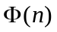= (p-1)*(q-1)) in cell B9. Note that the Euler totient would be difficult to determine from the modulus by itself; one needs to know the two primes. Write your two primes, your modulus, and your Euler totient below:
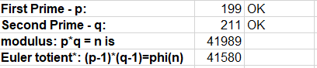
- Choose a small number (no more that two digits) that has no factors (except 1) in common with the Euler totient. Enter this number as your public key and enter it in cell B15. If cell C15 displays the message Invalid Public Key, you need to select a different public key. When you have chosen a valid public key, the message OK will appear in cell C15. The spreadsheet will automatically compute your private key in cell B20. The private key is chosen so that (Public Key)*(Private Key) leaves a remainder of one when divided by the Euler totient. (This would not be possible if the private had a factor other than 1 in common with the Euler totient.) Write your public and private keys below:
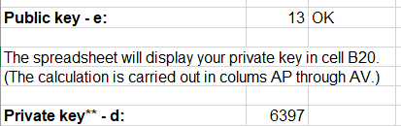
- Once both you and your partner have each created a modulus and pair of keys, you are ready to exchange encrypted messages. Give your modulus and public key to your partner. Do not give your partner your private key or Euler totient. In return, your partner will give you her/his public key and modulus.
- Click on the tab for the Encoding worksheet. Enter your partner’s modulus and public key in cells B6 and B7. Write these values below:
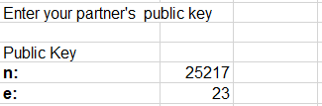
- Enter a message in cell B11. This message should consist of a string of fifteen or more capital letters with no spaces or punctuation marks. The spreadsheet will encipher only the first fifteen letters of your message. Your message could be a short phrase or sentence, your mother’s name or your pet iguana’s name. For example, you can use PLEASEHELPMENOW to test this spreadsheet. Note that a message to be enciphered is usually called plaintext. The enciphered form of the message is called the ciphertext.
- The ciphertext will appear in cell B13. (At the end of step 8.) The spreadsheet determines the ciphertext as follows:
- Split the plaintext up into blocks of three letters (called trigraphs).
- Obtain a numeric representation for each letter based on its position in the alphabet (A→0, b→1, etc.).
- Compute a numeric code for each trigraph using the formula
(First Letter Code) * 26² + (Second Letter Code) * 26 + (Third Letter code).
For the mathematically inclined, this is interpreting each trigraph as a number in base twenty-six.
- Encipher each plaintext trigraph code by computing (Plaintext trigraph code)^{Public Key}, dividing the result by the Modulus and taking the remainder – RSA encryption.
- Convert each enciphered trigraph code into a quadragraph – a block of four letters – as follows:
- Divide the code by 26^{3.} The quotient is the code for the first letter of the quadragraph. The spreadsheet uses the remainder to get codes for the other three letters.
- Divide the remainder from the first step by 26². The quotient is the code for the second letter. The spreadsheet uses the remainder to get the codes for the other two letters.
- Divide the remainder from the second step by 26. The quotient is the code for the third letter and the remainder is the code for the fourth letter.
For the mathematically inclined, this quadragraph calculation determines the representation of the enciphered message as a four-digit number in base twenty-six (using the letters of the alphabet as our digits).

Some of the details of this calculation appear in cells A16:K38 of the Encoding worksheet. Enter the plaintext and ciphertext below. Show the steps of the conversion process in the table.
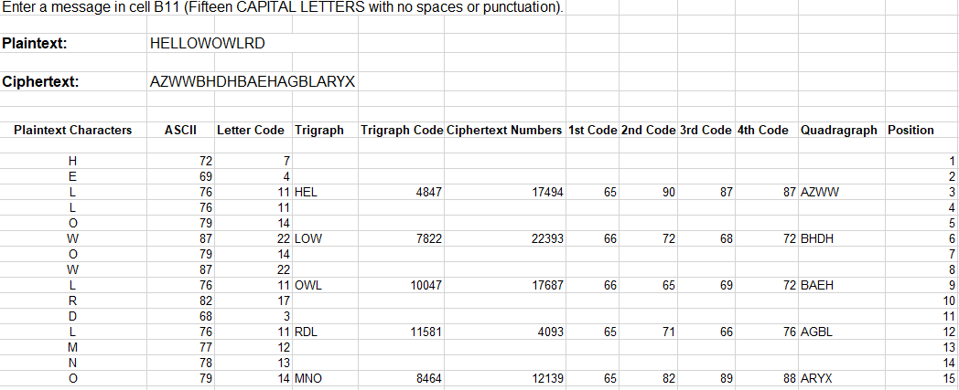
- Give the ciphertext (but not the plaintext) to your partner. In return, your partner will give you a ciphertext message. Record the ciphertext message from your partner below. In the rest of this exercise, you will be deciphering this message.
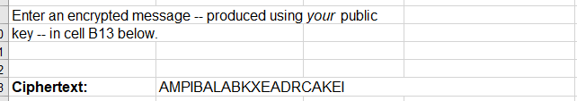Click on the tab for the Decoding worksheet. Enter your modulus and your private key in cells B6 and B7 of this worksheet. Enter the ciphertext you received from your partner as the “Encrypted Message” in cell B13. The deciphering process is similar to the enciphering process:
- Split the ciphertext up into quadragraphs (instead of trigraphs).
- Obtain the numeric representation for each letter and compute a numeric code for each quadragraph using the formula
(First Letter Code) * 26³ + (Second Letter Code) * 26² + (Third Letter Code) * 26 + (Fourth Letter Code).
RSA Decryption - Decipher each ciphertext quadragraph code by computing
(Ciphertext quadragraph code)^{Private Key},
dividing the result by the Modulus and taking the remainder
- Convert each deciphered quadragraph code into a trigraph.
- Divide the code by 26². The quotient is the code for the first letter.
- Divide the remainder from the first step by 26. The quotient will be the code for the second letter and the remainder the code for the third.

Note that deciphering uses the private key in place of the public key. Some of the details of this calculation appear in cells A19:D23 of the Decoding Worksheet. The deciphered message should appear in cell B13. Record the results of each deciphering step in the table below.

