  - Cheng-Lung, Peng
  - Email: philip01169@gmail.com
  - Phone no: +886-933-043027
  - Education
National Taiwan University, Taipei, Taiwan
Master of Science in Computer Science and Information Engineering Sept. 2011 - Aug. 2013
(GPA: 4.20/4.30)

National Cheng Kung University, Tainan, Taiwan
Bachelor of Science in Computer Science and Information Engineering Sept. 2007 - June 2011
(GPA: 3.89/4.0)

  - Skills & Qualifications
7+ years of programming experience using C/C++ on Linux and MS Windows
1+ years of programming experience using Java with Eclipse IDE
1+ years of programming experience using HTML and JavaScript

  - Language Abilities
Chinese: native
English: intermediate
Japanese: beginning

  - Honors & Awards
Academic Achievement:
National Outstanding Collegians in Taiwan, 2011
Presidential Award in National Cheng Kung University, 2008-2009

Programming:
Second Place, Southern Collegiate Programming Contest, 2011
Honorable Mention, ACM-ICPC Asia Kaohsiung Regional Contest, 2010
Third Place, National Collegiate Programming Contest, 2010
Rank 6/124 (3.8%), Basic/Graduate Programming Exam, Oct. 11, 2010
Seventh Place, Central Collegiate Programming Contest, 2010
Rank 1105/3000 (37%), Google Code Jam Round 2, 2010
Rank 806/3075 (26%), Google Code Jam Round 1C, 2010
Third Place, Southern Collegiate Programming Contest, 2010
Third Place, CSIE Programming Contest in NCKU, 2010
Fourth Place, C/C++·Java programming contest in Yuan Ze University, 2010
Second Place, CSIE Programming Contest in NCKU, 2009

Others:
Second Place, Mahjong Contest in Taoyuan City, Oct. 4, 2015
Second Place, Mahjong Contest in Taoyuan City, Sep. 5, 2015
Second Place, Mahjong Contest in Zhongli Dist., Taoyuan City, June 2015
First Place, Mahjong Contest in National Taiwan University of Science and Technology, 2011
Semifinals, Microsoft Third Teenage Reasoning King, 2008
  - Related Experience/Projects
Related Experience:

VIVOTEK, New Taipei City, Taiwan
Firmware Engineer in the Department of Project Development Dec. 2014 - Present
Thesis:

Topic: Delay-sensitive In-network Data Aggregation for Server-centric Datacenters
Advisor: Cheng-Fu Chou (周承復)
Laboratory: Communications and Multimedia Laboratory

Thesis Summary: In this paper, we investigated the problem of minimizing bandwidth consumption through data aggregation in on-line and deadline-aware services for server-centric data center networks. We know that the amount of processing data is enormous in these services, and therefore we can make a lot of profit even though we only save a small portion of total bandwidth consumption. We formulate the problem as an Integer Program to show the difficulty of solving it in polynomial time. After that, we propose an algorithm that uses the property of multiple paths between servers to build a shortest-path Steiner tree. We evaluate its performance against the optimum and other works about solving the Steiner tree problems. Our results confirm that our SDC aggregation-tree algorithm can achieve lower bandwidth consumption (about 18.5%) and lower delay no matter for instances or for flows than the previous heuristic algorithms.

  - Autobiography
My name is Philip. I had a dream of studying Computer Science at university during my adolescence. Both my parents supported my decision, so I could learn without any worries. I hope my way could be an example for my younger brother who is also majoring in Computer Science.
I didn’t know how to manage my time effectively when I was a freshman; however, I participated in many activities in the Department of Computer Science and the clubs at school. At the end of the semester, I thought I couldn’t take everything well. Dr. Lai, the principal in NCKU, once said, “Students should not only play but grow at university.” I rethought what I would like to get in the four years after these words. After adjusting my timetable and taking exams again and again, I regained my lost confidence and took the first place during the second semester. In the next year, I played roles of the Minister of Activities in Recreation Leader Training Association, the same job in the Computer Science Week and the class monitor. At that time I could allocate my time efficiently and finally won the presidential award in my sophomore year; besides, I was selected as one of national outstanding collegians before graduation.
I practiced ACM problems during the rest of my college years. This could enhance logical thinking, teamwork and programming skills. Furthermore, thanks to my professor Dr. Chou, I finished my master thesis in the Communications and Multimedia Laboratory and the topic is “Delay-sensitive Data Aggregation for Server-centric Datacenters.” The honors and the thesis summary are listed above.
VIVOTEK is the first company I joined. I am responsible for solving sample requests and developing Original Design Manufacturer (ODM) products. In this position, I can work with many people from different departments, thus improving communication skills; moreover, when I need to modify modules I am not familiar with in limited time, I have to ask my good colleagues in the same division for help, and I can also give them ideas on other tasks. The program languages I use in this job are C, Shell, HTML and JavaScript on Linux platform.
I have been a Dcard user for three years. It would be my pleasure if I could have a chance to contribute to Dcard. I hope that you will give me an interview at some time convenient to you.

Transcripts (English Version with GPA)
Image of transcript in Master:
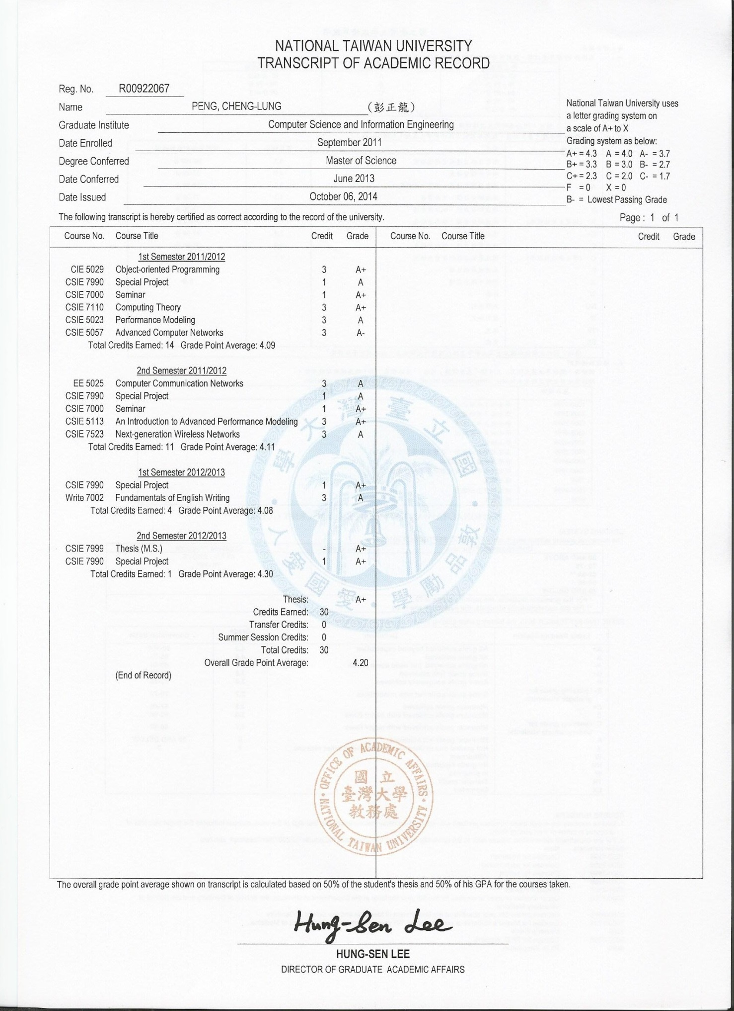
Image of transcript in Bachelor:

