1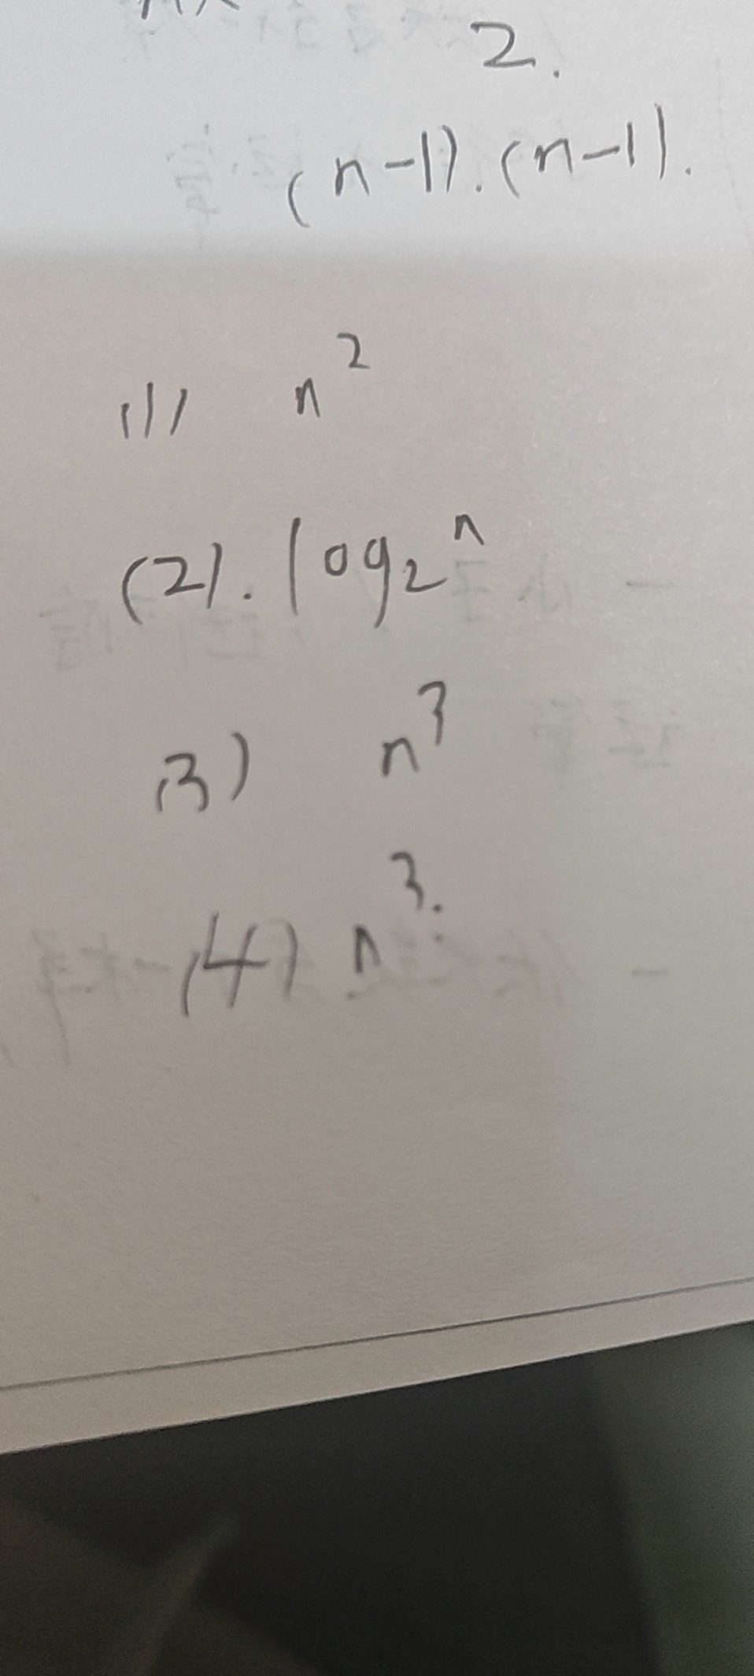

2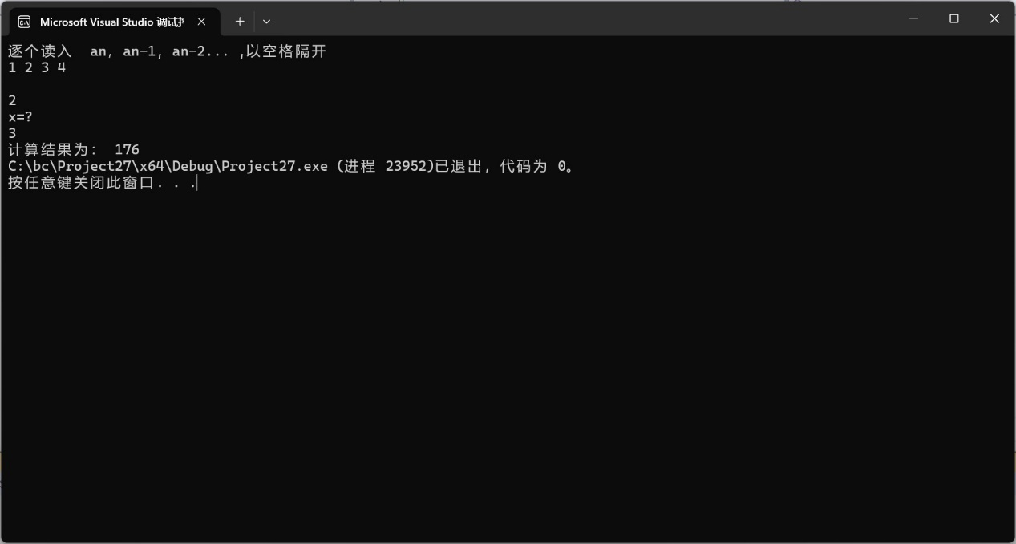

#include <iostream>

#include <vector>

using namespace std;

int main(int argc, char** argv) {

cout << "逐个读入 an，an-1, an-2... ,以空格隔开" << endl;

vector<int> a;

int i = 0;

do {

cin >> i;

a.push_back(i);

} while (getchar() != '\n');

int x;

cout << "x=?" << endl;

cin >> x;

int value = a[0];

for (int i = 0; i < a.size() - 1; i++)

{

value = value * x + a[i + 1];

}

cout << "计算结果为： " << value;

return 0;

}

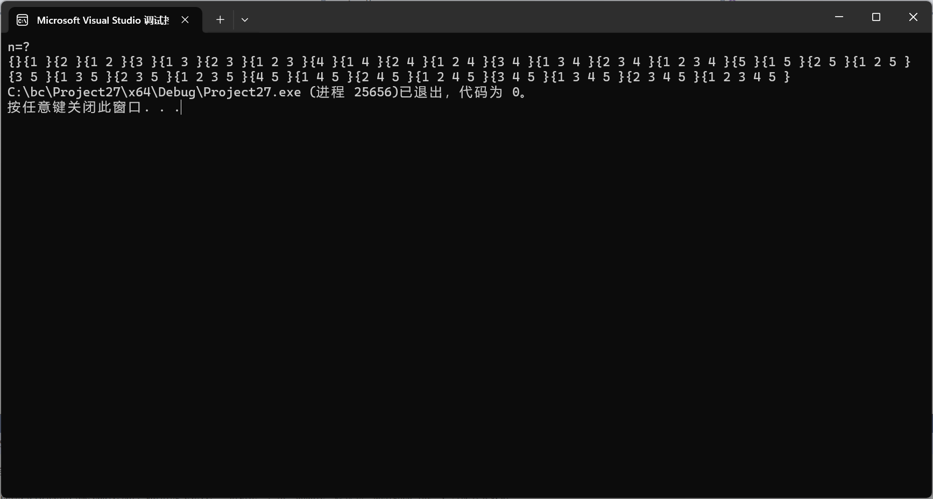

#include <iostream>

#include <math.h>

using namespace std;

void printPowerSet(int* set, int set_size)

{

unsigned int pow_set_size = pow(2, set_size); // 幂集集合个数为2^n

int counter, j;

/*Run from counter 000..0 to 111..1*/

for (counter = 0; counter < pow_set_size; counter++) {

cout << "{";

for (j = 0; j < set_size; j++) {

/* 1<<0 = 1 1<<1 = 10 1<<2 = 100

eg.counter = 7 = 111

那么 set[0] set[1] set[2]都要输出

*/

if (counter & (1 << j))

cout << set[j] << " ";

}

cout << "}";

}

}

/*Driver code*/

int main()

{

cout << "n=?" << endl;

int set[5];

for (int i = 0; i < 5; i++) set[i] = i + 1;

printPowerSet(set, 5);

return 0;

}

3

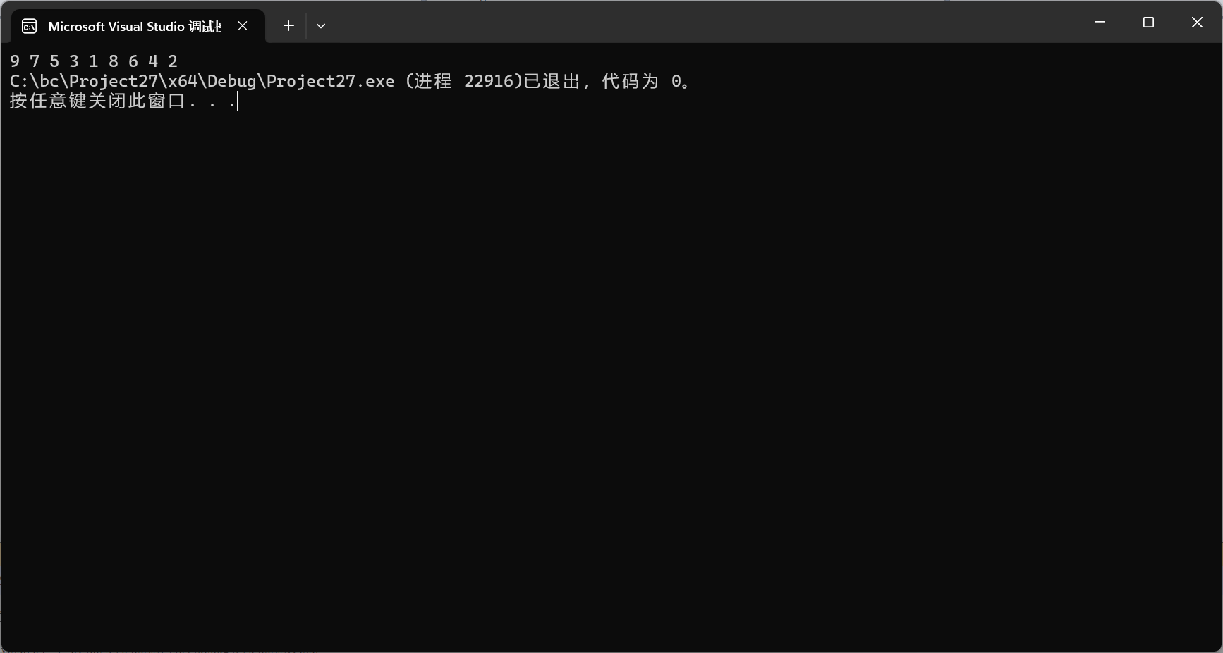

#include<iostream>

using namespace std;

void Get(int A[], int MaxSize)

{

int first(0), last(MaxSize - 1);

while (first < last)

{

if (A[first] % 2 == 1 && A[last] % 2 == 0)

{

first++; last--;

continue;

}

if (A[first] % 2 == 0 && A[last] % 2 == 1)

{

int m = A[first];

A[first] = A[last];

A[last] = m;

first++; last--;

continue;

}

if (A[first] % 2 == 1 && A[last] % 2 == 1)

{

first++;

continue;

}

if (A[first] % 2 == 0 && A[last] % 2 == 0)

{

last--;

continue;

}

}

}

void Print(int a[], int Maxsize)

{

for (int i = 0; i < Maxsize; i++)

{

cout << a[i] << " ";

}

}

int main()

{

int array1[] = { 2,4,6,8,1,3,5,7,9 };

int array1Size = sizeof(array1) / sizeof(int);

Get(array1, array1Size);

Print(array1, array1Size);

}

5.

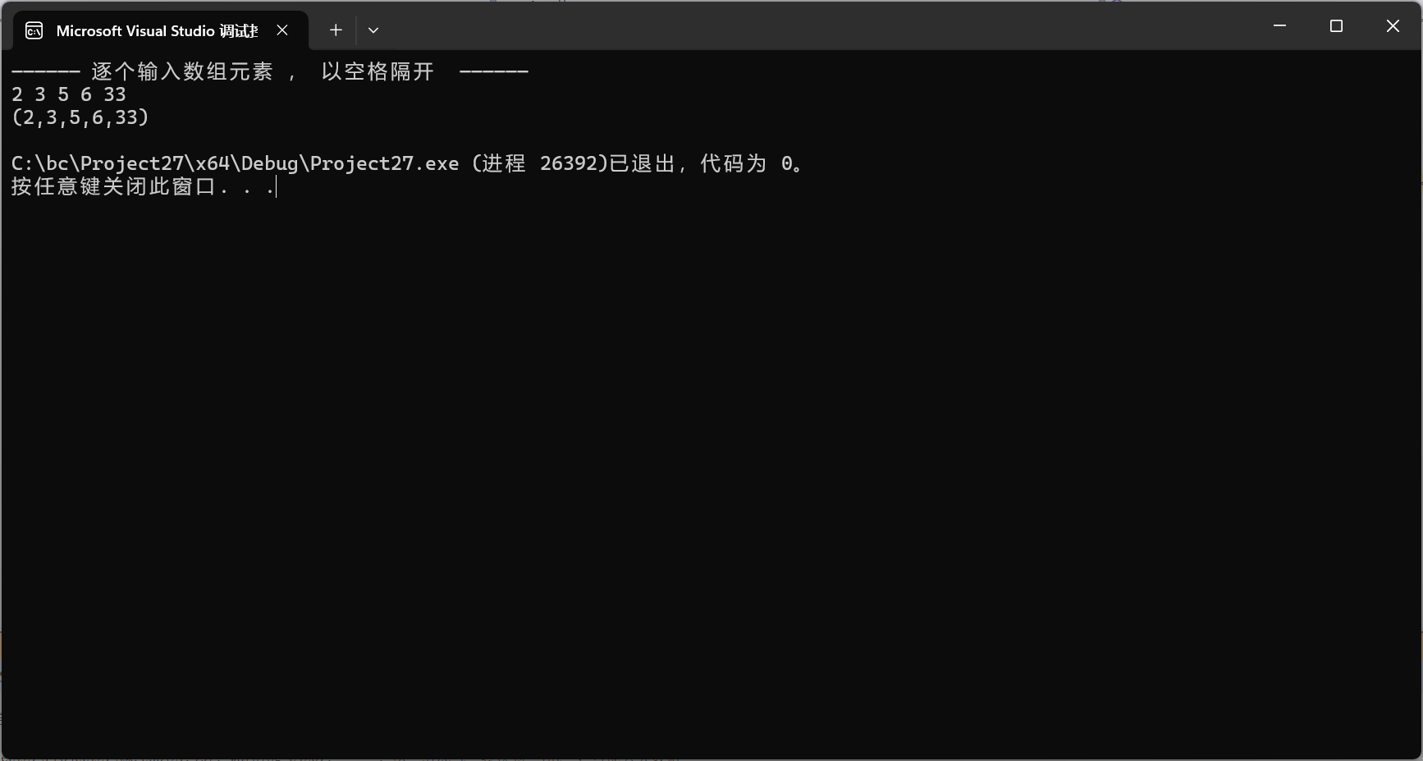

#include <iostream>

#include <vector>

using namespace std;

int main(int argc, char** argv) {

cout << "—————— 逐个输入数组元素 ， 以空格隔开 —————— " << endl;

vector<int> a;

int i = 0;

do {

cin >> i;

a.push_back(i);

} while (getchar() != '\n');

int start = 0;

int end;

for (int i = 1; i < a.size() - 1; i++) {

if (((a[i - 1] > a[i]) & (a[i] < a[i + 1])) | ((a[i - 1] < a[i]) & (a[i] > a[i + 1]))) {

end = i;

cout << "(";

for (int j = start; j < end + 1; j++) {

cout << a[j];

if (j != end) cout << ",";

}

cout << ")" << endl;

start = end;

}

if (i == a.size() - 2) {

end = a.size() - 1;

cout << "(";

for (int j = start; j < end + 1; j++) {

cout << a[j];

if (j != end) cout << ",";

}

cout << ")" << endl;

}

}

return 0;

}