HW_5_Robotics_multirotors_0851084

1. Linear optimization
2. Use xlsread() to load data from .xls file to matlab workspace.
3. Define $A$ and $Y$ that mentioned in lecture.
4. By $x={\left(A^{T}A\right)}^{-1}A^{T}Y$, calculate the vector $x$.
5. Use xlswrite() to write data from matlab workspace to .xls file.
6. Gradient Descent
7. Use xlsread() to load data from .xls file to matlab workspace.
8. Normalize the accelerometer measurement from .xls file.
9. Set initialized orientation ${}_{E}^{S}{q_{0}}$
10. Set learning rate $μ$ and iterations.
11. By $f\left(\begin{matrix}{}_{E}^{S}{\hat{q}}, & {}_{}^{E}{\hat{d}}, & {}_{}^{s}{\hat{S}}\end{matrix}\right)=\left[\begin{matrix}2\left(q_{2}q_{4}-q_{1}q_{3}\right)-a_{x} \\ 2\left(q_{1}q_{2}+q_{3}q_{4}\right)-a_{y} \\ 2\left(\frac{1}{2}-{q_{2}}^{2}-{q_{3}}^{2}\right)-a_{z}\end{matrix}\right]$,

$J_{g}\left({}_{E}^{S}{\hat{q}}\right)=\left[\begin{matrix}\begin{matrix}\begin{matrix}-2q_{3} & 2q_{4}\end{matrix} & \begin{matrix}-2q_{1} & 2q_{2}\end{matrix}\end{matrix} \\ \begin{matrix}\begin{matrix}2q_{2} & 2q_{1}\end{matrix} & \begin{matrix}2q_{4} & 2q_{3}\end{matrix}\end{matrix} \\ \begin{matrix}\begin{matrix}0 & -4q_{2}\end{matrix} & \begin{matrix}-4q_{3} & 0\end{matrix}\end{matrix}\end{matrix}\right]$,

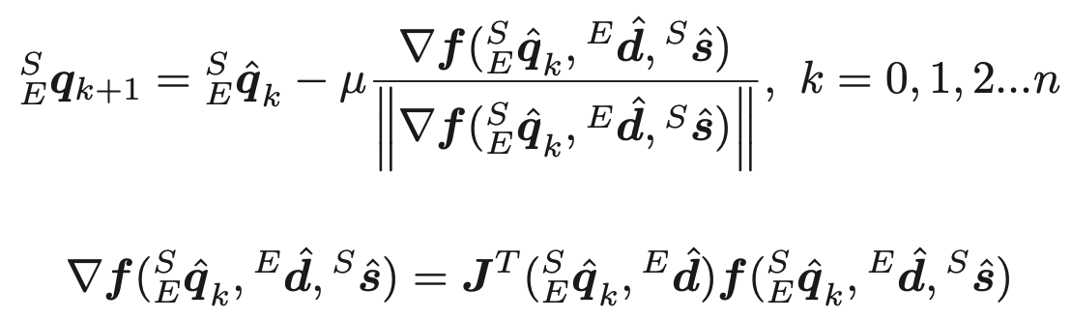

Calculate orientation in every step.

