Get: companies

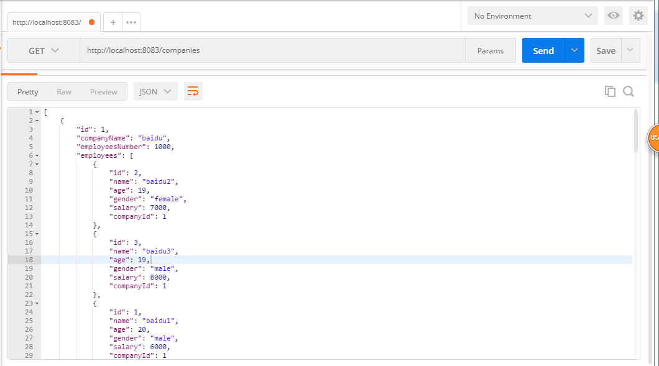

Get: <http://localhost:8083/companies/1>

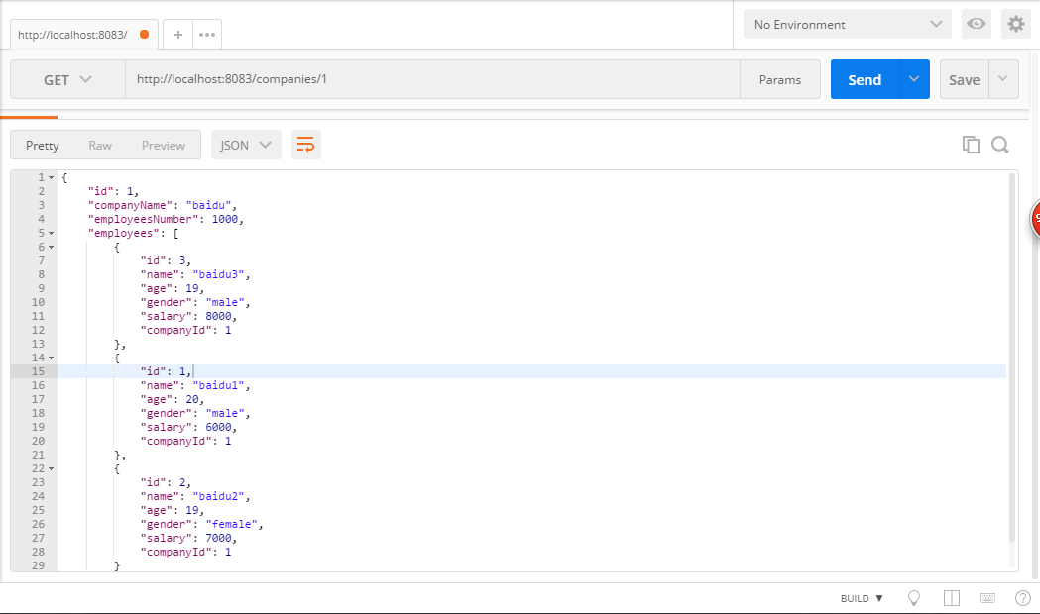

Get: <http://localhost:8083/companies/1/employees>

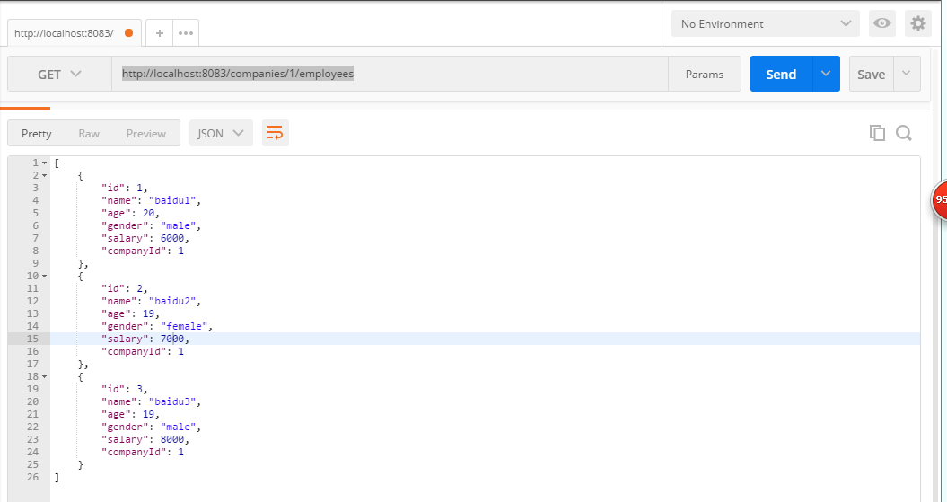

Get: http://localhost:8083/companies/page/1/pageSize/5

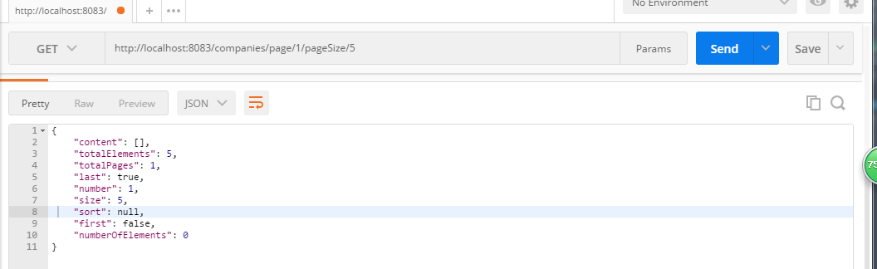

Post: http://localhost:8083/companies?companyName=myCompany&employeesNumber=100

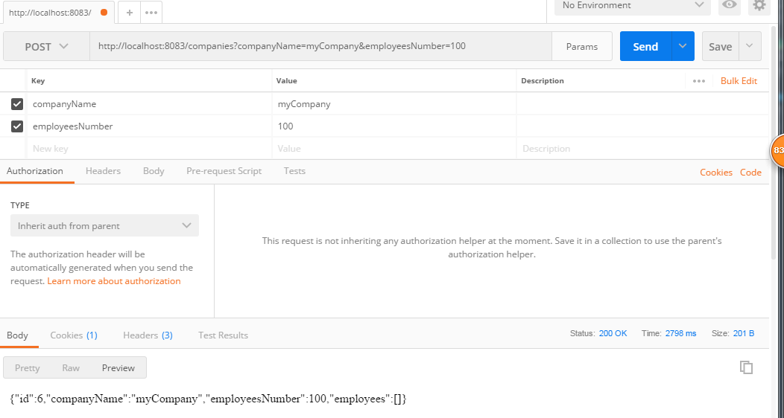

Put: http://localhost:8083/companies/6?companyName=test_updata&employeesNumber=12

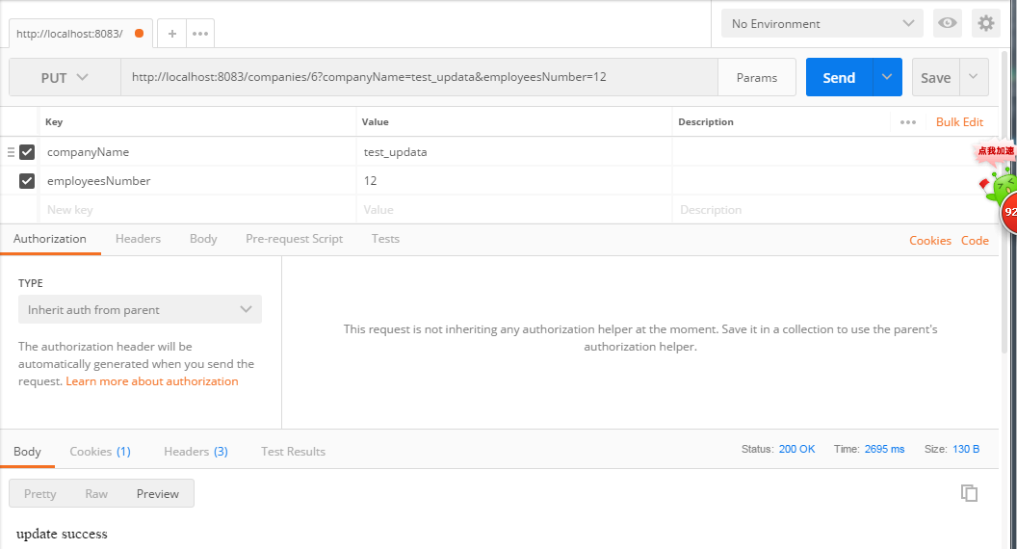

Delete: http://localhost:8083/companies/1

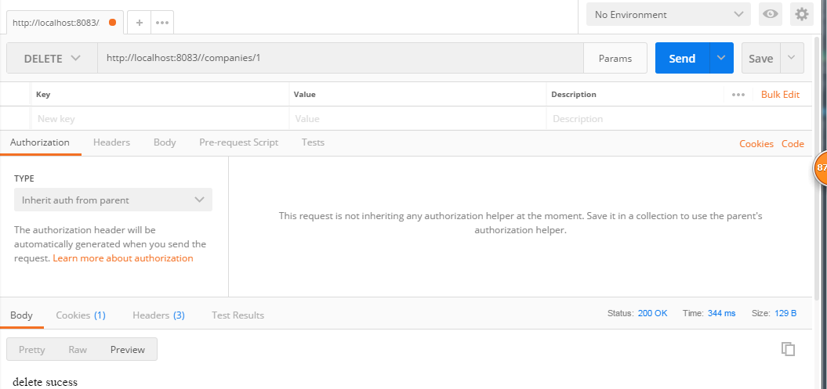

Get: http://localhost:8084/employees

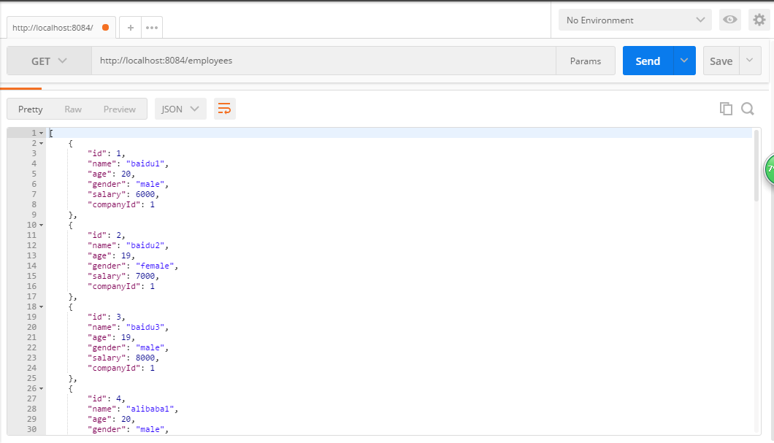

Get: <http://localhost:8084/employees/1>

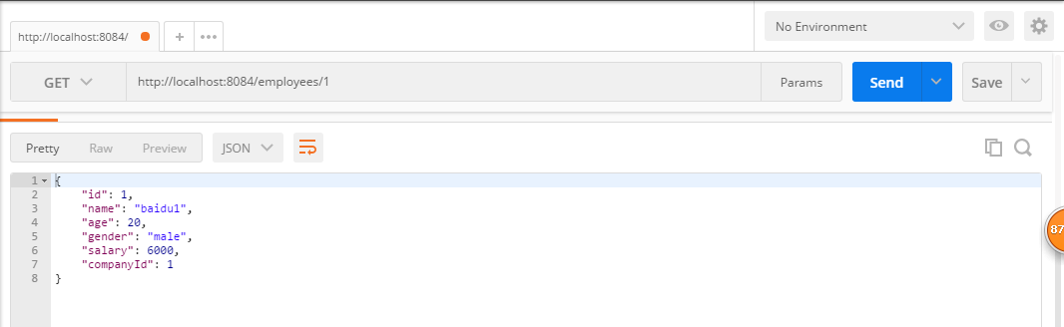

Get: http://localhost:8083/employees/page/1/pageSize/5

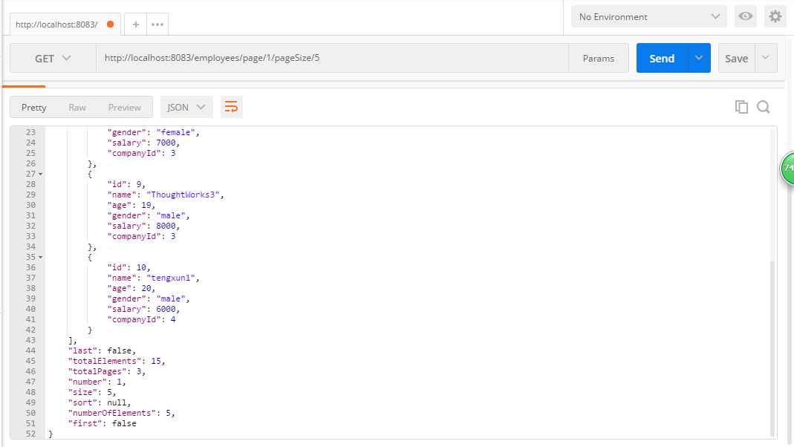

Get: http://localhost:8083/employees/male

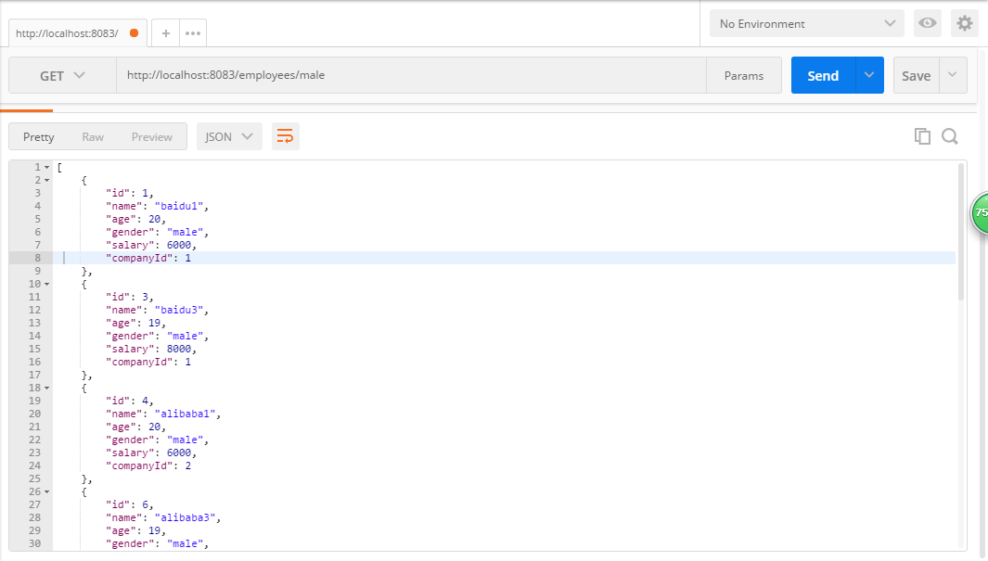

POST: http://localhost:8083/employees?name=testadd&age=12&gender=male&salary=1000&companyId=2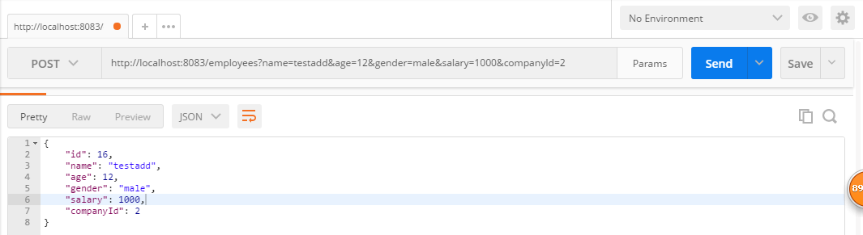

Put: http://localhost:8083/employees/16?name=testaupdate&age=12&gender=male&salary=1000&companyId=2

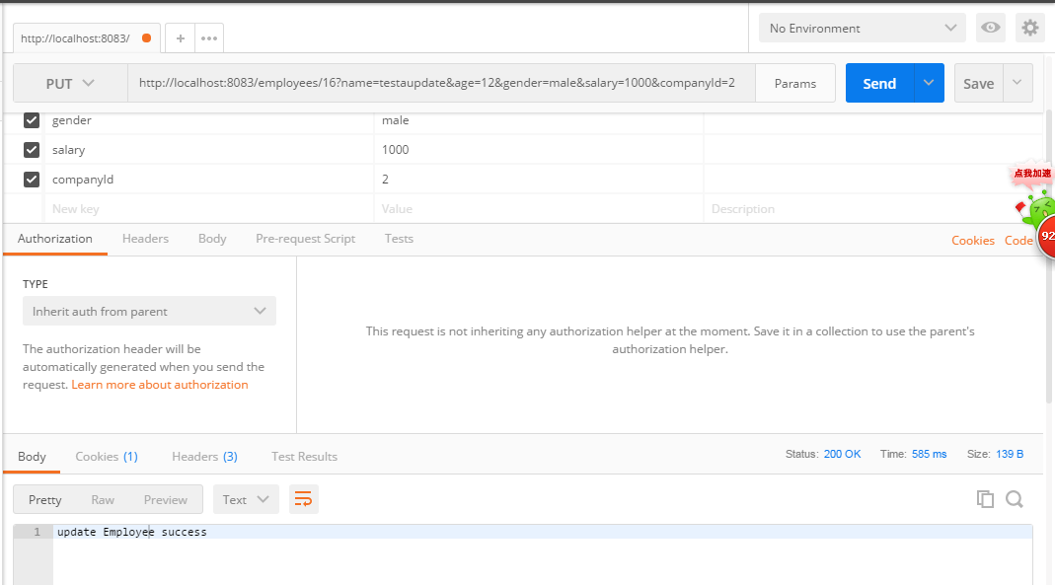

Delete: http://localhost:8083/employees/1

