PART I: on Emp2 expression in fixed single-cell RNA libraries.
Following up from our last discussion regarding overall Emp2 gene expression in our single-cell libraries, we double checked our pipeline to find any potential source of signal loss for this gene. Our conclusion is:
- Count summarization and normalization didn't seem to affect our Emp2 expression estimates in any sample, and the reported levels match those expected based on data alignment.
- To fully address this issue, we screened the raw data from scratch looking for all the sequencing reads that could potentially match Emp2 probes. The 10X mouse probe set for this single cell platform includes 3 different probes targeting Emp2:
GAAGCTCCGATCATGACACACAGACAGGACATGAGCTGGATGATGGACGT | ENSMUSG00000022505|Emp2|3fb85fb | spliced
TGGTAGAAATGAACAGGAGTGCCGTGGACACGATGTGGAAGACAATGATG | ENSMUSG00000022505|Emp2|a178ea9 | unspliced
TCGGTACAGTTTGTGCTGTTGGTGCACACTCTCCAGAGGTCAGCAGAGAA | ENSMUSG00000022505|Emp2|baa5e6d | unspliced

- Of the three probes, one targets the splice junction in the last 2 exons, and the remaining probes target the other 2 coding exons. Most genes in the panel are equally targeted by 2 unspliced and 1 spliced probe.
- We performed a brute-force search of the 3 probes through the entire raw sequencing files, to estimate the maximal number of counts we could expect for Emp2 before any analysis and filtering is performed. What we found is that the maximum number of Emp2-derived sequence reads in the raw files closely matched the original number of counts we had compiled using the 10X processing pipeline.
- We therefore conclude that Emp2 is in the low-expression tail for all/most of the retinal cell types. This agrees with what we have found before in bulk RNA-Seq, but it is aggravated here as, in single-cell screens, at typical sequencing depth the number of detected genes is, at best, sparse in most cases.
- To understand how this compares with an external single-cell reference (Human Protein Atlas, https://www.proteinatlas.org/), we checked human EMP2 raw expression in retinal cell types as compared to highly expressed cell markers.
- EMP2 shows ~1.5counts/cell in RPEs, and less than 1count/cell in Muller glial cells (although there seems to be a subcluster of EMP2-high Muller glial
- In contrast, the clustering gene (CLU) shows 3,500counts/cell in RPEs and 50 counts/cell in Muller glial cells.
- The distribution across cell-types in our samples largely matches that found in human, with predominant expression of EMP2 in the endothelial compartment, followed by epithelial subtypes.
- It is worth mentioning that the same results apply for the Cav1 gene discussed before, predominantly endothelial and also in the low-expression tail of most retinal cell types including RPEs.

PART II. GSEA pathway analyses
Note: most of the analyses presented below are based on Gene Set Enrichment analysis for specific functional categories (barrier, signal transduction, angiogenesis). The lists of genes employed can be found in Supplementary_2/GSEA_genelists/
A. Barrier genes – RPE (2174 cells). Results in Supplementary_2/barrier/
To visualize the expression trends of barrier genes between WT and Emp2 knockout (Emp2ko) in RPE cells, we generated a scatter plot using the signed log p-values from differential expression analyses. The x-axis represents the signed log p-values for the WT_nor vs. WT_OIR comparison, while the y-axis corresponds to the Emp2ko_nor vs. Emp2ko_OIR comparison. Barrier genes with an absolute signed log p-value greater than 2 in only one of the genotypes are highlighted in red.
Of note, the Atp1b2 gene is strongly upregulated after OIR in WT mice, showing little regulation in Emp2ko mice. This and other Na,K-ATPases subunits have been implicated in age-related RPE dysfunction and polarity (https://pubmed.ncbi.nlm.nih.gov/30160348/ , https://pubmed.ncbi.nlm.nih.gov/32855284/). On its turn, the Slc7a5 aminoacid transporter (a.k.a. Lat1, expressed in ARPE-19 cells https://pubmed.ncbi.nlm.nih.gov/19890975/) shows more significant upregulation after OIR in Emp2ko mice, and a significant down-regulation of the transferrin receptor gene (Tfrc) may protect RPE cells from oxidative damage in Emp2ko mice by reducing iron levels (highly speculative, we know).
The full differential expression results of barrier genes in both phenotypes is provided as a supplementary table (RPE_table.csv). In addition to the genes highlighted here and in the figure below, this table can be used to identify other genes with genotype-specific effect size (e.g. Gja1, a.k.a Connexin 43, is much more strongly upregulated in response to OIR in Emp2ko, a gene involved in many aspects of RPE function as Rab11 trafficking, gap junction and electrical transport in RPEs https://pubmed.ncbi.nlm.nih.gov/35275193/).

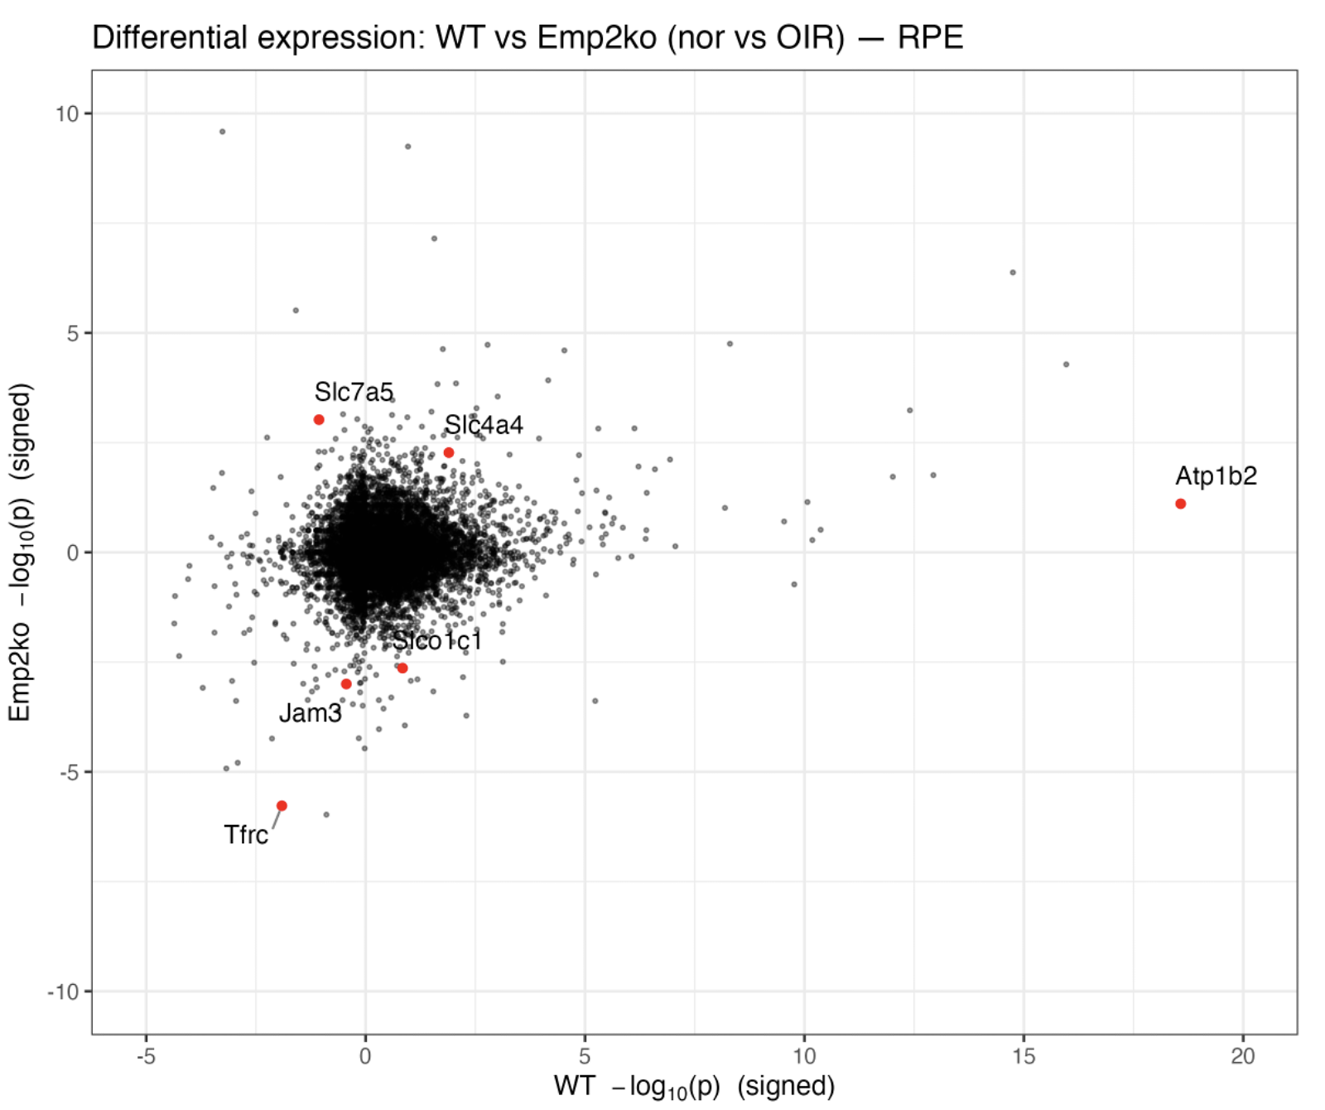

B. Analysis of signal transduction pathways. Results in Supplementary_2/signal_transduction/
For this analysis, we merged the BC and R_BC clusters to generate a unique bipolar cell (BCs) cluster (259 cells total). We also analyzed the Rp cluster (7071 cells). On these cell clusters, we conducted Gene Set Enrichment Analysis (GSEA) to assess if genes involved in signal transduction (a large gene set obtained from reference databases) were enriched among those differentially expressed between normoxia and oxygen-induced retinopathy (OIR) conditions.
B.1. WT (nor_vs_OIR)
In wild-type samples, we observe a positive enrichment of signal transduction genes in both Rp and BC cells (more significant in the former). It is worth noting that there is a substantial difference in cell numbers between the two clusters: 7,071 cells in the Rp versus only 259 in the BCs, and therefore harder to reach statistical significance in BCs.
Still, the signal transduction gene set is so big and diverse that a more insightful analysis may require semi-manual interpretation of the behavior of smaller sets or individual genes, particularly as compared to their trend in Emp2KO mice.
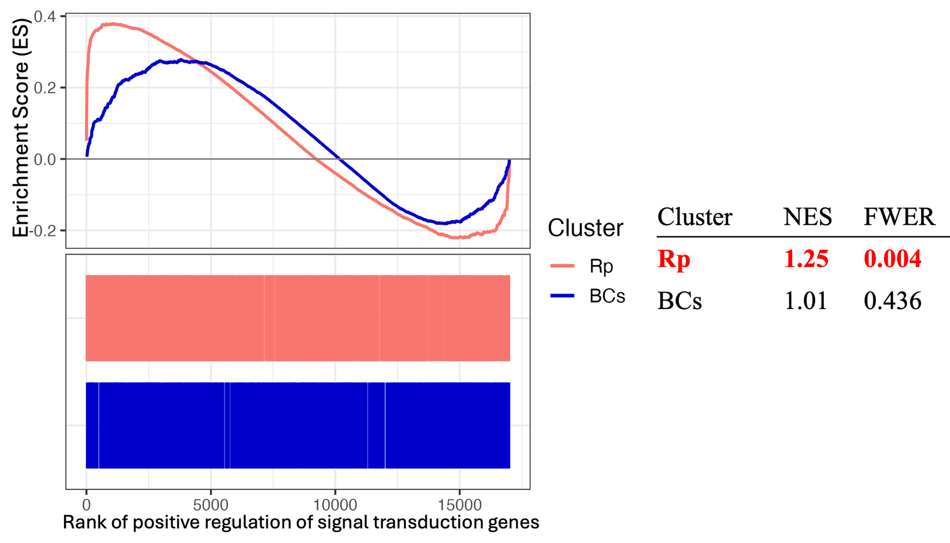

B.2. Emp2KO (nor_vs_OIR)
It is therefore striking that, in the Emp2ko samples, we do not observe any (statistically) significant positive or negative enrichment of signal transduction genes in any cluster.
There are still, of course, numerous signal transduction genes significantly up/down regulated. The next sections provide a more detailed account of differences in specific signal transduction genes between both genotypes.
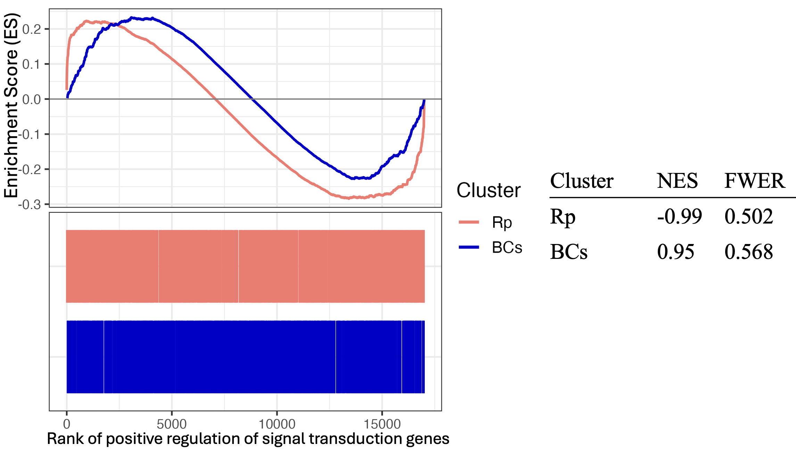

B.3. BCs (259 cells), differences between WT and Emp2KO
The plot below compares the expression changes of signal transduction genes between WT and Emp2ko in BCs cells. The signal transduction genes with an absolute signed log p-value greater than 2 specifically in one genotype are highlighted.
Overall, WT BCs seem to be more responsive to OIR that Emp2KO BC cells, specifically for signal transduction genes. As an example, Fgf2 and Edn2 are both secreted protective factors in the retinal microenvironment (https://pubmed.ncbi.nlm.nih.gov/31979254/ https://pubmed.ncbi.nlm.nih.gov/32150249/) and WT cells regulate these genes more significantly after OIR. The Unc13a gene (a.k.a. Munc13) is involved in synaptogenesis and synaptic vesicle maturation, and its isoforms are known to define specific subsets of bipolar cells (https://pubmed.ncbi.nlm.nih.gov/33105896/). It is also one of the few genes transcriptionally regulated during transcorneal electrical stimulation (https://pmc.ncbi.nlm.nih.gov/articles/PMC11656077/). It is also striking that WT bipolar cells upregulate Vegfa way more significantly than Emp2Ko cells, which might be related with the pro-survival role of Vegfa in these cells (https://www.sciencedirect.com/science/article/pii/S0002944014001692).
A subset of genotype-specific genes is displayed on the plot, and the supplementary table (BCs_table.csv) provides the full list along with their respective signed log p-values from both genotypes.
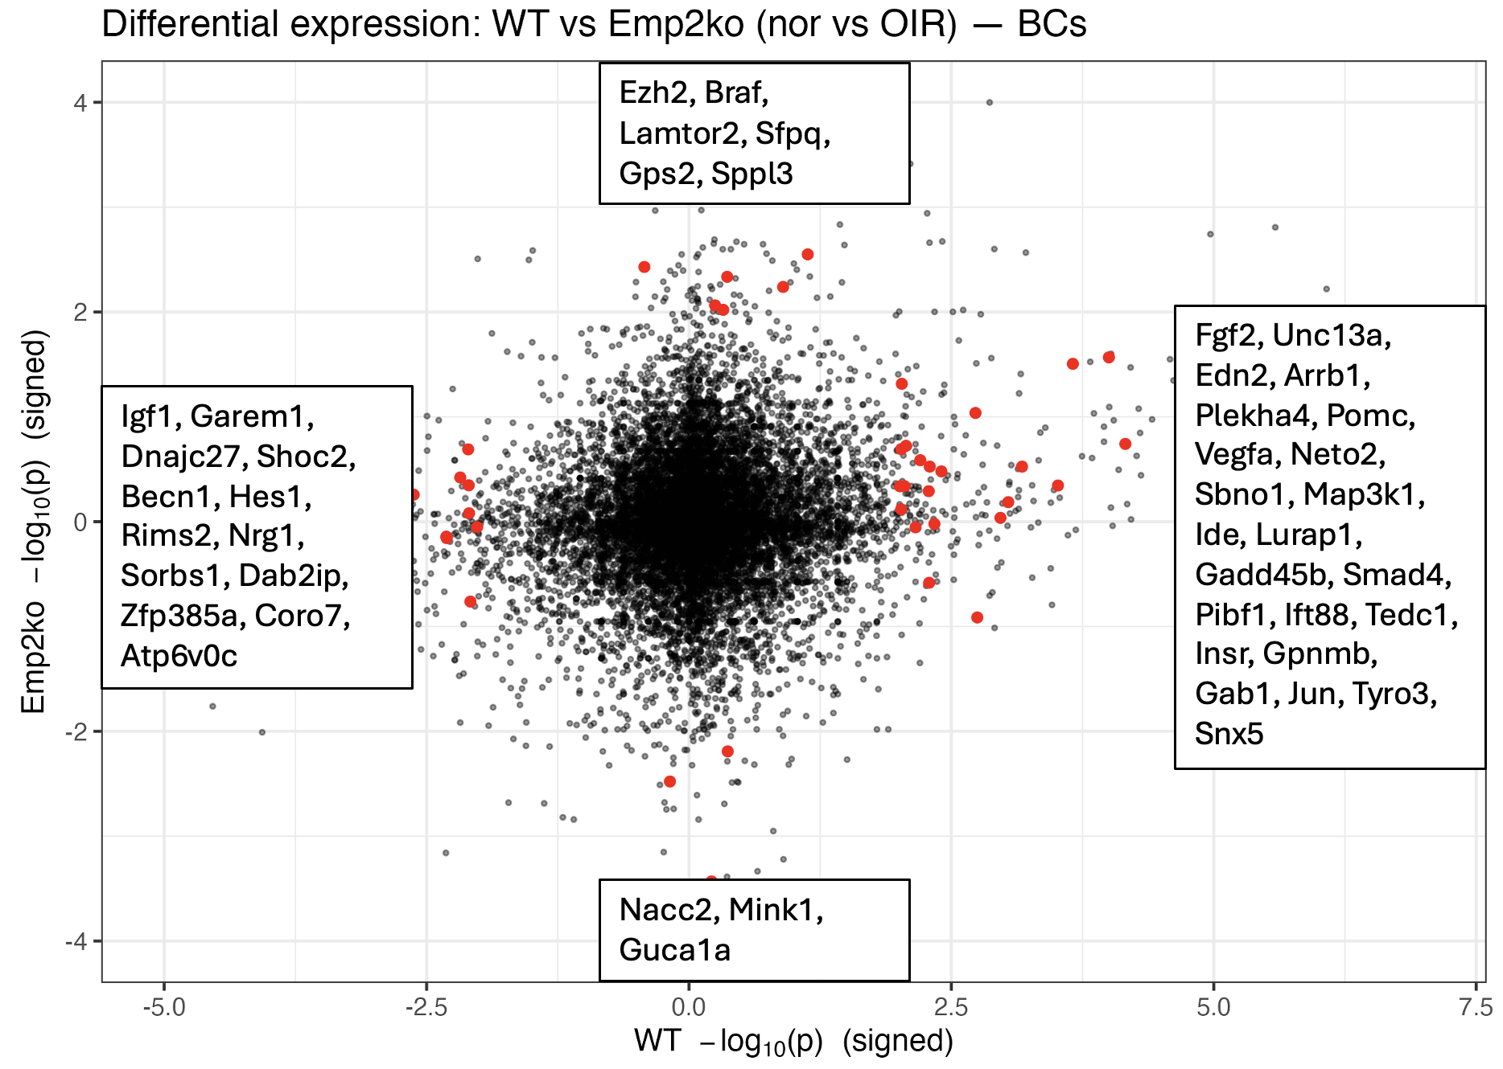

B.4. RPs (7071 cells), differences between WT and Emp2KO
A similar comparative analysis of signal transduction genes between WT and Emp2ko in the RP cells follows. The signal transduction genes with an absolute signed log p-value greater than 2 in only one genotype are highlighted in the plot below. A subset of these genes is labelled on the plot, and a supplementary table (Rp_table.csv) provides the full list along with their respective signed log p-values from both comparisons.
We observe significant correlation in gene regulation in both genotypes after OIR, although the level of regulation seems to be higher in WT for most genes. Of note, the activin receptor Acvr2b, clusterin (Clu) and Pros1 (TAM receptor ligand involved in photoreceptor phagocytosis https://pubmed.ncbi.nlm.nih.gov/38928335/) are significantly more upregulated in WT RP cells.
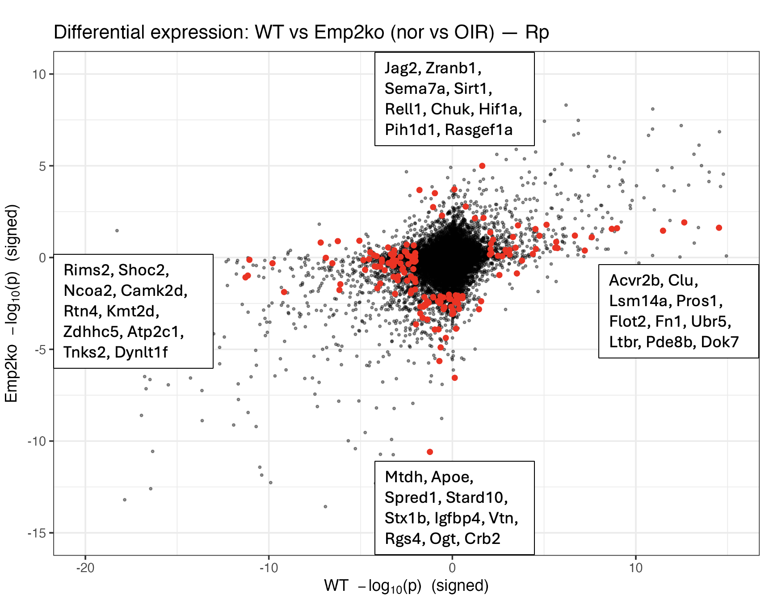

C. Analysis of angiogenesis pathways. Results in Supplementary_2/hallmark_angiogenesis/
C.1. Hallmark Angiogenesis - WT (nor_vs_OIR)
In WT samples, angiogenesis-related genes (we used a restricted hallmark set of 36 genes) were negatively enriched in the RPE cluster (meaning, a higher proportion of those genes are downregulated after OIR). In contrast, significant positive enrichment was found in Microglia, Cone, and R_BC clusters.
Note: Again, the number of cells in each cluster/cell-type is a limiting factor to reach statistical significance, therefore the interpretation of these results might be better framed withing the context of WT vs. Emp2Ko differences. To that end, excel spreadsheets are provided in the shared folder with cell-type specific differential results (nor vs. OIR) in both genotypes. As the number of genes in this pathway is very small, WT vs KO differences in specific genes can be easily addressed (see below)

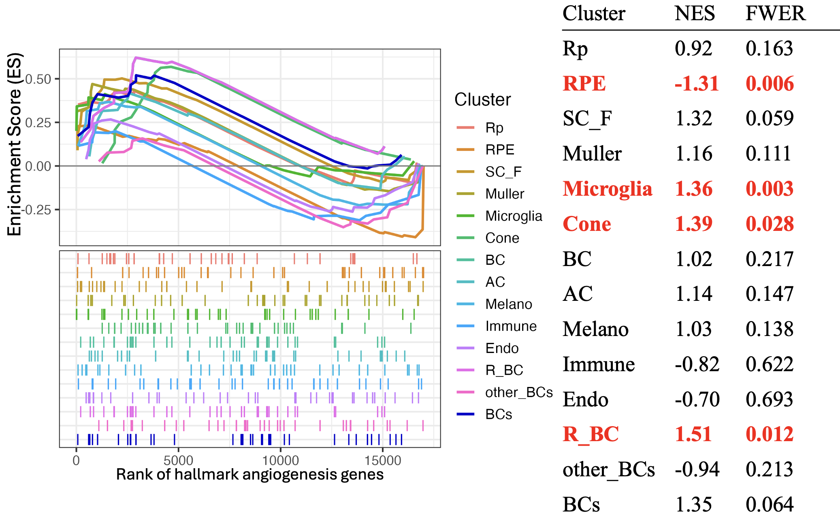

C.2.Hallmark Angiogenesis – Emp2ko (nor_vs_OIR)
In Emp2ko samples, hallmark angiogenesis genes were again negatively enriched in the RPE. Of note, the microglia cluster showed negative enrichment for this genotype, and positive enrichment was found in the endothelial cell cluster (with borderline significance as it is made up of very few cells).
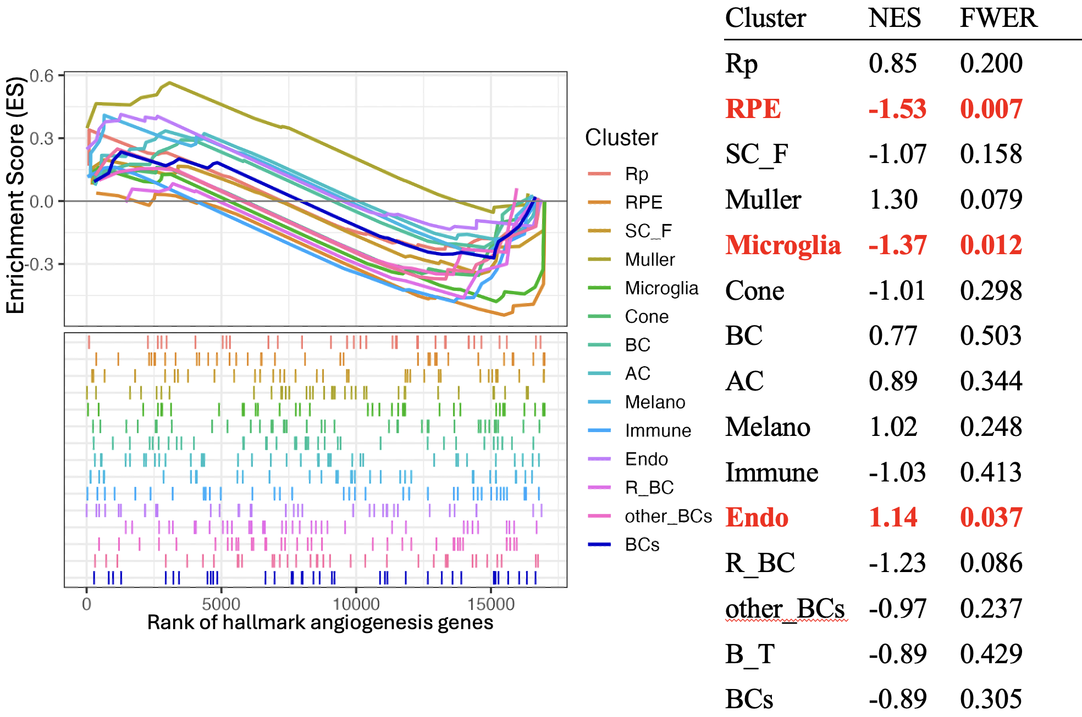

To facilitate the comparison of the trends in angiogenesis genes between genotypes in each cell type, please refer to the file Supplementary_2/hallmark_angiogenesis/MERGED_angiogenesis.xlsx. For each cell type, we include the signed log fold change in WT and Emp2Ko cells. Although there seems to be significant changes in many genes across cell types, it is interesting to observe that most angiogenesis genes are regulated in cell-type specific manner. For instance, the significant upregulation of Ccnd2 (cyclin gene), Vtn (vitronectin) and Timp1 (tissue inhibitor of metalloproteinase 1) exclusively in WT mice seems to be specific of RPE and Muller cells. In both cell types, the overexpression and secretion of Timp1 has been reported and interpreted as a protective factor for photoreceptor survival (https://pubmed.ncbi.nlm.nih.gov/37440036/ https://www.sciencedirect.com/science/article/pii/S0378111998005216 https://iovs.arvojournals.org/article.aspx?articleid=2123804). It could be speculated that enhanced secretion of Timp1 in WT promotes neovascularization (https://pubmed.ncbi.nlm.nih.gov/11193216/).

signed log-pvalue = [sign of the fold change] * [-log10(p-value)]. The signed log-pvalue is used as a summary statistic: it provides a measure of statistical significance, and the sign is borrowed from the fold change to inform for the direction of regulation (up/down)
positive enrichment: a higher proportion of genes in the set are upregulated by OIR. There can still be a significant number of downregulated genes, particularly in this case where the signal transduction pathway has so many genes.

