Differential Expression Analysis in Wild Type and Emp2 Knockout Mouse Retina Under Normoxia and OIR Conditions
Single-cell RNA sequencing (scRNA-seq) provides an in-depth view of cellular transcriptomic landscapes, allowing for the identification of differentially expressed genes across conditions in specific cell types. In this study, we perform a differential expression (DE) analysis on 4 distinct mouse retina scRNA-seq samples:
- Wild Type Normoxia (WT_nor)
- Wild Type Oxygen-Induced Retinopathy (WT_OIR)
- Emp2 Knockout Normoxia (Emp2ko_nor)
- Emp2 Knockout Oxygen-Induced Retinopathy (Emp2ko_OIR)
We first compared WT_nor and Emp2ko_nor mouse retinas to identify transcriptional changes associated with Emp2ko in a Normoxia background. Focusing on the four largest cell clusters—Rod photoreceptors (Rp), Retinal Pigment Epithelium (RPE), Sclera & Cornea/Fibroblasts (SC_F), and Müller Glia (Muller)—we conducted differential expression analysis for each cluster. To visualize significantly upregulated and downregulated genes, we generated volcano plots based on fold change and nominal p-values.
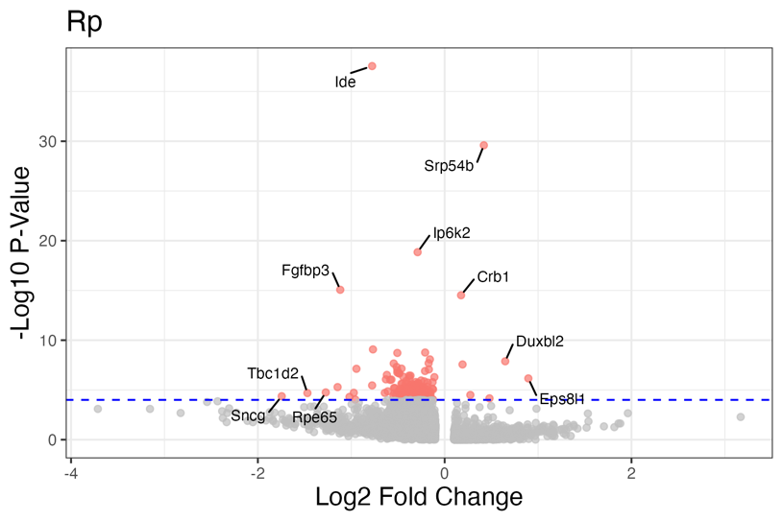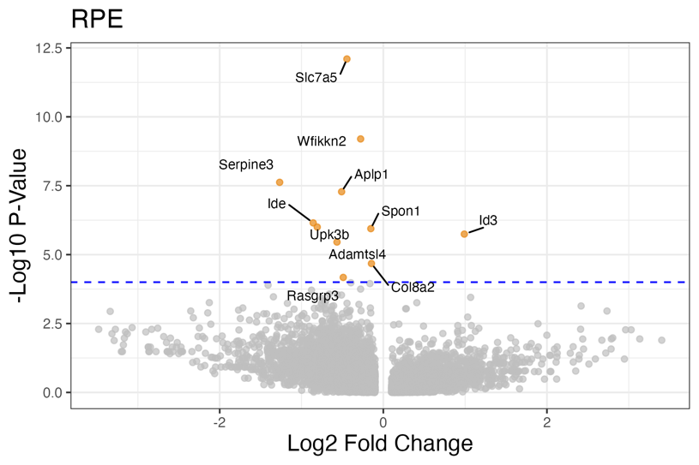
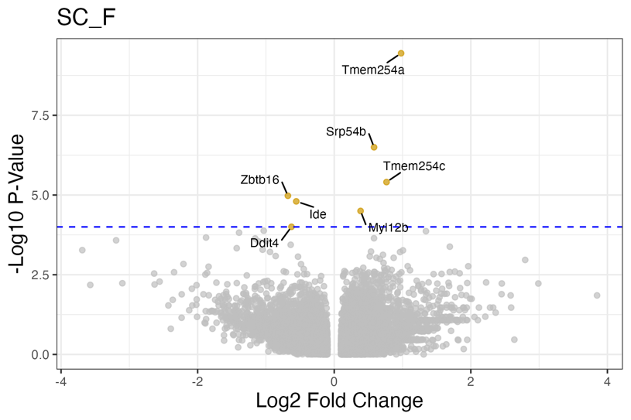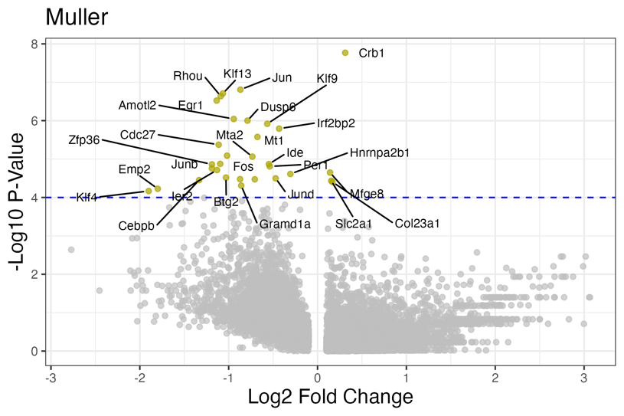

Then, we selected the four most significant genes (smallest p-values) from each cluster and visualized their expression distributions with violin plots, highlighting gene expression differences between WT_nor and Emp2ko_nor conditions.
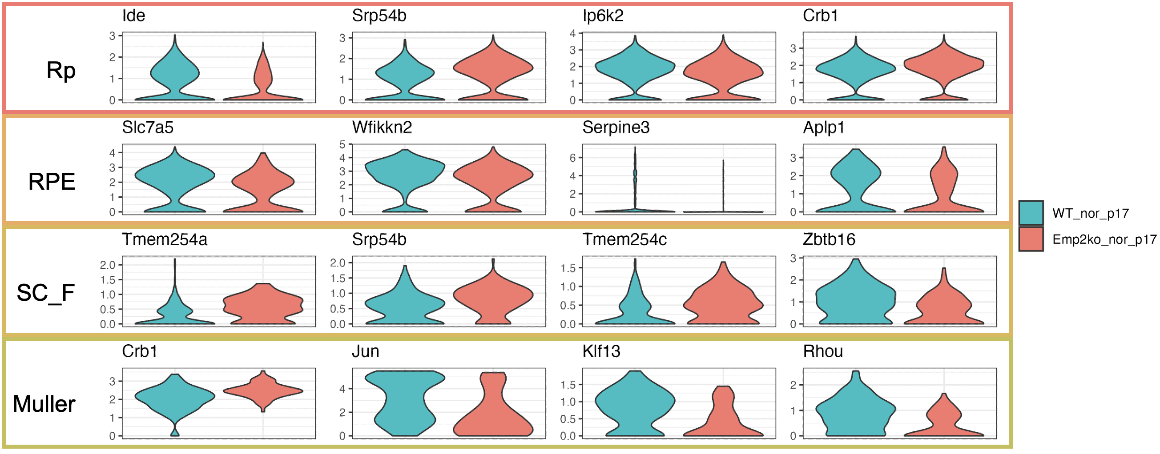
WTvsEmp2ko_nor
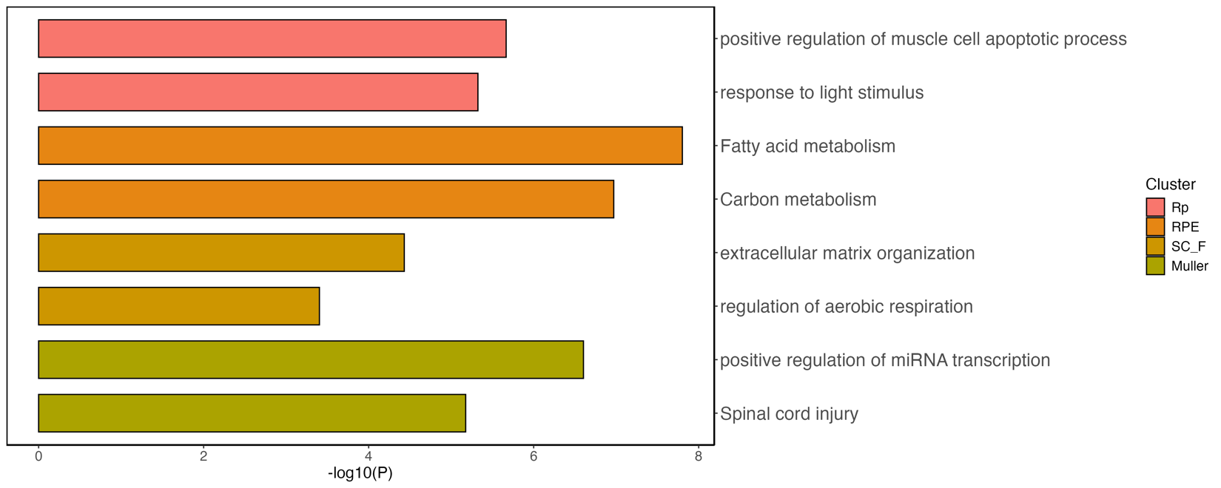
_{Mapk signaling}
_{Muscle tissue development}

Next, we expanded our analysis to compare differential gene expression between OIR and Normoxia in both WT and Emp2ko mice. To integrate both comparisons, we generated scatter plots with WT_nor vs. WT_OIR on the x-axis and Emp2ko_nor vs. Emp2ko_OIR on the y-axis, allowing us to identify genes specific to each condition.
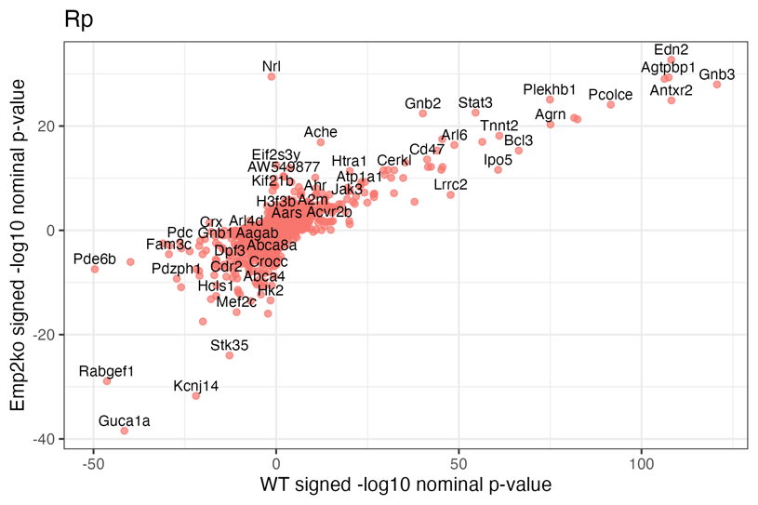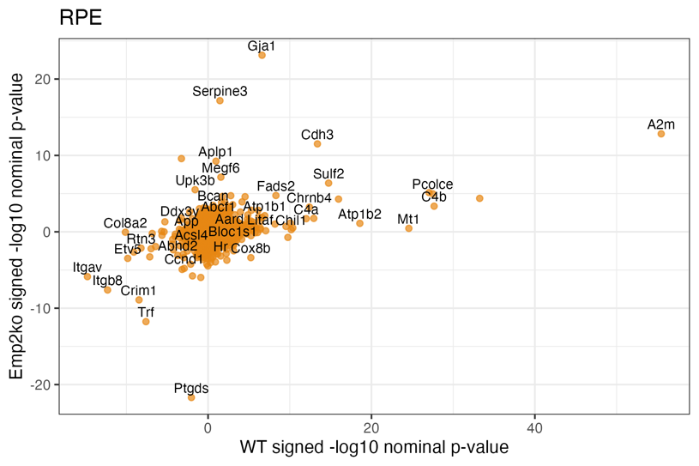
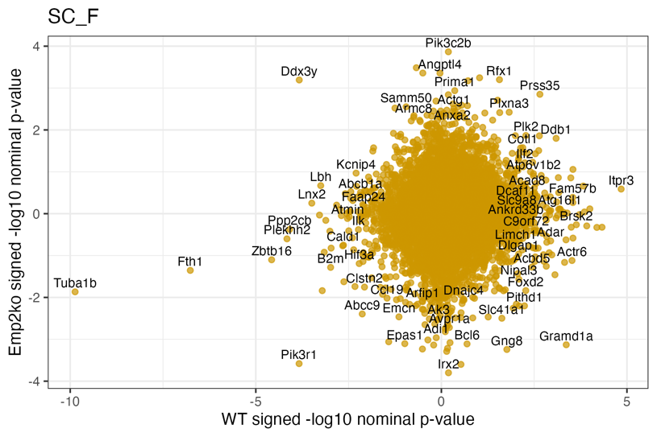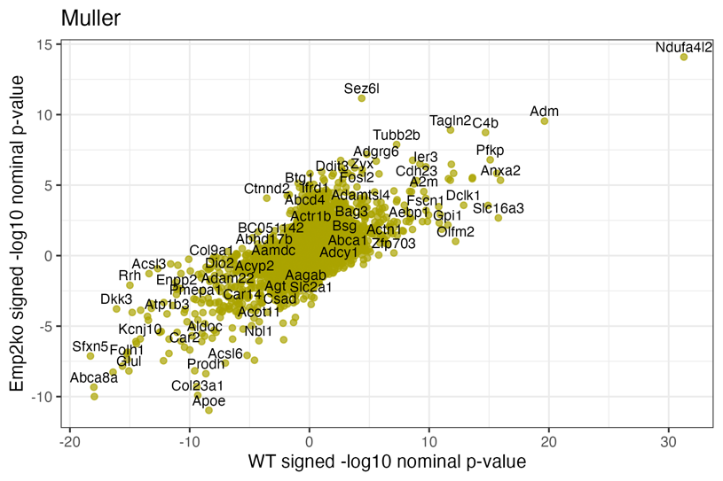

Using targeted filtering and sorting criteria, we identified the four most significant genes from each test within each cluster based on statistical significance and expression patterns. These selected genes are displayed in the panel, providing a clear comparison of key transcriptional changes across conditions.
WT_nor vs. WT_OIR
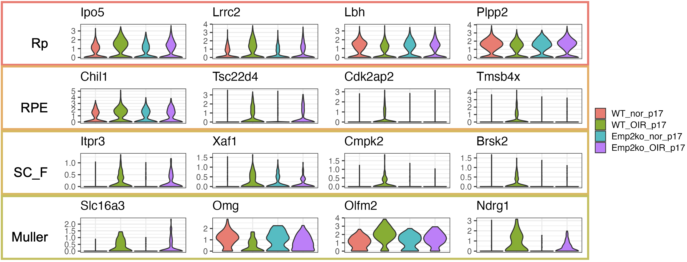
Emp2ko_nor vs. Emp2ko _OIR
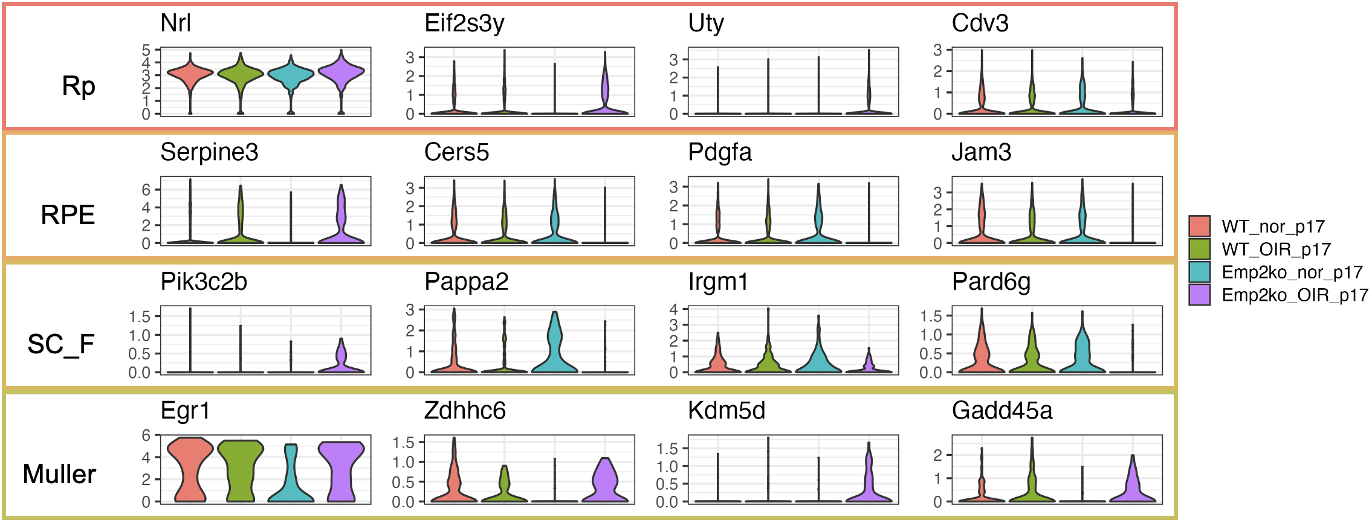

Genotype-specific analysis: genes more regulated in WT_norvsOIR
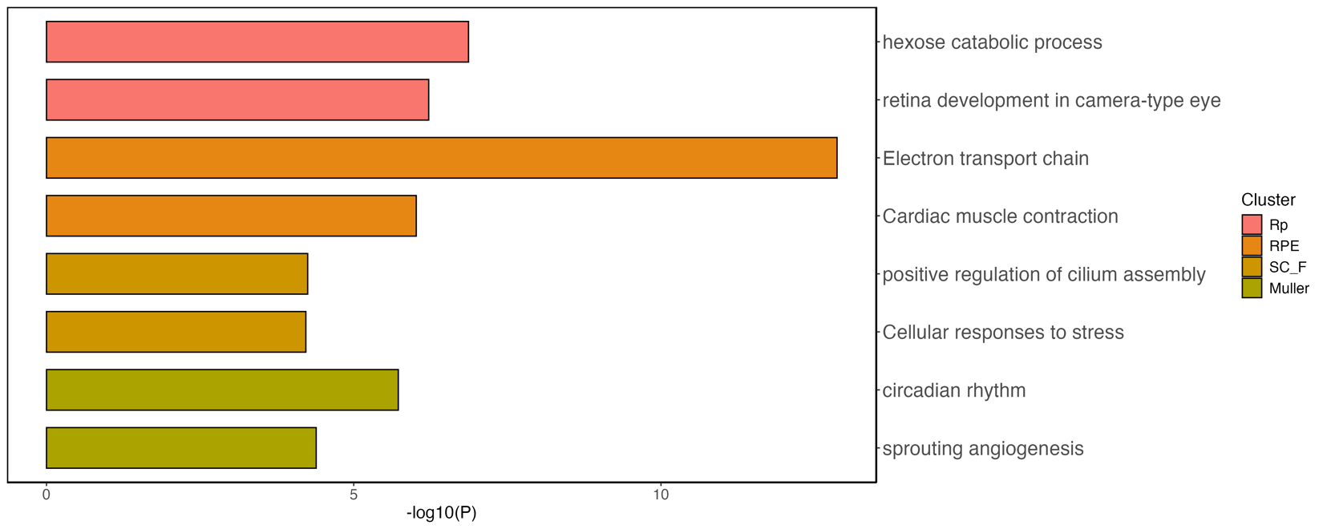
Genotype-specific analysis: genes more regulated in Emp2ko_norvsOIR
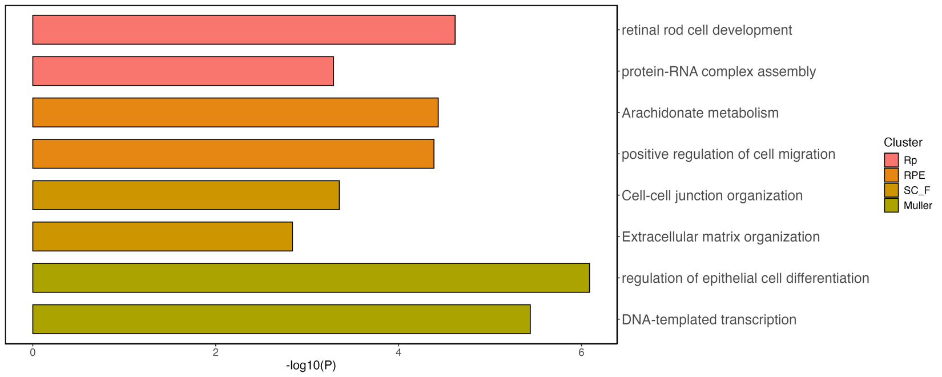
Supplementary
Global_norvsOIR
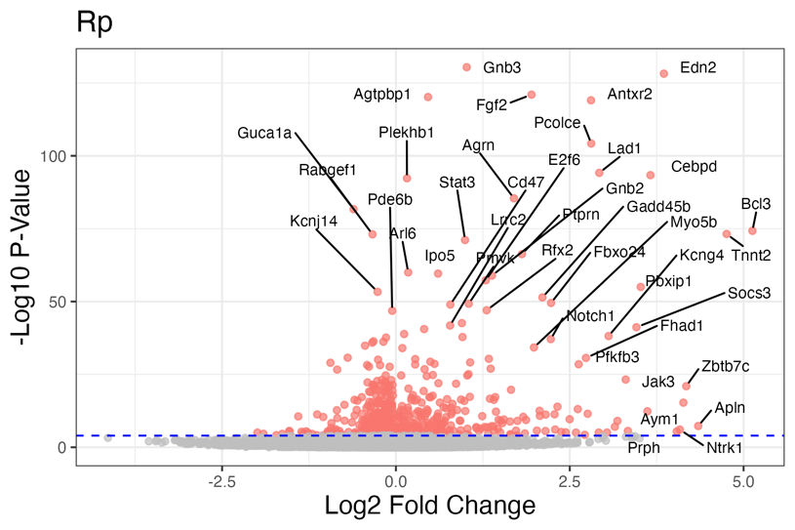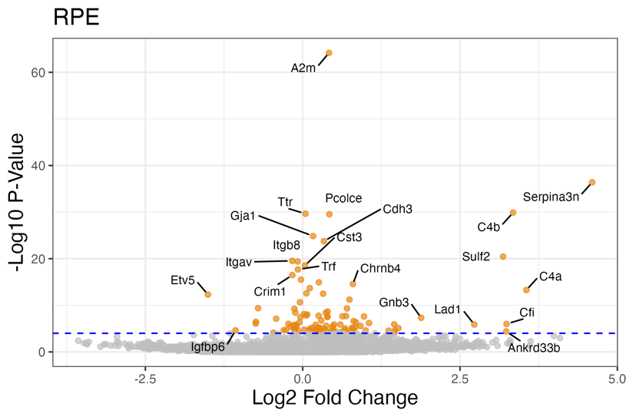
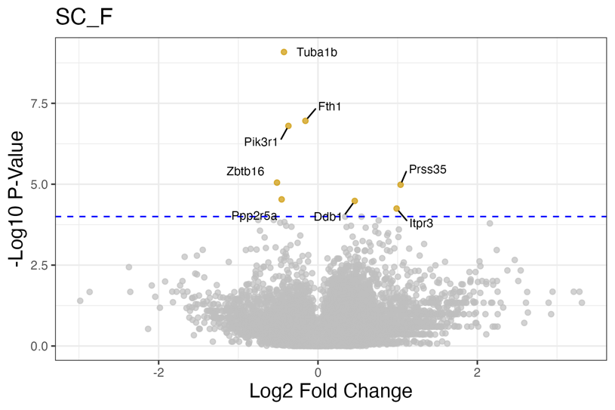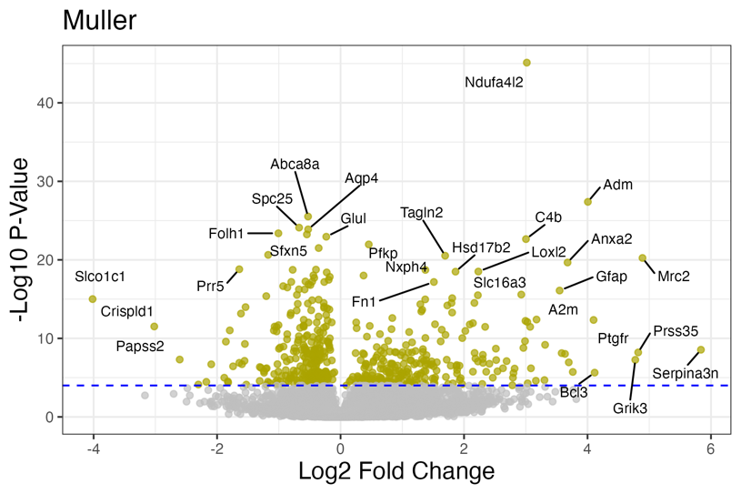

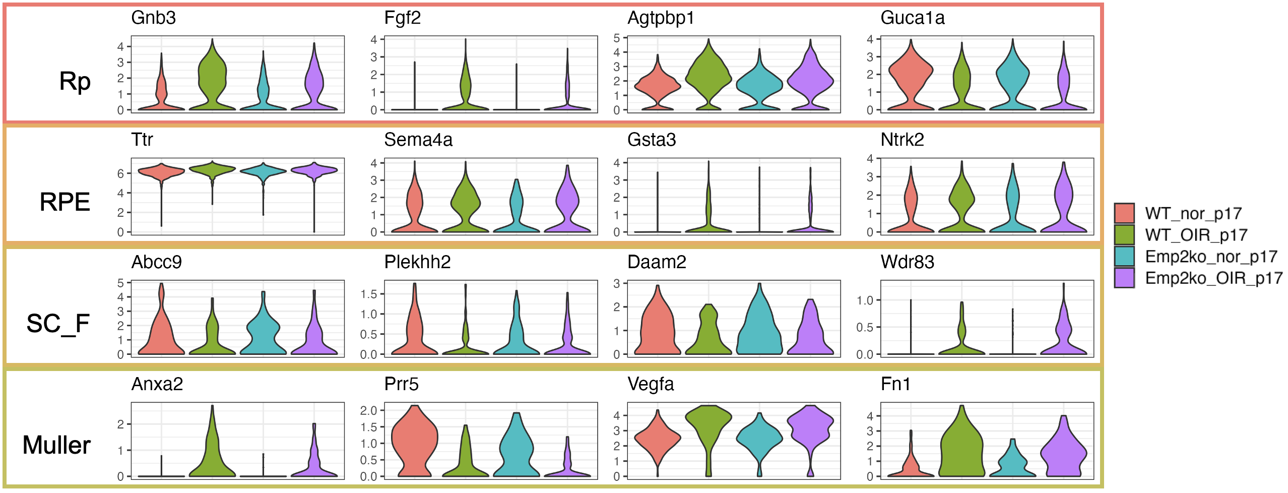

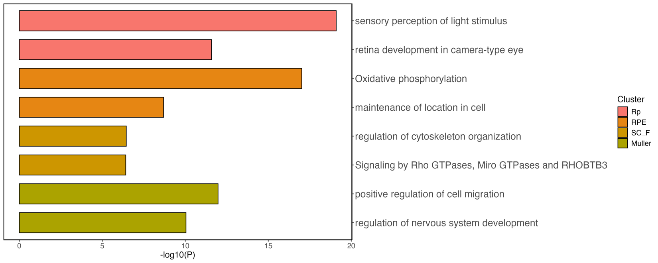

Global_WTvsEmp2ko
