Subclusters
After completing the differential expression analysis, we aim to further explore the heterogeneity within clusters by identifying and characterizing potential subclusters. Our focus will be on 4 major cell types of interest: Rod Photoreceptors (Rp), Retinal Pigment Epithelium (RPE), Sclera & Cornea/Fibroblasts (SC_F), and Müller Glia (Muller). By dissecting these clusters into finer subpopulations, we seek to uncover distinct cellular subsets, their transcriptional profiles, and potential functional differences. This deeper analysis will enhance our understanding of cellular diversity and provide valuable insights into how these subpopulations contribute to the overall cellular response under our experimental conditions. First, we identify the total number of subclusters within the main cluster. Next, a stacked barplot visualizes the proportion of each subcluster across individual samples, offering insights into their distribution. Following that, we examine the split UMAP to determine if any subclusters are specifically associated with conditions or experimental groups. Finally, marker genes for the subclusters are selected and displayed in a bubble plot.

Rod Photoreceptors (Rp)
The Rp cluster consists of 4 distinct subclusters. The Stacked bar plot reveals that the subcluster distributions in Normoxia (WT_nor_p17 and Emp2ko_nor_p17) group are relatively similar, while those in Hyperoxia (WT_OIR_p17 and Emp2ko_OIR_p17) group also share a comparable composition. Notably, subcluster 3 is almost exclusively present in hyperoxia samples, suggesting a strong association with the OIR condition. To further characterize these subclusters, we identified key marker genes that best define each subpopulation, providing insights into their potential biological roles and responses to different experimental conditions.

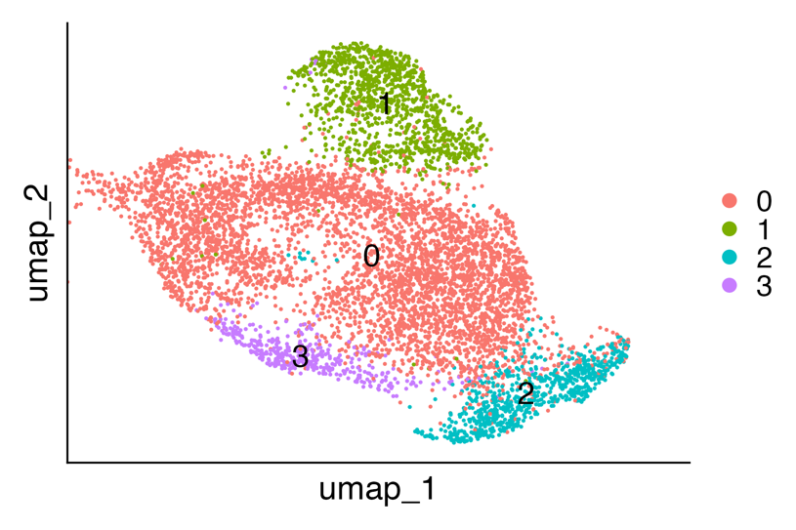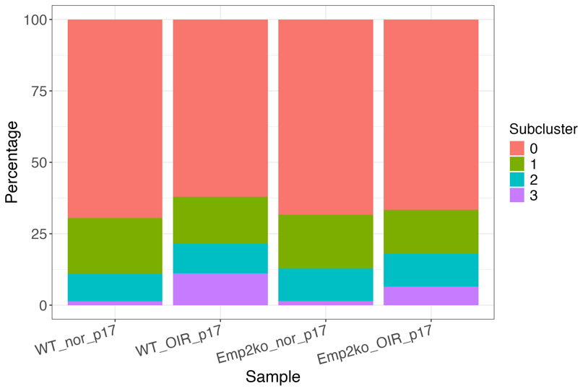
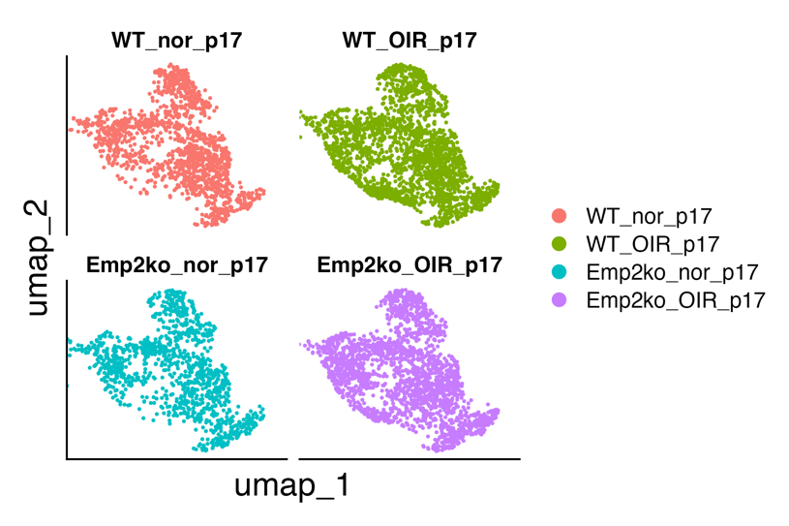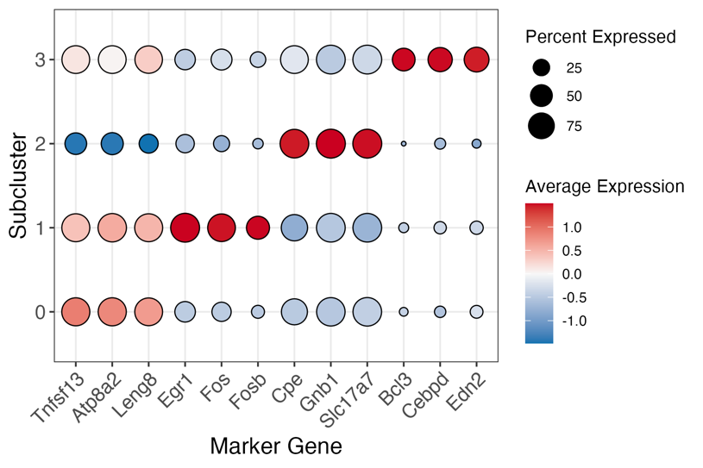

Supplementary

Retinal Pigment Epithelium (RPE)
The PRE cluster consists of 2 subclusters, each maintaining a relatively consistent proportion across all samples. Both the stacked bar plot and split UMAP visualization show no noticeable differences in subcluster composition between conditions, indicating that their distribution remains stable regardless of the condition.

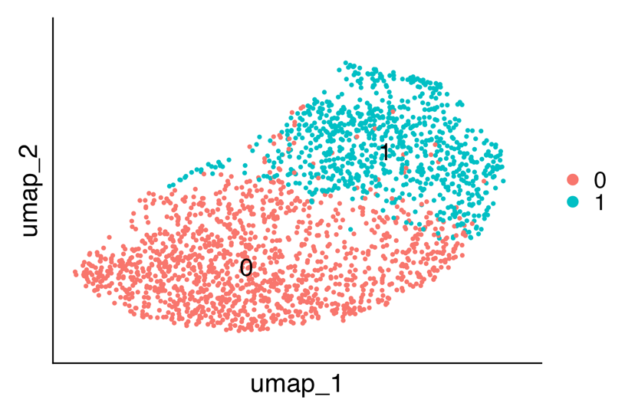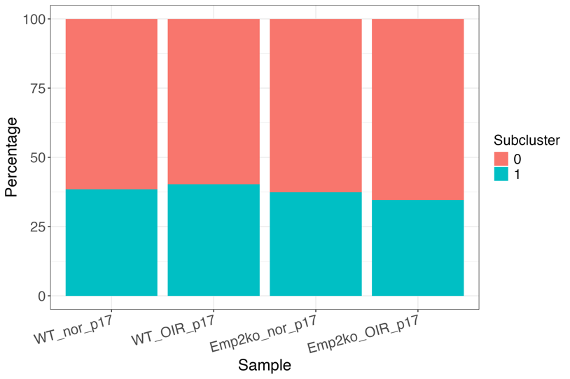
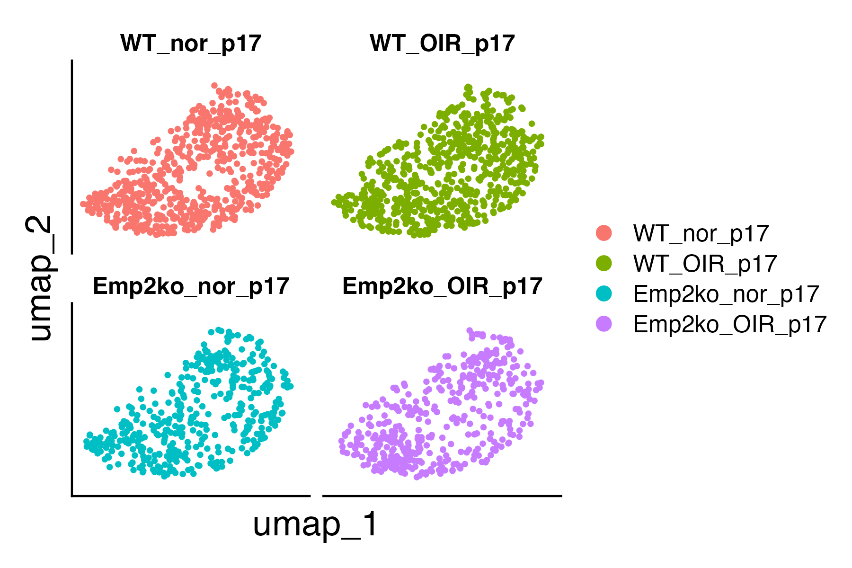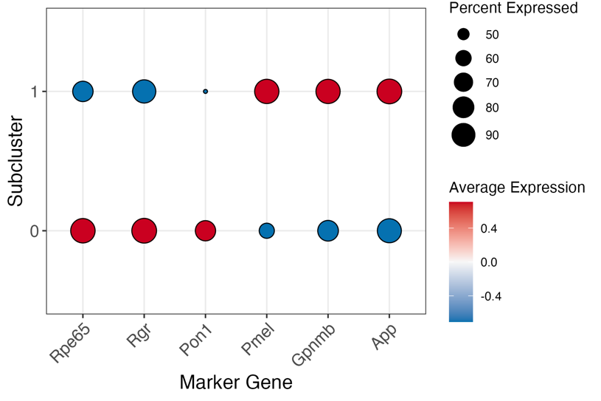

Sclera & Cornea/Fibroblasts (SC_F)
The SC_F cluster consists of three subclusters. While subcluster 0 is slightly more prevalent in WT_OIR, the overall proportions remain relatively consistent across all samples. Both the stacked bar plot and split UMAP visualization show no significant differences in subcluster composition between conditions.

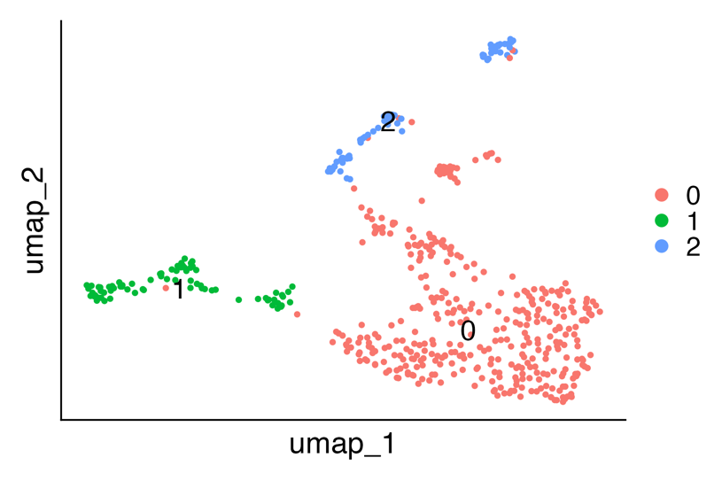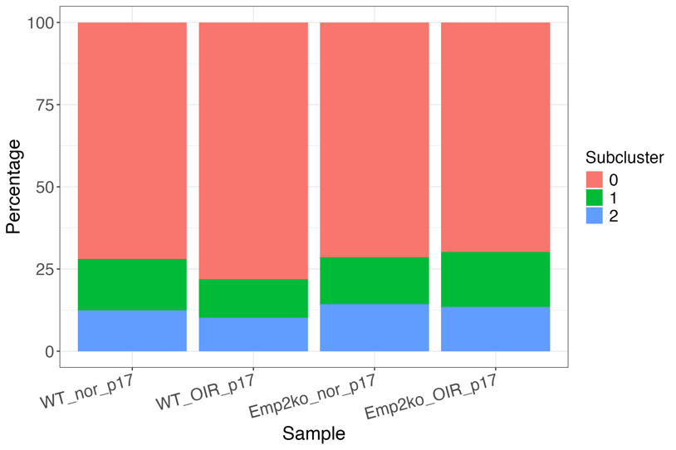
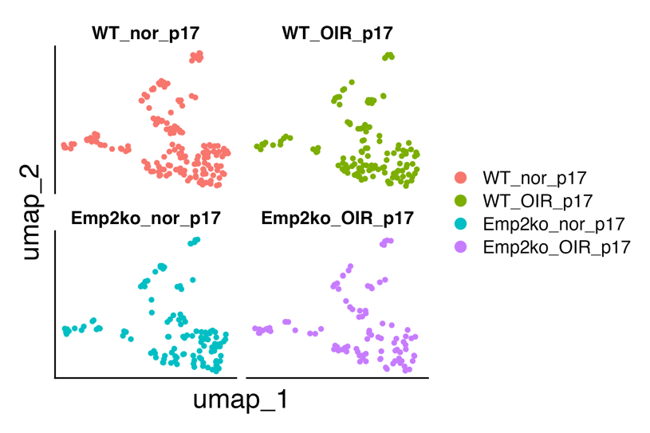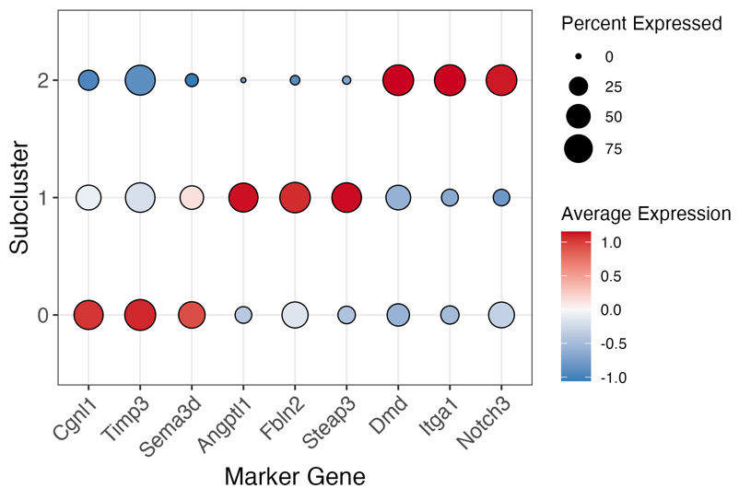

Müller Glia (Muller)
The Muller cluster is composed of two subclusters. In Emp2ko_nor, subcluster 1 is slightly more prevalent than subcluster 0; however, the overall proportions remain consistent across all samples. Both the stacked bar plot and split UMAP visualization indicate no significant differences in subcluster composition between conditions.
