Main Clusters
We employed single-cell RNA sequencing (scRNA-seq) data to examine the differentially expressed genes of the major cell types (Figure 1A). To gain deeper insights into the UMAP results, we separated the UMAP by sample, allowing us to visually compare the distribution patterns of each sample (Supplementary Figure 1A). These cells were clustered based on the expression of canonical marker genes (Figure 1B) (Supplementary Figure 1B) [1]. Differentially expressed genes were identified from the integrated dataset as those significantly expressed in a specific cluster compared to all other clusters combined. In our analysis, we discovered 14 main clusters: Rod photoreceptors (Rp) [2, 3], Retinal Pigment Epithelium (RPE) cells [4], Sclera & Cornea and Fibroblasts (SC_F) [5], Müller Glial cells (Muller) [6], Microglia cells (Microglia) [7], Cone photoreceptors (Cone) [8], Bipolar cells (BC) [9], Amacrine cells (AC) [10], Melanocytes (Melano) [11, 12], Immune cells (Immune) [13, 14], Endothelial cells (Endo) [15, 16], Rod Bipolar cells (R_BC) [17, 18], other Bipolar cells (other_BCs) [19, 20], and B/T cells (B_T) [21]. Finally, we calculated the proportion of each cell type within each sample, revealing that cell type proportions varied under different conditions. For instance, the Rp cluster was less abundant in the normoxia samples compared to the OIR samples (Figure 1C).

A
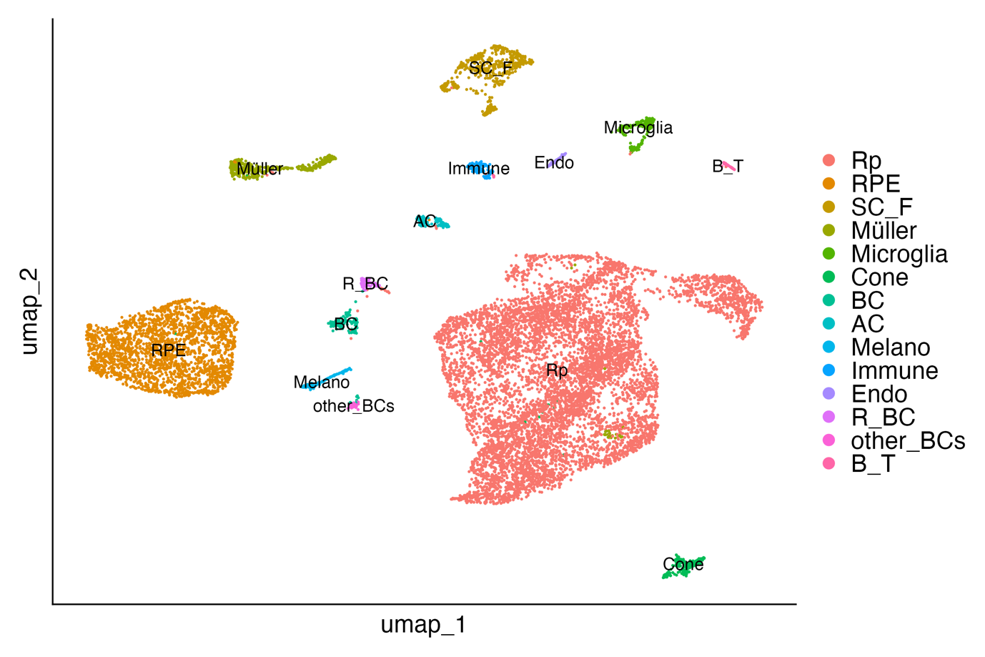

B
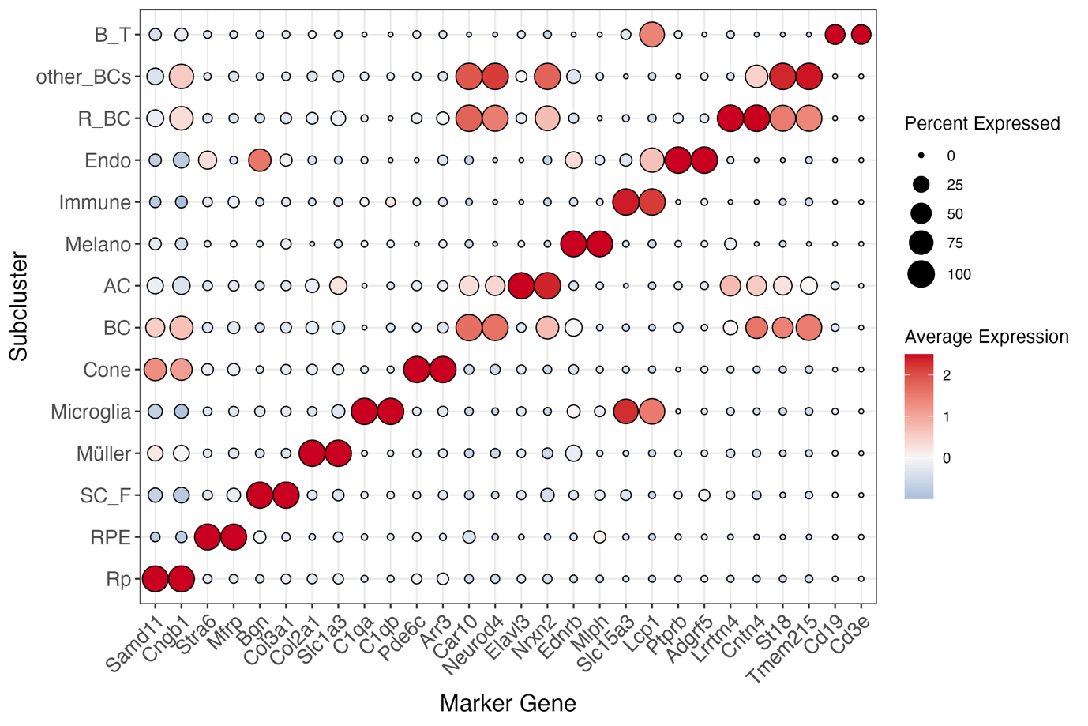
C
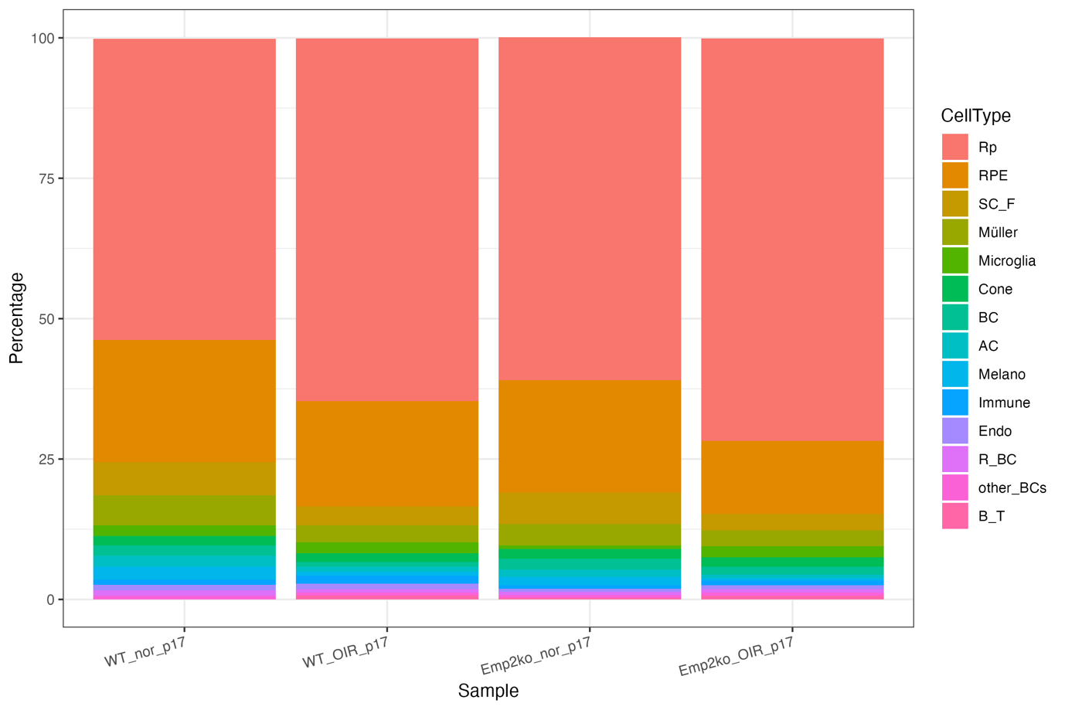
Figure 1. Overview of Cellular Composition in the Mouse Retina. (A) The UMAP visualization was generated using scRNA-seq data from mouse retinal tissue. Fourteen distinct cell clusters were identified, each representing a specific cell type in the retina. (B) We analyzed the differentially expressed genes in each cluster and examined whether these genes correspond to canonical marker genes. (C) A bar plot was used to highlight the distribution of cell types as a percentage within each sample.

Supplementary A
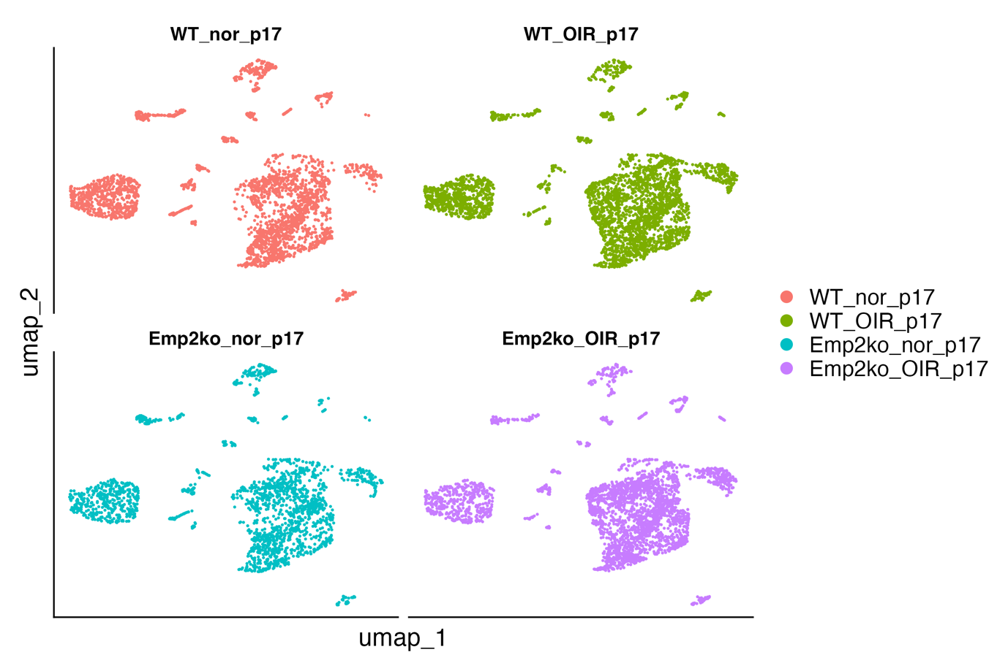
Supplementary B
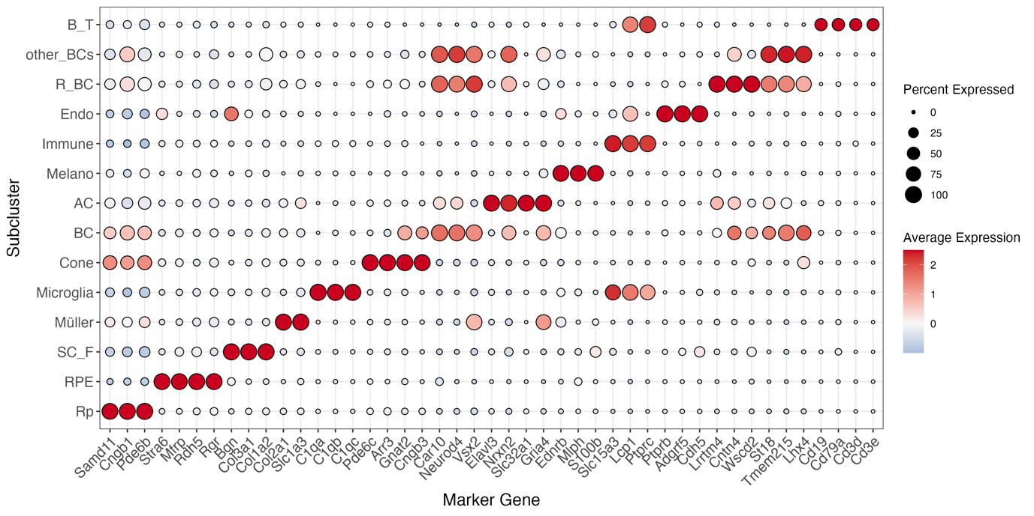

References
1. Geisert, E.E., et al., Gene expression in the mouse eye: an online resource for genetics using 103 strains of mice. Mol Vis, 2009. 15: p. 1730-63.
2. Park, H., et al., Visually-driven ocular growth in mice requires functional rod photoreceptors. Invest Ophthalmol Vis Sci, 2014. 55(10): p. 6272-9.
3. Cavanaugh, B.L., et al., A new mouse model for PRPH2 pattern dystrophy exhibits functional compensation prior and subsequent to retinal degeneration. Hum Mol Genet, 2024. 33(21): p. 1916-1928.
4. Strunnikova, N.V., et al., Transcriptome analysis and molecular signature of human retinal pigment epithelium. Hum Mol Genet, 2010. 19(12): p. 2468-86.
5. Youkilis, J.C. and S. Bassnett, Single-cell RNA-sequencing analysis of the ciliary epithelium and contiguous tissues in the mouse eye. Exp Eye Res, 2021. 213: p. 108811.
6. Roesch, K., et al., The transcriptome of retinal Muller glial cells. J Comp Neurol, 2008. 509(2): p. 225-38.
7. Yasuda, M., et al., RNA sequence reveals mouse retinal transcriptome changes early after axonal injury. PLoS One, 2014. 9(3): p. e93258.
8. Brennenstuhl, C., et al., Targeted ablation of the Pde6h gene in mice reveals cross-species differences in cone and rod phototransduction protein isoform inventory. J Biol Chem, 2015. 290(16): p. 10242-55.
9. Kim, D.S., et al., Identification of molecular markers of bipolar cells in the murine retina. J Comp Neurol, 2008. 507(5): p. 1795-810.
10. Trepp, C., A.M. Quintela Pousa, and V. Enzmann, Transcriptome Analysis Did Not Show Endogenous Stem Cell Characteristics in Murine Lgr5(+) Retinal Cells. Int J Mol Sci, 2019. 20(14).
11. Saldana-Caboverde, A. and L. Kos, Roles of endothelin signaling in melanocyte development and melanoma. Pigment Cell Melanoma Res, 2010. 23(2): p. 160-70.
12. Halawi, A., O. Abbas, and M. Mahalingam, S100 proteins and the skin: a review. J Eur Acad Dermatol Venereol, 2014. 28(4): p. 405-14.
13. Juchem, K.W., et al., NFAM1 Promotes Pro-Inflammatory Cytokine Production in Mouse and Human Monocytes. Front Immunol, 2021. 12: p. 773445.
14. Wright, M.D., et al., Gene structure, chromosomal localization, and protein sequence of mouse CD53 (Cd53): evidence that the transmembrane 4 superfamily arose by gene duplication. Int Immunol, 1993. 5(2): p. 209-16.
15. Niaudet, C., et al., Adgrf5 contributes to patterning of the endothelial deep layer in retina. Angiogenesis, 2019. 22(4): p. 491-505.
16. Kunzel, S.H., et al., Transcriptome Analysis of Choroidal Endothelium Links Androgen Receptor Role to Central Serous Chorioretinopathy. Eur J Ophthalmol, 2024. 34(5): p. 1532-1540.
17. Sinha, R., et al., LRRTM4: A Novel Regulator of Presynaptic Inhibition and Ribbon Synapse Arrangements of Retinal Bipolar Cells. Neuron, 2020. 105(6): p. 1007-1017 e5.
18. Woods, S.M., et al., A comparative analysis of rod bipolar cell transcriptomes identifies novel genes implicated in night vision. Sci Rep, 2018. 8(1): p. 5506.
19. Park, K.U., et al., Gsg1, Trnp1, and Tmem215 Mark Subpopulations of Bipolar Interneurons in the Mouse Retina. Invest Ophthalmol Vis Sci, 2017. 58(2): p. 1137-1150.
20. Dong, X., et al., LIM-Homeodomain Transcription Factor LHX4 Is Required for the Differentiation of Retinal Rod Bipolar Cells and OFF-Cone Bipolar Subtypes. Cell Rep, 2020. 32(11): p. 108144.
21. Etebar, F., et al., Tissue-Specific Immune Transcriptional Signatures in the Bordering Tissues of the Mouse Retina and Brain. Invest Ophthalmol Vis Sci, 2024. 65(12): p. 42.

