Differential Abundant Tests
Finally, we conducted a differential abundance analysis on our single-cell dataset using miloR to examine cell population changes within the Rp cluster. This approach allowed us to identify differentially abundant cell populations between conditions by leveraging graph-based neighborhoods of cells. Specifically, we compared cell abundance differences between WT and Emp2ko as well as Normoxia and Hyperoxia, providing insights into how these conditions influence cellular composition.

WT vs. Emp2ko in the Rp cluster

- This UMAP shows that while the overall cellular composition remains largely unchanged between WT and Emp2ko, there could be subtle variations in cell abundance within the Rp cluster.
- Each node in this graph represents a neighborhood, while edges indicate the degree of overlap between neighborhoods based on shared cells. The node layout is derived from the UMAP embedding of individual cells, with each node positioned according to its index cell's location. Significantly differentially abundant (DA) neighborhoods are color-coded based on their log-Fold Change (logFC) values, where blue represents a positive fold change (higher abundance in Emp2ko), and red represents a negative fold change (lower abundance in Emp2ko). The size of each node reflects the number of cells in that neighborhood, while edge transparency indicates the strength of neighborhood overlap. This visualization helps identify regions of significant differential abundance within the dataset. Therefore, our primary focus is on the region with the highest concentration of dark red, indicating the most significant negative fold changes in this plot.
- After identifying neighborhoods, we conduct a one-vs-all differential expression test to find marker genes specific to those cells. MiloR defines neighborhood groups based on the biological question and stores them in the NhoodGroup column. We focus on NhoodGroup 6, which contains the highest concentration of dark red dots, and compare it with the most similar group, NhoodGroup 2, to identify key differences.
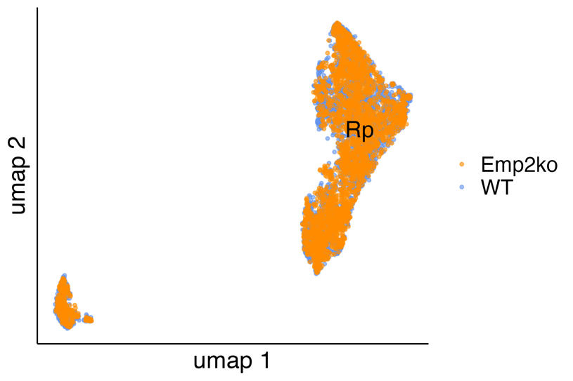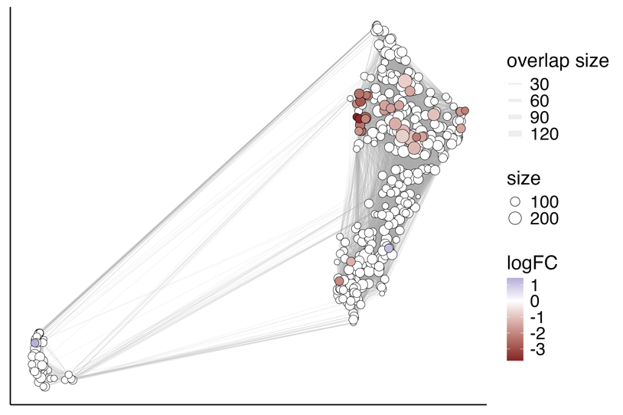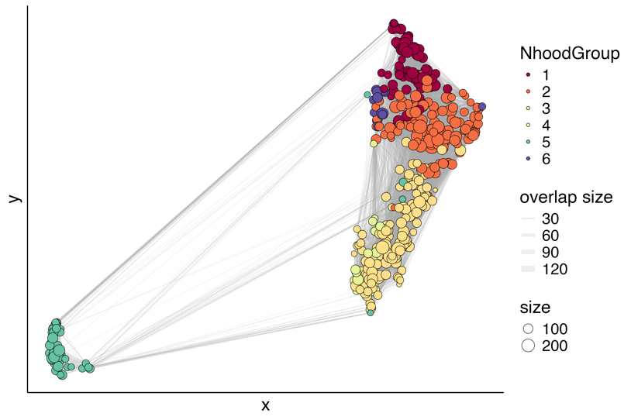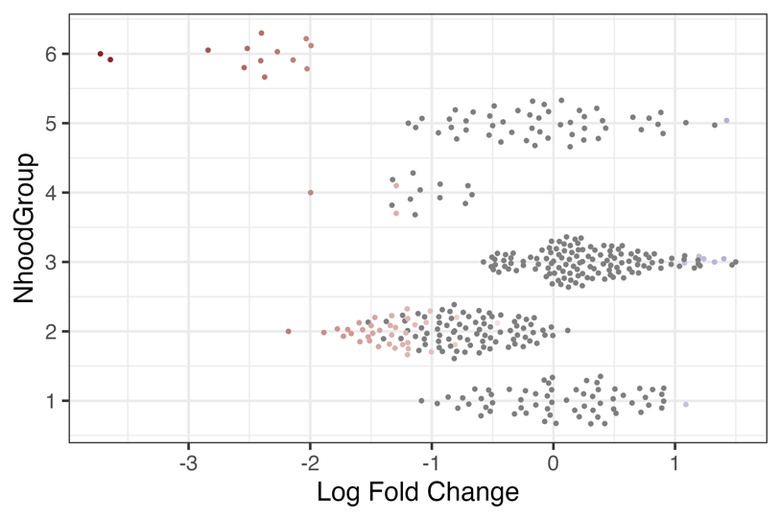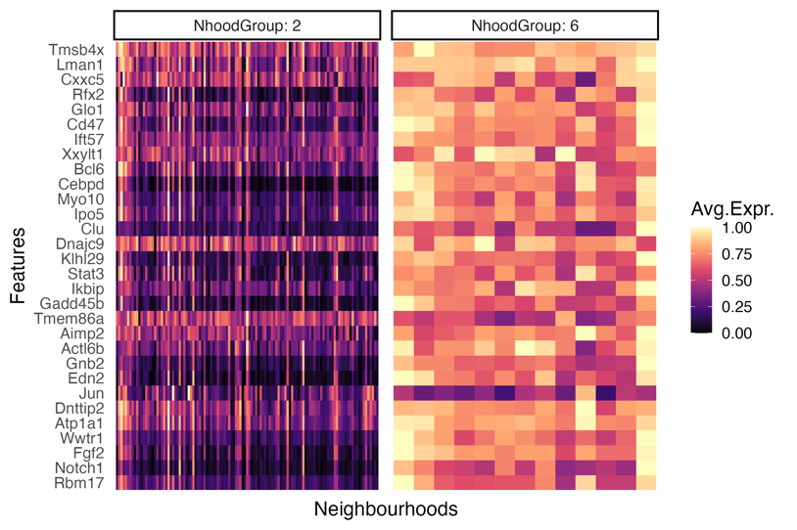

Normoxia vs. Hyperoxia in the Rp cluster

- The UMAP presents the distribution of cells in the Normoxia vs. Hyperoxia groups, highlighting regions with higher concentrations of Hyperoxia cells and areas with more Normoxia cells within the Rp cluster.
- We focus on the region with the highest concentration of dark blue, indicating the most significant positive fold changes.
- NhoodGroup 5 includes most dark blue region we would like to compare it with NhoodGroup 1.

