12/30 無向、有向圖練習

(1) 

1. 相鄰矩陣:

|  |  |  |  |  |  |
| --- | --- | --- | --- | --- | --- |
|  | A | B | C | D | E |
| A | 0 | 1 | 0 | 1 | 0 |
| B | 1 | 0 | 1 | 1 | 0 |
| C | 0 | 1 | 0 | 0 | 1 |
| D | 1 | 1 | 0 | 0 | 1 |
| E | 0 | 0 | 1 | 1 | 0 |

1. 分支度: The degree of nodes A,C,,E= 2

The degree of nodes B,D= 3

1. 相鄰串列: 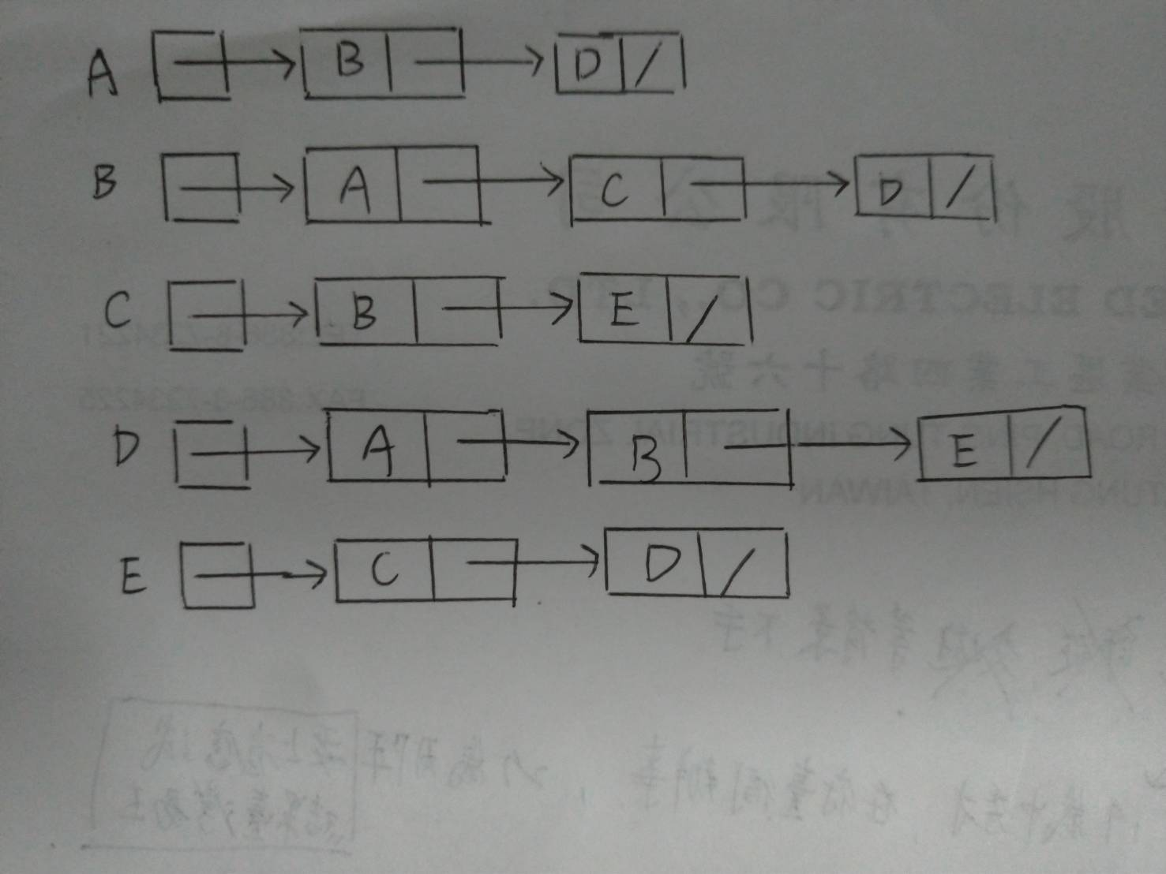

(2) 

1. 相鄰矩陣:

|  |  |  |  |  |  |
| --- | --- | --- | --- | --- | --- |
|  | A | B | C | D | E |
| A | 0 | 1 | 0 | 0 | 0 |
| B | 0 | 0 | 1 | 1 | 0 |
| C | 0 | 0 | 0 | 0 | 1 |
| D | 1 | 0 | 0 | 0 | 0 |
| E | 0 | 0 | 0 | 1 | 0 |

2.分支度: A,C,D,E: Indegree = 1, outdegree = 1; degree = 2

B: Indegree = 1, outdegree = 2; degree = 3