**Please keep it, as the dataset is not public.**

**Part 1. Retrieval (4p)**

n_queries = 4  
xp_idx0 = np.random.choice(np.where(labels == 0)[0])  
xp_idx1 = np.random.choice(np.where(labels == 1)[0])  
xp_idx2 = np.random.choice(np.where(labels == 2)[0])  
xp_idx3 = np.random.choice(np.where(labels == 3)[0])  
  
queries = [xp_idx0, xp_idx1, xp_idx2, xp_idx3]  
queries_metric = metric[queries, :]  
  
euc_dist = torch.cdist(queries_metric, metric, p=2)  
cloeset_50_value, cloeset_50_pos = torch.topk(euc_dist, 28, dim=1, largest=False, sorted=True, out=None)

plt_Compare = plt  
plt_Compare.clf()  
f, axarr = plt_Compare.subplots(n_queries, 1, gridspec_kw={'wspace': 0, 'hspace': 0})  
for i in range(n_queries):  
 ax = axarr[i]  
 # img_t = torch.cat((anchors[queries[i], :, :, :].unsqueeze(0), anchors[cloeset_50_pos[i, :], :, :, :]))  
 img_t = anchors[cloeset_50_pos[i, 0:4], :, :, :]  
  
 plot_out = torchvision.utils.make_grid(img_t, nrow=4, normalize=True, padding=1)  
 image_transposed = plot_out.numpy().transpose((1, 2, 0))  
 ax.imshow(image_transposed)  
 ax.axis('off')  
plt_Compare.savefig(args.experiment_name + '_Comparring.png')  
f.show()

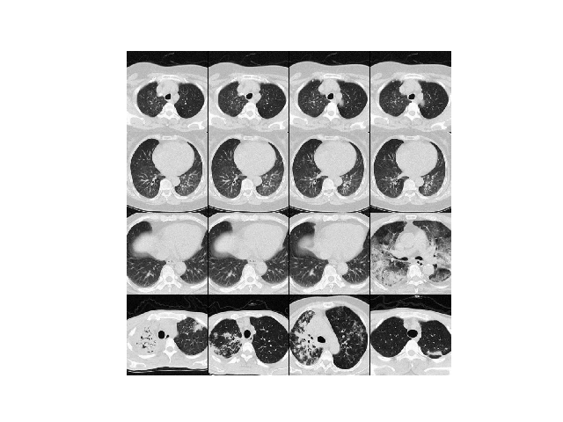But I failed to draw this figure with heatmaps.

**Calculating the accuracy, precision, recall and mAP:**

predict_label = torch.cat(([labels[cloeset_50_pos[0, 1:]], labels[cloeset_50_pos[1, 1:]], labels[cloeset_50_pos[2, 1:]], labels[cloeset_50_pos[3, 1:]]]), 0)  
labels = th_delete(labels, queries)  
torch.sum(predict_label == labels)  
accuracy_rate = torch.sum(predict_label == labels)/len(labels)

### Part 2. Metric Learning (6p)

I used the resnet18 as the base network.

**Choose the proper sequence of dataset:**

x = self.inputs[idx]  
t = self.targets[idx]  
xp_idx = np.random.choice(np.where(self.targets == t)[0])  
xn_idx = np.random.choice(np.where(self.targets != t)[0])  
xp = self.inputs[xp_idx]  
xn = self.inputs[xn_idx]  
return x, xp, xn, t

**Get the output of three images sets -> anchors, positives and negatives:**

anchors = anchors.to(device)  
positives = positives.to(device)  
negatives = negatives.to(device)  
  
anc_metric = model(anchors)  
pos_metric = model(positives)  
neg_metric = model(negatives)  
  
loss = criterion(anc_metric, pos_metric, neg_metric)

**Define the criterion as Tripletloss, and the margin value:**

class TripletLoss(nn.Module):  
 def __init__(self, margin=0.2):  
 super(TripletLoss, self).__init__()  
 self.margin = margin  
  
 def forward(self, a, p, n):  
 loss = torch.norm(a - p, p=2, dim=1) - torch.norm(a - n, p=2, dim=1) + self.margin  
 loss = F.relu(loss).mean()  
 return loss

**Plot the t-SNE, confusion matrix and roc curve from test.py script:**

