Please keep it, as the dataset is not public.

Part 1. Retrieval (4p)
n_queries = 4
xp_idx0 = np.random.choice(np.where(labels == 0)[0])
xp_idx1 = np.random.choice(np.where(labels == 1)[0])
xp_idx2 = np.random.choice(np.where(labels == 2)[0])
xp_idx3 = np.random.choice(np.where(labels == 3)[0])
queries = [xp_idx0, xp_idx1, xp_idx2, xp_idx3]
queries_metric = metric[queries, :]
euc_dist = torch.cdist(queries_metric, metric, p=2)
cloeset_50_value, cloeset_50_pos = torch.topk(euc_dist, 28, dim=1, largest=False, sorted=True, out=None)
plt_Compare = plt
plt_Compare.clf()
f, axarr = plt_Compare.subplots(n_queries, 1, gridspec_kw={'wspace': 0, 'hspace': 0})
for i in range(n_queries):
ax = axarr[i]
# img_t = torch.cat((anchors[queries[i], :, :, :].unsqueeze(0), anchors[cloeset_50_pos[i, :], :, :, :]))
img_t = anchors[cloeset_50_pos[i, 0:4], :, :, :]
plot_out = torchvision.utils.make_grid(img_t, nrow=4, normalize=True, padding=1)
image_transposed = plot_out.numpy().transpose((1, 2, 0))
ax.imshow(image_transposed)
ax.axis('off')
plt_Compare.savefig(args.experiment_name + '_Comparring.png')
f.show()

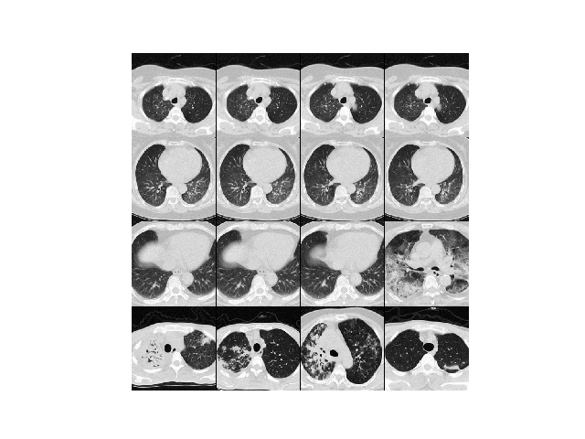But I failed to draw this figure with heatmaps.

Calculating the accuracy, precision, recall and mAP:
predict_label = torch.cat(([labels[cloeset_50_pos[0, 1:]], labels[cloeset_50_pos[1, 1:]], labels[cloeset_50_pos[2, 1:]], labels[cloeset_50_pos[3, 1:]]]), 0)
labels = th_delete(labels, queries)
torch.sum(predict_label == labels)
accuracy_rate = torch.sum(predict_label == labels)/len(labels)

Part 2. Metric Learning (6p)
I used the resnet18 as the base network.
Choose the proper sequence of dataset:
x = self.inputs[idx]
t = self.targets[idx]
xp_idx = np.random.choice(np.where(self.targets == t)[0])
xn_idx = np.random.choice(np.where(self.targets != t)[0])
xp = self.inputs[xp_idx]
xn = self.inputs[xn_idx]
return x, xp, xn, t

Get the output of three images sets -> anchors, positives and negatives:
anchors = anchors.to(device)
positives = positives.to(device)
negatives = negatives.to(device)
anc_metric = model(anchors)
pos_metric = model(positives)
neg_metric = model(negatives)
loss = criterion(anc_metric, pos_metric, neg_metric)

Define the criterion as Tripletloss, and the margin value:
class TripletLoss(nn.Module):
def __init__(self, margin=0.2):
super(TripletLoss, self).__init__()
self.margin = margin
def forward(self, a, p, n):
loss = torch.norm(a - p, p=2, dim=1) - torch.norm(a - n, p=2, dim=1) + self.margin
loss = F.relu(loss).mean()
return loss

Plot the t-SNE, confusion matrix and roc curve from test.py script:
