電腦視覺 HW10

學生:葉政樑 學號:R08945006

1. 作業目標:

* Laplace Mask1 (0, 1, 0, 1, -4, 1, 0, 1, 0): 15
* Laplace Mask2 (1, 1, 1, 1, -8, 1, 1, 1, 1):15
* Minimum variance Laplacian: 20
* Laplace of Gaussian: 3000
* Difference of Gaussian: 1

1. 方法:

* 將影像與各個運算子做運算
* Zero-crossing edge detectors判斷

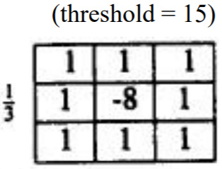

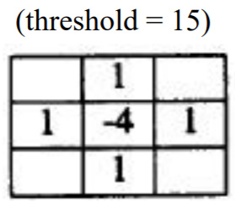

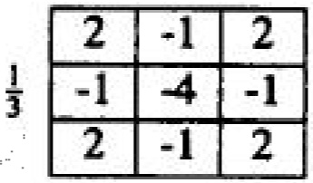

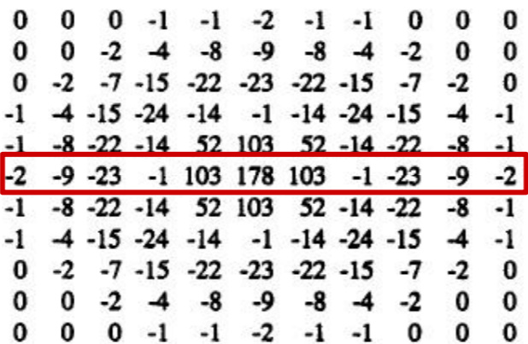

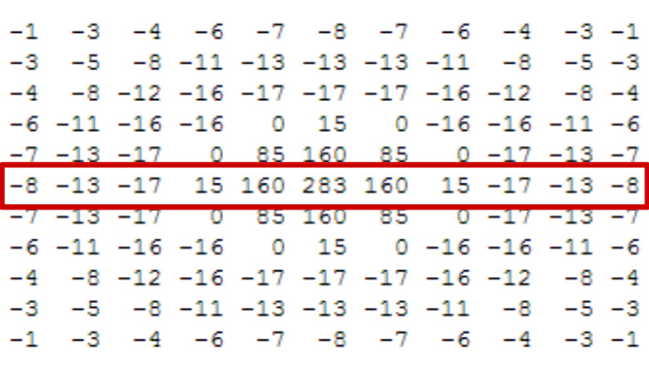

**Zero crossing:**

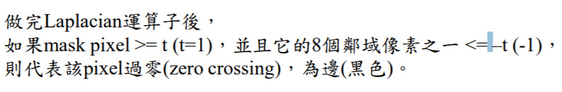

1. 核心程式碼片段:

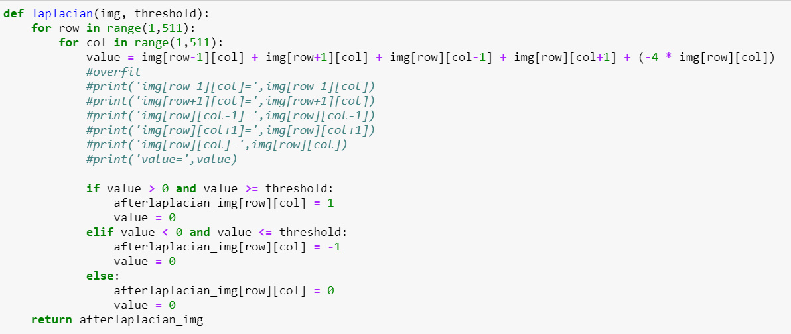

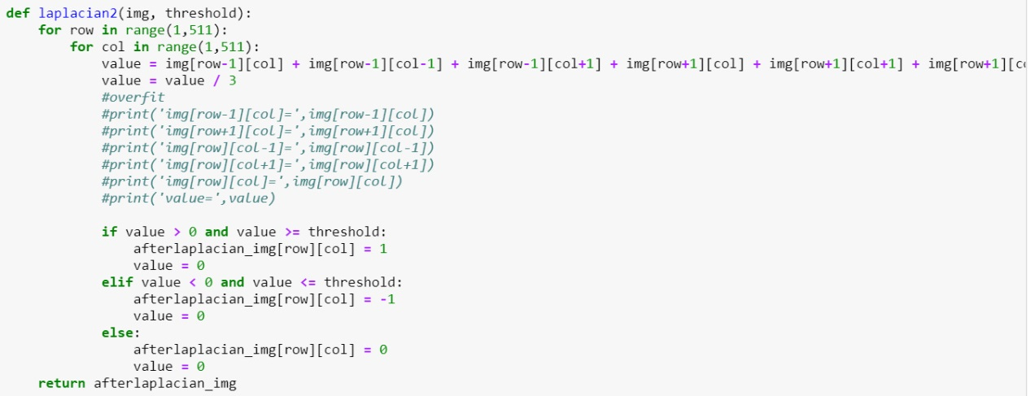

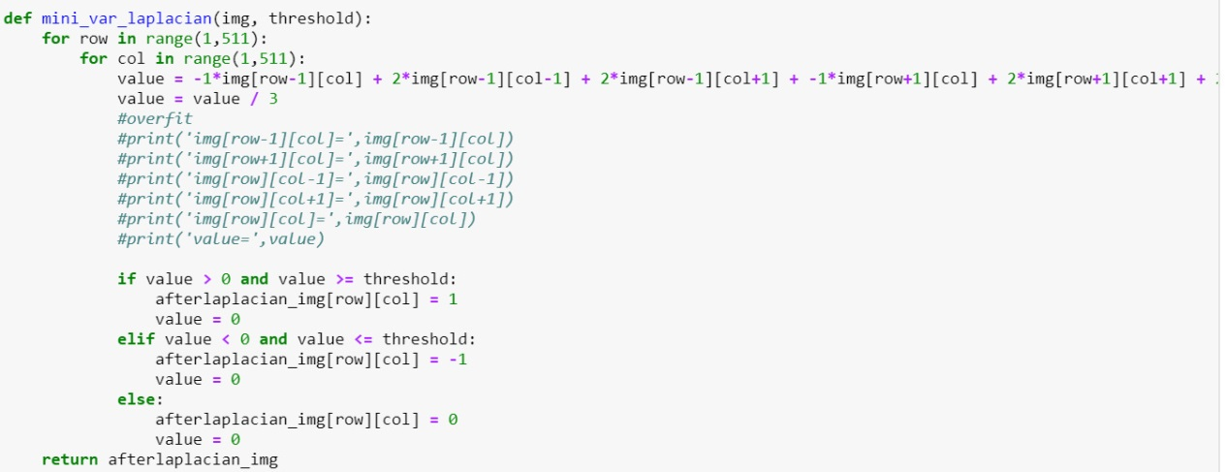

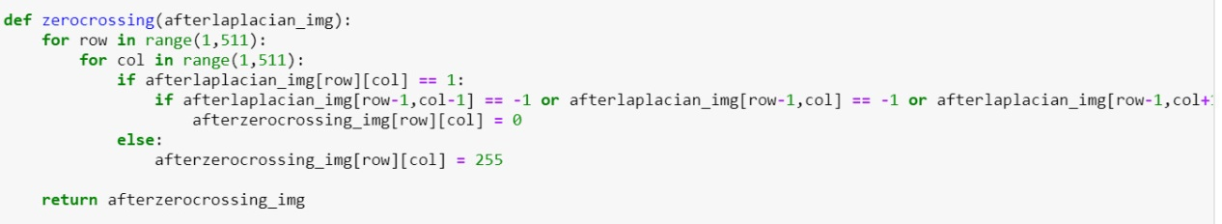

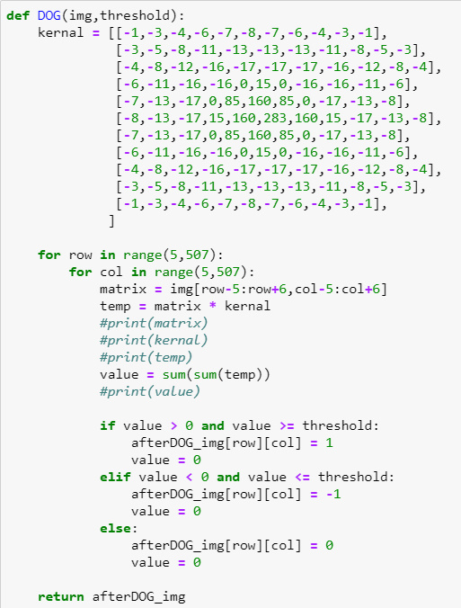

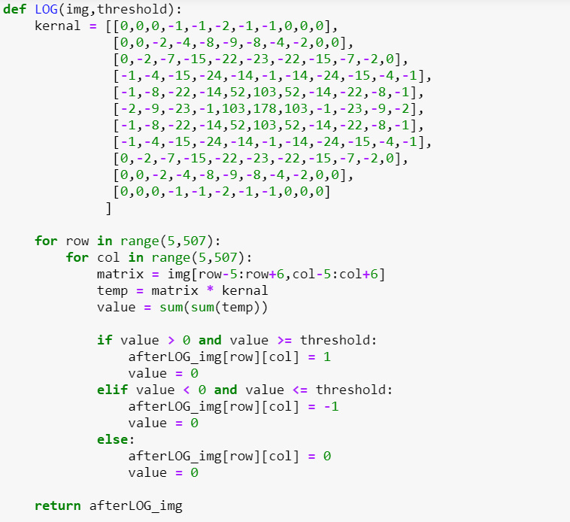

1. 成果:







左到右分別為:

Laplace Mask1 (0, 1, 0, 1, -4, 1, 0, 1, 0): 15

Laplace Mask2 (1, 1, 1, 1, -8, 1, 1, 1, 1):15

➢ Minimum variance Laplacian: 20





左到右為: ➢

Laplace of Gaussian: 3000

➢ Difference of Gaussian: 1