基礎生醫影像處理技術 作業1

葉政樑 R08945006

Theoretical questions Q1 + Q2:

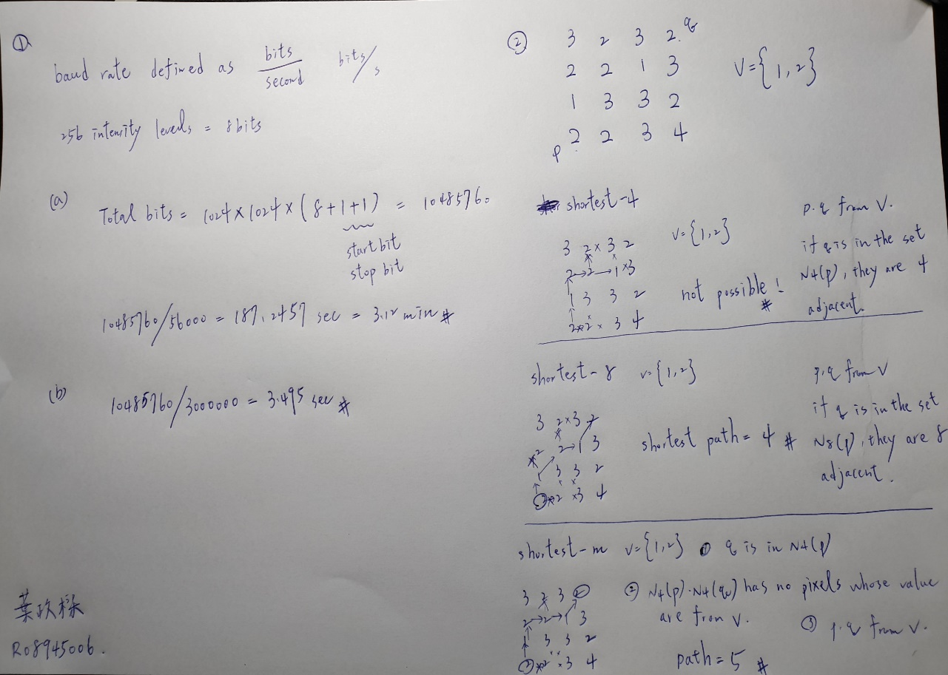

Programming exercises:

Q1:

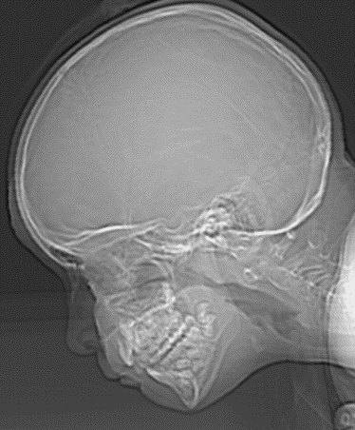 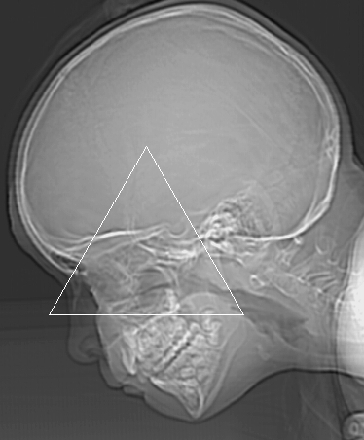

Q2:

|  |  |  |  |
| --- | --- | --- | --- |
| Gray level 256 | Gray level 128 | Gray level 64 | Gray level 32 |
|  |  |  |  |
| Gray level 16 | Gray level 8 | Gray level 4 | Gray level 2 |
|  |  |  |  |

Q3:

|  |  |  |
| --- | --- | --- |
|  |  |  |
|  |  |  |

Q4:

|  |  |
| --- | --- |
| Original image | Histogram equalization |
|  |  |
| Gamma adjust | CLAHE(BEST RESULT)  (Contrast Limited Adaptive Histogram Equalization) |
|  |  |