DEVELOPMENT OF SELF-ORGANISING MAP DATABASE

Project Proposal



Information Technology Capstone Project

COMP5703/5707/5708

Group Members

1. FirstName LastName (SID)
2. FirstName LastName (SID)
3. FirstName LastName (SID)
4. FirstName LastName (SID)
5. FirstName LastName (SID)

Abstract

The abstract should be between 150-600 words. Briefly summarise your proposal. The abstract is usually written last, when you have a clear idea of your proposal as a whole. The aim of this section is to quickly introduce the reader to the project, and ideally engage their interest and encourage them to read the rest of the proposal. You should include an overview of the project, its motivation, the objectives, and the methods you plan to use. Do not include details in this section , you will have plenty of space in later sections. Also remember that the reader may not understand the technical details of your project so avoid jargon and leave in-depth discussion for later sections.

Table of Contents

Abstract i

Table of Contents ii

1. Introduction 1

2. Related Literature 1

2.1 Literature Review 1

3. Research/Project Problems 2

3.1 Research/Project Aims & Objectives 2

3.2 Research/Project Questions 2

3.3 Research/Project Scope 2

4. Methodologies 2

4.1 Methods 3

4.2 Data Collection 3

4.3 Data Analysis 3

4.4 Deployment 3

4.5 Testing 3

5. Resourc es 3

5.1 Hardware & Software 4

5.2 Materials 4

5.3 Roles & Responsibilities 4

6. Expected Outcomes 4

6.1 Project Deliverables 4

6.2 Implications 4

7. Milestones / Schedule 5

References 7

# Introduction

In this section you will describe the context of your proposal. You will introduce the general background knowledge needed to understand the research topic (as it relates to your proposal), the motivation for your project, and the benefits that may be provided by addressing the research question. This should enable a clear and concise description of the problem that your proposal addresses. Write in a way that people or reader who does not have the same background will be able to follow or understand. No technical information is needed to be described in this section.

# Related Literature

Describe in detail the related knowledge needed to understand your work and how it relates to existing work. This may take the form of a literature review, or a review of related projects.

## Literature Review

A literature review is done by analysing and articulating the published sources and literature on the specific topic of the project. In this section, you should emphasise the review is needed and why the selected topic is essential for the project. Moreover, the scope of the literature reviewed and the selection criteria, such as the type of sources, keyword and any particular date range, need to be specified.

The literature reviewed can be in the form of an article such as conference paper, journal paper, a research report or thesis. The literature review usually consists of three main components: an introduction, a body and a conclusion. Furthermore, the literature review is not only summaries one by one of the source. Instead, it constructs an essay that flows from one topic to another that relates to the project problem that is to be solved.

For this type of project, the expectation of the literature to support the argument is at least 10 – 15 citations that compile state of the art discussion related to the problem of the project. Do not forget to consider the reliability of the sources.

# Research/Project Problems

Clearly state the problem or question the project intends to investigate. Describe the scope of your project since it may not be feasible to completely solve the problem. State the objectives and how completion will be measured.

## Research/Project Aims & Objectives

In this section, the aims and objectives of the project associated with the research question or problem should be explained in detail.

## Research/Project Questions

In this section, an apparent problem or question faced by the client needs to be defined and stated. Sometimes, even though the client already stated their problem it might be only the symptoms.

## Research/Project Scope

In many cases, the problem might be too big to be solved. The scope needs to be stated in this section to make it easier to justify the outcome or the completion of the project.

# Methodologies

Depending on the nature of your project, the methodologies adopted will be different.

**IS projects**: In this section, the group/student should explain the methodology that will be used to solve the problem or problems at the core of the project. The methodology section should explain and inform the reader as to how data was collected, how the IT artefact is developed and tested and so forth. You should explain the reasons why you chose a particular technique and procedure for your project. By providing sufficient information in your report you will allow others to replicate your methodology. Moreover, the appropriate sample size also needs to be considered in order to ensure a statistically rigorous recommendations based on your findings.

**SW Development**: Describe the methods you will use to solve the problem you are addressing, such as the SDLC methodology adopted, for example Agile. Explain how data is collected, the techniques used to analyse data, the models chosen, and how accuracy of analysis was determined. You should explain the reasons why you chose a particular technique and procedure for your project. You should also include how you intend to deploy the system to your clients as well as the testing processes involved.

**Data Science project**s: Describe the methods you will use to solve the problem you are addressing. Explain how data is collected, the techniques used to analyse data, the models chosen, and how accuracy of analysis was determined. You should explain the reasons why you chose a particular technique and procedure for your project.

For software development project, include additonal sections where appropriate.

## Methods

Describe the methods you will use to solve the problem you are addressing.

## Data Collection

Explain how data is collected.

## Data Analysis

Explain the techniques used to analyse data

## Deployment

**SW projects**: Explain the deployment of the system on client’s infrastructure. Remember to mention how updates and bug fixes will be distributed after the deployment.

## Testing

**SW projects**: Include the detailed description of your testing process and methodologies. Examples include: Test Driven Development (TDD), Unit Testing, Integration Testing, vigorous testing, etc. Remember to explain why the methodology was chosen and how the defined testing process will contribute to the quality software development in your specific project.

# Resources

## Hardware & Software

|  |  |
| --- | --- |
| **Compatible hardware** | |
| Major operating System | Windows: the system will run on 64 bit Windows desktop systems; the system version is better from Windows 7 to Windows 10.  Mac (two latest publicly-released version) |
| Memory | Minimum memory is 2GB RAM, 4GB or over than 4GB RAM is recommended. |
| Browser | As this is a web application, supported and recommended browsers including:   * Mozilla Firefox (later then version 39.0) * Google Chrome (later than version 42.0) * Apple Safari (later than version 10.1) * Microsoft Edge |
| Hard disk space | At least 10GB |

|  |  |  |
| --- | --- | --- |
| Software technologies | | |
| Stacks | Software technologies | Reasons |
| Frontend | React | We chose React because it can make programmers well focus on the interaction of a website and easily manage flow of data through the application, as well as helping us write usable codes. |
| Redux | When we realised that we may have many components, states and system actions in the React, we decided to adopt Redux. Redux can help us manage and control those shared data and handle system behaviours. |
| Bootstrap | Bootstrap is helpful for responsive website development. It also contains many pre-built CSS styles and classes, which highly save our time. |
| Reactstrap | To some extend, Reactstrap is necessary, because React relies on Reactstrap to implement Bootstrap. On the other hand, React simplifies the usage of Bootstrap. |
| JSX | React uses a syntax extension of Javascript called JSX, it allows us to write HTML directly within JavaScript.  JSX let you use the full programmatic power of JavaScript within HTML and helps to keep our code readable |
| Representation State Transfer(REST) API | Axios | Axios provides an easier way to make HTTP request, including response timeout and automatic JSON data transformation, which simplifies our processes. |
| Backend | Python | Considering this system is related to a deep learning model, which means we need to handle some data. Therefore, Python is the suitable option. |
| Flask | Flask is very suitable for web application, as 1) it is very easy to start, even if a programmer is not familiar with it, 2) its built-in tools, libraries and mechanisms make programming easier and make code scalable, readable and maintainable. |
| Database | MongoDB Atlas | The primary reason for choosing MongoDB is that it stores data in JSON-like document, which is very convenient for frontend to fetch data. The second reason is MongoDB manages data very well because of its flexible stored structure. Moreover, it totally meets a requirement of our client that easily read and store a uploaded dataset. |

## Materials

1. Training datasets and trained models. In order to accurately visualise the result produced from a trained mode, we need these two resources, which were provided by our client and can be found in the website (<http://www.cis.hut.fi/research/som_pak/>).
2. Official documents related to our technology stack. To complete this project, we need to reference those official documents to obtain means for implementing the system.
3. Other learning materials (e.g. GitHub, YouTube) are able to provide insights and new ideas for us.

## Roles & Responsibilities

In this section, the detail of responsibilities of each member of the team should be defined, such as who did what? Each member can have more than one role, depending on the nature of the project.

|  |  |
| --- | --- |
| Members | Responsibilities |
| Yuqi Mao (Team leader, frontend developer) | * Coordinating the requirements of the client and the capability of the team. * Representing the team to communicate and negotiate with the client if it needs. * Planning and controlling the project quality and schedule. * Ensuring the process of the project is smooth. * Deciding the technology stack of the project and task allocation. * Ensuring everyone is on the same page * Responsible for user interface design and system logic design * Responsible for frontend implementation and delivering in time. * Responsible for reporting the progress to the client in time. * Responsible for working with backend programmer for system integration. |
| Jiayu Huang (Frontend programmer) | * Responsible for user interface design * Responsible for frontend implementation and delivering on time. * Responsible for reporting the progress to the client in time. * Responsible for working with backend programmers for system integration. * Responsible for attending team meeting and client meeting actively. |
| Cheng Liang (Backend and database developer) | * Responsible for database design and backend logic design * Responsible for backend implementation and delivering on time * Responsible for reporting the progress to the client in time. * Responsible for working with frontend programmers for system integration. * Responsible for attending team meeting and client meeting actively. |
| Mingyi Li (Backend and Database developer) | * Responsible for database design and backend logic design * Responsible for backend implementation and delivering on time * Responsible for reporting the progress to the client in time. * Responsible for working with frontend programmers for system integration. * Responsible for attending team meeting and client meeting actively. |
| Anzi Liu (Backend developer) | * Responsible for backend implementation and delivering on time * Responsible for reporting the progress to the client in time. * Responsible for working with frontend programmers for system integration. * Responsible for attending team meeting and client meeting actively. |

# Expected Outcomes

## Project Deliverables

Our project deliverable includes:

|  |
| --- |
| **Project management deliverables:** |
| Project schedule and task allocation sheet,  Roles and Responsibilities declaration,  Weekly progress report,  Project proposal,  Project presentation |

|  |
| --- |
| **Project deliverables** |
| All source code,  System instruction (including system installation, running and system functionality description) |

## Implications

The implications of the project contain three aspects. The first one is the implication for our client. Our system can benefit his research in the SOM area in dataset management and modal management, especially visualisation. Currently, even if there are some tools, such as matplotlib (a python library), can help visualise SOM models, it is still hard to realise the interaction between the researchers and these models. The value of our system is to provide a dynamic and interactive visualisation for researchers, which can save their time and allow them focus on the result and data analysis.

Secondly, it popularises the application of SOM. Through our system, people can easily analyse SOM models, thereby lowering the entry level to learn and apply SOM, which may attract more and more people to use SOM and produce more applications.

Lastly, completing this project also benefits our team itself. This project will familiarise us in full-stack development. In this project, we use some popular technologies, which makes us learn new things and become more confident in job seeking after graduate. Moreover, the project can improve many soft skills for us, such as communication, coordination, time controlling and so on.

# Milestones / Schedule

Our project will be lasted for around three months, which starts from week 1 (Mar 5, 2021) to week 15 (Jun 18, 2021).

According to our project schedule, we will analyse and plan our project between week 1 and week 4. Then the development phase happens from week 6 to week 7. After, System testing will be done within week 10, and week 11 is for system deployment. After system integration, we will do documentation, final report and delivery to finalise the project.

The details of our project schedule and milestones can be seen in the next pictures and table. Moreover, we have four milestones:

Milestone 1: proposal report (week 5) - indicating our system’s analyse and plan are done.

Milestone 2: Progress report (week 9) - indicating our implementation is finished.

Milestone 3: System integration (week 11) - indicating our system can be rolled out.

Milestone 4: Final report and delivery (week 15) - indicating our project can be closed.

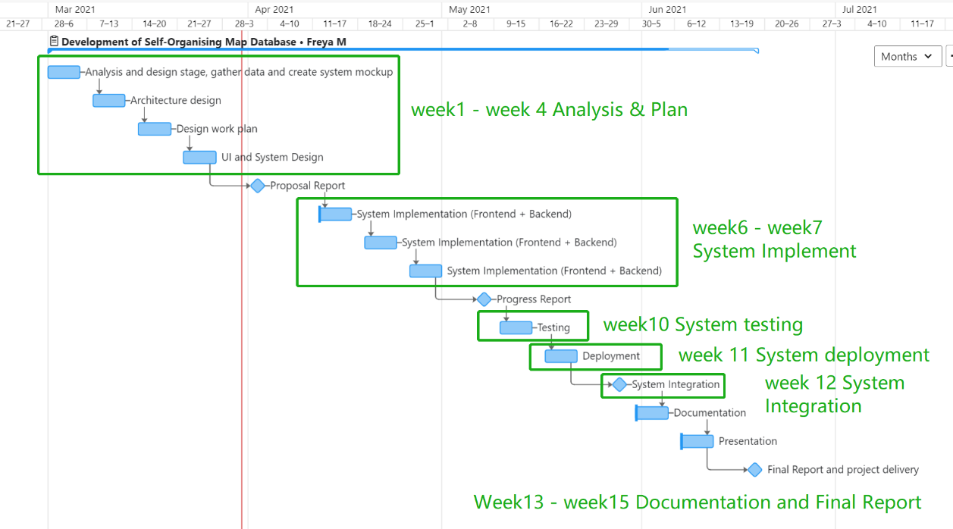

|  |  |  |  |
| --- | --- | --- | --- |
| 1. **Milestone** | **Tasks** | **Reporting** | **Date** |
| Week-1 | Analysis and design stage, gather data and create system mockup | Client meeting to review the project | Mar 5, 2021 |
| Week-2 | Architecture design | Client meeting to discuss requirements | Mar 12, 2021 |
| Week-3 | Design work plan | Client meeting to review the work plan | Mar 19, 2021 |
| Week-4 | UI and system plan | Client meeting to review the system design | Mar 26, 2021 |
| Week-5 | Proposal Report Due |  | Apr 2, 2021 |
| Week-6 | System Implementation (Frontend + Backend) | Client meeting to review the project progress | Apr 16, 2021 |
| Week-7 | System Implementation (Frontend + Backend) | Client meeting to review the project progress | Apr 23, 2021 |
| Week-8 | System Implementation (Frontend + Backend) | Client meeting to review the project progress | Apr 30, 2021 |
| Week-9 | Progress Report Due |  | May 7, 2021 |
| Week-10 | Testing | Client meeting to review the test results | May 14, 2021 |
| Week-11 | Deployment | Client meeting to review the system deployment | May 21, 2021 |
| Week-12 | System Integration | Client meeting to review the system Integration | May 28, 2021 |
| Week-13 | Documentation | Client meeting to review the documentation | Jun 4, 2021 |
| Week-14 | Presentation | None | Jun 11, 2021 |
| Week-15 | Final Report and Project delivery | None | Jun 18, 2021 |

The table below shows our task distribution by work break down for system implementation.

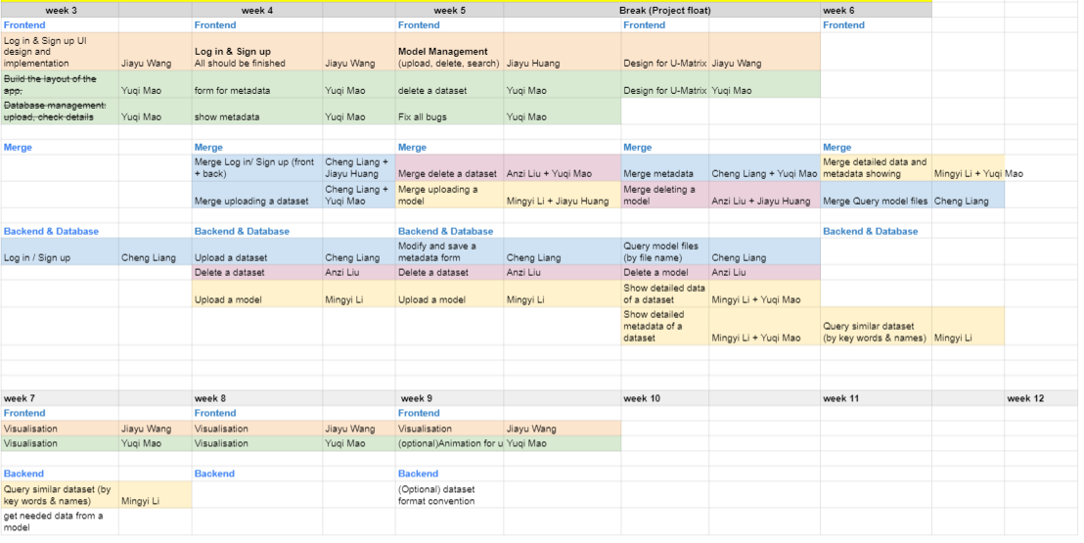

References

American Psychological Association (APA). (2010). *Publication Manual of the American Psychological Association* (6th Ed.). Washington, DC: Author.

* You are strongly encouraged to use information from reputable websites such as Wall Street Journal, New York Times, and websites from Governments, as well as books, academic journals and magazines (e.g., The Economist). Some well-regarded journals you may refer to are: Harvard Business Review, Information Systems Research, Management Science and MIS Quarterly.
* Please cite all references at the end of your paper (both proposal and final report). You should include references to facts, figures and any other information that you obtained from various sources. References from relevant papers in the University Digital Library are preferred over Internet sources as Internet sources may not always be reliable.
* Whenever you quote, paraphrase, summarise or refer to ideas, facts, figures or findings from another source (e.g. research paper, book, website), you should cite the source, with appropriate formatting, in the sentence that mentions these ideas or figures. It is not sufficient to just provide a list of references at the end of your paper. The source that you use should be cited in the text of your paper, either in parentheses or as part of the text itself. We suggest the use of APA style for referencing. If the references quite a lot, you can use the reference management system such as Endnote that provided by the University of Sydney (<http://libguides.library.usyd.edu.au/endnote)>.
* You are reminded that the University takes plagiarism infringements seriously. If the sources are not cited correctly, it may be deemed as plagiarism. Please note that your submission will be forwarded to an automated plagiarism checking system.

[Extra page inserted to ensure correct even-page footer for this section. Delete this when bibliography is at least 2 pages long.]