# Title Page (Placeholder)
University of Bristol MSc Robotics Dissertation
Title: [NEEDS_USER_CONFIRMATION]
Author: [NEEDS_USER_CONFIRMATION]
(TOC will populate after updating fields)

Abstract
Large language models (LLMs) have shown potential for high-level reasoning and decision-making, but their use in traffic control remains challenging because model outputs may be unreliable and require additional validation and safety mechanisms. This dissertation investigates the use of an LLM-assisted decision pipeline for cooperative control at an unsignalised intersection using Simulation of Urban MObility (SUMO).
A structured control architecture was developed to separate LLM-based decision generation from response parsing, deterministic validation, cooperative post-processing, safety verification, and fallback handling. Four controller configurations were evaluated: a rule-based baseline, a raw LLM controller, a hybrid LLM controller with cooperative post-processing, and a hybrid controller with an additional safety verification layer. Experiments were conducted with 4-vehicle and 8-vehicle scenarios across three random seeds, using waiting time, mean speed, completion rate, collisions, provider reliability, and intervention behaviour as the main evaluation measures.
The results show that the LLM-assisted pipelines achieved lower operational waiting time and higher mean speed than the rule-based baseline in the tested scenarios. Mean waiting time increased from 82.0 to 242.0 steps for the rule-based controller when the scenario increased from four to eight vehicles, compared with approximately 15.0 to 15.3 steps for the LLM-assisted pipelines. However, live LLM availability was a major limitation: only 4 of 2,784 provider requests succeeded in the corrected 8-vehicle experiments, causing the system to rely heavily on deterministic fallback behaviour. No collisions were observed, but neither the cooperative post-processing nor safety layer was sufficiently activated to demonstrate an independent performance benefit.
These findings show that a structured and traceable LLM-assisted control architecture can be implemented and evaluated in SUMO, while also demonstrating that reliable model access and clearer isolation of individual pipeline components are necessary before improvements can be attributed directly to the LLM.

1 Introduction

1.1 Background and Motivation
Unsignalised intersections present a challenging coordination problem for autonomous vehicles because several vehicles may approach a shared conflict area simultaneously while following intersecting trajectories. Without traffic signals or a centralised right-of-way mechanism, vehicles must determine when to proceed, wait, or yield while maintaining both traffic efficiency and safety. Autonomous intersection management has therefore been studied as a multi-agent coordination problem in which vehicle interactions must be managed to reduce unnecessary delay while avoiding conflicting movements (Dresner and Stone, 2008; Safarov, 2022).
Recent developments in large language models (LLMs) have created new possibilities for incorporating high-level reasoning into autonomous systems. LLMs have demonstrated capabilities in planning, interpreting structured context, and generating decisions from complex inputs, while multimodal and embodied language models have further explored the connection between language-based reasoning and physical environments (Huang et al., 2022; Driess et al., 2023). These developments have also motivated research into the application of LLMs to autonomous driving and vehicle decision-making.
However, directly using an LLM as a vehicle controller introduces important practical limitations. Model responses may be unavailable, malformed, inconsistent, or unsuitable for immediate execution. Furthermore, when an LLM is combined with conventional rules and safety mechanisms, improvements in system performance cannot necessarily be attributed to the language model alone. A practical control architecture therefore requires mechanisms for validating model outputs, handling failures, coordinating decisions between vehicles, and enforcing safety constraints.
This dissertation investigates this problem through a structured LLM-assisted decision architecture for an unsignalised intersection simulated in Simulation of Urban MObility (SUMO). Rather than treating the LLM as an independent end-to-end controller, the proposed architecture integrates language-model decisions with deterministic validation, fallback behaviour, cooperative post-processing, and safety verification. This structure also enables the behaviour of individual stages to be recorded and analysed.

1.2 Problem Statement and Research Gap
Existing research provides several foundations for this work. Autonomous intersection management demonstrates the importance of coordination between vehicles sharing conflict areas, while research on language-model planning shows the potential of LLMs to generate high-level actions from structured information. Work on embodied and multimodal language models further highlights the importance of grounding language-based reasoning in environmental state information. More recent autonomous-driving research has begun to investigate LLMs as components of driving decision and reasoning systems.
Despite this progress, an important practical question remains: how should an LLM be incorporated into a traffic-control pipeline when its output cannot be assumed to be continuously available or directly executable?
This dissertation addresses this question through a controlled comparison of four architectures: a rule-based controller, a raw LLM controller, a hybrid LLM controller incorporating cooperative post-processing, and a hybrid LLM controller incorporating both cooperative post-processing and deterministic safety verification. All controllers are evaluated within the same SUMO intersection environment and under consistent experimental conditions.
The study therefore focuses on pipeline-level behaviour rather than attempting to demonstrate general superiority of LLM-based autonomous driving. Particular attention is given to both traffic performance and the reliability of the LLM integration, including provider availability, parsing, fallback behaviour, and downstream interventions. This allows the experimental results to distinguish, where possible, between behaviour originating from the language model and behaviour produced by deterministic components of the overall control system.

1.3 Aim and Objectives
The aim of this dissertation is to evaluate whether a structured LLM-assisted decision pipeline can support efficient cooperative decision-making at an unsignalised intersection while maintaining traceability, reproducibility, and deterministic safeguards.
To achieve this aim, the study has the following objectives:
- Design and implement comparable rule-based and LLM-assisted controllers for an unsignalised intersection in SUMO.
- Develop a staged decision architecture separating LLM decision generation, validation, fallback handling, cooperative post-processing, and safety verification.
- Establish consistent experimental conditions for comparing the controller architectures.
- Evaluate the controllers across multiple vehicle scales and random seeds.
- Measure traffic performance using completion, operational waiting, mean speed, and collision-related outcomes.
- Evaluate the reliability of the LLM-assisted pipeline using provider success, parsing, fallback, latency, and intervention measurements.
- Analyse the results while distinguishing observed pipeline-level performance from effects that can specifically be attributed to the LLM.

1.4 Research Questions
The dissertation addresses the following research questions:
RQ1: How does the traffic efficiency of the LLM-assisted architecture compare with the rule-based baseline at an unsignalised intersection?
RQ2: To what extent does cooperative post-processing alter the behaviour and performance of the raw LLM pipeline?
RQ3: What effect does deterministic safety verification have on the hybrid pipeline, and is any safety-efficiency trade-off observable under the evaluated scenarios?
RQ4: How does controller behaviour change when the traffic scale increases from four to eight vehicles under the evaluated low-density intersection scenario?

1.5 System Overview and Contributions
To investigate these questions, a staged control architecture was implemented. At each decision point, the current traffic state and route-conflict information are converted into a structured prompt for the language model. The returned response is parsed and validated before being passed through deterministic interface rules. Depending on the controller configuration, cooperative post-processing and safety verification may then modify the proposed actions before they are applied in SUMO. When a usable LLM decision is unavailable, deterministic fallback behaviour allows the simulation to continue.
The architecture records decisions at different stages of the pipeline, allowing model responses, fallback events, post-processing interventions, and safety interventions to be analysed separately. This traceability is particularly important because the observed traffic behaviour may result from interactions between learned and deterministic components rather than from the LLM alone.
The main contributions of the dissertation are therefore:
- the implementation of four comparable controller architectures within a common SUMO unsignalised-intersection environment;
- a modular LLM-assisted decision pipeline combining model-generated decisions with deterministic validation, fallback handling, cooperative processing, and safety verification;
- a controlled evaluation of traffic performance across four-vehicle and eight-vehicle scenarios; and
- an evaluation framework that considers provider reliability, parsing, fallback behaviour, and downstream interventions alongside conventional traffic-performance measures.
Together, these contributions provide an experimental basis for assessing both the potential and the practical limitations of integrating LLM-based reasoning into cooperative traffic-control systems.

1.6 Dissertation Structure
The remainder of this dissertation is organised as follows. Chapter 2 reviews relevant research on autonomous intersection management, language-model planning, embodied reasoning, and LLM-assisted autonomous driving, and establishes the research context for the proposed architecture. Chapter 3 describes the methodology and system design, including the SUMO environment, controller architectures, LLM decision pipeline, cooperative processing, fallback mechanism, and safety verification. Chapter 4 presents the experimental design, scenarios, evaluation metrics, and execution procedure. Chapter 5 reports the experimental results for traffic performance and LLM-pipeline reliability. Chapter 6 discusses these findings in relation to the research questions and existing literature. Chapter 7 examines the main methodological and validity limitations. Finally, Chapter 8 summarises the conclusions and identifies directions for future work.

2 Literature Review

2.1 Autonomous Intersection Management and Unsignalised Junction Control
Autonomous intersection management (AIM) addresses the coordination of vehicles within shared conflict areas without relying exclusively on conventional traffic signals. A fundamental challenge is determining how access to the intersection should be allocated when multiple vehicles approach simultaneously. Dresner and Stone (2008) proposed a reservation-based multi-agent approach in which vehicles request access to intersection space and an intersection manager determines whether their trajectories can be accommodated safely. Their work established an important principle for subsequent AIM research: intersection control can be formulated as a coordination and scheduling problem rather than solely as a vehicle-control problem.
This perspective is particularly relevant to unsignalised intersections, where vehicle interactions and behavioural assumptions can have a substantial effect on traffic flow. Safarov (2022), studying an unregulated junction, demonstrated that vehicle behaviour and interaction strategies influence both efficiency and the resulting traffic dynamics. These findings indicate that intersection performance depends not only on road geometry or vehicle dynamics, but also on the decision policies governing interactions between road users.
The existing literature therefore establishes two requirements relevant to this dissertation. First, vehicles approaching a shared conflict region require some form of coordinated access policy. Second, evaluating such a policy requires consideration of both traffic efficiency and safe conflict resolution. These principles provide the basis for examining whether newer decision-making approaches, including LLM-assisted architectures, can contribute to intersection coordination.

2.2 Cooperative and Multi-Agent Decision-Making
Intersection management is inherently a multi-agent problem because the action selected by one vehicle changes the feasible actions available to others. A vehicle cannot therefore make an effective intersection decision solely from its own desired trajectory; it must also account for other vehicles that may occupy or enter conflicting regions.
The reservation-based system proposed by Dresner and Stone (2008) illustrates this explicitly. Individual vehicles communicate their intended movements, while coordination is achieved through a mechanism that determines whether those movements are mutually compatible. Safarov (2022) similarly demonstrates that interaction between participants affects the overall behaviour of an unregulated junction. Together, these studies suggest that coordination should be treated as an explicit component of intersection decision-making rather than an assumed consequence of independently generated vehicle actions.
This distinction becomes particularly important when introducing learning-based or language-model-based decision systems. A model may generate an individually reasonable action without ensuring that the collection of actions produced for several vehicles is mutually compatible. Consequently, an LLM-assisted intersection controller requires a mechanism through which individual decisions can be interpreted within the wider traffic state.
The literature reviewed here therefore motivates the separation between individual decision generation and system-level coordination. However, the available intersection-management studies primarily employ deterministic, optimisation-based, or predefined coordination mechanisms. This leaves open the question of how an LLM-generated proposal should interact with explicit cooperative rules in a controlled multi-vehicle environment.

2.3 Language Models as Planners and Embodied Reasoners
The use of language models for decision-making is partly motivated by their demonstrated ability to generate high-level plans. Huang et al. (2022) investigated language models as zero-shot planners and showed that pretrained models can use task descriptions to generate sequences of actions without task-specific training. Their results demonstrate the potential of language models to contribute to planning, but also reveal an important limitation: linguistically or semantically plausible outputs are not necessarily directly executable within a physical or simulated environment.
This distinction between reasoning and execution is particularly relevant to autonomous systems. A decision generated by an LLM must ultimately be translated into an action supported by the underlying control environment. The planning literature therefore suggests that language-model outputs require grounding, validation, or another form of interface between high-level reasoning and executable actions.
Driess et al. (2023) extend this concept through PaLM-E, an embodied multimodal language model that incorporates continuous sensor modalities into a language-model architecture. Their work demonstrates the value of grounding language-based reasoning in information describing the state of the physical environment. Although the scale and architecture of PaLM-E differ substantially from the intersection-control problem considered in this dissertation, the underlying principle is relevant: decision-making becomes more meaningful when the language model receives structured information about the environment in which its outputs will be applied.
Together, these studies suggest a useful role for language models as high-level reasoning or planning components rather than unrestricted low-level controllers. For traffic-control applications, this implies that environmental state representation, output constraints, and executable-action validation are important elements of the overall architecture.

2.4 Large Language Models for Autonomous Driving
Recent research has increasingly examined the use of LLMs and multimodal language models within autonomous-driving systems. This work extends beyond general planning by considering how language-based reasoning can interact with driving scenes, vehicle states, and safety-critical decisions.
Cui et al. (2025), in LLM4AD, examine the potential roles of LLMs across autonomous-driving tasks while also identifying practical challenges associated with their deployment. These include latency, reliability, transparency, safety, privacy, and the difficulty of transferring language-model capabilities into dependable driving behaviour. Such limitations are particularly important for real-time control because a useful decision mechanism must not only generate appropriate outputs but must also do so consistently and within operational constraints.
Hou et al. (2025) present DriveAgent, which adopts a more structured approach to reasoning for autonomous driving. Rather than relying on a single unconstrained model output, the system organises reasoning into distinguishable components. This modular direction is significant because it provides greater opportunity to inspect how intermediate reasoning contributes to the eventual driving decision.
Similarly, Dong et al. (2026) investigate LLM-based interactive decision-making for autonomous driving using explicit representations of the driving environment and safety-related constraints. Their approach reflects a broader movement from free-form language generation towards structured decision architectures in which model reasoning is bounded by information about the driving scene and the requirements of the control task.
These studies indicate that the central research question is shifting from whether an LLM can produce driving-related reasoning to how such reasoning can be integrated reliably into an executable autonomous system. However, the complexity of the architectures and scenarios used across the literature also makes direct comparison difficult. Different studies use different state representations, model interfaces, safety mechanisms, evaluation environments, and performance criteria. This motivates controlled evaluation in which the contribution and limitations of individual components can be observed more directly.

2.5 Reliability, Safety, and Hybrid Decision Architectures
Reliability is particularly important when language-model outputs influence actions in a dynamic environment. The planning limitations identified by Huang et al. (2022) illustrate that plausible model outputs may still fail to correspond to valid executable actions. Autonomous-driving studies extend this concern by highlighting latency, robustness, transparency, and safety as practical barriers to deployment (Cui et al., 2025).
These limitations motivate hybrid architectures in which model-generated decisions are constrained by deterministic mechanisms. Such mechanisms can perform several functions. Output validation can restrict the model to an allowable action space; fallback logic can maintain operation when a valid model response is unavailable; cooperative rules can reconcile decisions involving multiple agents; and safety constraints can prevent selected actions from violating predefined conditions.
An important consequence is that the behaviour of a hybrid system cannot automatically be interpreted as the behaviour of the language model itself. If deterministic components modify or replace model-generated decisions, measured traffic performance reflects the complete decision architecture. Evaluating such systems therefore requires more than conventional traffic metrics. Model availability, successful parsing, fallback frequency, intervention rates, and latency can provide evidence about how decisions were actually produced.
This distinction is especially relevant to simulation-based evaluation. A controller may continue operating successfully despite unreliable model access if a deterministic fallback mechanism is available. In that case, successful traffic operation demonstrates robustness of the complete architecture, but provides weaker evidence for the effectiveness of the language model considered independently. Separating these two interpretations is necessary for a defensible assessment of LLM-assisted control.

2.6 Research Gap
The reviewed literature establishes several complementary strands of research. Autonomous intersection management demonstrates that intersections can be treated as multi-agent coordination problems in which access to shared conflict space must be explicitly managed (Dresner and Stone, 2008). Research on unregulated junctions further shows that behavioural assumptions and interaction strategies can significantly affect traffic performance (Safarov, 2022). Language-model planning research demonstrates the potential of pretrained models for high-level action generation while also exposing the gap between plausible reasoning and executable behaviour (Huang et al., 2022). Embodied language-model research emphasises the importance of grounding model reasoning in environmental state information (Driess et al., 2023). More recent autonomous-driving studies extend these ideas towards structured LLM-based driving systems while identifying reliability, latency, safety, and transparency as continuing challenges (Cui et al., 2025; Hou et al., 2025; Dong et al., 2026).
Taken together, these studies suggest that LLMs may contribute to high-level decision-making in autonomous systems, but they do not remove the need for deterministic coordination, validation, and safety mechanisms. Furthermore, the diversity of existing architectures makes it difficult to determine whether observed performance originates from the language model, surrounding deterministic components, or their interaction.
This dissertation addresses a narrower methodological gap by evaluating several decision architectures under a common SUMO unsignalised-intersection environment. The comparison includes rule-based control, direct LLM-assisted decision-making, cooperative post-processing, and deterministic safety verification while also recording the reliability and decision path of the LLM integration. By evaluating these architectures under consistent scenarios and metrics, the study aims to examine not only whether the resulting traffic behaviour differs, but also how the different components contribute to that behaviour.
This leads to four research questions concerning the traffic efficiency of LLM-assisted control, the effect of cooperative post-processing, the role of deterministic safety verification, and the behaviour of the system as the evaluated traffic scale increases from four to eight vehicles.

3 Methodology and System Design

3.1 System Overview
This study investigates cooperative vehicle decision-making at an unsignalised intersection using Simulation of Urban MObility (SUMO). The experimental system combines microscopic traffic simulation with four alternative decision architectures, allowing rule-based and LLM-assisted control strategies to be evaluated under the same intersection environment.
The proposed system follows a modular architecture rather than using the LLM as an end-to-end vehicle controller. Traffic state information is obtained from the SUMO simulation and converted into a structured representation describing the vehicles relevant to the current decision. For LLM-assisted controllers, this state is incorporated into a structured prompt and submitted to the language model. The returned decisions are subsequently parsed and validated before optional cooperative and safety-processing stages determine the actions applied to the simulated vehicles.
The complete decision process can therefore be represented as:
SUMO traffic state → state representation → decision generation → validation → cooperative processing → safety verification → vehicle action → logging
Separating these stages makes it possible to examine both traffic-level performance and the internal behaviour of the LLM-assisted pipeline.

3.2 SUMO Simulation Environment
SUMO was used as the microscopic traffic simulator because it provides explicit control over vehicle routes, traffic states, vehicle speeds, and simulation progression. The study considers an unsignalised intersection in which vehicles approach from predefined routes and may encounter other vehicles with conflicting trajectories.
At each simulation step, the controller obtains the state of relevant vehicles from SUMO. The information used for decision-making includes vehicle identity, route information, position relative to the controlled intersection region, and the conflict relationships between routes. Vehicles are classified according to whether they are within the region in which intersection decisions are required.
The control system uses three high-level vehicle actions:
- PROCEED, allowing the vehicle to continue through the controlled region;
- WAIT, requiring the vehicle to remain stopped or prevented from proceeding; and
- FREE, indicating that the vehicle is outside the active control region and should follow normal simulator behaviour.
This abstraction was selected because the research focuses on high-level intersection coordination rather than low-level steering or trajectory generation.

3.3 Controller Architectures
Four controller architectures were evaluated using the same SUMO environment and action space.

3.3.1 Rule-Based Controller
The rule-based controller provides the deterministic baseline. Decisions are generated without calling an external language model. Vehicle actions are determined from the predefined intersection-control logic and current traffic state.
This controller provides the reference against which the traffic performance of the LLM-assisted architectures is evaluated.

3.3.2 Raw LLM Controller
The Raw LLM controller introduces the language model as the primary decision-generation component. A structured representation of the current traffic state is supplied to the model, which returns vehicle-level actions from the permitted decision set.
The returned response cannot be applied directly to the simulation. It first passes through the parsing and validation stages described in Section 3.5. If a usable model decision cannot be obtained, deterministic fallback behaviour is used so that the simulation can continue.

3.3.3 Hybrid LLM Controller
The Hybrid LLM controller extends the Raw LLM architecture by introducing cooperative post-processing after the initial LLM decision has been parsed and validated.
The purpose of this stage is to evaluate whether explicit deterministic coordination can improve or modify decisions generated by the language model. Where the route relationships and local traffic conditions permit compatible movements, the post-processor may modify the validated decisions before they are applied to the vehicles.

3.3.4 Hybrid LLM with Safety Verification
The final architecture adds a deterministic safety-verification stage to the Hybrid LLM pipeline. After cooperative processing, the proposed actions are checked against predefined conflict conditions. If a proposed action violates these conditions, the safety layer can replace it with a more conservative action.
This produces a layered architecture in which model-generated decisions remain subject to deterministic constraints before execution.

3.4 LLM Input and Output Interface
A fixed prompt structure was used throughout the formal evaluation to ensure that differences between runs were not introduced by prompt modification. The canonical prompt configuration was identified as P1_BASELINE.
Rather than requesting free-form driving advice, the model receives structured information describing the current decision context. This includes the relevant vehicles and the information required to reason about their movements through the intersection.
The model is required to return a single structured JSON object containing vehicle-level decisions. Each decision is restricted to the predefined action space:
PROCEED, WAIT, or FREE.
Vehicles outside the active control region are assigned FREE, while controlled vehicles are expected to receive an admissible intersection action. Free-form explanations are not required because the output must be machine-readable and suitable for subsequent validation.
Constraining both the input representation and output space reduces ambiguity between language-model reasoning and simulator execution.

3.5 Decision Processing Pipeline

3.5.1 Provider Request
For the LLM-assisted controllers, the structured prompt is submitted to a live language-model provider. The formal experiments used Groq with the openai/gpt-oss-20b model.
The request configuration was fixed throughout the evaluated experiments:

3.5.2 Parsing and Validation
The provider response is parsed into the expected vehicle-action structure. Only actions belonging to the predefined decision space are accepted. Missing or invalid controlled-vehicle actions are converted to the conservative WAIT action.
The validation stage therefore provides an explicit boundary between language-model output and executable simulator behaviour. A syntactically generated response is not automatically treated as a valid control decision.

3.5.3 Deterministic Fallback
The LLM-assisted architectures include deterministic fallback behaviour for cases in which a usable model response is unavailable. This allows the control loop to continue despite provider failures or unusable responses.
Fallback events are recorded separately from successful model-generated decisions. This distinction is necessary because traffic performance produced during fallback operation cannot be attributed solely to the LLM.

3.5.4 Cooperative Post-Processing
The cooperative post-processing stage is enabled for the Hybrid and Hybrid + Safety controllers. It evaluates the validated actions in relation to the current route relationships and local traffic state.
Where movements are considered compatible, the post-processor may modify conservative waiting decisions to permit additional progress. The purpose of this stage is to introduce explicit coordination after individual decisions have been generated.

3.5.5 Safety Verification
The Hybrid + Safety architecture applies an additional deterministic verification stage after cooperative processing. Proposed vehicle actions are checked against predefined conflict conditions before they are executed.
Where a proposed action is considered unsafe according to these rules, the verifier can downgrade the action to a more conservative decision. This provides an independent safety boundary between upstream decision generation and vehicle execution.

3.6 Traceability and Data Collection
The experimental implementation records decisions at multiple stages of the pipeline. For each relevant decision event, the system can distinguish between the provider response, parsed decision, validated decision, post-processed decision, and final action applied to the simulation.
Additional diagnostic information records whether a provider request was attempted and successful, whether parsing succeeded, whether fallback behaviour was used, and whether cooperative or safety processing modified the decision.
This logging structure supports two complementary forms of evaluation. Traffic-level metrics measure the behaviour of the complete controller within SUMO, while decision-pipeline metrics indicate how that behaviour was produced.
This distinction is important for interpreting the results because successful traffic operation does not necessarily imply successful LLM operation.

3.7 Reproducibility Controls
The experimental configuration was fixed before the final formal evaluation. The controller definitions, action space, prompt structure, request configuration, vehicle scales, scenario definitions, random seeds, and evaluation metrics were held constant within the corresponding experimental comparisons.
Formal experiments were executed using predefined experiment matrices rather than manually configured individual runs. Run-level metadata and traces were retained to allow the configuration and outcome of each experiment to be reconstructed.
The final analysis uses validated four-vehicle and eight-vehicle experimental evidence. Details of the experimental matrix, scenario scales, seeds, run validity criteria, and evaluation metrics are presented in Chapter 4.

4 Experimental Design

4.1 Experimental Objective
The experimental evaluation was designed to compare four intersection-control architectures under controlled and repeatable SUMO conditions. The primary objective was to determine how the introduction of LLM-based decision generation, cooperative post-processing, and deterministic safety verification affected traffic performance and decision-pipeline behaviour.
The experiment therefore varied the controller architecture and traffic scale while keeping the underlying intersection scenario, action space, prompt configuration, and evaluation procedure fixed.
Two types of outcomes were considered. Traffic-level metrics were used to evaluate the behaviour of the complete controller within SUMO, while pipeline-level metrics were used to determine how successfully the LLM and subsequent processing stages contributed to the final decisions.

4.2 Experimental Factors
Three experimental factors were considered:
The four controller architectures correspond to progressively different decision pipelines. The Rule-Based controller provides the deterministic baseline. Raw LLM introduces model-generated decisions with validation and fallback handling. Hybrid LLM additionally applies cooperative post-processing, while Hybrid LLM + Safety introduces the deterministic safety-verification stage described in Chapter 3.
Each controller was evaluated using three seeds at both vehicle scales. The intended experimental design therefore corresponds to:

4.3 Experimental Evidence and Run Validity
The final dissertation analysis combines two validated experimental batches. The four-vehicle results are taken from the valid 4V runs of the original formal evaluation, whereas the eight-vehicle results are taken from a corrected execution batch.
During post-experiment trace validation, the nominal eight-vehicle runs from the original batch were found not to represent the intended 8V scenario: although the experimental metadata specified eight vehicles, the underlying traces contained only four vehicles. Investigation identified an execution-level configuration error in which the default four-vehicle SUMO configuration was loaded instead of the generated scenario-specific eight-vehicle configuration.
The execution path was subsequently corrected without changing the controller algorithms, prompt, model configuration, decision semantics, cooperative processing, or safety rules. A corrected eight-vehicle experiment was then executed and validated. Each retained 8V run contained eight observed vehicles, eight departures, and eight arrivals.
The final evidence used in this dissertation is therefore:
The invalid nominal 8V runs from the original batch and the intermediate rerun were excluded from all final comparative results.

4.4 Controlled Experimental Conditions
The following conditions were held constant across the relevant controller comparisons:
- the SUMO intersection network and scenario family;
- low-density traffic configuration;
- vehicle action space: PROCEED, WAIT, and FREE;
- canonical prompt structure for LLM-assisted controllers;
- LLM provider and model configuration;
- parser and validation behaviour;
- deterministic fallback mechanism;
- random-seed set; and
- logging and metric definitions.
For the LLM-assisted controllers, the live provider was Groq and the model was openai/gpt-oss-20b. The request configuration used a maximum completion length of 256 tokens, low reasoning effort, a 30-second timeout, and no automatic retries.
The same configuration was retained across Raw LLM, Hybrid LLM, and Hybrid LLM + Safety so that differences between these controllers were attributable to the downstream processing stages rather than changes in the LLM request configuration.

4.5 Evaluation Metrics
The evaluation uses both traffic-performance metrics and decision-pipeline metrics.

4.5.1 Traffic Performance Metrics
Completion rate measures the proportion of departed vehicles that successfully reach their destination:
Completion Rate = N_arrived / N_departed
Throughput is reported as the total number of vehicles that arrived during the simulation. In this implementation, throughput therefore represents an arrival count rather than a conventional vehicles-per-unit-time flow rate.
Mean waiting time is an operational stopping measure derived from the number of simulation steps for which a vehicle's post-action speed is below the predefined stopping threshold of 0.1 m/s. It should therefore be interpreted as a stop-like occupancy measure rather than a conventional queueing-theory delay metric.
Mean speed is calculated from the recorded post-action vehicle speeds and provides a complementary measure of traffic progression through the scenario.
Collision count records collisions observed during each experimental run.

4.5.2 LLM and Pipeline Metrics
For the three LLM-assisted controllers, additional metrics were collected to characterise the decision pipeline.
Provider success rate measures the proportion of attempted live-provider requests that returned a successful response:
Provider Success Rate = N_successful requests / N_attempted requests
Parser success rate records how often a provider response was successfully converted into the required structured decision representation.
Fallback rate measures how often deterministic fallback behaviour was required following provider failure or unusable output.
Request latency records the time required for live-provider requests and is used to assess the operational cost of introducing an external LLM into the control loop.
Post-processing intervention records whether cooperative processing changed a validated decision.
Safety override records whether the deterministic safety verifier modified a proposed decision before execution.
Together, these metrics distinguish the behaviour of the complete traffic-control pipeline from the availability and behaviour of the language model itself.

4.6 Relationship Between Metrics and Research Questions
The evaluation strategy was aligned directly with the four research questions.
Research question | Primary comparison | Main evidence
RQ1 | Rule-Based vs LLM-assisted control | waiting time, mean speed, completion, collisions
RQ2 | Raw LLM vs Hybrid LLM | traffic metrics, post-processing interventions
RQ3 | Hybrid LLM vs Hybrid LLM + Safety | safety overrides, collisions, traffic metrics
RQ4 | 4V vs 8V | waiting time, mean speed, completion, pipeline reliability
Provider success, parser success, fallback behaviour, and latency are additionally used across the research questions to determine how much of the observed behaviour can reasonably be associated with live LLM operation.

4.7 Experimental Procedure
For each experimental condition, the corresponding SUMO scenario was generated using the predefined vehicle scale and seed. The selected controller was then initialised using the fixed experimental configuration.
During simulation, vehicle states were obtained from SUMO and processed by the active controller. For LLM-assisted controllers, relevant states were converted into the structured prompt representation and submitted to the live provider when an LLM decision was required. The resulting response then passed through the parsing, validation, fallback, cooperative, and safety stages applicable to that controller architecture.
Simulation state, traffic outcomes, provider diagnostics, and intermediate decision states were recorded throughout each run. At the end of the run, summary metrics were generated from the stored traces.
Each retained run was subsequently checked against its intended scenario configuration and observed vehicle population before inclusion in the final analysis. This validation step was particularly important for the eight-vehicle condition because it prevented incorrectly configured runs from being treated as scalability evidence.

4.8 Validity Controls
Several measures were used to improve internal validity and reproducibility.
Three random seeds were used for each controller-scale combination to reduce dependence on a single scenario realisation. Controller order was counterbalanced across seeds to reduce systematic ordering effects. Prompt structure, request parameters, decision semantics, and evaluation metrics were fixed before the retained formal comparisons.
Detailed traces were retained for each run, allowing the configured vehicle count to be checked against the vehicles actually observed, departed, and arrived during simulation. Experimental artifacts were stored separately so that individual runs could be audited without relying only on aggregated summary statistics.
These controls were particularly important because the study depends on both simulator execution and an external LLM provider.

4.9 Experimental Validity Considerations
Several limitations affect interpretation of the experiment.
First, live-provider availability was substantially lower than expected, causing the LLM-assisted controllers to rely heavily on deterministic fallback. Consequently, traffic-level differences should be interpreted as the behaviour of the complete LLM-assisted pipeline rather than isolated language-model performance.
Second, all retained formal conditions achieved complete vehicle arrival, which limits the discriminative value of completion rate. Waiting behaviour and mean speed therefore provide more informative traffic-efficiency comparisons in these scenarios.
Third, the evaluation covers only four- and eight-vehicle low-density scenarios. It does not establish performance under dense traffic, larger vehicle populations, different junction geometries, or real-world driving conditions.
Finally, the safety verifier produced no overrides in the retained formal evidence. The experiments therefore demonstrate the presence and execution of the safety architecture, but do not provide sufficient evidence to quantify a safety-efficiency trade-off.
Detailed implications of these limitations are discussed in Chapters 6 and 7.

5 Results
- valid 4V evidence from results/formal_experiment/dissertation_formal_v2/
- corrected 8V evidence from results/formal_experiment/dissertation_formal_v4/
The nominal 8V formal_v2 traces are excluded because the raw traces show only 4 observed / departed / arrived vehicles.

1. Experimental validity
- Valid 4V evidence: 12 runs, 4 observed / departed / arrived vehicles per run, 0 collisions.
- Corrected 8V evidence: 12 runs, 8 observed / departed / arrived vehicles per run, 0 collisions.
- Corrected dissertation evidence base: 24 valid runs total.

Table 1. Experimental configuration
Dataset | Controllers | Vehicle scales | Seeds | Valid runs used | Status
formal_v2 | 4 | 4V + 8V planned | 1, 2, 3 | 12 valid 4V runs | 4V valid, 8V invalid
formal_v4 | 4 | 8V | 1, 2, 3 | 12 corrected 8V runs | Fully valid 8V evidence
Corrected dissertation evidence | 4 | 4V + 8V | 1, 2, 3 | 24 valid runs total | 4V from formal_v2, 8V from formal_v4

2. Traffic performance
The analysis remains descriptive because each controller-scale cell has n = 3 seeds.

Table 2. Traffic performance by controller and scale
Controller | Scale | Completion rate | Mean waiting time | Mean speed | Throughput | Collision count | Seed-level values
Rule-based | 4V | 100% | 82.000 ± 0.000 [82.000, 82.000] steps | 2.310 ± 0.000 [2.310, 2.310] m/s | 4.000 ± 0.000 [4.000, 4.000] | 0 | completion [1.0, 1.0, 1.0], waiting [82, 82, 82], speed [2.310, 2.310, 2.310]
Rule-based | 8V | 100% | 242.042 ± 110.586 [86.000, 329.125] steps | 1.189 ± 0.754 [0.655, 2.255] m/s | 8.000 ± 0.000 [8.000, 8.000] | 0 | completion [1.0, 1.0, 1.0], waiting [86, 311, 329.125], speed [2.255, 0.655, 0.658]
Raw LLM | 4V | 100% | 15.000 ± 0.000 [15.000, 15.000] steps | 6.803 ± 0.000 [6.803, 6.803] m/s | 4.000 ± 0.000 [4.000, 4.000] | 0 | completion [1.0, 1.0, 1.0], waiting [15, 15, 15], speed [6.803, 6.803, 6.803]
Raw LLM | 8V | 100% | 15.292 ± 2.045 [12.875, 17.875] steps | 6.599 ± 0.254 [6.265, 6.880] m/s | 8.000 ± 0.000 [8.000, 8.000] | 0 | completion [1.0, 1.0, 1.0], waiting [17.875, 12.875, 15.125], speed [6.265, 6.880, 6.652]
Hybrid | 4V | 100% | 15.000 ± 0.000 [15.000, 15.000] steps | 6.803 ± 0.000 [6.803, 6.803] m/s | 4.000 ± 0.000 [4.000, 4.000] | 0 | completion [1.0, 1.0, 1.0], waiting [15, 15, 15], speed [6.803, 6.803, 6.803]
Hybrid | 8V | 100% | 15.292 ± 2.045 [12.875, 17.875] steps | 6.599 ± 0.254 [6.265, 6.880] m/s | 8.000 ± 0.000 [8.000, 8.000] | 0 | completion [1.0, 1.0, 1.0], waiting [17.875, 12.875, 15.125], speed [6.265, 6.880, 6.652]
Hybrid + Safety | 4V | 100% | 15.000 ± 0.000 [15.000, 15.000] steps | 6.803 ± 0.000 [6.803, 6.803] m/s | 4.000 ± 0.000 [4.000, 4.000] | 0 | completion [1.0, 1.0, 1.0], waiting [15, 15, 15], speed [6.803, 6.803, 6.803]
Hybrid + Safety | 8V | 100% | 15.292 ± 2.045 [12.875, 17.875] steps | 6.599 ± 0.254 [6.265, 6.880] m/s | 8.000 ± 0.000 [8.000, 8.000] | 0 | completion [1.0, 1.0, 1.0], waiting [17.875, 12.875, 15.125], speed [6.265, 6.880, 6.652]

Interpretation
- The rule-based baseline degrades substantially from 4V to 8V.
- The LLM-assisted pipeline remains comparatively stable over the tested 4V-to-8V range.
- Completion rate saturates at 100% in every valid cell, so it does not separate controllers.
- Collision count remains 0 throughout the valid corrected evidence.

3. LLM/provider reliability

Table 3. Provider/parser/fallback reliability
Controller | Scale | Provider attempts | Provider successes | Success rate | Parser success given success | Fallback count | Fallback rate | Seed-level successes | Seed-level fallback counts
Raw LLM | 4V | 444 | 26 | 5.86% | 100% | 418 | 94.14% | [26, 0, 0] | [122, 148, 148]
Raw LLM | 8V | 928 | 2 | 0.22% | 100% | 926 | 99.78% | [1, 1, 0] | [289, 334, 303]
Hybrid | 4V | 444 | 22 | 4.95% | 100% | 422 | 95.05% | [22, 0, 0] | [126, 148, 148]
Hybrid | 8V | 928 | 1 | 0.11% | 100% | 927 | 99.89% | [0, 1, 0] | [290, 334, 303]
Hybrid + Safety | 4V | 444 | 22 | 4.95% | 100% | 422 | 95.05% | [22, 0, 0] | [126, 148, 148]
Hybrid + Safety | 8V | 928 | 1 | 0.11% | 100% | 927 | 99.89% | [0, 0, 1] | [290, 335, 302]

Interpretation
- Provider success is low in every live LLM-bearing cell.
- The corrected 8V boundary records 4 successful provider calls out of 2,784 attempts across the three live-provider controllers.
- Successful responses used finish_reason = stop and finite token usage (prompt_tokens = 543, completion_tokens = 35-37, reasoning_tokens = 9-11).
- Parser success given provider success is 100% in the corrected evidence.
- In the final evidence boundary, fallback_used and fallback_triggered match provider_failure_rows exactly, so the fallback denominator is the same as the failure denominator.

4. Decision-flow behaviour
The trace schema preserves raw, validated, postprocessed, and final decisions separately.

Table 4. Decision-source / postprocessor / safety behaviour
Controller | Scale | Dominant decision pattern | Postprocessor intervention | Safety override | Practical note
Rule-based | 4V | deterministic interface rule | 0 | 0 | No live provider path is used.
Rule-based | 8V | deterministic interface rule | 0 | 0 | No live provider path is used.
Raw LLM | 4V | fallback-heavy live path | 0 | 0 | Live provider exists, but most attempts fail.
Raw LLM | 8V | fallback-heavy live path | 0 | 0 | Live provider reliability is weaker at 8V.
Hybrid | 4V | fallback-heavy live path | 0 | 0 | Cooperative logic is present, but not visibly exercised in the valid evidence.
Hybrid | 8V | fallback-heavy live path | 0 | 0 | No visible cooperative intervention in the corrected 8V evidence.
Hybrid + Safety | 4V | fallback-heavy live path | 0 | 0 | Safety verifier is operational but not triggered.
Hybrid + Safety | 8V | fallback-heavy live path | 0 | 0 | Safety verifier is operational but not triggered.

5. Safety observations
- Collision count is 0 in every valid run.
- Safety override count is 0 in every valid run.
- The safety verifier exists and is logged, but it is not meaningfully exercised in the corrected formal evidence.

6. Corrected result boundary
- formal_v2 valid 4V is usable evidence.
- formal_v4 corrected 8V is usable evidence.
- formal_v2 nominal 8V traces are historical execution-layer failure evidence and must not be used in the final dissertation results.

7. Final evidence provenance
- Final 4V source: formal_v2 valid 4V runs
- Final 8V source: formal_v4
- Excluded from final tables: formal_v2 nominal 8V, formal_v3
The identical 8V traffic results for Raw LLM, Hybrid, and Hybrid + Safety are consistent with fallback dominance, very low provider success, zero visible postprocessor intervention, and zero safety overrides. This is a pipeline-level explanation, not evidence that the three architectures are intrinsically equivalent.
Figure summaries of the corrected evidence are presented below for direct dissertation use.
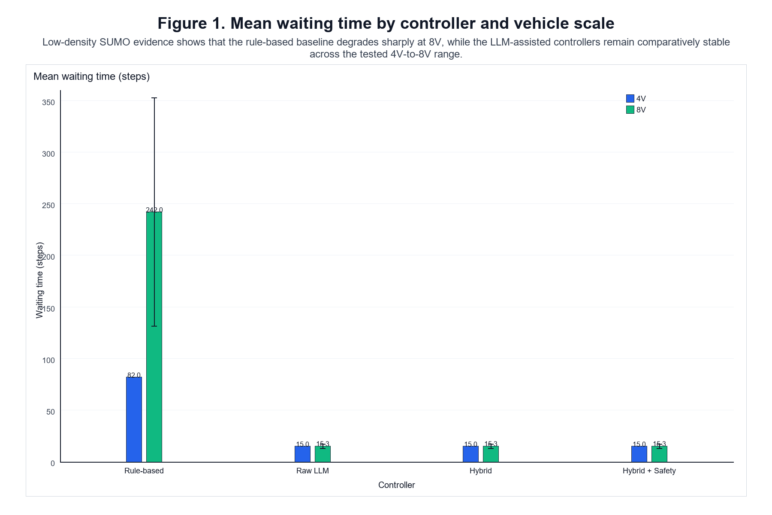
Figure 1. Mean waiting time by controller and vehicle scale in the corrected formal evidence.
Interpretation: The LLM-assisted controllers show lower mean waiting time than the rule-based baseline across the tested 4V and 8V scenarios.
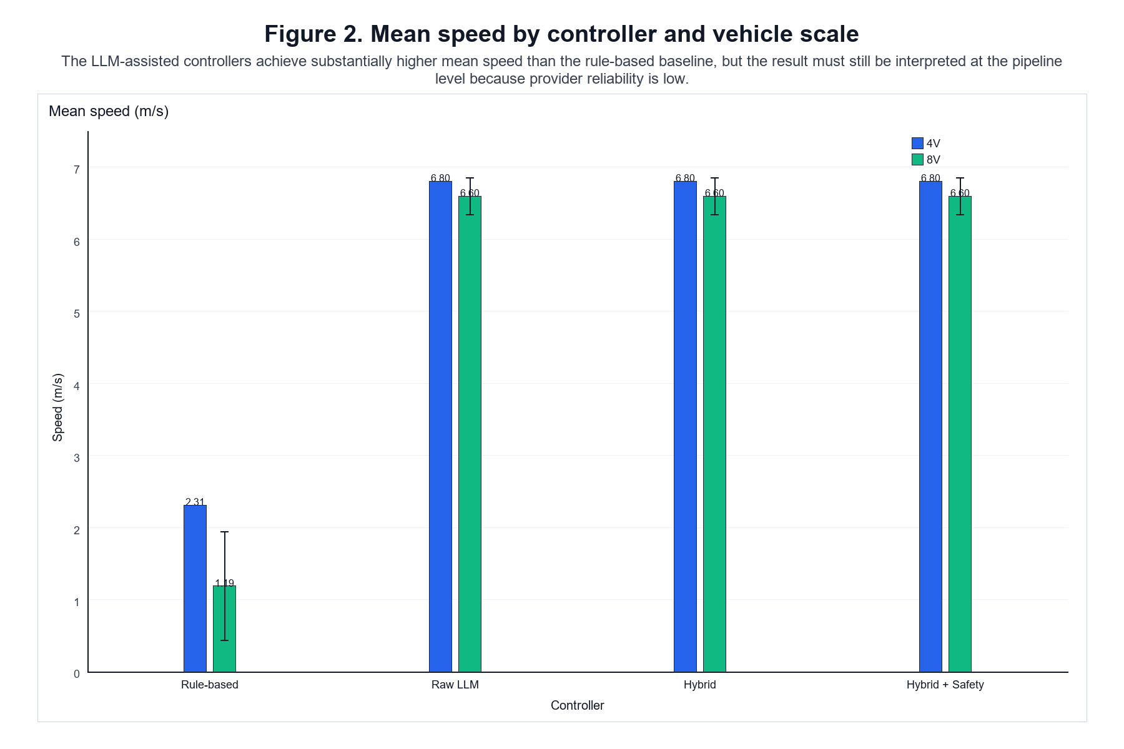
Figure 2. Mean speed by controller and vehicle scale in the corrected formal evidence.
Interpretation: The LLM-assisted controllers show higher mean speed than the rule-based baseline in the tested scenarios.
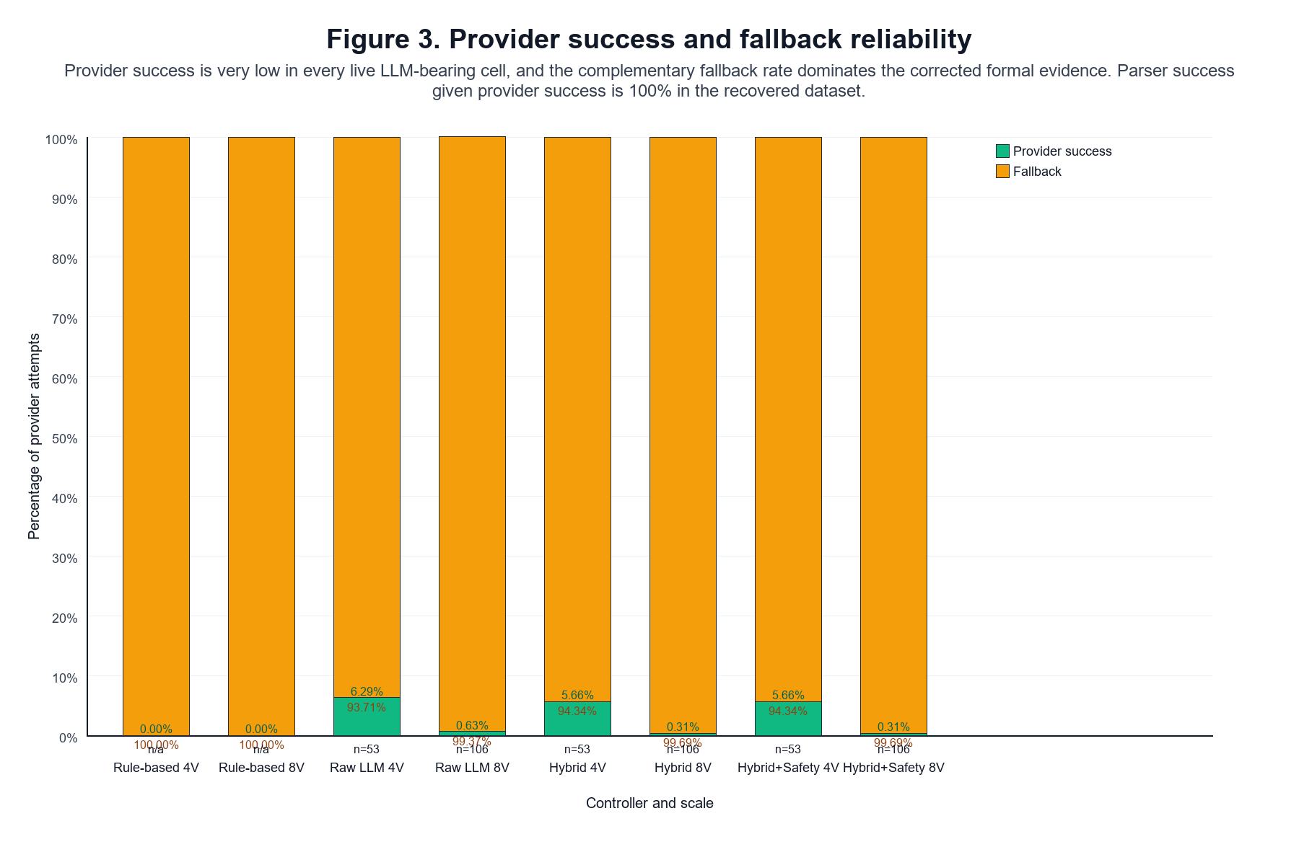
Figure 3. Provider success and fallback rate by LLM controller and scale.
Interpretation: Provider reliability is low and fallback-heavy, so the traffic results should be interpreted at the pipeline level rather than as isolated model behaviour.
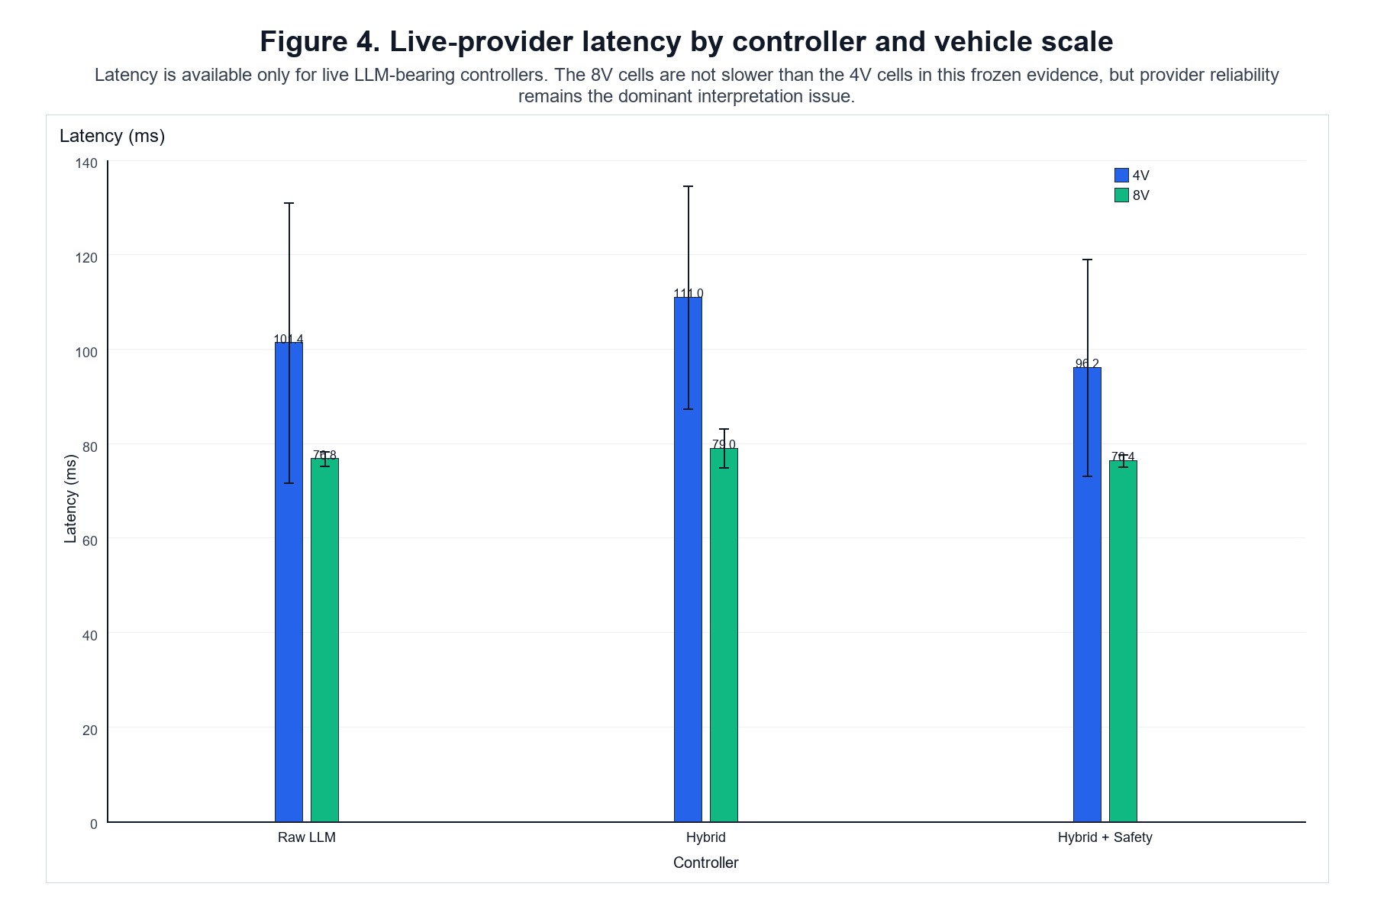
Figure 4. Mean provider latency by LLM controller and scale.
Interpretation: Latency exists but is not the dominant threat; availability and success rate are more important validity concerns.

6 Discussion
- valid 4V evidence from formal_v2
- corrected 8V evidence from formal_v4

1. RQ1: Rule-based vs LLM-assisted architecture

Observed result
The LLM-assisted pipeline exhibits lower waiting time and higher mean speed than the rule-based baseline in the corrected evidence.
- 4V rule-based: waiting 82.0 steps, speed 2.3098 m/s
- 4V LLM-assisted: waiting 15.0 steps, speed 6.8026 m/s
- 8V rule-based: waiting 242.0417 steps, speed 1.1895 m/s
- 8V LLM-assisted: waiting 15.2917 steps, speed 6.5991 m/s

Interpretation
The evidence supports a cautious statement that the LLM-assisted pipeline improves traffic efficiency in the tested SUMO scenarios.
The LLM-assisted pipeline exhibited lower waiting time and higher mean speed than the rule-based baseline in the tested SUMO scenarios.
The live provider path is fallback-heavy, so the observed traffic advantage belongs to the pipeline rather than to a model-only controller.

2. RQ2: Raw vs Hybrid

Observed result
The corrected evidence does not show a clear traffic-performance advantage for hybrid over raw LLM.
The 4V and 8V valid cells are effectively similar on the traffic metrics, and the corrected evidence contains no visible postprocessor intervention.

Interpretation
The cooperative stage is implemented, but the valid formal evidence does not show that it changes traffic outcomes in a measurable way. The correct reading is therefore:
No clear traffic-performance advantage was observed for the hybrid architecture over the raw LLM architecture in the corrected formal evidence.
Provider reliability also does not show a stable hybrid advantage. The live-provider path remains weak and seed-sensitive.

3. RQ3: Safety layer behaviour

Observed result
The corrected valid evidence shows:
- 0 collisions in every valid run,
- 0 safety overrides in every valid run,
- no visible safety-verifier intervention.

Interpretation
The safety layer is present and traceable, but the evaluated scenarios did not sufficiently exercise it. The dissertation should not attribute improved safety to the safety layer.
A defensible formulation is:
The safety layer was implemented and operationally present, but the formal evidence did not sufficiently exercise it.

4. RQ4: 4V to 8V scalability

Observed result
- Traffic-level behaviour
- Rule-based performance degrades substantially from 4V to 8V. - LLM-assisted traffic metrics remain comparatively stable over the evaluated 4V-to-8V range.
- Provider-level behaviour
- Live-provider reliability remains weak at both scales. - The corrected 8V evidence is especially fallback-heavy.

Interpretation
The bounded dissertation claim should be:
Within the evaluated low-density 4V and 8V SUMO scenarios, the LLM-assisted pipeline remained operational and showed comparatively stable traffic-level performance, while provider reliability remained a first-order limitation.

5. Provider reliability as a validity threat
Provider reliability is the main interpretive limitation of the dissertation. In the corrected 8V evidence, provider attempts total 2784 and provider successes total 4, corresponding to a success rate of approximately 0.14% and a fallback rate of approximately 99.86%.
- - provider success is extremely low (4 successes in 2784 attempts in the corrected 8V evidence),
- RateLimitError dominates failures,
- fallback-heavy execution is the norm,
- successful provider calls are rare and seed-sensitive.
This means the dissertation's traffic results should be read as the behaviour of a structured pipeline under constrained provider availability, not as a clean test of model intelligence alone.

6. Supported findings
The corrected dissertation supports the following bounded claims:
- a structured, traceable LLM-assisted control pipeline can be implemented in SUMO,
- the pipeline can be compared against a rule-based baseline in a frozen experimental design,
- the pipeline shows lower waiting time and higher mean speed than the rule-based baseline in the tested scenarios,
- traffic-level performance remains comparatively stable from 4V to 8V,
- provider reliability and fallback behaviour are first-order validity threats,
- the safety layer exists but was not strongly exercised,
- the cooperative postprocessor was not visibly exercised in the valid formal evidence.

7. Unsupported claims
The corrected evidence does not prove:
- superiority of the LLM component alone,
- general scalability to denser or larger scenarios,
- real-world validity,
- safety superiority,
- a visible effect from cooperative postprocessing,
- sufficient provider reliability for deployment.

9. Revised RQ summary
- RQ1: supported cautiously, at the pipeline level.
- RQ2: no clear traffic-performance advantage for hybrid over raw LLM.
- RQ3: safety layer present but insufficiently exercised.
- RQ4: traffic robustness is visible from 4V to 8V, but provider reliability remains a major limitation.
The near-identical 8V traffic results for Raw LLM, Hybrid, and Hybrid + Safety are best explained by the evidence showing fallback dominance, very low provider success, zero visible postprocessor intervention, and zero safety overrides. That does not mean the three architectures are intrinsically equivalent; it means the distinctive LLM/postprocessing/safety stages were rarely exercised in the corrected formal evidence.

7 Limitations

7.1 Experimental scale and statistical scope
The formal evaluation was limited to two traffic scales, consisting of four-vehicle and eight-vehicle scenarios, with three seeds for each controller-scale condition. This design provides repeated observations for descriptive comparison but remains too small to support strong inferential or general scalability claims. The reported means and standard deviations should therefore be interpreted as summaries of the evaluated scenarios rather than estimates of performance across a wider traffic population.
In particular, the transition from 4V to 8V provides evidence about behaviour within this specific range only. No formal evidence was collected for 16V or higher traffic scales, and the results should not be extrapolated to substantially denser traffic conditions.

7.2 Simulation scope and external validity
The experiments were conducted at a single unsignalised intersection in SUMO under a controlled low-density scenario. This restricted environment was useful for maintaining consistent conditions across controller architectures, but it does not capture the full complexity of real traffic.
The evaluation does not include multiple interacting intersections, heterogeneous road geometries, mixed human and autonomous traffic, perception uncertainty, communication delays between vehicles, or other disturbances that may occur in real deployments. Furthermore, the study contains no hardware-in-the-loop or real-road validation. The conclusions are therefore limited to the evaluated simulation environment.

7.3 Provider reliability and fallback dependence
The strongest limitation concerns the reliability of the external LLM provider. In the corrected 8V experiments, only 4 of 2,784 provider requests were successful, corresponding to a success rate of approximately 0.14%. Consequently, approximately 99.86% of requests entered the deterministic fallback path.
This substantially affects the interpretation of the traffic results. Although the LLM-assisted architectures achieved lower operational waiting and higher mean speed than the rule-based baseline, these results cannot be attributed primarily to successful live LLM reasoning. They instead describe the behaviour of the complete control pipeline under severe provider unavailability.
The fallback mechanism allowed the system to remain operational despite provider failures, which demonstrates an aspect of architectural robustness. However, it also prevents the experiment from providing a clean measurement of the contribution made by the LLM itself.

7.4 Limited isolation of individual pipeline components
The architecture separates provider output, parsing, validation, fallback handling, cooperative post-processing, and safety verification, and these stages are individually traceable. Nevertheless, the current experimental design does not provide a causal ablation of their individual contributions.
In particular, the corrected evidence does not establish how traffic performance would change under consistently successful provider access, without deterministic fallback, or with systematically activated post-processing and safety stages. Additional controlled ablation experiments would therefore be required to distinguish the contributions of the LLM, fallback mechanism, cooperative logic, and safety verifier.
This limitation is particularly important when interpreting the near-identical traffic results of the Raw LLM, Hybrid, and Hybrid + Safety controllers. Their similarity should not be taken as evidence that the architectures are intrinsically equivalent; rather, their distinguishing stages were rarely exercised in the retained experiments.

7.5 Limited evidence for cooperative and safety mechanisms
Neither the cooperative postprocessor nor the safety verifier was meaningfully exercised in the final experimental evidence. No visible postprocessor interventions or safety overrides were recorded, while no collisions occurred in the retained runs.
The absence of collisions is therefore an observation about the evaluated scenarios rather than evidence that the safety verifier improved safety. Similarly, the absence of postprocessor intervention means that the experiment cannot establish a measurable traffic benefit from the cooperative stage.
The implementation and trace data demonstrate that these mechanisms are present in the architecture, but scenarios specifically designed to trigger conflicts and cooperative opportunities would be required to evaluate their effectiveness.

7.6 Metric and evidence limitations
The waiting metric used in this study is an operational proxy derived from the number of recorded time steps for which speed_after_action < 0.1 m/s, normalised over the observed vehicles. It therefore represents stop-like occupancy rather than a queueing-theory delay measure or a direct estimate of physical waiting time. Comparisons using this metric remain meaningful within the consistent experimental protocol, but its absolute values should not be interpreted as conventional traffic delay measurements.
Completion rate also provides limited discrimination because every retained run achieved 100% completion. Consequently, operational waiting, mean speed, provider reliability, and decision-flow measurements provide more informative comparisons between controllers.
Finally, the evidence base required correction after trace-level validation identified that the nominal 8V runs in the original formal_v2 batch had loaded the four-vehicle SUMO configuration. These runs were excluded rather than corrected retrospectively, and the final 8V analysis uses the independently executed formal_v4 evidence in which eight vehicles were observed, departed, and arrived in every retained run. This correction reduces contamination of the final analysis, although it also demonstrates the importance of execution-level provenance checks in simulation studies.

7.7 Overall scope of the conclusions
Taken together, these limitations define a relatively narrow interpretation of the dissertation findings. The study provides evidence that a structured and traceable LLM-assisted pipeline can be implemented and evaluated in a controlled SUMO intersection scenario, and that the complete pipeline produced favourable traffic metrics relative to the selected rule-based baseline in the tested conditions.
However, the experiments do not establish superiority of the LLM component itself, general scalability, real-world effectiveness, or measurable benefits from the cooperative and safety stages. The strongest conclusion is therefore a pipeline-level one: the architecture remained operational and produced comparatively efficient traffic behaviour under the evaluated conditions, while external-provider reliability substantially constrained the extent to which this behaviour could be attributed to live LLM decision-making.
.

8 Conclusion and Future Work

8.1 Conclusion
This dissertation investigated whether a structured LLM-assisted decision pipeline could support cooperative decision-making at an unsignalised intersection in SUMO. Rather than treating the LLM as an end-to-end controller, the proposed architecture separates model-based decision generation from response parsing, deterministic validation and fallback, cooperative post-processing, safety verification, and trace logging. This design enabled the behaviour of different stages of the control pipeline to be recorded and evaluated separately.
Four controller architectures were evaluated: a rule-based baseline, a Raw LLM controller, a Hybrid controller incorporating cooperative post-processing, and a Hybrid + Safety controller incorporating both cooperative post-processing and deterministic safety verification. The final evaluation considered four-vehicle and eight-vehicle scenarios with three seeds for each controller-scale condition.
The results show a clear difference between the rule-based baseline and the LLM-assisted pipelines within the tested scenarios. At 4V, the rule-based controller recorded a mean operational waiting measure of approximately 82 steps and a mean speed of 2.31 m/s, compared with approximately 15 steps and 6.80 m/s for the LLM-assisted controllers. At 8V, the difference became larger: the rule-based controller recorded approximately 242.04 waiting steps and a mean speed of 1.19 m/s, whereas the LLM-assisted controllers recorded approximately 15.29 waiting steps and 6.60 m/s. All retained runs achieved complete vehicle arrival and no collisions were recorded.
These results indicate that the evaluated LLM-assisted pipelines maintained comparatively stable traffic-level performance as the scenario increased from four to eight vehicles, while the rule-based baseline experienced a substantial reduction in efficiency. However, this result must be interpreted together with the reliability evidence. In the corrected 8V experiments, only 4 of 2,784 live-provider requests succeeded, corresponding to a success rate of approximately 0.14%. The remaining requests entered the deterministic fallback path. The observed traffic performance therefore characterises the complete fallback-capable architecture under constrained provider availability rather than the independent capability of the LLM.

8.2 Answers to the Research Questions
RQ1 asked whether an LLM-assisted architecture could improve traffic efficiency relative to rule-based control. Within the evaluated SUMO scenarios, the LLM-assisted pipelines produced substantially lower operational waiting and higher mean speed than the rule-based baseline. This supports a pipeline-level performance advantage under the tested conditions, but does not establish that the LLM component itself was responsible for the improvement.
RQ2 examined whether cooperative post-processing meaningfully changed the behaviour of the Raw LLM controller. No clear traffic-performance advantage was observed for the Hybrid controller over the Raw LLM controller. The corrected evidence contains insufficient postprocessor intervention to establish a measurable benefit from the cooperative stage. Consequently, the study confirms the presence and traceability of this stage but not its effectiveness.
RQ3 considered the effect of deterministic safety verification. No collisions occurred in the retained experiments, but no safety overrides were recorded either. The safety verifier was therefore implemented as part of the architecture but was not sufficiently exercised by the tested scenarios to establish either a safety benefit or a safety-efficiency trade-off.
RQ4 examined behaviour as the scenario increased from four to eight vehicles. The rule-based baseline showed substantially higher operational waiting and lower mean speed at 8V, whereas the traffic metrics of the LLM-assisted pipelines remained comparatively stable. This provides evidence of robustness across the evaluated 4V-to-8V range. It does not demonstrate general scalability to denser traffic, larger vehicle populations, or more complex road networks.

8.3 Contributions
The principal contribution of this dissertation is a reproducible and traceable framework for evaluating LLM-assisted decision pipelines for unsignalised intersection control. The study demonstrates how model proposals, validation, fallback handling, cooperative processing, safety verification, and final control decisions can be separated rather than evaluated as a single opaque controller.
A second contribution is the inclusion of provider reliability and decision provenance as part of the experimental evaluation. The results demonstrate why traffic-level performance alone can provide an incomplete account of an LLM-assisted control system. In this study, favourable traffic metrics coexisted with extremely low live-provider availability, making fallback behaviour essential to understanding the observed results.
The dissertation therefore contributes primarily an engineering and evaluation framework rather than evidence of general LLM superiority in autonomous driving. Its value lies in showing how an LLM-assisted controller can be evaluated in a way that distinguishes system-level performance from the behaviour of the underlying language model.

8.4 Future Work
Future work should first address the provider-reliability limitation. Repeating the evaluation with more reliable hosted access or a local or self-hosted model would allow a substantially larger proportion of decisions to originate from the LLM. This would make it possible to distinguish model behaviour from fallback behaviour more clearly.
A second priority is controlled ablation. Experiments could separately disable deterministic fallback, cooperative post-processing, and safety verification to quantify the contribution of each stage. In particular, scenarios containing deliberately constructed route conflicts and cooperative opportunities would allow the postprocessor and safety verifier to be exercised systematically rather than merely remaining available in the pipeline.
The experimental scope should also be expanded. Higher-density traffic, larger vehicle populations such as 16V scenarios, additional intersection geometries, and a larger number of random seeds would provide stronger evidence about robustness and scalability. More complex scenarios could additionally include heterogeneous traffic behaviour, communication uncertainty, or multiple interacting intersections.
Finally, simulation results should eventually be tested under progressively more realistic conditions. Hardware-in-the-loop experiments, real-time execution constraints, and ultimately appropriately controlled physical validation would provide evidence about whether the pipeline architecture remains practical when assumptions made in SUMO no longer hold.
Overall, this dissertation demonstrates that a structured, traceable LLM-assisted decision architecture can be systematically evaluated for unsignalised intersection control. The evaluated pipeline achieved favourable traffic-level results relative to the selected rule-based baseline, but the experiments also revealed that provider availability and fallback behaviour are central to interpreting those results. The main outcome is therefore not evidence that an LLM alone provides superior intersection control, but evidence that LLM-assisted control should be evaluated as a complete decision pipeline whose model, deterministic safeguards, fallback mechanisms, and infrastructure dependencies are all visible in the experimental analysis.

References
Cui, C., Ma, Y., Yang, Z., Zhou, Y., Liu, P., Lu, J., Li, L., Chen, Y., Panchal, J.H., Abdelraouf, A., Gupta, R., Han, K. and Wang, Z. (2025) ‘Large language models for autonomous driving (LLM4AD): Concept, benchmark, experiments, and challenges’, arXiv preprint, arXiv:2410.15281v3.
Dong, X., Li, J., Xie, J., Yi, Y., Jia, T., Fang, S., Tian, Y. and Hang, P. (2026) ‘Large language model based interactive decision-making for autonomous driving’, arXiv preprint, arXiv:2604.23513v1.
Dresner, K. and Stone, P. (2008) ‘A multiagent approach to autonomous intersection management’, Journal of Artificial Intelligence Research, 31, pp. 591–656.
Driess, D., Xia, F., Sajjadi, M.S.M., Lynch, C., Chowdhery, A., Ichter, B., Wahid, A., Tompson, J., Vuong, Q., Yu, T., Huang, W., Chebotar, Y., Sermanet, P., Duckworth, D., Levine, S., Vanhoucke, V., Hausman, K., Toussaint, M., Greff, K., Zeng, A., Mordatch, I. and Florence, P. (2023) ‘PaLM-E: An embodied multimodal language model’, arXiv preprint, arXiv:2303.03378v1.
Hou, X., Wang, W., Yang, L., Lin, H., Feng, J., Min, H. and Zhao, X. (2025) ‘DriveAgent: Multi-agent structured reasoning with LLM and multimodal sensor fusion for autonomous driving’, arXiv preprint, arXiv:2505.02123v1.
Huang, W., Abbeel, P., Pathak, D. and Mordatch, I. (2022) ‘Language models as zero-shot planners: Extracting actionable knowledge for embodied agents’, arXiv preprint, arXiv:2201.07207v2.
Safarov, K. (2022) The impact of autonomous vehicles on traffic performance at an unregulated junction. PhD thesis. University of Bristol.

Appendices
These appendices collect evidence-backed material that is useful for reproducibility but too detailed for the main narrative.

Appendix A. Prompt Contract and Architecture
This appendix records the frozen prompt contract and the staged controller architecture used in the dissertation.
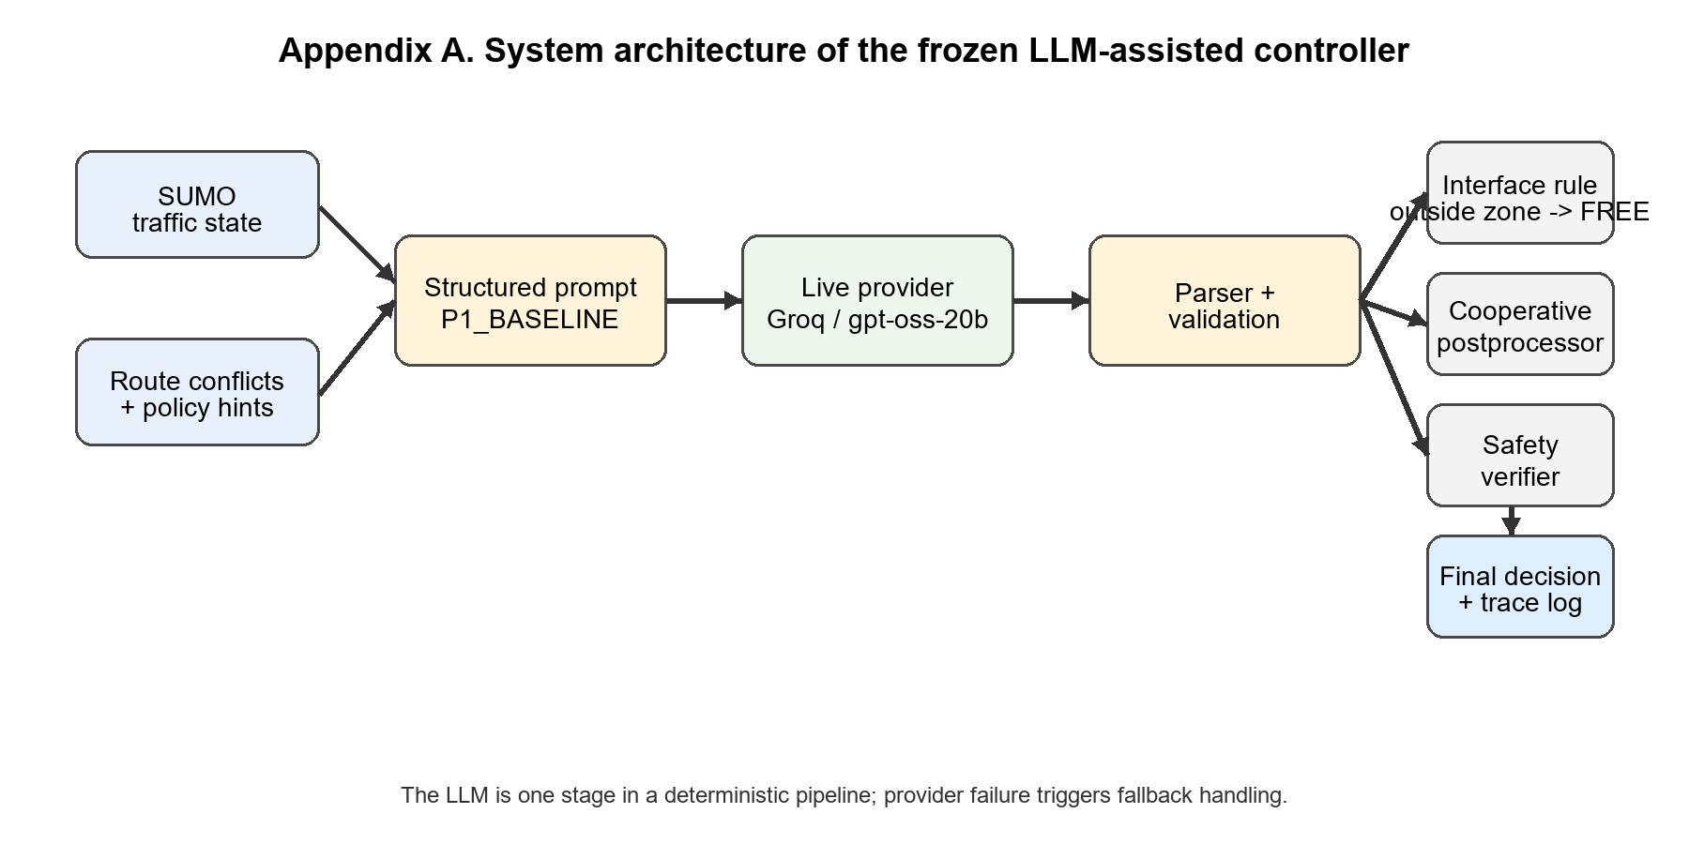
Figure A1. System architecture of the frozen LLM-assisted intersection controller.
Table A1. P1_BASELINE prompt input/output schema
Field | Evidence-backed content
Prompt identifier | P1_BASELINE
Input blocks | Traffic state, route conflicts, and policy hints
Output schema | Exactly one JSON object with a decisions map
Decision labels | PROCEED, WAIT, FREE
Hard constraints | One decision per vehicle; outside control zone -> FREE; no prose or markdown

Appendix B. Frozen Request Configuration
This appendix records the frozen live-provider request settings used for the final evidence boundary.
Table B1. Frozen provider request configuration
Parameter | Value
Provider | Groq
Base URL | https://api.groq.com/openai/v1
Model | openai/gpt-oss-20b
Max completion tokens | 256
Reasoning effort | low
Timeout | 30.0 s
Max retries | 0
Not set explicitly | temperature, top_p, seed, reasoning_format

Appendix C. Experimental Matrix and Evidence Boundary
This appendix summarises the final evidence boundary used in the dissertation.
Table C1. Final evidence boundary
Dataset / batch | Role in dissertation
formal_v2 valid 4V | Included as the final 4V evidence
formal_v4 corrected 8V | Included as the final 8V evidence
formal_v2 nominal 8V | Excluded because the raw traces captured only four vehicles
formal_v3 | Excluded because two rule-based 8V runs did not complete all arrivals

Appendix D. Controller Semantics
The dissertation compares four controller variants that share the same SUMO scenario and decision space.
Table D1. Controller variants and enabled pipeline stages
Controller | Enabled stages
Rule-based | Deterministic interface rule only
Raw LLM | Structured prompt, provider request, parsing, validation, and fallback
Hybrid | Raw LLM plus cooperative post-processing
Hybrid + Safety | Hybrid plus deterministic safety verification

Appendix E. Abbreviations
Table E1. Abbreviations used in the dissertation
Abbreviation | Meaning
LLM | Large language model
SUMO | Simulation of Urban MObility
RQ | Research question
TOC | Table of contents
DOCX | Microsoft Word document format

