University of Bristol MSc Robotics Dissertation
Title: A Structured LLM-Assisted Decision Pipeline for Unsignalised Intersection Control in SUMO
Author: [Cheng Peng]
Supervisor: [Amina Hamoud]

Abstract
Large language models (LLMs) have shown potential for high-level reasoning and decision-making, but their application to traffic control remains challenging because model outputs may be unavailable, invalid, or unsuitable for direct execution. This dissertation investigates a structured LLM-assisted decision pipeline for decision-making at an unsignalised intersection using Simulation of Urban MObility (SUMO).
The proposed architecture separates LLM-based decision generation from response parsing, deterministic validation and fallback, cooperative post-processing, and safety verification. Four controller configurations were evaluated: a rule-based baseline, a Raw LLM controller, a Hybrid controller with cooperative post-processing, and a Hybrid + Safety controller with additional deterministic safety verification. Experiments were conducted using four-vehicle and eight-vehicle scenarios across three random seeds. Traffic performance was evaluated using operational waiting time, mean speed, completion rate, and collisions, while provider reliability and downstream interventions were recorded to characterise the decision pipeline.
Across the tested scenarios, the LLM-assisted pipelines produced lower operational waiting and higher mean speed than the rule-based baseline. Mean waiting increased from 82.0 to 242.0 steps for the rule-based controller as the scenario increased from four to eight vehicles, whereas the LLM-assisted pipelines recorded approximately 15.0 and 15.3 steps respectively. However, live-provider reliability was a major limitation. In the corrected eight-vehicle experiments, only 4 of 2,784 provider requests succeeded, causing the LLM-assisted controllers to rely predominantly on deterministic fallback behaviour. No collisions were observed, while neither cooperative post-processing nor safety verification was sufficiently activated to demonstrate an independent performance benefit.
The results therefore demonstrate favourable traffic performance for the complete LLM-assisted pipeline under the evaluated conditions, rather than superiority of the LLM component itself. The main contribution is a reproducible and traceable framework for evaluating LLM-assisted intersection control while explicitly accounting for provider reliability, fallback behaviour, and deterministic intervention when interpreting system-level performance.
.

1 Introduction

1.1 Background and Motivation
Unsignalised intersections present a challenging coordination problem for autonomous vehicles because multiple vehicles may approach a shared conflict area simultaneously while following intersecting trajectories. In the absence of traffic signals, vehicles must determine when to proceed, wait, or yield while maintaining both traffic efficiency and safety. Autonomous intersection management has therefore been studied as a multi-agent coordination problem in which access to shared conflict areas must be managed to reduce unnecessary delay while avoiding conflicting movements (Dresner and Stone, 2008; Safarov, 2022).
Recent developments in large language models (LLMs) have created new possibilities for incorporating high-level reasoning into autonomous systems. LLMs have demonstrated capabilities in planning and generating actions from contextual information, while embodied and multimodal language models have further explored how language-based reasoning can be grounded in representations of physical environments (Huang et al., 2022; Driess et al., 2023). These developments have also motivated growing interest in the application of LLMs to autonomous-driving decision-making.
However, directly incorporating an LLM into a vehicle-control system introduces important practical challenges. Model responses may be unavailable, malformed, inconsistent, or unsuitable for immediate execution. Moreover, when an LLM operates alongside conventional rules, fallback mechanisms, and safety constraints, observed system performance cannot necessarily be attributed to the language model alone. A practical LLM-assisted control architecture therefore requires mechanisms for validating model outputs, handling provider or parsing failures, coordinating vehicle decisions, and constraining unsafe actions.
This dissertation investigates these issues through a structured LLM-assisted decision architecture for an unsignalised intersection simulated in Simulation of Urban MObility (SUMO). Rather than treating the LLM as an independent end-to-end controller, the proposed architecture integrates model-generated decisions with deterministic validation and fallback handling, with additional cooperative post-processing and safety verification in the relevant controller variants. The architecture also records intermediate and final decisions, allowing the behaviour of different stages of the pipeline to be examined separately.

1.2 Problem Statement and Research Gap
Existing research provides several foundations for this work. Autonomous intersection-management research demonstrates the importance of coordinating vehicles that share conflict areas. Research on language-model planning shows that LLMs can generate high-level actions from contextual information, while embodied and multimodal models highlight the importance of grounding such reasoning in representations of the environment. More recent work has begun to investigate LLMs as components of autonomous-driving reasoning and decision-making systems.
However, these research areas leave an important practical evaluation problem. When an LLM is incorporated into a traffic-control system, its output cannot necessarily be assumed to be continuously available, valid, or directly executable. Consequently, evaluating only the final traffic outcome may obscure the contributions of provider availability, parsing, fallback logic, cooperative processing, and safety constraints.
This dissertation addresses this problem through a controlled comparison of four controller architectures: a rule-based baseline, a Raw LLM controller, a Hybrid controller incorporating cooperative post-processing, and a Hybrid + Safety controller incorporating both cooperative post-processing and deterministic safety verification. The controllers are evaluated within the same SUMO intersection environment using consistent scenarios, decision interfaces, and evaluation measures.
The research gap addressed by this dissertation is therefore the need for a reproducible pipeline-level evaluation of LLM-assisted intersection control in which traffic performance is examined alongside the reliability and behaviour of the individual decision stages. Particular attention is given to provider availability, response parsing, deterministic fallback, cooperative post-processing, and safety intervention. This design allows the study to examine not only whether the complete pipeline produces different traffic outcomes from a rule-based baseline, but also how far those outcomes can be associated with the LLM and its surrounding deterministic components.

1.3 Aim and Objectives
The aim of this dissertation is to evaluate whether a structured LLM-assisted decision pipeline can support efficient decision-making at an unsignalised intersection while maintaining traceability, reproducibility, and deterministic safeguards.
To achieve this aim, the study has the following objectives:
- Design and implement comparable rule-based and LLM-assisted controllers for an unsignalised intersection in SUMO.
- Develop a staged decision architecture separating LLM decision generation, validation, fallback handling, cooperative post-processing, and safety verification.
- Establish consistent experimental conditions for comparing the controller architectures.
- Evaluate the controllers across multiple vehicle scales and random seeds.
- Measure traffic performance using completion rate, operational waiting, mean speed, and collision-related outcomes.
- Evaluate the reliability of the LLM-assisted pipeline using provider success, parsing, fallback, latency, and intervention measurements.
- Interpret the results while distinguishing overall pipeline performance from effects that can specifically be attributed to individual components.

1.4 Research Questions
The dissertation addresses the following research questions:
RQ1: How does the traffic efficiency of the LLM-assisted pipeline compare with the rule-based baseline at an unsignalised intersection?
RQ2: To what extent does cooperative post-processing alter the decisions and traffic performance of the Raw LLM pipeline?
RQ3: What effect does deterministic safety verification have on the Hybrid pipeline, and is any safety-efficiency trade-off observable under the evaluated scenarios?
RQ4: How does controller behaviour change when the scenario increases from four to eight vehicles under the evaluated low-density intersection conditions?

1.5 System Overview and Contributions
To investigate these questions, a staged control architecture was implemented. At each decision point, the current traffic state and route-conflict information are converted into a structured prompt for the LLM. The returned response is parsed and validated before deterministic interface rules are applied. Depending on the controller configuration, cooperative post-processing and safety verification may subsequently modify the proposed actions before they are applied in SUMO. When a usable LLM decision is unavailable, deterministic fallback handling allows the control process to continue.
The architecture records decisions at multiple stages of the pipeline, allowing provider responses, validated decisions, fallback events, post-processing interventions, and safety interventions to be analysed separately. This traceability is important because the observed traffic behaviour may result from interactions between LLM-generated and deterministic components rather than from the LLM alone.
The main contributions of this dissertation are:
- the implementation of four comparable controller architectures within a common SUMO unsignalised-intersection environment;
- a modular LLM-assisted decision pipeline combining model-generated decisions with deterministic validation, fallback handling, cooperative post-processing, and safety verification;
- a controlled evaluation of traffic performance across four-vehicle and eight-vehicle scenarios and multiple random seeds; and
- an evaluation framework that examines provider reliability, parsing, fallback behaviour, and downstream interventions alongside conventional traffic-performance measures.
Together, these contributions provide an experimental framework for assessing both the potential and the practical limitations of integrating LLM-based decision-making into unsignalised intersection control.

1.6 Dissertation Structure
The remainder of this dissertation is organised as follows. Chapter 2 reviews relevant research on autonomous intersection management, language-model planning, embodied reasoning, and LLM-assisted autonomous driving, establishing the research context for the proposed architecture. Chapter 3 describes the methodology and system design, including the SUMO environment, controller architectures, LLM decision pipeline, cooperative processing, fallback mechanism, and safety verification. Chapter 4 presents the experimental design, scenarios, evaluation metrics, and execution procedure. Chapter 5 reports the experimental results for traffic performance and LLM-pipeline reliability. Chapter 6 discusses these findings in relation to the research questions and existing literature. Chapter 7 examines the principal methodological limitations and threats to validity. Finally, Chapter 8 summarises the conclusions and identifies directions for future work.

2 Literature Review

2.1 Autonomous Intersection Management and Unsignalised Junction Control
Autonomous intersection management (AIM) treats an intersection as a shared coordination problem in which multiple vehicles compete for access to a common conflict space. Rather than relying on conventional traffic signals, an autonomous intersection controller must determine which vehicles may proceed while preventing incompatible movements and avoiding unnecessary delay.
Dresner and Stone (2008) established an influential framework for this problem through reservation-based intersection management. Their approach allows autonomous vehicles to request access to the intersection and assigns movement permissions according to predicted trajectories and conflicts. This work demonstrated that intersection performance depends not only on vehicle dynamics but also on the coordination policy used to allocate access to the shared conflict region.
Safarov (2022) examined autonomous-vehicle behaviour at an unregulated junction and similarly showed that traffic performance is affected by the behavioural assumptions applied to interacting vehicles. This is relevant to the present study because it demonstrates that even within a fixed road environment, changes in decision policies can significantly affect traffic flow.
More recent work has continued to formulate unsignalised intersection management as a cooperative multi-agent decision problem. Zhao et al. (2025), for example, proposed a centralised cooperative control approach for connected and autonomous vehicles at unsignalised all-directional intersections using constrained multi-agent reinforcement learning. Their formulation explicitly considers both traffic efficiency and safety, demonstrating that the coordination problem identified in earlier AIM research remains relevant in contemporary learning-based control.
Together, these studies establish two important foundations for the present dissertation. First, unsignalised intersection control is fundamentally an interaction and coordination problem rather than an isolated vehicle-control problem. Second, both efficiency and safety depend strongly on the decision policy used to allocate access to the conflict space. The present study builds on this foundation by investigating whether LLM-assisted reasoning can be incorporated into such a coordination architecture.

2.2 Cooperative and Multi-Agent Decision-Making
The shared nature of an intersection means that vehicle decisions cannot always be considered independently. Allowing one vehicle to proceed may constrain the actions available to another vehicle whose route intersects the same conflict region. Effective intersection management therefore requires some representation of relationships between vehicles and their intended movements.
Traditional AIM approaches address this through explicit reservation or priority mechanisms (Dresner and Stone, 2008), while more recent approaches increasingly formulate the problem as cooperative multi-agent optimisation or reinforcement learning. Zhao et al. (2025), for example, model autonomous intersection control as a constrained multi-agent problem in which traffic efficiency must be improved without violating safety requirements.
These approaches illustrate an important distinction between individual decision generation and system-level coordination. A locally reasonable action for one vehicle may not remain appropriate once the intentions and conflicts of surrounding vehicles are considered. Coordination mechanisms therefore provide an additional decision layer that considers interactions across multiple agents.
This distinction motivates the cooperative component used in the present dissertation. The LLM is not assumed to be inherently cooperative simply because it receives information about multiple vehicles. Instead, the architecture separates initial decision generation from deterministic cooperative post-processing. This allows the effect of explicit coordination logic to be distinguished from the behaviour of the upstream model.
Such separation is also useful experimentally. If the final action differs from the initial model proposal, the system can identify whether the change resulted from validation, cooperative processing, safety verification, or fallback handling. This provides greater traceability than treating the complete controller as a single decision-making black box.

2.3 Language Models as Planners and Embodied Reasoners
The development of large language models has created interest in their use beyond conventional natural-language tasks. In particular, several studies have investigated whether language models can transform structured descriptions of an environment into high-level plans or actions.
Huang et al. (2022) investigated language models as zero-shot planners for embodied agents. Their work demonstrated that pretrained language models can generate high-level action sequences from task descriptions without task-specific model training. However, the study also highlighted an important limitation: semantically plausible language output is not automatically executable by an embodied agent. Generated actions must be grounded in the set of actions that the environment can actually perform.
Driess et al. (2023) extended the relationship between language reasoning and embodied environments through PaLM-E, which incorporates continuous sensor modalities into an embodied multimodal language model. Their work demonstrates the importance of grounding language-based reasoning in representations of the physical environment rather than relying only on unconstrained textual interaction.
Wen et al. (2023) applied this general direction more directly to autonomous driving through DiLu. The framework combines reasoning and reflection components with an interactive driving environment and explores how knowledge encoded in LLMs can contribute to driving decisions. DiLu therefore represents a transition from general embodied language planning towards language-model-assisted decision-making in autonomous vehicles.
These studies provide an important methodological basis for the present dissertation. The role of the LLM is not to generate low-level steering trajectories or directly manipulate vehicle dynamics. Instead, the model receives a structured description of the current traffic situation and produces a high-level decision from a restricted action space. The decision must then pass through deterministic processing before it can affect the simulator.
This staged approach reflects a broader lesson from embodied language-model research: language models are more suitable for control when their reasoning is grounded in structured environmental information and connected to clearly defined executable actions.

2.4 Large Language Models for Autonomous Driving
Recent research has begun to investigate the role of LLMs more directly within autonomous-driving systems. These studies range from language-based driving agents to benchmarks and modular reasoning architectures.
DiLu demonstrates how an LLM can act as a knowledge-driven reasoning component within an autonomous-driving environment (Wen et al., 2023). Other work has explored related approaches in which language-model reasoning is connected to conventional driving functions rather than replacing the complete driving stack.
LaMPilot provides another example of this approach. Ma et al. (2024) proposed a framework in which LLMs respond to driving instructions by generating programs that use established functional primitives. They also introduced LaMPilot-Bench to evaluate language-model programs quantitatively in autonomous-driving scenarios. This is particularly relevant to the present dissertation because it demonstrates the importance of evaluating language-model behaviour through constrained, executable interfaces rather than only assessing natural-language output.
The broader development of this field is reviewed by Li et al. (2024), who distinguish applications of LLMs in modular autonomous-driving pipelines from more integrated end-to-end approaches. Their review also identifies real-time inference, safety assurance, and deployment cost as important unresolved challenges for LLM-enabled autonomous driving.
LLM4AD further examines the use of language models across autonomous-driving tasks and emphasises challenges involving latency, trust, transparency, safety, and deployment constraints (Cui et al., 2025). These concerns are particularly important when an external LLM provider becomes part of a real-time control architecture.
DriveAgent provides a more explicitly modular example. Hou et al. (2025) introduce a structured multi-agent reasoning architecture combining LLM reasoning with multimodal information. The broader significance of this approach is the separation of reasoning functions into identifiable components rather than treating the language model as an opaque source of final control actions.
Dong et al. (2026) similarly investigate LLM-based interactive decision-making for autonomous driving using structured representations and explicit safety considerations. Their work is particularly relevant to the present dissertation because it treats driving as an interaction-aware decision problem in which LLM reasoning operates within constraints rather than independently of them.
Collectively, this literature suggests a shift from asking whether LLMs can generate plausible driving decisions towards asking how language models should be integrated into larger autonomous-driving systems. The present dissertation follows this second perspective. The LLM acts as one decision-generation stage within a pipeline that also includes validation, fallback handling, cooperative processing, and safety verification.

2.5 Reliability, Safety, and Hybrid Pipeline Design
The integration of language models into autonomous-driving systems introduces additional reliability concerns because model-generated output cannot automatically be assumed to be available, correct, grounded, or executable.
Huang et al. (2022) already demonstrate this distinction in embodied planning: generating a semantically plausible plan does not guarantee that the plan can be executed in the target environment. Similar concerns become more significant in autonomous driving because incorrect or unavailable decisions may directly affect a safety-relevant control process.
Recent reviews of LLM-based autonomous driving identify real-time inference and safety assurance as unresolved deployment challenges (Li et al., 2024; Cui et al., 2025). These issues imply that evaluation should extend beyond whether an LLM can produce a plausible driving decision. The reliability and operational behaviour of the surrounding system must also be considered.
Empirical work on vision-language models provides further evidence for the importance of explicit reliability evaluation. Xie et al. (2025) introduced DriveBench and evaluated 12 VLMs across 17 settings for autonomous-driving tasks. Their results show that apparently plausible responses may not always reflect reliable grounding in the underlying input, particularly when visual information is degraded or unavailable.
The failure mode studied by Xie et al. (2025) differs from the provider-availability problem investigated in the present dissertation. Nevertheless, both illustrate a broader methodological point: apparently functional language-based driving systems should not be evaluated solely from their final outputs. Reliability of the model interface and the provenance of the final decision are also important.
This motivates the hybrid architecture evaluated in this dissertation. Model-generated decisions are separated from parsing, validation, deterministic fallback, cooperative post-processing, and safety verification. The architecture therefore provides defined behaviour even when a model response is unavailable or unusable.
Importantly, this architecture also changes what must be measured experimentally. Traffic performance alone cannot reveal whether a successful vehicle movement originated from the LLM, deterministic fallback, cooperative processing, or safety intervention. The evaluation therefore records provider success, parser success, fallback behaviour, latency, post-processing intervention, and safety overrides alongside conventional traffic metrics.

2.6 Research Gap
The literature establishes several components relevant to the present study, but these components are usually investigated separately.
Traditional autonomous intersection management demonstrates the importance of explicit access coordination in shared conflict spaces (Dresner and Stone, 2008). Research on unregulated and unsignalised intersections further demonstrates that traffic performance depends strongly on vehicle behaviour and coordination policy (Safarov, 2022; Zhao et al., 2025).
Language-model planning research demonstrates that LLMs can generate high-level plans but that these plans must be grounded in executable actions (Huang et al., 2022). Embodied language-model research reinforces the importance of structured environmental grounding (Driess et al., 2023). Autonomous-driving studies such as DiLu and LaMPilot subsequently demonstrate how language models can be incorporated into driving-related reasoning and executable decision frameworks (Wen et al., 2023; Ma et al., 2024).
More recent autonomous-driving research has increasingly adopted modular and structured LLM architectures while highlighting unresolved issues involving safety, reliability, latency, and deployment (Li et al., 2024; Cui et al., 2025; Hou et al., 2025; Dong et al., 2026). Empirical reliability studies such as DriveBench further demonstrate the importance of examining how language-based models fail rather than considering only successful outputs (Xie et al., 2025).
However, comparatively little attention has been given to controlled pipeline-level evaluation in which LLM decision generation, deterministic fallback, cooperative processing, and safety verification are separately traceable while being compared under the same unsignalised-intersection scenario.
The research gap addressed in this dissertation is therefore methodological rather than simply the application of an LLM to a new traffic scenario. The study investigates how a structured LLM-assisted control pipeline behaves relative to deterministic control when the decision architecture and experimental conditions are held constant, while explicitly measuring both traffic outcomes and the reliability of the LLM integration.
This leads to four research questions. RQ1 examines traffic efficiency relative to rule-based control. RQ2 evaluates whether cooperative post-processing produces a measurable change relative to the Raw LLM architecture. RQ3 examines the effect of deterministic safety verification. RQ4 evaluates how controller behaviour changes between the tested four-vehicle and eight-vehicle scenarios.
Together, these questions connect the established intersection-management problem with emerging LLM-assisted driving research while retaining a controlled and traceable experimental scope.

3 Methodology and System Design

3.1 System Overview
This study investigates cooperative vehicle decision-making at an unsignalised intersection using Simulation of Urban MObility (SUMO). The experimental system combines microscopic traffic simulation with four alternative decision architectures, enabling rule-based and LLM-assisted control strategies to be evaluated within a common intersection environment.
The system adopts a modular architecture rather than using the LLM as an end-to-end vehicle controller. During simulation, traffic-state information is obtained from SUMO and converted into a structured representation of the vehicles relevant to the current decision. For the LLM-assisted controllers, this representation is incorporated into a predefined prompt and submitted to the language model. The returned output is then parsed and validated before any optional cooperative or safety-processing stages are applied.
The overall control process is:
SUMO traffic state → state representation → decision generation → parsing and validation → cooperative post-processing → safety verification → vehicle action → trace logging
Not every controller uses every stage. The Rule-Based controller generates decisions deterministically, the Raw LLM controller uses the LLM interface followed by validation and fallback handling, the Hybrid controller additionally enables cooperative post-processing, and the Hybrid + Safety controller adds deterministic safety verification.
This separation serves two purposes. First, it provides a common architecture through which alternative controller configurations can be compared. Second, it preserves intermediate decision states so that observed traffic behaviour can be related to provider availability, validation, fallback, post-processing, and safety intervention rather than being attributed automatically to the LLM.

3.2 SUMO Simulation Environment
Simulation of Urban MObility (SUMO) was used as the microscopic traffic simulation environment for this study. SUMO is an open-source microscopic traffic simulator designed for traffic-network modelling and supports explicit representation of individual vehicles, routes, road networks, and time-stepped traffic behaviour (Alvarez Lopez et al., 2018). Its support for external interaction with the simulation also makes it suitable for experiments in which vehicle behaviour is controlled by decision algorithms outside the simulator. Alvarez Lopez et al. describe SUMO as a microscopic traffic simulation platform supporting large road networks, multimodal traffic and external control, providing an established methodological basis for its use in traffic-control research.
In this dissertation, SUMO provides the traffic environment while the proposed control architecture determines high-level intersection decisions. The study considers a single unsignalised intersection in which vehicles approach from predefined routes and may encounter vehicles travelling along conflicting trajectories. The simulation therefore provides a controlled environment for comparing controller architectures while keeping the underlying road network and traffic scenario consistent.
At each simulation step, the control system obtains the state of vehicles relevant to the intersection. The decision representation includes vehicle identity, route information, position relative to the controlled intersection region, and conflict relationships between routes. These variables provide the structured environmental information required by both the deterministic and LLM-assisted controllers.
Vehicles are classified according to whether they are within the active control region. For vehicles requiring an intersection decision, the controller operates over three high-level actions:
PROCEED permits the vehicle to continue through the controlled region.
WAIT prevents the vehicle from proceeding until a subsequent control decision permits movement.
FREE indicates that the vehicle is outside the active decision region and can continue according to the normal simulator behaviour defined by the implementation.
This action abstraction deliberately separates high-level coordination from low-level vehicle dynamics. The dissertation does not attempt to use the LLM to generate steering commands, acceleration trajectories, or continuous vehicle-control signals. Instead, SUMO remains responsible for microscopic vehicle simulation, while the experimental controllers determine discrete access decisions associated with the intersection.
This separation is important for the research design. All four controller architectures interact with the same simulation environment and use the same high-level action space, allowing differences in observed traffic behaviour to be associated with the evaluated decision architectures rather than changes in the underlying simulator. The detailed controller implementations and LLM-assisted decision stages are described in Sections 3.3–3.6.

3.3 Controller Architectures
Four controller architectures were implemented within the same simulation environment. They share the same high-level action space and scenario representation but differ in how decisions are generated and subsequently processed.

3.3.1 Rule-Based Controller
The Rule-Based controller provides the deterministic baseline and does not invoke an external language model. Vehicle actions are determined from the predefined intersection-control logic and current traffic state.
Its purpose is to provide a conventional deterministic reference against which the complete LLM-assisted pipelines can be evaluated. Comparisons with this controller are therefore interpreted as comparisons between controller architectures rather than between individual decision-generation components.

3.3.2 Raw LLM Controller
The Raw LLM controller uses the language model as the primary proposal-generation component. A structured representation of the current traffic state is incorporated into the canonical prompt, and the model is requested to return vehicle-level actions belonging to the permitted decision set.
The provider response is not applied directly to SUMO. It first passes through parsing and validation, and deterministic fallback handling is available when a usable provider response cannot be obtained. The Raw LLM controller therefore represents the least modified LLM-assisted architecture in the comparison, but it remains a pipeline rather than an unconstrained model controller.

3.3.3 Hybrid LLM Controller
The Hybrid controller extends the Raw LLM pipeline by applying deterministic cooperative post-processing after the model output has been parsed and validated.
This stage considers the validated vehicle decisions together with route relationships and the current traffic state. Its purpose is to determine whether compatible vehicle movements can be allowed to progress without relying exclusively on the independently generated model proposals.
The Hybrid controller therefore enables the experiment to examine whether adding an explicit cooperative decision stage measurably changes the decisions or traffic performance produced by the Raw LLM pipeline.

3.3.4 Hybrid LLM with Safety Verification
The Hybrid + Safety controller extends the Hybrid architecture with an additional deterministic safety-verification stage. Following cooperative post-processing, proposed actions are checked against the conflict conditions encoded by the safety logic before they are executed.
If an action violates those conditions, the safety verifier can replace it with a more conservative action. The safety layer therefore acts as a final deterministic boundary between upstream decision generation and execution in SUMO.
The comparison between Hybrid and Hybrid + Safety is intended to determine whether this additional verification stage changes the decision path or introduces an observable safety-efficiency trade-off under the evaluated scenarios.

3.4 LLM Input and Output Interface
A fixed prompt structure was used during the formal evaluation to prevent prompt variation from becoming an additional experimental factor. The canonical prompt configuration was designated P1_BASELINE.
Rather than requesting free-form driving advice, the interface supplies structured information describing the vehicles relevant to the current decision and their traffic context. This representation provides the model with the information required to propose high-level intersection actions while constraining the interaction to the decision problem evaluated in the simulation.
The required response is a single JSON object containing vehicle-level decisions. Each action is restricted to the canonical decision space:
PROCEED, WAIT, or FREE.
Vehicles outside the active control region are represented using FREE, while vehicles subject to intersection control must receive an admissible control action. Free-form explanations are not required because the response must be machine-readable and subsequently processed by the controller.
The fixed prompt and restricted output contract reduce variation in the model interface and provide a defined boundary between language-model generation and executable simulator actions.

3.5 Decision Processing Pipeline

3.5.1 Provider Request
For the LLM-assisted controllers, the structured prompt is submitted to an external language-model provider. The formal evaluation used Groq with the openai/gpt-oss-20b model.
The request configuration was fixed as follows: maximum completion length of 256 tokens, low reasoning effort, a 30 s timeout, and zero automatic retries. Keeping these settings constant prevents variation in request configuration from becoming an uncontrolled experimental factor.
Provider availability is treated as part of the observed pipeline behaviour rather than being assumed. Each request can therefore result either in a usable provider response or in a failure that must be handled by subsequent deterministic logic.

3.5.2 Parsing and Validation
Provider responses are parsed into the expected vehicle-action representation before any action is executed. Only decisions belonging to the predefined action space are accepted.
For controlled vehicles, missing or invalid actions are normalised to the conservative WAIT action. Vehicles outside the active control region are handled according to the deterministic interface rule and are assigned FREE.
This stage establishes an explicit boundary between model output and simulator execution. Producing a response is therefore not equivalent to producing an executable control decision: the output must first satisfy the required structure and action constraints.

3.5.3 Deterministic Fallback
The LLM-assisted controllers include deterministic fallback handling for cases in which a usable model response is unavailable. This ensures that provider failure does not automatically terminate the simulation or leave vehicles without an executable decision.
Fallback use is recorded independently from successful provider-generated decisions. This distinction is methodologically important because a run can remain operational even when the external model is unavailable. Traffic performance observed during such operation therefore represents the behaviour of the complete fallback-capable pipeline rather than the isolated performance of the LLM.

3.5.4 Cooperative Post-Processing
Cooperative post-processing is enabled in the Hybrid and Hybrid + Safety architectures. The stage receives validated vehicle actions and evaluates them together with the route-conflict representation and current traffic state.
Where the encoded compatibility conditions permit additional vehicle progress, the post-processor can modify validated actions before execution. This creates an explicit system-level coordination stage after model proposal generation.
The Raw LLM and Hybrid configurations differ primarily in the presence of this stage, allowing its observable contribution to be examined through recorded decision changes and traffic-level outcomes.

3.5.5 Safety Verification
The Hybrid + Safety architecture applies deterministic safety verification after cooperative post-processing. The verifier evaluates the proposed actions against the conflict relationships represented by the system.
When a proposed movement violates the encoded safety conditions, the verifier can replace the action with a more conservative decision before execution. Safety interventions are recorded separately so that the analysis can determine whether the verifier was actually exercised during the formal experiments.
The presence of a safety layer should therefore not itself be interpreted as evidence of improved safety. Its empirical contribution depends on whether it changes decisions under the evaluated scenarios.

3.6 Control Loop and Decision Execution
The controller operates repeatedly as the SUMO simulation progresses. At each decision point, the current traffic state is retrieved and converted into the representation required by the active controller. The selected controller then generates or obtains candidate vehicle actions, after which the applicable validation, fallback, cooperative, and safety stages are executed.
The resulting final decisions are translated into the corresponding simulator-level behaviour and applied to the relevant vehicles. SUMO then advances the traffic state, after which the process is repeated using the updated vehicle configuration.
This closed-loop structure is important because controller decisions are not generated once for an entire episode. Decisions are repeatedly conditioned on the evolving simulation state, allowing the interaction between vehicles and the controller to develop over the course of each run.

3.7 Traceability and Data Collection
The implementation records information from multiple stages of the decision process. For each relevant decision event, the trace can distinguish between the provider-level response and the parsed, validated, post-processed, and final decisions produced by the pipeline.
Diagnostic fields additionally record whether a provider request was attempted and successful, whether parsing succeeded, whether fallback handling was used, and whether cooperative post-processing or safety verification changed the decision. Traffic-state information required for subsequent performance analysis is also retained.
This logging design supports two complementary levels of evaluation. Traffic metrics describe the behaviour of the complete controller within SUMO, whereas pipeline metrics provide evidence about how the resulting decisions were produced.
The distinction is particularly important for LLM-assisted control because successful completion of a traffic scenario does not necessarily imply that the language model was successfully invoked throughout the run. Provider reliability and deterministic fallback must therefore be considered alongside traffic performance.

3.8 Reproducibility Controls
The experimental method was fixed before the final formal evaluation. Controller definitions, the canonical action space, prompt structure, provider request configuration, scenario definitions, vehicle scales, random seeds, and evaluation metrics were held constant within the corresponding comparisons.
Formal experiments were executed through predefined experiment matrices rather than through manually configured individual runs. Run-level metadata and decision traces were retained to support reconstruction and audit of individual experimental outcomes.
The final dissertation analysis uses validated four-vehicle and eight-vehicle evidence. The experimental matrix, seed selection, run-validity criteria, evaluation metrics, and treatment of corrected experimental evidence are described separately in Chapter 4.

4 Experimental Design

4.1 Experimental Objective
The experimental evaluation was designed to compare four intersection-control architectures under controlled and repeatable SUMO conditions. The primary objective was to determine how LLM-assisted decision generation and the addition of cooperative post-processing and deterministic safety verification affected both traffic performance and decision-pipeline behaviour.
The experiment varied controller architecture and traffic scale while maintaining consistent simulation scenarios, decision semantics, LLM configuration, and evaluation procedures across the relevant comparisons.
Two categories of outcomes were considered. Traffic-level metrics were used to evaluate the behaviour of the complete controller within SUMO, while pipeline-level metrics were used to examine provider availability, parsing, fallback operation, and downstream intervention. This distinction was necessary because successful traffic operation did not necessarily imply successful or continuous LLM operation.

4.2 Experimental Factors
The formal evaluation considered three experimental factors: controller architecture, vehicle scale, and random seed.
Four controller architectures were evaluated:
- Rule-Based;
- Raw LLM;
- Hybrid LLM;
- Hybrid LLM + Safety.
Each controller was evaluated using two traffic scales, consisting of four vehicles (4V) and eight vehicles (8V). Three random seeds were used for each controller-scale combination.
The complete retained design therefore contained:
4 controllers × 2 vehicle scales × 3 seeds = 24 valid experimental runs.
This factorial structure enabled comparisons between controller architectures at the same vehicle scale and comparisons of controller behaviour as the number of vehicles increased from four to eight.

4.3 Experimental Evidence and Run Validity
The final analysis contains 24 valid runs: 12 four-vehicle runs and 12 eight-vehicle runs. The four-vehicle evidence was retained from the original formal experiment, while the eight-vehicle condition was re-executed after an execution-layer configuration error was identified during trace validation.
In the original nominal eight-vehicle runs, the experiment metadata specified an eight-vehicle scenario, but the recorded traces contained only four observed, departed, and arrived vehicles. Investigation showed that these runs had loaded the default four-vehicle SUMO configuration rather than the intended scenario-specific eight-vehicle configuration. These runs were therefore excluded from the final analysis.
The eight-vehicle condition was subsequently re-executed using the corrected scenario configuration. The correction affected scenario loading rather than the experimental method: controller algorithms, prompt structure, provider request configuration, action semantics, post-processing logic, and safety logic were unchanged.
A run was accepted as valid only when its recorded execution was consistent with the intended scenario configuration. For the retained evidence, the four-vehicle runs contained four observed, departed, and arrived vehicles, while the corrected eight-vehicle runs contained eight observed, departed, and arrived vehicles.
This validation ensured that comparisons between 4V and 8V represented genuine differences in simulated vehicle population rather than configuration metadata alone.

4.4 Controlled Experimental Conditions
The following conditions were held constant across the relevant controller comparisons:
- SUMO intersection network and scenario family;
- low-density traffic configuration;
- vehicle action space (PROCEED, WAIT, FREE);
- canonical prompt structure for the LLM-assisted controllers;
- LLM provider and model configuration;
- parser and validation behaviour;
- deterministic fallback mechanism;
- random-seed set; and
- logging and metric definitions.
All live LLM calls used the same request configuration: Groq as the provider, openai/gpt-oss-20b as the model, a maximum completion length of 256 tokens, low reasoning effort, a 30 s timeout, and zero automatic retries.
These parameters were held constant so that variation in controller behaviour was not introduced by changes to the LLM request configuration. Other generation parameters were not experimentally varied.

4.5 Evaluation Metrics
The evaluation considered both traffic-performance metrics and LLM-pipeline metrics.

4.5.1 Traffic Performance Metrics
Completion rate measures the proportion of departed vehicles that successfully reach their destination:
Completion Rate = N_arrived / N_departed
Throughput is reported as the total number of vehicles that arrived during the simulation. In this implementation, throughput therefore represents an arrival count rather than a conventional vehicles-per-unit-time flow rate.
Mean waiting time is an operational stopping measure derived from the number of simulation steps for which a vehicle's post-action speed is below the predefined stopping threshold of 0.1 m/s. It should therefore be interpreted as a stop-like occupancy measure rather than a conventional queueing-theory delay metric.
Mean speed is calculated from the recorded post-action vehicle speeds and provides a complementary measure of traffic progression through the scenario.
Collision count records collisions observed during each experimental run.

4.5.2 LLM and Pipeline Metrics
For the three LLM-assisted controllers, additional metrics were collected to characterise the decision pipeline.
Provider success rate measures the proportion of attempted live-provider requests that returned a successful response:
Provider Success Rate = N_successful requests / N_attempted requests
Parser success rate records how often a provider response was successfully converted into the required structured decision representation.
Fallback rate measures how often deterministic fallback behaviour was required following provider failure or unusable output.
Request latency records the time required for live-provider requests and is used to assess the operational cost of introducing an external LLM into the control loop.
Post-processing intervention records whether cooperative processing changed a validated decision.
Safety override records whether the deterministic safety verifier modified a proposed decision before execution.
Together, these metrics distinguish the behaviour of the complete traffic-control pipeline from the availability and behaviour of the language model itself.

4.6 Relationship Between Metrics and Research Questions
The evaluation strategy was aligned directly with the four research questions.
Research question | Primary comparison | Main evidence
RQ1 | Rule-Based vs LLM-assisted control | Operational waiting, mean speed, completion rate, collisions
RQ2 | Raw LLM vs Hybrid LLM | Traffic metrics and post-processing interventions
RQ3 | Hybrid LLM vs Hybrid LLM + Safety | Safety overrides, collisions and traffic metrics
RQ4 | 4V vs 8V | Operational waiting, mean speed, completion rate and pipeline reliability
Provider success, parser success, fallback behaviour, and request latency were additionally examined across the LLM-assisted conditions. These metrics were used to determine whether observed traffic outcomes were associated with successful live-model operation or predominantly with the deterministic components of the pipeline.

4.7 Experimental Procedure
For each experimental condition, the corresponding SUMO scenario was generated using the predefined vehicle scale and random seed. The selected controller was then initialised using the fixed experimental configuration.
During each run, vehicle states were obtained from SUMO and supplied to the active controller. For LLM-assisted architectures, relevant traffic states were converted into the structured prompt representation and submitted to the live provider when an LLM decision was required. Provider outputs then passed through the parsing, validation, fallback, cooperative post-processing, and safety-verification stages applicable to the selected controller architecture.
Final vehicle actions were applied to the simulation, after which SUMO advanced and the decision process continued using the updated traffic state. Traffic outcomes, provider diagnostics, and intermediate decision states were recorded throughout each run.
At the end of each run, summary metrics were derived from the recorded traces. Run validity was subsequently checked by comparing the intended vehicle population with the vehicles actually observed, departed, and arrived during simulation. Only runs satisfying the required execution conditions were retained for final analysis.

4.8 Validity Controls
Several measures were used to improve experimental validity and reproducibility.
Three random seeds were evaluated for each controller-scale combination to reduce dependence on a single scenario realisation. Controller execution order was counterbalanced across seeds to reduce systematic ordering effects. Prompt structure, provider request parameters, action semantics, and metric definitions were kept fixed across the corresponding comparisons.
Run-level traces and metadata were retained rather than relying solely on aggregated results. This allowed the intended scenario configuration to be compared with the vehicle population actually observed during execution and enabled provider, parsing, fallback, post-processing, and safety behaviour to be examined separately.
The discovery and exclusion of the incorrectly configured nominal eight-vehicle runs illustrates the importance of this trace-level validation. Configuration metadata alone was not treated as sufficient evidence that the intended experimental condition had been realised.

4.9 Experimental Validity Considerations
Several limitations constrain the interpretation of the experimental results.
The most important is live-provider reliability. Provider availability was substantially lower than expected, causing the LLM-assisted controllers to rely heavily on deterministic fallback. Consequently, traffic-level performance represents the behaviour of the complete LLM-assisted pipeline under the observed provider conditions rather than the isolated performance of the language model.
Completion rate also had limited discriminative value because all retained runs achieved complete vehicle arrival. Operational waiting and mean speed therefore provide more informative measures of traffic efficiency within the evaluated scenarios.
The experiment covers only four- and eight-vehicle conditions in a low-density, single-intersection environment. The results do not establish performance under dense traffic, larger vehicle populations, different intersection geometries, or real-world driving conditions.
Finally, no safety overrides were recorded in the retained formal evidence. Although the safety-verification mechanism was implemented as part of the evaluated architecture, the scenarios did not exercise it sufficiently to quantify its independent effect or establish a safety-efficiency trade-off.
These limitations are considered further in Chapters 6 and 7.

5 Results
This chapter reports the final dissertation evidence within the corrected boundary and presents descriptive comparisons across controller and scale.
The usable dataset combines 12 valid 4V runs from formal_v2 with 12 corrected 8V runs from formal_v4.
The excluded nominal 8V formal_v2 traces and the intermediate rerun are retained only as validity history and are not part of the final comparison.

5.1 Experimental Evidence and Validity
The final evidence set is deliberately narrow. It covers a single SUMO intersection, two vehicle scales, four controllers, and three seeds per condition.
This scope is sufficient for descriptive comparison, but it does not support inferential claims about universal model superiority or broader traffic regimes.
Accordingly, the results describe the behaviour of the complete pipeline under a frozen experiment rather than an all-purpose traffic benchmark.

Table 1. Experimental configuration
Dataset | Controllers | Vehicle scales | Seeds | Valid runs used | Status
formal_v2 | 4 | 4V + 8V planned | 1, 2, 3 | 12 valid 4V runs | 4V valid, 8V invalid
formal_v4 | 4 | 8V | 1, 2, 3 | 12 corrected 8V runs | Fully valid 8V evidence
Corrected dissertation evidence | 4 | 4V + 8V | 1, 2, 3 | 24 valid runs total | 4V from formal_v2, 8V from formal_v4

5.2 Traffic Performance
Table 2 summarises the traffic outcomes for the final evidence set, reporting completion rate, mean waiting time, mean speed, throughput, and collision count using the aggregated seed means and standard deviations.
Table 2. Traffic performance by controller and scale
Controller | Scale | Completion rate | Mean waiting time (mean ± SD) | Mean speed (mean ± SD) | Throughput | Collisions
Rule-based | 4V | 100% | 82.000 ± 0.000 steps | 2.310 ± 0.000 m/s | 4.000 ± 0.000 | 0
Rule-based | 8V | 100% | 242.042 ± 110.586 steps | 1.189 ± 0.754 m/s | 8.000 ± 0.000 | 0
Raw LLM | 4V | 100% | 15.000 ± 0.000 steps | 6.803 ± 0.000 m/s | 4.000 ± 0.000 | 0
Raw LLM | 8V | 100% | 15.292 ± 2.045 steps | 6.599 ± 0.254 m/s | 8.000 ± 0.000 | 0
Hybrid | 4V | 100% | 15.000 ± 0.000 steps | 6.803 ± 0.000 m/s | 4.000 ± 0.000 | 0
Hybrid | 8V | 100% | 15.292 ± 2.045 steps | 6.599 ± 0.254 m/s | 8.000 ± 0.000 | 0
Hybrid + Safety | 4V | 100% | 15.000 ± 0.000 steps | 6.803 ± 0.000 m/s | 4.000 ± 0.000 | 0
Hybrid + Safety | 8V | 100% | 15.292 ± 2.045 steps | 6.599 ± 0.254 m/s | 8.000 ± 0.000 | 0

Across both scales, the rule-based baseline records substantially higher waiting times than the LLM-assisted controllers.
At 4V, the baseline records 82.000 steps of mean waiting time, whereas the LLM-assisted controllers record 15.000 steps.
At 8V, the baseline rises to 242.042 steps, while the LLM-assisted controllers remain at 15.292 steps.
Mean speed follows the same pattern: the baseline falls to 1.189 m/s at 8V, while the LLM-assisted controllers remain at 6.599 m/s.
Completion rate is 100% in every valid cell, and collision count remains zero throughout the final evidence.

5.3 Provider and Parser Reliability
Table 3. Provider/parser/fallback reliability
Controller | Scale | Provider attempts | Provider successes | Success rate | Parser success given success | Fallback count | Fallback rate | Seed-level successes | Seed-level fallback counts
Raw LLM | 4V | 444 | 26 | 5.86% | 100% | 418 | 94.14% | [26, 0, 0] | [122, 148, 148]
Raw LLM | 8V | 928 | 2 | 0.22% | 100% | 926 | 99.78% | [1, 1, 0] | [289, 334, 303]
Hybrid | 4V | 444 | 22 | 4.95% | 100% | 422 | 95.05% | [22, 0, 0] | [126, 148, 148]
Hybrid | 8V | 928 | 1 | 0.11% | 100% | 927 | 99.89% | [0, 1, 0] | [290, 334, 303]
Hybrid + Safety | 4V | 444 | 22 | 4.95% | 100% | 422 | 95.05% | [22, 0, 0] | [126, 148, 148]
Hybrid + Safety | 8V | 928 | 1 | 0.11% | 100% | 927 | 99.89% | [0, 0, 1] | [290, 335, 302]

Provider success is low in every live LLM-bearing cell, and the corrected 8V boundary records only 4 successful provider calls out of 2,784 attempts across the three live-provider controllers.
Successful responses used finish_reason = stop and finite token usage, while parser success given provider success remained 100% in the corrected evidence.
The fallback path therefore dominates the live execution history, with provider failures mapping directly to fallback usage in the final evidence boundary.
The traffic results should therefore be interpreted as pipeline behaviour under constrained provider availability rather than as a clean measurement of model-only capability.

5.4 Decision-Flow Behaviour
The trace schema preserves raw, validated, postprocessed, and final decisions separately, which makes it possible to describe the complete control pipeline rather than only the final action.
Table 4. Decision-source / postprocessor / safety behaviour
Controller | Scale | Dominant decision pattern | Postprocessor intervention | Safety override | Practical note
Rule-based | 4V | deterministic interface rule | 0 | 0 | No live provider path is used.
Rule-based | 8V | deterministic interface rule | 0 | 0 | No live provider path is used.
Raw LLM | 4V | fallback-heavy live path | 0 | 0 | Live provider exists, but most attempts fail.
Raw LLM | 8V | fallback-heavy live path | 0 | 0 | Live provider reliability is weaker at 8V.
Hybrid | 4V | fallback-heavy live path | 0 | 0 | Cooperative logic is present, but not visibly exercised in the valid evidence.
Hybrid | 8V | fallback-heavy live path | 0 | 0 | No visible cooperative intervention in the corrected 8V evidence.
Hybrid + Safety | 4V | fallback-heavy live path | 0 | 0 | Safety verifier is operational but not triggered.
Hybrid + Safety | 8V | fallback-heavy live path | 0 | 0 | Safety verifier is operational but not triggered.
The retained traces show that the final decision is usually inherited from fallback handling rather than from a live postprocessor or safety override.

5.5 Safety Outcomes
Collision count is zero in every valid run.
Safety override count is zero in every valid run.
The safety verifier remained logged and traceable, but the corrected formal evidence does not show it being meaningfully exercised.

5.6 Summary
The retained evidence combines a strong traffic advantage for the LLM-assisted pipeline with weak provider reliability and negligible downstream intervention by the cooperative and safety stages.
The identical 8V traffic results for Raw LLM, Hybrid, and Hybrid + Safety are consistent with fallback dominance and very low provider success.
Their similarity should be understood as a consequence of the execution path rather than as evidence that the controller variants are intrinsically equivalent.
Figures 1 to 4 summarise the corrected evidence in compact form.
Figure 1 shows mean waiting time across controller and scale.
Figure 2 shows mean speed across controller and scale.
Figure 3 shows provider success and fallback rate for the live LLM controllers only.
Figure 4 shows live-provider latency across the live LLM controllers.
Taken together, these figures provide a compact visual summary of the corrected dissertation evidence.
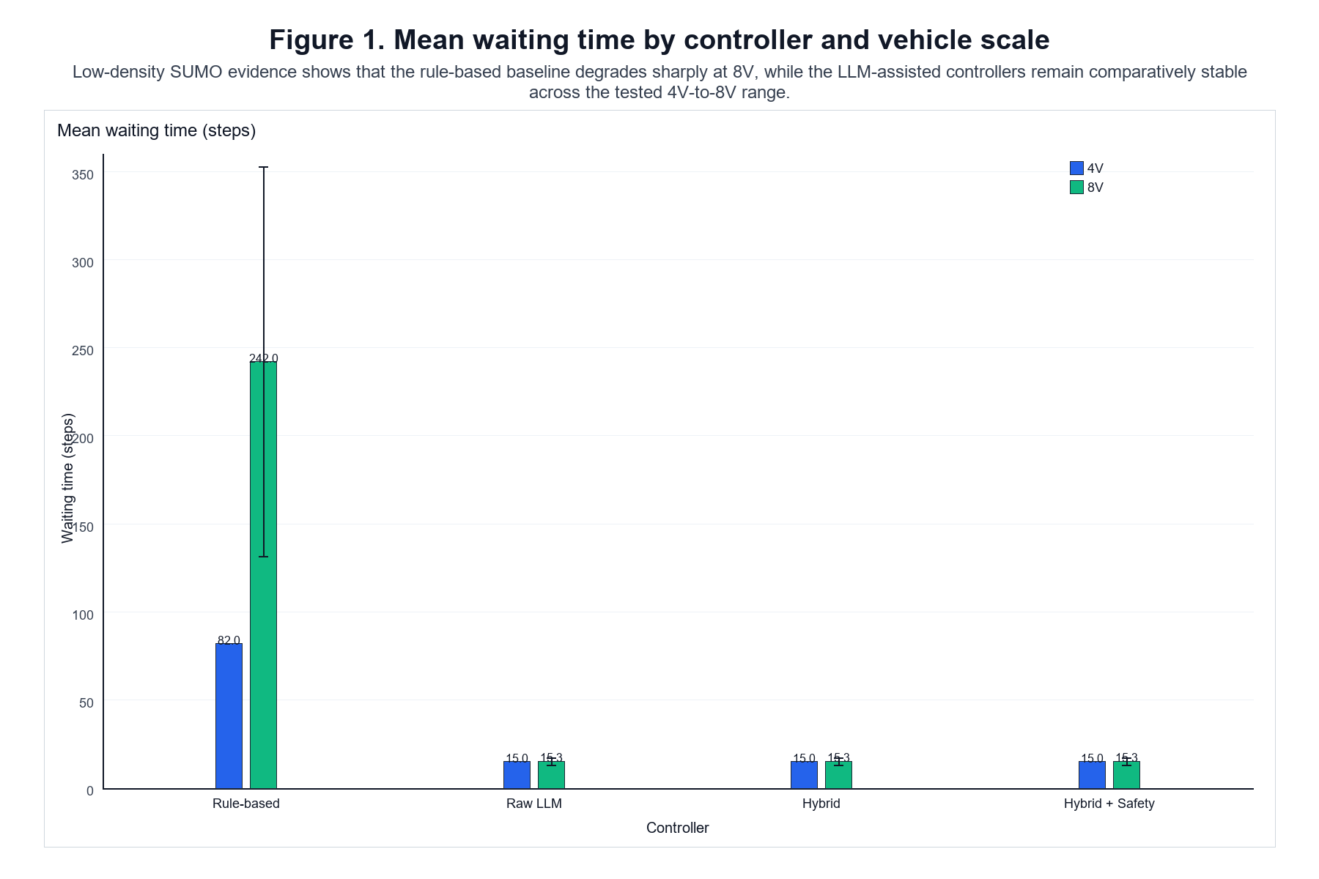
Figure 1 shows that the waiting-time gap between the rule-based baseline and the LLM-assisted pipelines persists across both vehicle scales.
This indicates that the LLM-assisted controllers achieve lower mean waiting time than the rule-based baseline across the tested 4V and 8V scenarios.
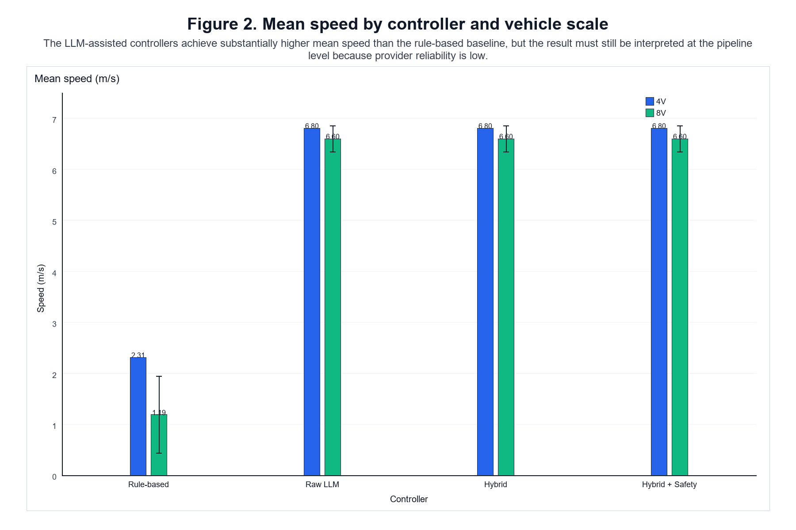
Figure 2 shows that the same pattern appears in mean speed, with the LLM-assisted pipelines maintaining substantially higher speed than the baseline.
This indicates that the LLM-assisted controllers achieve higher mean speed than the rule-based baseline in the tested scenarios.
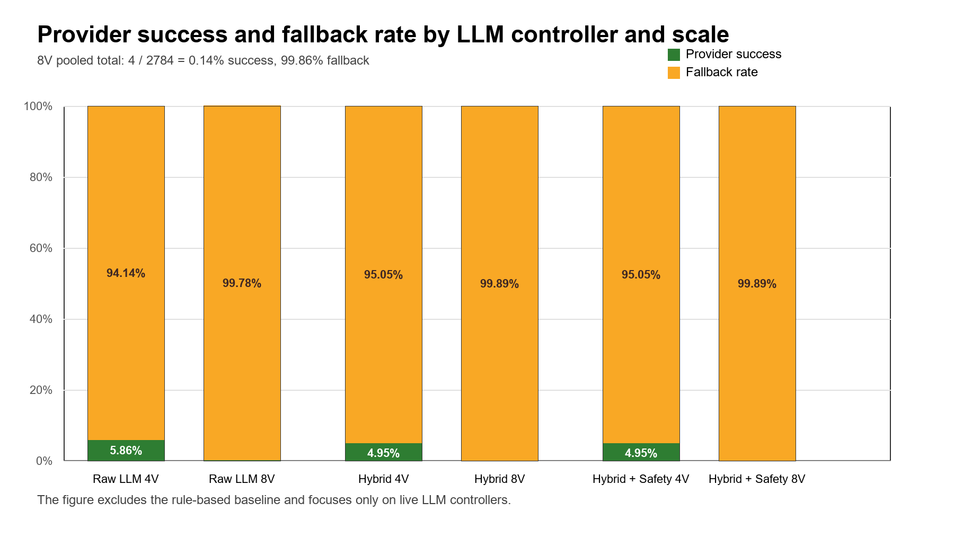
Figure 3 is limited to the live LLM controllers and shows the extreme fallback dominance that underpins the reliability discussion in this chapter.
This shows that provider reliability is low and fallback-heavy, so the traffic results should be interpreted at the pipeline level rather than as isolated model behaviour.
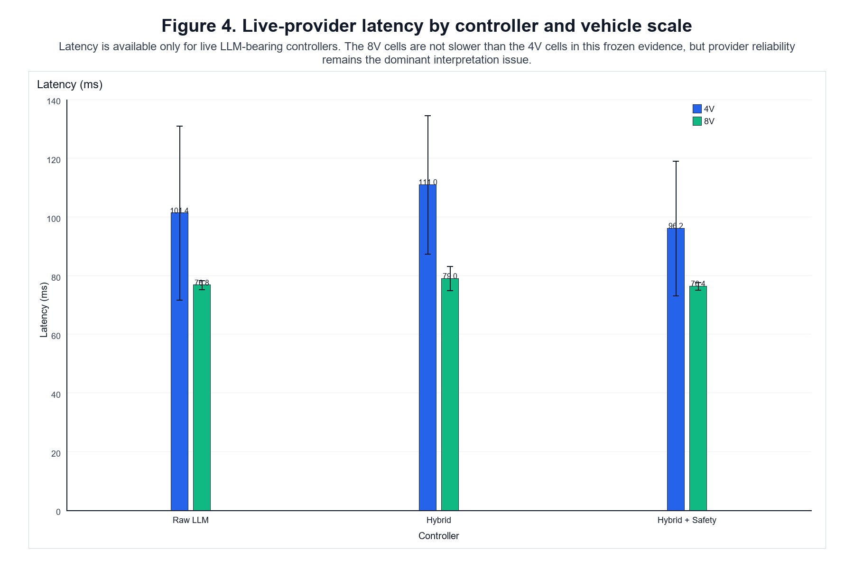
Figure 4 shows that the surviving live-provider calls are few but still measurable in latency, which is useful for understanding execution cost rather than control quality.
This suggests that latency is present but less important than availability and success rate as a validity concern.

6 Discussion
This chapter interprets the experimental findings in relation to the four research questions and the literature reviewed in Chapter 2. The discussion focuses on the complete LLM-assisted control pipeline rather than the language model in isolation, because the retained experiments were strongly influenced by deterministic fallback and other downstream processing stages.

6.1 Traffic Efficiency and RQ1
RQ1 examined how the traffic efficiency of the LLM-assisted architectures compared with the Rule-Based baseline. Across both evaluated vehicle scales, the LLM-assisted pipelines produced substantially lower operational waiting and higher mean speed than the Rule-Based controller.
At 4V, the Rule-Based controller recorded 82.0 operational waiting steps and a mean speed of 2.31 m/s, compared with 15.0 steps and 6.80 m/s for the LLM-assisted architectures. At 8V, Rule-Based operational waiting increased to approximately 242.0 steps and mean speed decreased to 1.19 m/s, whereas the LLM-assisted architectures recorded approximately 15.3 waiting steps and 6.60 m/s.
These results indicate a clear traffic-level performance difference between the complete controller architectures under the tested conditions. However, they do not establish that the LLM itself caused the improvement. Provider reliability was extremely low, and the LLM-assisted controllers relied predominantly on deterministic fallback. RQ1 is therefore supported only at the pipeline level: the complete LLM-assisted architecture performed more efficiently than the selected Rule-Based baseline in the evaluated scenarios.

6.2 Cooperative Post-Processing and RQ2
RQ2 investigated whether cooperative post-processing produced a measurable difference relative to the Raw LLM architecture.
The retained evidence shows no meaningful separation between Raw LLM and Hybrid on the reported traffic metrics. Their 4V and 8V traffic outcomes were effectively identical, and no post-processing interventions were recorded in the final evidence.
This result does not demonstrate that cooperative post-processing is ineffective in principle. Instead, it indicates that the mechanism was not sufficiently exercised under the evaluated conditions to establish an independent contribution. The extremely high fallback rate further reduced the opportunity for differences between Raw LLM and Hybrid to emerge.
RQ2 therefore remains unresolved in terms of performance benefit. The architecture provides a traceable cooperative stage, but the current experiment does not demonstrate that this stage materially changed traffic outcomes.

6.3 Safety Verification and RQ3
RQ3 examined whether deterministic safety verification affected the Hybrid pipeline and whether any safety-efficiency trade-off could be observed.
No collisions occurred in the retained runs, but no safety overrides were recorded either. The safety verifier was therefore present in the control architecture but did not modify the executed decisions in the evaluated scenarios.
The zero-collision result should not be interpreted as evidence that the safety verifier caused improved safety. Because the verifier did not intervene, its independent effect cannot be isolated from the behaviour of the rest of the pipeline. Likewise, no measurable safety-efficiency trade-off can be inferred from the current data.
The most defensible answer to RQ3 is therefore that deterministic safety verification was implemented and traceable, but the low-density scenarios did not exercise it sufficiently to evaluate its contribution.

6.4 Behaviour from 4V to 8V and RQ4
RQ4 considered how controller behaviour changed as the scenario increased from four to eight vehicles.
The Rule-Based controller degraded substantially at the larger scale. Operational waiting increased markedly and mean speed decreased, with substantial variation between seeds. In contrast, the LLM-assisted pipelines retained similar traffic metrics between 4V and 8V.
This indicates that the complete LLM-assisted architecture remained comparatively stable across the evaluated range. However, the result should not be interpreted as evidence of general scalability. Only two vehicle scales were tested, both within a low-density single-intersection environment, and the live-provider path became even less reliable at 8V.
RQ4 therefore supports a limited robustness claim across the tested 4V-to-8V range, but not broader scalability to denser traffic, larger vehicle populations, or more complex road networks.
6.5 Provider Reliability and Attribution of Performance
Provider reliability was the principal operational limitation of the formal experiments. In the corrected 8V experiments, only 4 of 2,784 live-provider requests succeeded, corresponding to approximately 0.14% provider success and 99.86% fallback use. The 4V experiments were also fallback-dominated, although provider success was slightly higher.
This has an important implication for interpretation of the formal traffic results. The lower operational waiting and higher mean speed observed for the LLM-assisted controllers cannot be interpreted as evidence that successful live LLM reasoning independently caused the improvement. Most requests requiring provider interaction were handled through deterministic fallback. The formal 24-run experiment therefore supports a pipeline-level performance comparison rather than an isolated comparison between LLM reasoning and deterministic control.
To investigate this attribution problem separately, a post-hoc diagnostic analysis was conducted after the formal experiment. This supplementary analysis was not part of the original 24-run experimental matrix and should not be interpreted as additional formal traffic evidence. Instead, its purpose was to determine whether successful Gemini-generated decisions differed from the deterministic fallback policy when provider reliability was no longer the dominant failure mode.
In a reliable Gemini Raw LLM 4V seed-1 pilot, all 53 logical provider requests succeeded, all 53 responses were parsed successfully, and no fallback was triggered. Despite successful live-model operation, the resulting traffic performance was identical to the corresponding fallback-only execution. Decision-level alignment further showed complete agreement between Gemini and fallback: all 132 comparable vehicle-level decisions agreed at both the raw and final decision stages.
A further discriminative-state audit examined states containing greater potential for policy differentiation. Eleven mixed route-group states were identified, containing 39 comparable vehicle-level decisions. Gemini and deterministic fallback again agreed on all 39 decisions. Therefore, the absence of an incremental Gemini traffic effect cannot be explained solely by provider failure or by downstream deterministic logic overwriting different model decisions. Under the tested prompt, state representation, action space, and scenario, the successful model behaviour itself reproduced the observed fallback policy.
These findings reveal a second attribution limitation beyond provider reliability. The canonical prompt and deterministic fallback encode substantially overlapping decision semantics. Consequently, even reliable provider operation does not necessarily create behaviour that is experimentally distinguishable from fallback. The formal experiments demonstrate favourable performance of the complete fallback-capable pipeline relative to the selected Rule-Based baseline, while the post-hoc attribution evidence provides no observed incremental traffic benefit attributable specifically to Gemini under the tested conditions.
This distinction is central to the interpretation of the dissertation. Provider reliability determines whether the LLM can participate in the control loop, whereas experimental identifiability determines whether its contribution can be distinguished from deterministic components when it does participate.
Table 5. Post-hoc attribution comparison for the 4V seed-1 diagnostic condition
Evidence | Genuine Gemini | Fallback-only
Logical provider requests | 53 | N/A
Provider success | 53/53 (100%) | N/A
Parser success | 53/53 (100%) | N/A
Fallback rate | 0/53 (0%) | 100% by ablation design
Mean operational waiting | 11.0 steps | 11.0 steps
Mean speed | 7.58 m/s | 7.58 m/s
Completion | 4/4 | 4/4
Collisions | 0 | 0
Despite fully successful provider operation in the Gemini condition, no incremental traffic-performance difference was observed relative to the fallback-only execution.
Table 6. Post-hoc Gemini–fallback decision-agreement analysis
Comparison | Comparable decisions | Agreements | Agreement
Raw decision | 132 | 132 | 100%
Final decision | 132 | 132 | 100%
High-discrimination subset | 39 | 39 | 100%
The complete raw-decision agreement indicates that the identical final behaviour was not produced by downstream deterministic processing erasing different upstream decisions. No upstream Gemini–fallback disagreement was observed in the comparable states.

6.6 Relationship to Existing Literature
The findings are broadly consistent with several themes identified in Chapter 2.
Dresner and Stone (2008) treat intersection management as an explicit coordination problem in which access to shared conflict space must be controlled. The present results reinforce the importance of the surrounding coordination policy: traffic outcomes were determined by the complete decision architecture rather than by isolated vehicle-level proposals.
The distinction between plausible model output and executable action also reflects the planning limitations discussed by Huang et al. (2022). In the present system, LLM output is not executed directly but is constrained by parsing, validation, fallback handling, and subsequent deterministic processing. This supports the broader argument that high-level language-model reasoning requires an interface to executable control.
Similarly, the structured and grounded reasoning perspectives represented by Driess et al. (2023), Hou et al. (2025), and Dong et al. (2026) are consistent with the modular design used in this dissertation. Rather than relying on free-form language generation, the controller operates over a structured traffic-state representation and a restricted action space.
The reliability concerns identified in LLM-based autonomous-driving research are particularly relevant to the present findings. Cui et al. (2025) highlight latency, robustness, transparency, and safety as deployment challenges. The severe provider failure observed here provides a concrete example of why such operational factors need to be evaluated alongside traffic-level performance.
The main difference from much of the reviewed work is that this dissertation makes provider success, fallback behaviour, and downstream interventions explicit parts of the evaluation. This allows favourable traffic results to be separated from evidence about whether the LLM itself was successfully contributing to those results.
6.7 Overall Interpretation
Taken together, the formal and supplementary evidence support a bounded but coherent interpretation of the proposed architecture.
The formal 24-run experiment shows that the complete LLM-assisted pipelines produced substantially lower operational waiting and higher mean speed than the selected Rule-Based baseline under the evaluated 4V and 8V conditions. However, severe provider unreliability caused deterministic fallback to dominate the formal LLM-assisted runs. These traffic results therefore demonstrate a pipeline-level performance advantage rather than an independently identified LLM effect.
The post-hoc attribution analysis strengthens this interpretation from a different direction. When Gemini provider reliability was restored to 100% in the 4V seed-1 diagnostic condition, successful Gemini decisions still produced the same observed traffic performance as fallback-only execution. Decision-level analysis found 100% agreement between Gemini and fallback across 132 comparable decisions, including complete agreement across a 39-decision high-discrimination subset.
The attribution limitation therefore cannot be explained solely by provider failure. Under the tested prompt, state representation, action space, and scenario, Gemini behaviour was not experimentally distinguishable from the deterministic fallback policy. This suggests that the canonical prompt and fallback logic encoded substantially overlapping control semantics.
The evidence for cooperative post-processing and safety verification remains similarly limited. Neither stage was meaningfully activated in the retained formal runs, so their independent performance contributions cannot be established. Likewise, the stability observed between 4V and 8V supports only a limited robustness claim within the evaluated range rather than general scalability.
The four research questions can therefore be answered as follows: RQ1 is supported at the complete-pipeline level; RQ2 does not demonstrate an independent cooperative-postprocessing benefit; RQ3 does not establish an independent safety-verification effect; and RQ4 supports stable pipeline behaviour across the evaluated 4V-to-8V range but not beyond it.
More broadly, the study demonstrates that traceability alone is insufficient for causal attribution. A pipeline may record precisely where decisions originate while still failing to distinguish the behavioural contribution of individual components if those components implement highly similar policies. Reliable evaluation of LLM-assisted control therefore requires both execution provenance and experimentally discriminative controller designs.

7 Limitations

7.1 Experimental Scale and Statistical Scope
The formal evaluation was limited to two traffic scales, consisting of four-vehicle and eight-vehicle scenarios, with three random seeds for each controller-scale condition. This design provides repeated observations for descriptive comparison but remains too small to support strong inferential claims or general conclusions about scalability.
The reported means and standard deviations should therefore be interpreted as summaries of the evaluated conditions rather than estimates of performance across a broader traffic population. In particular, the transition from 4V to 8V provides evidence only within this specific range. No formal evidence was collected for 16V or higher traffic scales, and the results should not be extrapolated to substantially denser traffic conditions.

7.2 Simulation Scope and External Validity
The experiments were conducted at a single unsignalised intersection in SUMO under a controlled low-density scenario. This restricted environment enabled consistent comparison between controller architectures but does not capture the full complexity of real traffic.
The evaluation does not include multiple interacting intersections, heterogeneous road geometries, mixed human and autonomous traffic, perception uncertainty, communication delays, or other disturbances that may occur in real deployments. The study also contains no hardware-in-the-loop or real-road validation. The conclusions are therefore limited to the evaluated simulation environment.

7.3 Provider Reliability and Fallback Dependence
Provider reliability represents the most significant limitation of the LLM-assisted evaluation. In the corrected 8V experiments, only 4 of 2,784 live-provider requests succeeded.
This substantially constrains interpretation of the traffic results. Although the LLM-assisted architectures produced lower operational waiting and higher mean speed than the Rule-Based baseline, these outcomes cannot be attributed primarily to successful live LLM reasoning. Instead, they reflect the behaviour of the complete control pipeline under severe provider unavailability.
The deterministic fallback mechanism allowed the system to continue operating despite provider failures, demonstrating a degree of architectural robustness. However, this same robustness prevents the experiments from providing a clean measurement of the contribution made by the LLM itself.

7.4 Limited Isolation of Individual Pipeline Components
The architecture separates provider output, parsing, validation, fallback handling, cooperative post-processing, and safety verification, and these stages are individually traceable. Nevertheless, the current experimental design does not isolate their causal contributions.
The retained evidence does not establish how traffic performance would change under consistently successful provider access, with fallback disabled, or with cooperative and safety stages deliberately activated. Controlled ablation studies would therefore be required to distinguish the effects of the LLM, deterministic fallback, cooperative logic, and safety verification.
This limitation is particularly important when interpreting the near-identical traffic outcomes of the Raw LLM, Hybrid, and Hybrid + Safety controllers. Their similarity should not be interpreted as evidence that the architectures are intrinsically equivalent; rather, their distinguishing stages were rarely exercised in the retained experiments.
7.5 Experimental Identifiability of LLM and Fallback Behaviour
A further limitation concerns the behavioural identifiability of the LLM relative to deterministic fallback. Although the architecture records decision provenance and distinguishes successful provider responses from fallback execution, traceability does not by itself guarantee that the behavioural contribution of the two policies can be separated experimentally.
Post-hoc analysis showed that the canonical prompt and deterministic fallback encode substantially overlapping decision semantics. In the reliable Gemini 4V seed-1 diagnostic condition, Gemini and fallback produced identical raw and final decisions across all 132 comparable vehicle-level decisions. Complete agreement was also observed in a 39-decision subset selected from states with greater apparent opportunities for policy differentiation.
This means that restoring provider reliability alone is insufficient to identify an independent LLM contribution. If both the LLM prompt and deterministic fallback encourage essentially the same control policy, successful LLM operation may remain behaviourally indistinguishable from fallback even when both components are fully traceable.
Future causal evaluation therefore requires experimental conditions designed to separate the policies rather than merely observing them. This may require prompts that permit genuinely context-dependent reasoning, fallback policies with clearly defined and distinct semantics, scenario states that create competing but admissible actions, and controlled ablations in which the resulting policies can be compared independently.

7.6 Limited Evidence for Cooperative and Safety Mechanisms
Neither the cooperative post-processor nor the safety verifier was meaningfully exercised in the final experimental evidence. No post-processing interventions or safety overrides were recorded, while no collisions occurred in the retained runs.
The absence of collisions is therefore an observation about the evaluated scenarios rather than evidence that the safety verifier improved safety. Similarly, the absence of post-processing intervention means that the experiment cannot establish a measurable traffic benefit from the cooperative stage.
Scenarios specifically designed to generate competing movements, cooperative opportunities, or safety-critical conflicts would be required to evaluate these mechanisms more directly.

7.7 Metric and Evidence Limitations
The operational waiting metric used in this study is derived from the number of recorded simulation steps for which speed_after_action < 0.1 m/s, normalised over the observed vehicles. It therefore represents stop-like occupancy rather than a conventional queueing-theory delay measure or a direct estimate of physical waiting time.
Comparisons using this metric remain meaningful because the same definition was applied consistently across all retained conditions. However, the absolute values should not be interpreted as conventional traffic delay in seconds.
Completion rate also provides limited discrimination because every retained run achieved 100% completion. Operational waiting, mean speed, provider reliability, and decision-pipeline measurements therefore provide more informative comparisons between controller architectures.
A further limitation concerns experimental execution validity. The original nominal 8V evidence was excluded after trace-level validation showed that those runs had not instantiated the intended eight-vehicle scenario. The final 8V analysis therefore uses a separately executed and validated corrected dataset. This correction strengthens the final evidence base, but it also highlights the importance of validating realised simulation conditions rather than relying on configuration metadata alone.

7.8 Overall Scope of the Conclusions
Taken together, these limitations define a deliberately narrow interpretation of the dissertation findings. The study demonstrates that a structured and traceable LLM-assisted pipeline can be implemented and evaluated in a controlled SUMO intersection environment, and that the complete pipeline produced favourable traffic metrics relative to the selected Rule-Based baseline under the tested conditions.
However, the experiments do not establish superiority of the LLM component itself, general scalability, real-world effectiveness, or measurable independent benefits from the cooperative and safety stages. The principal conclusion is therefore at the pipeline level: the architecture remained operational and produced comparatively efficient traffic behaviour within the evaluated scenarios, while external-provider reliability substantially limited the extent to which those outcomes could be attributed to live LLM decision-making.
The post-hoc attribution analysis further shows that this limitation is not attributable only to unreliable provider access. Even under successful Gemini operation, the observed policy matched deterministic fallback in the examined diagnostic states. The study therefore cannot establish an incremental LLM-specific contribution under the current prompt, fallback design, and scenario distribution.

8 Conclusion and Future Work

8.1 Conclusion
This dissertation investigated whether a structured LLM-assisted decision pipeline could support cooperative decision-making at an unsignalised intersection in SUMO. Rather than treating the LLM as an end-to-end controller, the proposed architecture separates model-based decision generation from parsing, deterministic validation, fallback handling, cooperative post-processing, safety verification, and trace logging. This modular design enables both traffic performance and the contribution of individual decision stages to be examined.
Four controller architectures were evaluated: a Rule-Based baseline, a Raw LLM controller, a Hybrid controller incorporating cooperative post-processing, and a Hybrid + Safety controller incorporating deterministic safety verification. The final evaluation covered four-vehicle and eight-vehicle scenarios, with three random seeds for each controller-scale condition.
Across the evaluated scenarios, the LLM-assisted pipelines produced substantially lower operational waiting and higher mean speed than the Rule-Based baseline. At 4V, mean operational waiting was approximately 82.0 steps for the Rule-Based controller and 15.0 steps for the LLM-assisted controllers, while mean speed was 2.31 m/s and 6.80 m/s, respectively. At 8V, Rule-Based operational waiting increased to approximately 242.04 steps and mean speed decreased to 1.19 m/s, whereas the corresponding LLM-assisted values remained approximately 15.29 steps and 6.60 m/s. All retained runs achieved complete vehicle arrival, and no collisions were observed.
However, the formal experiment does not establish that the LLM independently caused this traffic advantage. Provider reliability was extremely low, and deterministic fallback dominated the formal LLM-assisted execution path. The formal traffic results therefore characterise the complete fallback-capable pipeline rather than isolated LLM performance.
Supplementary post-hoc attribution analysis was subsequently used to examine whether this limitation resulted only from provider failure. Under a reliable Gemini 4V seed-1 diagnostic condition, all 53 provider requests succeeded and no fallback was triggered. Nevertheless, Gemini produced the same traffic outcomes as fallback-only execution and agreed with fallback on all 132 comparable vehicle-level decisions. Complete agreement was also retained across a 39-decision high-discrimination subset.
The evidence therefore identifies two distinct limitations to LLM-specific attribution: unreliable provider access in the formal experiment and insufficient behavioural separation between the canonical LLM policy and deterministic fallback when reliable model access was available. Consequently, the strongest supported result is a pipeline-level traffic advantage relative to the selected Rule-Based baseline, not an independently demonstrated Gemini advantage.

8.2 Answers to the Research Questions
RQ1: How does the traffic efficiency of the LLM-assisted architecture compare with the Rule-Based baseline?
The LLM-assisted pipelines produced lower operational waiting and higher mean speed than the Rule-Based baseline across both evaluated vehicle scales. RQ1 therefore supports a performance advantage for the complete LLM-assisted pipeline under the tested conditions, but not for the LLM component in isolation.
RQ2: To what extent does cooperative post-processing alter the Raw LLM pipeline?
No measurable traffic-performance advantage was observed for Hybrid over Raw LLM, and no post-processing interventions were recorded in the retained evidence. The cooperative stage was therefore implemented and traceable but was not sufficiently exercised to establish an independent performance benefit.
RQ3: What effect does deterministic safety verification have on the Hybrid pipeline?
No safety overrides were recorded, although no collisions occurred in the retained experiments. The current evidence therefore does not establish an independent safety benefit or a safety-efficiency trade-off attributable to the safety verifier.
RQ4: How does controller behaviour change from four to eight vehicles?
The Rule-Based baseline exhibited substantially higher operational waiting and lower mean speed at 8V, whereas the LLM-assisted traffic metrics remained comparatively stable. This supports robustness of the complete pipeline across the evaluated 4V-to-8V range, but does not establish general scalability beyond these conditions.

8.3 Contributions
The principal contribution of this dissertation is a reproducible and traceable framework for evaluating LLM-assisted decision pipelines for unsignalised intersection control. The architecture separates model-generated decisions, parsing and validation, deterministic fallback, cooperative post-processing, safety verification, and final vehicle actions, allowing their roles within the control process to be examined explicitly.
A second contribution is the integration of provider reliability and decision provenance into the evaluation. The experiments demonstrate that favourable traffic-level performance does not necessarily imply successful LLM operation. In the present study, the LLM-assisted pipelines continued to produce favourable traffic outcomes despite extremely low provider success because deterministic fallback maintained system operation.
The dissertation therefore contributes primarily an engineering and evaluation methodology for LLM-assisted traffic control rather than evidence of general LLM superiority. In particular, it demonstrates the importance of evaluating both system-level outcomes and the execution path through which those outcomes are produced.
8.4 Future Work
The highest priority for future work is to redesign the experiment for stronger causal identification of the LLM contribution. The present study shows that provider reliability and behavioural identifiability are separate problems: restoring reliable model access does not establish an independent LLM effect when the model and deterministic fallback produce the same policy. Future experiments should therefore deliberately construct states in which multiple admissible decisions exist and in which contextual reasoning can produce behaviour that differs meaningfully from the fallback policy.
The prompt and fallback mechanism should also be redesigned to reduce semantic overlap. The deterministic fallback should remain safe and operationally useful, but it should not encode essentially the same policy that the LLM is being evaluated against. Controlled ablations should then compare reliable LLM-only, fallback-only, and combined pipeline conditions using identical traffic states. Decision-level disagreement, traffic outcomes, and downstream interventions should be analysed together to determine whether any incremental LLM contribution can be identified.
Provider reliability nevertheless remains an important engineering requirement. Future formal experiments should use a provider configuration or local/self-hosted model capable of sustaining sufficiently reliable and predictable inference throughout the complete experimental matrix. Reliability should be treated as a prerequisite for causal evaluation rather than as evidence of LLM effectiveness itself.

References
Alvarez Lopez, P., Behrisch, M., Bieker-Walz, L., Erdmann, J., Flötteröd, Y.-P., Hilbrich, R., Lücken, L., Rummel, J., Wagner, P. and Wießner, E. (2018) ‘Microscopic traffic simulation using SUMO’, 2018 21st International Conference on Intelligent Transportation Systems (ITSC), pp. 2575–2582. doi: 10.1109/ITSC.2018.8569938.
Cui, C., Ma, Y., Yang, Z., Zhou, Y., Liu, P., Lu, J., Li, L., Chen, Y., Panchal, J.H., Abdelraouf, A., Gupta, R., Han, K. and Wang, Z. (2024) ‘Large language models for autonomous driving (LLM4AD): Concept, benchmark, simulation, and real-vehicle experiment’, arXiv preprint, arXiv:2410.15281.
Dong, X., Li, J., Xie, J., Yi, Y., Jia, T., Fang, S., Tian, Y. and Hang, P. (2026) ‘Large language model based interactive decision-making for autonomous driving’, arXiv preprint, arXiv:2604.23513.
Dresner, K. and Stone, P. (2008) ‘A multiagent approach to autonomous intersection management’, Journal of Artificial Intelligence Research, 31, pp. 591–656.
Driess, D., Xia, F., Sajjadi, M.S.M., Lynch, C., Chowdhery, A., Ichter, B., Wahid, A., Tompson, J., Vuong, Q., Yu, T., Huang, W., Chebotar, Y., Sermanet, P., Duckworth, D., Levine, S., Vanhoucke, V., Hausman, K., Toussaint, M., Greff, K., Zeng, A., Mordatch, I. and Florence, P. (2023) ‘PaLM-E: An embodied multimodal language model’, Proceedings of the 40th International Conference on Machine Learning, Proceedings of Machine Learning Research, 202, pp. 8469–8488.
Hou, X., Wang, W., Yang, L., Lin, H., Feng, J., Min, H. and Zhao, X. (2025) ‘DriveAgent: Multi-agent structured reasoning with LLM and multimodal sensor fusion for autonomous driving’, IEEE Robotics and Automation Letters, 10, pp. 12189–12196. doi: 10.1109/LRA.2025.3619807.
Huang, W., Abbeel, P., Pathak, D. and Mordatch, I. (2022) ‘Language models as zero-shot planners: Extracting actionable knowledge for embodied agents’, Proceedings of the 39th International Conference on Machine Learning, Proceedings of Machine Learning Research, 162, pp. 9118–9147.
Li, Y., Katsumata, K., Javanmardi, E. and Tsukada, M. (2024) ‘Large language models for human-like autonomous driving: A survey’, arXiv preprint, arXiv:2407.19280.
Ma, Y., Cui, C., Cao, X., Ye, W., Liu, P., Lu, J., Abdelraouf, A., Gupta, R., Han, K., Bera, A., Rehg, J.M. and Wang, Z. (2024) ‘LaMPilot: An open benchmark dataset for autonomous driving with language model programs’, Proceedings of the IEEE/CVF Conference on Computer Vision and Pattern Recognition (CVPR), pp. 15141–15151.
Safarov, K. (2022) The impact of autonomous vehicles on traffic performance at an unregulated junction. PhD thesis. University of Bristol.
Wen, L., Fu, D., Li, X., Cai, X., Ma, T., Cai, P., Dou, M., Shi, B., He, L. and Qiao, Y. (2023) ‘DiLu: A knowledge-driven approach to autonomous driving with large language models’, arXiv preprint, arXiv:2309.16292.
Xie, S., Kong, L., Dong, Y., Sima, C., Zhang, W., Chen, Q.A., Liu, Z. and Pan, L. (2025) ‘Are VLMs ready for autonomous driving? An empirical study from the reliability, data and metric perspectives’, Proceedings of the IEEE/CVF International Conference on Computer Vision (ICCV), pp. 6585–6597.
Zhao, R., Wang, K., Li, Y., Fan, Y., Gao, F. and Gao, Z. (2025) ‘Centralized cooperative control for autonomous vehicles at unsignalized all-directional intersections: A multi-agent projection-based constrained policy optimization approach’, Expert Systems with Applications, 267, 126153. doi: 10.1016/j.eswa.2024.126153.

Appendices
These appendices collect evidence-backed material that is useful for reproducibility but too detailed for the main narrative.

Appendix A. Prompt Contract and Architecture
This appendix records the frozen prompt contract and the staged controller architecture used in the dissertation.
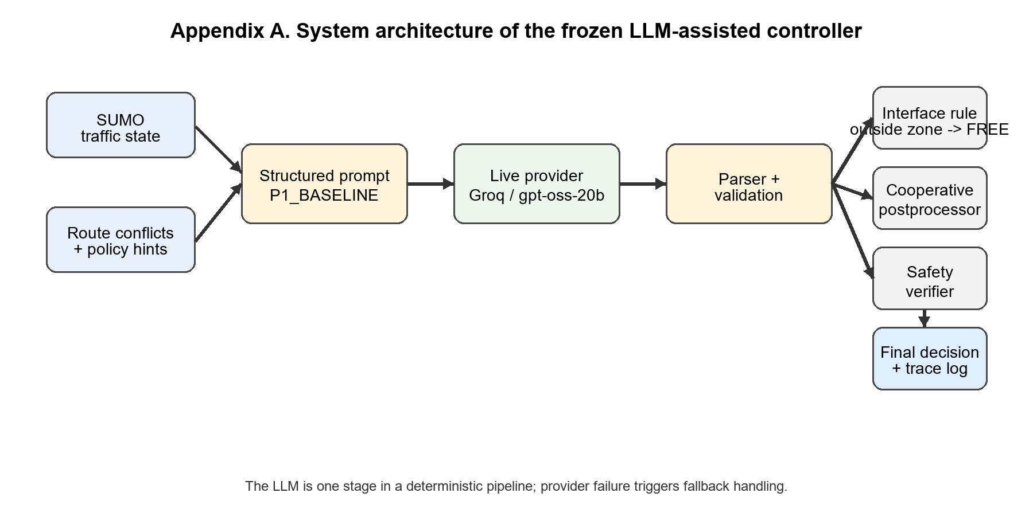
Figure A1. System architecture of the frozen LLM-assisted intersection controller.
Table A1. P1_BASELINE prompt input/output schema
Field | Evidence-backed content
Prompt identifier | P1_BASELINE
Input blocks | Traffic state, route conflicts, and policy hints
Output schema | Exactly one JSON object with a decisions map
Decision labels | PROCEED, WAIT, FREE
Hard constraints | One decision per vehicle; outside control zone -> FREE; no prose or markdown

Appendix B. Frozen Request Configuration
This appendix records the frozen live-provider request settings used for the final evidence boundary.
Table B1. Frozen provider request configuration
Parameter | Value
Provider | Groq
Base URL | https://api.groq.com/openai/v1
Model | openai/gpt-oss-20b
Max completion tokens | 256
Reasoning effort | low
Timeout | 30.0 s
Max retries | 0
Not set explicitly | temperature, top_p, seed, reasoning_format

Appendix C. Experimental Matrix and Seed-level Results
This appendix preserves the final evidence boundary and the seed-level values used to assemble the dissertation tables.
Table C1. Seed-level traffic values used to assemble Table 2
Controller / Scale | Seed-level raw values
Rule-based 4V | completion [1.0, 1.0, 1.0]; waiting [82, 82, 82]; speed [2.310, 2.310, 2.310]
Rule-based 8V | completion [1.0, 1.0, 1.0]; waiting [86, 311, 329.125]; speed [2.255, 0.655, 0.658]
Raw LLM 4V | completion [1.0, 1.0, 1.0]; waiting [15, 15, 15]; speed [6.803, 6.803, 6.803]
Raw LLM 8V | completion [1.0, 1.0, 1.0]; waiting [17.875, 12.875, 15.125]; speed [6.265, 6.880, 6.652]
Hybrid 4V | completion [1.0, 1.0, 1.0]; waiting [15, 15, 15]; speed [6.803, 6.803, 6.803]
Hybrid 8V | completion [1.0, 1.0, 1.0]; waiting [17.875, 12.875, 15.125]; speed [6.265, 6.880, 6.652]
Hybrid + Safety 4V | completion [1.0, 1.0, 1.0]; waiting [15, 15, 15]; speed [6.803, 6.803, 6.803]
Hybrid + Safety 8V | completion [1.0, 1.0, 1.0]; waiting [17.875, 12.875, 15.125]; speed [6.265, 6.880, 6.652]

Appendix D. Controller Semantics
The dissertation compares four controller variants that share the same SUMO scenario and decision space.
Table D1. Controller variants and enabled pipeline stages
Controller | Enabled stages
Rule-based | Deterministic interface rule only
Raw LLM | Structured prompt, provider request, parsing, validation, and fallback
Hybrid | Raw LLM plus cooperative post-processing
Hybrid + Safety | Hybrid plus deterministic safety verification

Appendix E. Abbreviations
Table E1. Abbreviations used in the dissertation
Abbreviation | Meaning
LLM | Large language model
SUMO | Simulation of Urban MObility
RQ | Research question

