Table of Contents
- Introduction
- Software required
- Tools and utilities used from the tpm2-tools project
- Attestation-Goals
- Privacy considerations
- Why anonymity or privacy matters?
- Solution
- TPM attestation
- What is a PCR and how are PCR values generated
- Initial state of the PCR
- Extending values into PCR indices
- Golden or reference PCR
- System software state
- Roots of trust for reporting (RTR)
- Roles identified in the bare bone remote attestation model
- Device service registration
- Service request Part 1 (Platform Anonymous Identity Validation)
- Service request Part 2 (Platform Software State Validation)
- Service delivery
- Simple attestation with tpm2-tools
- Scripts for implementation of the simple attestation framework
- Device-Node
- Service-Provider
- Privacy-CA
- FAQ

Introduction
This article shows how to use the utilities/ tools from the tpm2-tools project to set up a bare bone remote attestation of the system software state as reflected by the TPM2 platform-configuration-registers (PCR). The intent is to provide a general guidance on the topic and does not discuss or reference any attestation framework in particular.
CAUTION: All code samples for the sample attestation framework are strictly for demonstration purpose. It has not been evaluated for production use.

Software required
tpm2-tss v2.3.0
tpm2-abrmd v2.2.0
tpm2-tools v4.0
ibmswtpm
openssl

Tools and utilities used from the tpm2-tools project
tpm2_createprimary
tpm2_create
tpm2_createek
tpm2_createak
tpm2_getekcertificate
tpm2_makecredential
tpm2_activatecredential
tpm2_pcrextend
tpm2_pcrread
tpm2_quote
tpm2_checkquote
tpm2_getrandom
tpm2_readpublic

Attestation-Goals
“Attestation is the evidence or proof of something. It is a declaration that something exists or is the case. It is the action of being a witness to or formally certifying something.”
The literary-definition very much applies in the context of this tutorial which discusses attesting of the PCR contents in a TPM.
An attestation has two critical parts for it to hold true, namely:
Attestor identity: To believe something is true, one needs to vouch the authenticity of what is being attested. This inherently means the identity of the one who attests is known and or trusted.
Attestation data integrity: To believe something is true, both the process to generate the information and the process to protect the information from tampering need to be inherently trusted.

Privacy considerations
While private or sensitive portion of keys used to sign attestation blobs must remain confidential or secret, it is possible to identify a unique signer with the public key used to verify the signature over the attestation blobs. This defeats the anonymity or privacy of the platform user.

Why anonymity or privacy matters?
Let’s use a hypothetical example of a smart-lock device that has an embedded application. It has integrated multiple microservices from different providers that provide various services, namely:
Two-factor-authentication(2FA).
Facial-recognition.
Device-Logs.
If the device uses the same key across all the microservices for public key authentication and or signing attestation quotes. The service provider or a third party analytics could potentially stage a privacy violation knowingly or unknowingly simply by tracking usage of same public key. And so it can be determined that the device owner uses facial recognition for 2FA and operates the device consistently certain times of the day which updates the device logs.

Solution
There are at least four possible ways to resolve this.
Every user uses the same private/public key pair to sign attestation blobs. Cryptographically, this method is as strong as the process and controls involved in duplicating the private key into multiple platforms. Additionally, the strength is also dependent on the robustness of the methods and mechanisms to store the private key once imported in the platform. Revocation of the key implies that all the platforms having the key must be revoked and re-provisioned with new key. Refer tpm2_import that demonstrates a way to import external keys into the TPM.
Every user has a unique private key, however, all the private keys keys map to a single public key. This is possible with Intel® EPID technology. EPID also affords a mechanism to revoke a single key or all the platforms in the group. A similar direct-anonymous-attestation (DAA) based on elliptic curve cryptography scheme is also available in the TPM and is called ECDAA; it is not discussed in this tutorial.
Every user generates and uses a new key (ephemeral key) every time an attestation blob has to be signed. There are some unique challenges with this. If every attestation blob is signed with a brand-new key, how to infer the anonymous identity at the minimum to determine the genuineness of the platform and hence the attestation. It then follows that we need an anonymous identity that is cryptographically bound to a unique trusted identity and that the unique identity is never revealed to any entity other than the Privacy-CA.
A variant of #3. One AIK per party that’s verifying attestations. Allows abstracting the client ID, but the verifier knows it’s the same client on subsequent verifications. This is useful in applications like banking etc.
Note: Platform anonymity can also be defeated if the platform’s host-name and or ip-address remains the same on every connection. This is not a topic of discussion here, yet there is an assumption made here that sufficient measures are taken by the platform user to resolve this using a VPN or other reasonable mechanisms.

TPM attestation
Depending on the robustness and privacy rules of the system, platform anonymity may not be mandatory and so privacy considerations don’t apply. If that is the case or if methods #1 or #2 discussed above suffice your attestation and privacy needs, subsequent sections detailing information on TCG endorsement keys (EK) and attestation identity keys (AIK) are irrelevant.
Note: A more detailed discussion on TPM attestation terminologies can be found here. This document expands on that discussion to demonstrate how one can set up a minimal or bare bones attestation framework using tpm2-tools.
With these definitions in mind, let’s dive straight into TPM attestation topic. Of the various object types in the TPM, the following discussion is restricted to how the TPM PCR data can be attested securely and anonymously using method #3.

What is a PCR and how are PCR values generated
PCR or platform configuration registers are special TPM2 objects that can only be modified or written to by hash extension mechanism. In that, the incoming new value is concatenated with the existing value in the PCR and hashed. The new hash value now replaces the old value. This means that though it is a single location, the final value reflects a history of all the hash extensions. PCRs are arranged in banks, one each for a specific hash algorithm SHA1, SHA256, etc. Every bank has up to 32 PCRs. The Trusted Computing Group publishes a guideline of what part of system software should be extended to specific PCR indices in the PC Client specification. There is also a debug PCR at index 16 that can be reset to 0 by issuing the tpm2_pcrreset command. Other PCRs reset on TPM resets.
The fact that the only way to modify a PCR is to extend a hash and that the robustness mechanisms that prevent physical tampering of the values, make the TPM a root of trust for storage (RTS).

Initial state of the PCR
The initial values in a PCR index is determined by the platform-specific specification. Values at a given PCR index can be read using the tpm2_pcrread tool and specifying the PCR-selection string. Relevant to our example, let’s read PCR indices 0,1,2 in SHA1 and SHA256 banks.
tpm2_pcrread sha1:0,1,2+sha256:0,1,2
If running it on a simulator, the PCR are in the initial state, in that the PCR are not extended just yet. Hence, the default values (00/ FF) should be displayed as shown below.
SHA1
0 : 0000000000000000000000000000000000000000
1 : 0000000000000000000000000000000000000000
2 : 0000000000000000000000000000000000000000
SHA256
0 : 0000000000000000000000000000000000000000000000000000000000000000
1 : 0000000000000000000000000000000000000000000000000000000000000000
2 : 0000000000000000000000000000000000000000000000000000000000000000

Extending values into PCR indices
A PCR index can be modified only by extending it. In that, it cannot be set to an absolute value like a register. One of the three tools can modify the PCR values, namely:
tpm2_pcrextend: A pre-calculated digest of data is presented to the TPM.
tpm2_pcrevent: The data is directly presented to the TPM and the TPM calculates the data-digest prior to extending.
tpm2_pcrreset: The PCR index value is reset to zero. Not all PCR indices are resettable.
In the case of tpm2_pcrextend and tpm2_pcrevent, the TPM ultimately concatenates the incoming data-digest with the current value at the PCR index, hashes the concatenation-data and replaces the PCR index value in place.
It should be noted that the entity extending the PCR is inherently trusted. This trusted entity is called a Root-of-trust-for-measurement (RTM) in TCG terminology. Intel (R) Bootguard is an example. The tamper resistant code extends the initial measurements of the critical portions of the pre-boot software.
Relevant to our example scripts in this tutorial below is an example of how to use tpm2_pcrextend to modify PCR indices.
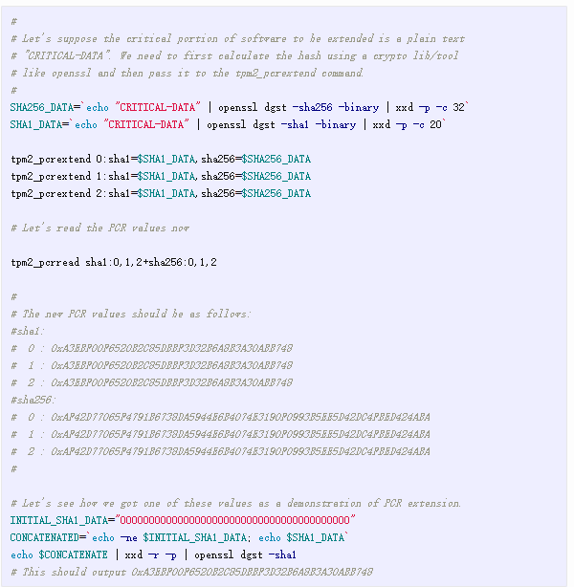

Golden or reference PCR
The term golden/ reference is not a formal terminology. It is simply a digest of the content of the PCR indices in a PCR selection. The selection is a choice of PCR indices across all the PCR banks. Values in a PCR index itself is a digest of the binary blob of software/ data that represents a known good state. The digest algorithm for individual PCR indices is the same as that of the specific bank. Whereas, the digest of the golden/ reference state has to be specified.
The golden/reference PCR state can be calculated in one of three ways:
Using the tpm2_quote tool. The signing scheme used to sign the quote determines the digest algorithm for the quote. This should be done once on a reference platform.
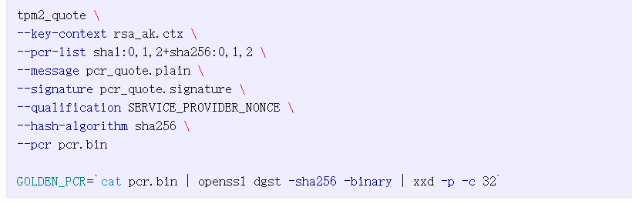
If only the PCR data is to be read from the reference platform, it can always be done using tpm2_pcrread tool as well. Also, the output of the tpm2_pcrread tool can be passed to the tpm2_checkquote tool directly. However, when doing so, specifying the PCR-selection information to the tpm2_checkquote tool is a must. Calculating the golden/ reference PCR data using this method is shown below.
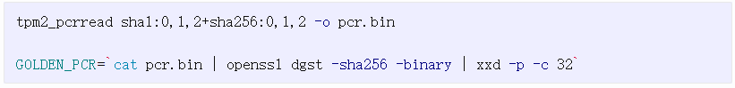
Entirely without the TPM as shown below.
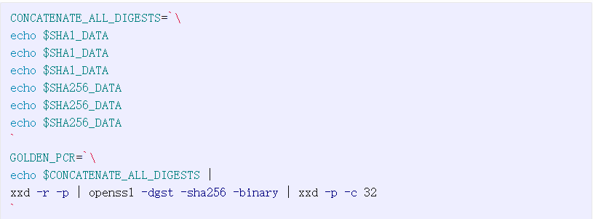
Using any of the 3 methods above the GOLDEN_PCR value is “e756e3af77a4f15a3f2ed489a7411a93d91d619506b6d1ed1121faaeaf45d8de”.

System software state
In a nutshell, this is a single digest aka measurement of interesting/ critical pieces of system software. To do this, a trusted portion of the software does the following:
Calculates the hash of the software module that will be loaded for execution.
Sends over the digest to the TPM and requests it be extended in the PCR.
Note: The trusted portion of the system software extending measurements is termed root-of-trust-for-measurement (RTM). This is inherently trusted.
Throughout the platform boot process, a log of all executable code and relevant configuration data is created and extended into PCRs. Each time a PCR is extended, a log entry is made in the TCG event log. This allows a challenger to see how the final PCR digests were built. The event log can be examined using the tpm2_eventlog tool. The event log is typically stored at this location /sys/kernel/security/tpm0/binary_bios_measurements.

Roots of trust for reporting (RTR)
The private or sensitive portion of the TPM key object is protected by the TPM. Couple this with authentication and enhanced authorization models the TPM design affords, the signatures generated from such keys are deemed trustworthy. As discussed earlier that identity is yet another facet to the trustworthiness of the signature and hence the data. We also determined that in order to preserve the privacy of the end user there is need for both anonymous identity and a unique identity that are cryptographically bound. Together these requirements form a criterion for defining a TPM object and these properties make the TPM a root of trust for reporting (RTR).
Of the four hierarchies the TPM is partitioned into, the endorsement hierarchy is to be used by the privacy administrator. The primary key created under the endorsement hierarchy provides the unique identity and is called the endorsement key (EK). Following properties make EKs special amongst other primary keys that can be created under any of the hierarchies:
TCG EK cannot be used as a signing key.
TCG EK authentication is a policy that references endorsement hierarchy authorization.
TCG EK are certified by the TPM manufacturer. More details on the key can be found from TCG EK credential specification. As already mentioned, the EK is a primary key and so can be created using the tpm2_createprimary tool by supplying the right attributes and authorization policy. In order to simplify attestation, a tool tpm2_createek is also available that has all the defaults specified by TCG EK credential spec.
The anonymous identity is the attestation identity key (AIK) created with the EK as its parent. There is no specific key template that is mandated by TCG that determines the AIK key attributes or authorization model. Since the key is typically used in privacy sensitive operations like quoting/ signing/ certifying , the key is a signing key created under endorsement hierarchy with privacy administrator controls. And so it’s authorization model typically references the authorization of the endorsement hierarchy through a policy. The association of the AIK to an EK is done using a cryptographical method called credential activation. Unlike EK which is a constant/ unique primary key that can be re-created, the AIK keys are ephemeral. In that, every time an AIK is created it results in a brand-new key and thus makes the key anonymous. The AIK as mentioned is a child of the EK primary key and can be created with the tool tpm2_create. Alternatively, the key can also be created using the tpm2_createak in order to simply attestation. The tool implements the TPM2_CC_Create command with the most commonly used AIK properties.
In summary,
The TPM manufacturer EK certificate vouches for unique identity; while the credential activation process vouches the association of the AIK to the EK and hence the TPM.
tpm2_createek and tpm2_createak tools can be used to create EK and AIK. Any further customizations to the keys outside the chosen defaults can be done by creating the objects with tpm2_createprimary and tpm2_create respectively.
Note: System software state can also be deemed as a system’s trusted identity without requiring a signing key. Such an identity is only useful for self attestation of the system. This is also known as local attestation. Local attestation has use cases like sealing-encryption-secrets or using PCR state as proxy authentication model to make authorization for TPM objects valid as long as system identity aka system software state does not change.

Roles identified in the bare bone remote attestation model
The primary goals for the minimal bare bone remote attestation are:
To demonstrate verification of an attestation quote.
The quote should contain the digest of the PCR values representing system software state.
Signer of the quote should be anonymous to the verifier; yet the verifier should be able to make a determination that the quote was signed by a valid signer.
To achieve the goals it is sufficient to have 3 players, namely:
Device-Node: The edge platform with a TPM whose system software state is of interest. It generates the attestation structures with digest of PCR data included in the quotes. The platform signs the quotes with an attestation identity key for anonymity. AIK is cryptographically bound to the unique identity key on the same platform. The unique identity key is the endorsement-key (EK).
Privacy-CA: The only trusted entity that can prove the association of an AIK to a valid EK without disclosing the EK to the “Service-Provider”. This is also the only entity in addition to the “Device-Node” that knows the EK for a given AIK from the “Device-Node“.
Service-Provider: The entity that the “Device-Node“ communicates with to avail services. The “Service-Provider“ need to ensure the following:
a. Entity requesting services has registered its unique identity with the “Privacy-CA“.
b. Anonymous identity belongs to the pool of registered unique identities that the “Privacy-CA“ stores.
c. System software state of the “Device-Node“ is an acceptable one.
In practice, however the various roles as shown here can be further broken down. As an example, all the verifications for anonymous-identity and system-software state can be handed off to an additional “Verifier“ role.
Let’s now look at the various stages of our example attestation framework.
Service-registration.
Service-request Part 1 (Anonymous identity validation).
Service-request Part 2 (Platform software state validation).
Service-delivery.

Device service registration
This is the stage where the “Device-Node“ requests services from the “Service-Provider“. The “Service-Provider“ has two requirements at this stage.
The “Device-Node“ sends its unique key to the “Privacy-CA“
The “Privacy-CA“ verifies the genuineness of the EK from the EK certificate validation and also the presence of the EK on the platform through the credential-activation process.
In order to verify that #1 & #2 above happened, the “Service-Provider“ creates an ephemeral secret called REGISTRATION-TOKEN that it shares only with the Privacy-CA who in turn reveals it to the “Device-Node“ if and only if all verifications on EK-certificate and Credential-Activation pass which are only possible if “Device-Node“ communicates the platform EK and AIK with the Privacy-CA. The “Device-Node“ then presents the REGISTRATION-TOKEN to the “Service-Provider“ to complete registration.
Note: The “Service-Provider“ has no further information recorded about the platform at the end of the registration. It only knows that a registration request was made by some platform and that it’s EK is registered in the pool of valid EKs with the Privacy-CA.
The sequence diagram below shows the interactions during the registration.
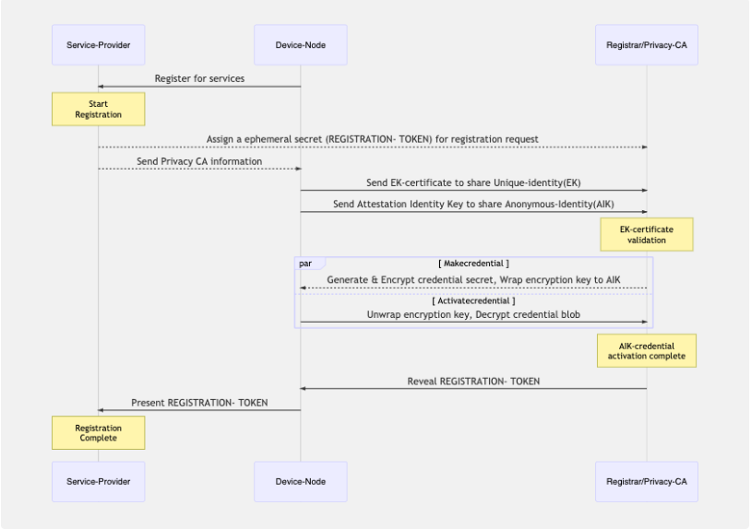

Service request Part 1 (Platform Anonymous Identity Validation)
This is the stage where a registered platform makes a service request to the “Service-Provider“ and sends an ephemeral AIK to securely procure the services. The “Service-Provider“ needs to know the following:
The AIK is a valid one and that the Privacy-CA can prove that the AIK is bound to an EK from the Privacy-CA’s trusted pool of EKs.
The AIK is from a TPM currently accessible to the platform.
In order to achieve this, The Privacy-CA needs to request the EK from the platform and also ensure the AIK is present on the platform through the credential activation process.
In order to verify these interactions between the “Privacy-CA“ and the “Device-Node“ occurred, the “Service-Provider“ creates an ephemeral secret called SERVICE-TOKEN that it shares with the “Privacy-CA“ who in turn reveals it to the “Device-Node“ after a successful credential activation process. The “Device-Node“ now proves the validity of the service request by presenting the SERVICE-TOKEN back to the “Service-Provider“.
The sequence diagram below shows the interactions during the service-request.
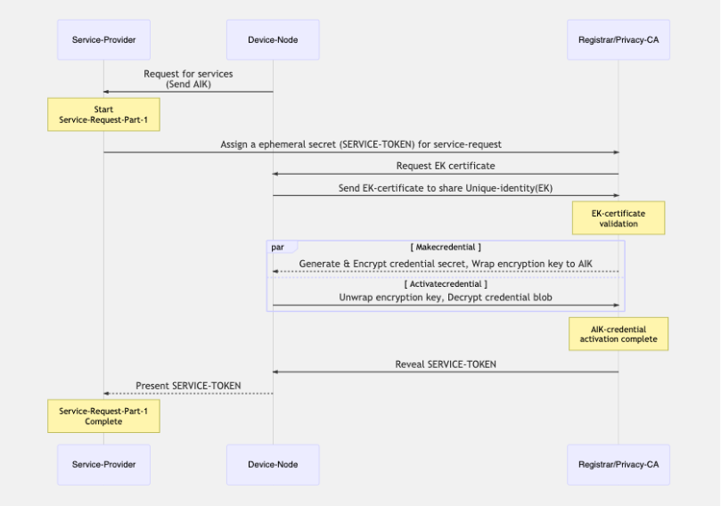

Service request Part 2 (Platform Software State Validation)
At this stage, by validating the “SERVICE-TOKEN” presented by the device, the “Service-Provider“ has ascertained the AIK comes from a registered platform and that it is a trusted signing key. Now the “Service-Provider“ needs to assured of the system-software state of the “Device-Node“. To achieve this the “Service-Provider“ requests an attestation quote from the “Device-Node“ that has to be signed with the AIK. In order to prevent replay attacks, the “Service-Provider“ generates a NONCE that needs to be added to the attestation quote before signing.
Below is a YAML representation of PCR included attestation data returned by tpm2_quote.
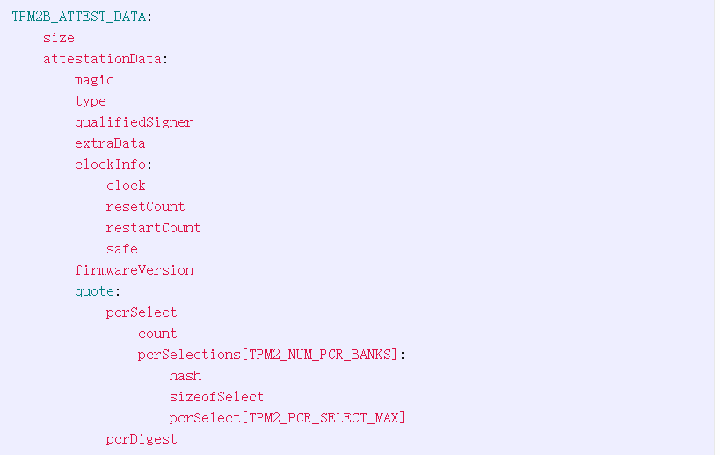
Shown above in yaml representation is all the information included in an attestation quote. Brief description of the important fields follow:
magic: the indication that this structure was created by a TPM always TPM2_GENERATED_VALUE.
type: The type of the attestation structure. It is TPM2_ST_ATTEST_QUOTE for the type that has the PCR information and being discussed at length here in.
qualifiedSigner: Qualified Name of the signing key. The term qualified name is the digest of all the Names of all the ancestor keys back to the Primary Seed at the root of the hierarchy.
extraData: External information supplied by caller. The NONCE generated by the “Service-Provider“ is added here in this field.
Clock: The time in milliseconds during which the TPM has been powered. This value is reset to zero when the Storage Primary Seed is changed TPM2_Clear.
resetCount: The number of occurrences of TPM Reset since the last TPM2_Clear.
restartCount: The number of times that TPM2_Shutdown or _TPM_Hash_Start have occurred since the last TPM Reset or TPM2_Clear.
Safe: Indicates that no value of Clock greater than the current value of Clock has been previously reported by the TPM. Set to YES on TPM2_Clear.
firmwareVersion: TPM vendor-specific value identifying the version number of the firmware.
pcrSelect: The information on algID, PCR selected, and the digest.
count: The number of selection structures. A value of zero is allowed. This indicates the count of selected PCR banks (SHA1, SHA256, etc.)
pcrSelections: This is a list of PCR selection structures.
hash: The hash algorithm associated with the selection bank.
sizeofSelect: The size in octets of the pcrSelect array. This indicates number of bytes required to represent all the PCRs in a bank. Every PCR is represented as a bit. E.g. For 24 PCRs per bank the sizeofselect should be 3 bytes.
pcrSelect: The bit map of selected PCR (the least significant byte first)
pcrDigest: The digest of selected PCR using hash algorithm of the signing key.
Below is an example dump from an attestation quote for PCR0 from SHA1 bank and PCR0, PCR1 from SHA256 bank.
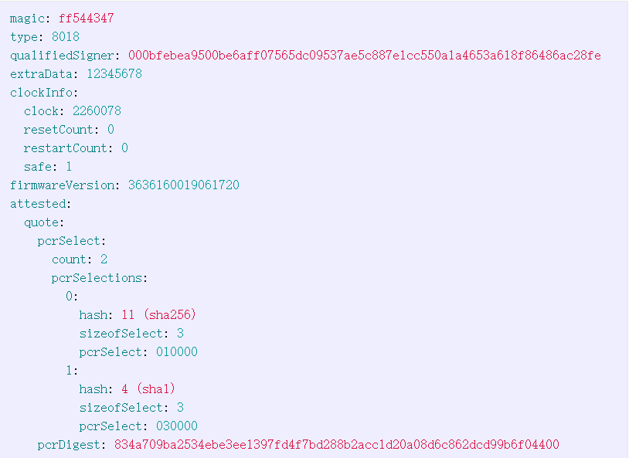
The sequence diagram below shown the interactions during this stage.
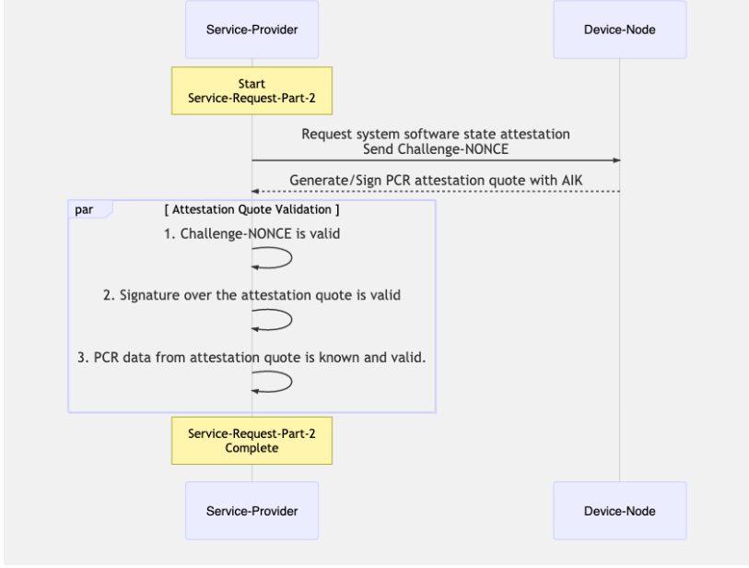

Service delivery
At this stage, by validating the “SERVICE-TOKEN“ and the attestation-quote it received from the “Device-Node“, the “Service-Provider“ has ascertained the “Device-Node“ anonymous identity and system-software state. With the system in a known state, the “Service-Provider“ can now wrap the “SERVICE-SECRET“ with the AIK Public Key.
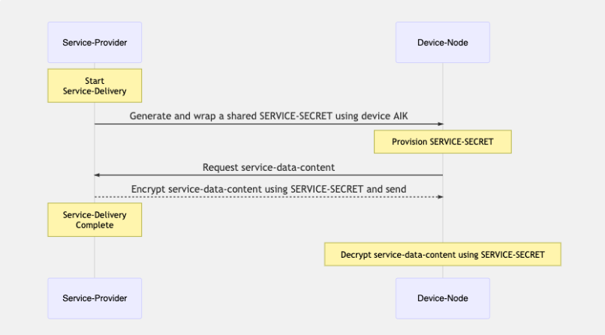

Simple attestation with tpm2-tools
The following demonstration shows the tpm2-tools involved in the sequence diagrams discussed above. Following the demonstration of the tpm2-tools in this section, there is a subsequent section showing the scripts for the different roles and their interactions in the simple attestation framework. It involves scripting the tools and the logic to move identities, quotes, tokens, nonce, etc. between the “Service-Provider“, “Device-Node“ and the “Privacy-CA“.
With that preface, let’s dive straight into the tpm2-tools.
“Device-Node“ creating the endorsement-key and the attestation-identity-key.
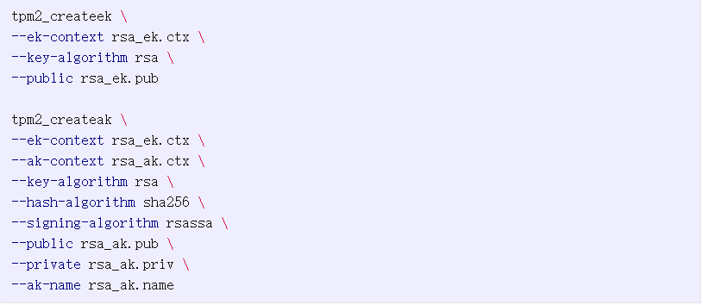
“Device-Node“ retrieving the endorsement-key-certificate to send to the “Privacy-CA“. There are two possible locations where the endorsement key certificates are provided by the TPM manufacturer. While most TPM manufacturers store them in the TCG specified NV indices , some make it available for download through a web hosting. Let’s look at both these methods.
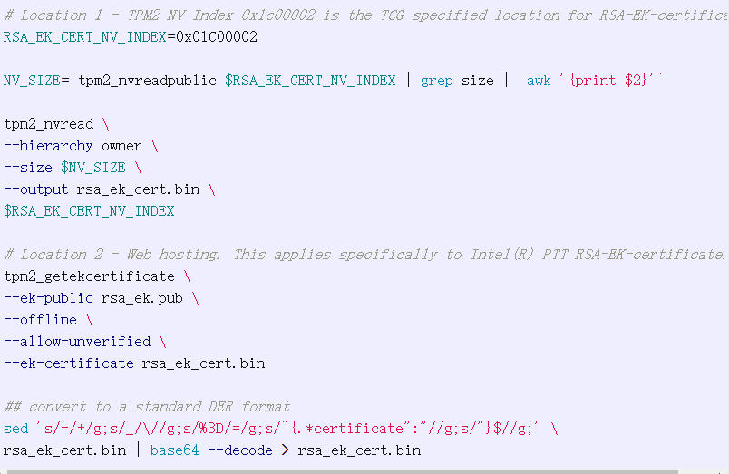
“Privacy-CA“ and the “Device-Node“ performing a credential activation challenge in order to verify the AIK is bound to the EK from the EK-certificate originally shared by the “Device-Node“. This is done in two different instances in the proposed simple-attestation-framework — Once when the “Service-Provider“ requests the “Device-Node“ to send over the identities as part of the service registration process. And the second time when the “Device-Node“ sends its AIK to the “Service-Provider“ and the “Service-Provider“ in turn sends it over to the “Privacy-CA“ in order to verify the anonymous identity.
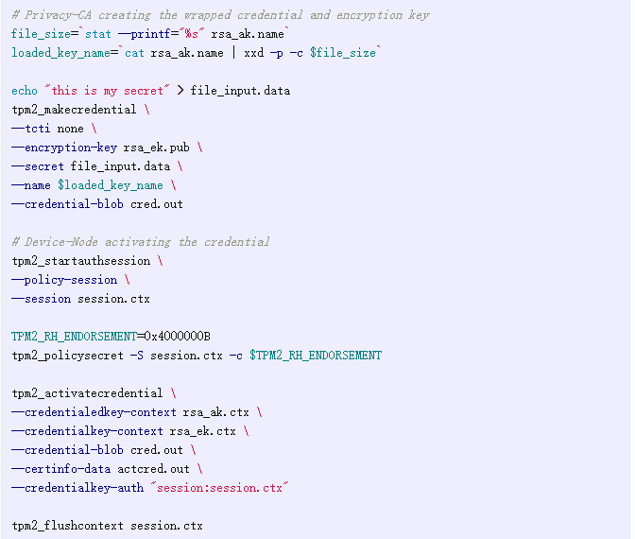
“Device-Node“ generating the PCR attestation quote on request from the “Service-Provider“. The “Service-Provider“ specifies the PCR-banks, PCR-indices, and the ephemeral NONCE data. The NONCE is to ensure there is no possibility of a replay attack on the quote verification and validation process. Validity of the signing key for attestation quote is ascertained to be a valid one by the “Privacy-CA“.
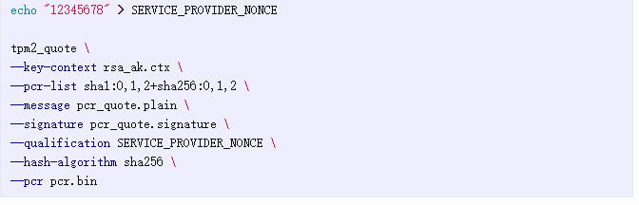
“Service-Provider“ verifying the attestation quote generated and signed by the “Device-Node“. To make the determination of the software-state of the “Device-Node“, after the signature and nonce verification process, the “Service-Provider“ validates the digest of the PCR values in the quote against a known-good-valid —the golden/ reference value ascertained previously.
