First question

First ,we go to browser's Settings page and Cookie and Site Permission.

Next, click "Manage and Delete Cookies and Site Data. Click to view all the cookies and site data, find the Cookie of the website and select Delete.

Second question

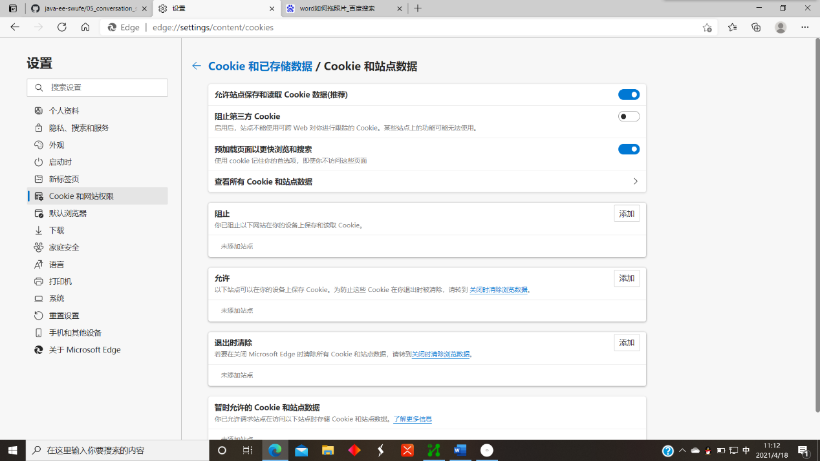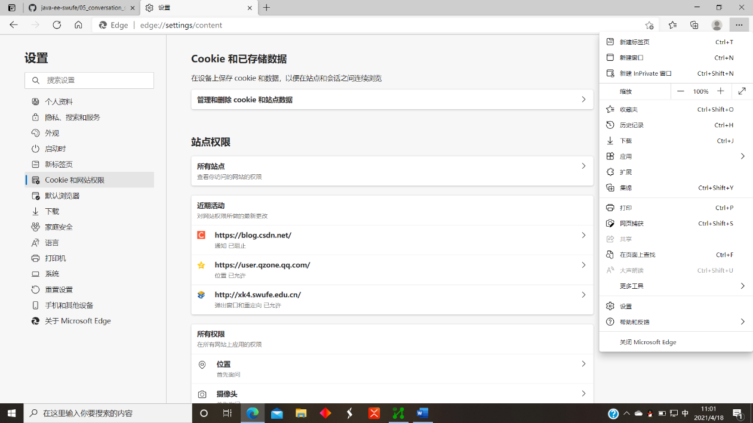Choose to block cookies from their website .Without cookie support, it will always be a new session.