Optimum Design
Homework #4 (Due 05/31/2022)

Numerically solve the following problems by any commercial software or your own code. For example, you can use one of the Matlab optimization functions or the C code in Numerical Recipes in C.

- A cylindrical tank has its height = h and the radius of the top and bottom = r (both in meters). What h and r values will minimize the total surface area (including the top, bottom, and the side) of this cylindrical tank. We are also told that the volume of this tank has to be fixed (i.e. πr²h = 20 m³). Please reformulate the objective function to include a penalty term, and solve the problem numerically using any method we have learned (e.g. the Nelder-Mead method or DFP method).

- Solve the following muscle force distribution problem. The F_{i} values are to be solved. Values of A_{i}, M_{i}, and d_{i} are given below. (The solution and the background ideas can be found in the paper by R.T. Raikova and B.I. Prilutsky, 2001. Sensitivity of predicted muscle forces to parameters of the optimization-based human leg model revealed by analytical and numerical analyses. Journal of Biomechanics, 34, 1243-1255.)
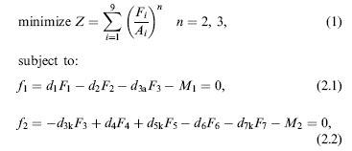

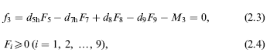
The values of the constants are given below:
M1=4; M2=33; M3=31;
The values of d1, d2, d3a, d3k, d4, d5k, d5h, d6, d7k, d7h, d8, d9 are included in the following vector: d=[0.0298 0.044 0.044 0.0138 0.0329 0.0329 0.0279 0.025 0.025 0.0619 0.0317 0.0368];
The values of A_{i} are also included in the vector A=[11.5 92.5 44.3 98.1 20.1 6.1 45.5 31.0 44.3];

